1. Support Platforms:

* Windows XP – Windows 8
* Linux and Ubuntu

2. Software requirements:

JDK and JRE must be installed in local machine, before run this hybrid framework.

3. Enter the browser configuration in XL sheet

We need to enter the browser name, URL and dimension size in XL configuration sheet. Check the below image for reference,

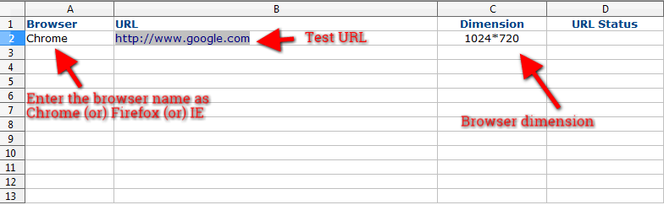

4. Setup the test-cases in XL sheet

Open Object sheet in XL

4.1 We need to setup the test-case id.

Note: If any test-cases will be failed, the screen-shot file name comes by test-case id. Not allows following characters in XL sheet test-case id field.

4.2 Enter the details whatever you need in Scenario/Branch and Test-case description columns in XL sheet.

4.3 Xpath - Enter/Paste the X-path locator element in XL sheet X-path column.

4.4 Actions:

Different actions are available, actions must be in lowercase, when enter in XL sheet action column.

click – use for clickable option
enter – to enter the characters
checkcontent – Enter the expected text-names in expected content column
dropdown – Enter the drop-down value(numeric) in Values column
mouseover
alertaccept
alertdismiss
alertsendkeys
getsize – We can get the size(Dimension – Width & Height) of the element
getlocation – We can get the location(x & Y) of the element
navigate – To navigate from one page to another page, Paste the navigate URL in “Values” column.
forward – Browser forward function
back – Browser backward function
refresh – Browser refresh function
gettitle – It can get the title of the page
getcurrenturl – It can get the current URL of the page.

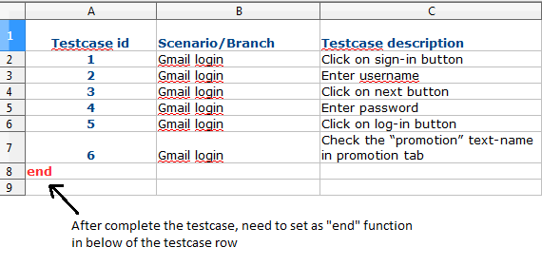

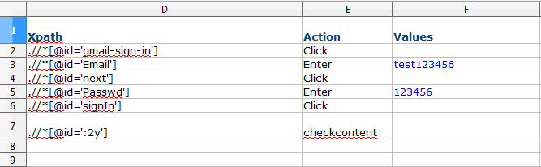

* Enter the expected content in expected column for check the text-names visible on page.
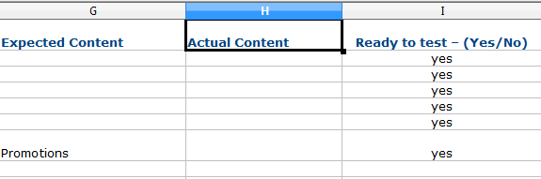
Execute the test-case

* After set all test-cases in XL sheet, run the Parameterization class file in Hybrid Framework.

Once test-cases will be completed, the results will be like this, open output file in test-result folder and find the failed test-case capture in screen-shot folder.

