Work Smart by Microsoft IT

Create a portable Windows 8 Environment by using Windows To Go

**Customization note:** This document contains guidance and/or step-by-step installation instructions that can be reused, customized, or deleted entirely if they do not apply to your organization’s environment or installation scenarios. The text marked by yellow highlighting indicates either customization guidance or organization-specific variables. All of the highlighted text in this document should either be deleted or replaced prior to distribution.

Windows To Go is a new feature in the Windows 8 Enterprise operating system that you can use to provision a USB drive with a complete, managed Windows 8 system image. You can insert the USB drive (known as a Windows To Go workspace) into any Windows 7–based or Windows 8–based host computer to boot and run a managed Windows 8 system without installing any software on the host computer. This guide shows you how to create a Windows To Go workspace.

Topics in this guide include:

Understanding the basics of Windows To Go

Creating a Windows To Go workspace

Suspending BitLocker protection on the host computer

Updating the configuration

Working with IntelliMirror

For more information

Understanding the basics of Windows To Go

You can create a Windows To Go workspace to boot a portable and managed Windows 8 system on a managed or unmanaged Windows 7–based or Windows 8–based host computer. For example, you might want to provide a company-owned Windows To Go workspace to a staff member who uses their own non-domain-joined computer at work. The Windows To Go workspace provides a domain-joined computer experience for this user, without modifying their personal consumer device. As another example, you can create a Windows To Go workspace for yourself to use on a home computer that’s running Windows 7.

You can use a Windows To Go workspace like any desktop, laptop, or tablet computer. For example, you can:

* Join a corporate domain.
* Connect to the corporate network from a remote site by using a virtual private network (VPN).
* Install applications.
* Access USB devices (such as a smart card reader) that are attached to the host.

A Windows To Go workspace works with any host computer (desktop, laptop, or tablet PC) that supports the **Boot To USB Hard Disk Drive** boot option. When you connect a Windows To Go workspace to a USB port on a host computer, the workspace is isolated from the host system’s hard drive to help prevent the hard drive from becoming compromised or infected. The user can switch between the Windows To Go workspace and the host hard drive at any time by inserting or removing the Windows To Go workspace during a system reboot.

Note: Windows To Go requires a USB 3.0 flash drive, which can be used on computers that have USB 3.x and USB 2.x ports.

Creating a Windows To Go workspace

To create a Windows To Go workspace, use the Windows To Go Creator provisioning tool. The provisioning tool is available from Control Panel in Windows 8 (Enterprise edition only).

To create a Windows To Go workspace by using the provisioning tool:

1. Ask your administrators to share a copy of the Windows installation image file (also known as a .wim file) that you can copy to your Downloads library folder.

-Or-

Ask your administrators to provide a Windows installation image file in DVD-ready format (also known as an .iso file) that you can copy to your Downloads library folder.

1. When the download is complete, open your Downloads folder on the host computer, press and hold (or right-click) the Windows 8 installation image .iso file, and then tap or click **MOUNT ISO**.

The .iso file appears as a disk drive on your host computer.

1. Swipe in from the right edge of the screen (point to the upper-right corner of the screen if you’re using a mouse), tap or click the Settings charm, and then tap or click the Control Panel app to open Control Panel.
2. In Control Panel, tap or click **Windows To Go**.
3. Insert a USB flash drive into a USB port on the host computer.

Note: Be sure to remove any files on the USB flash drive that you want to save. When you provision the USB flash drive, it will be reformatted and all data will be deleted.

1. On the **Choose the drive you want to use** screen, the provisioning tool displays any attached USB flash drives. Select the USB flash drive that you want to use, and then tap or click **Next**.  
   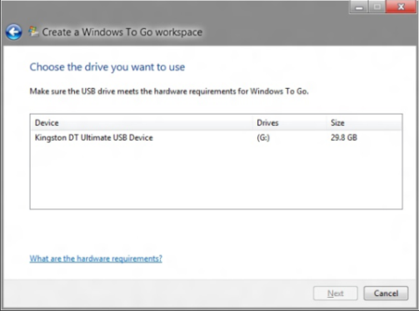
2. On the **Choose a Windows 8 image** screen, the provisioning tool displays the mounted .iso file. Tap or click the file, and then tap or click **Next**. (If you don’t see the .iso file, tap or click **Add search location** to select the file, and then tap or click **Next**.)  
   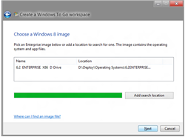
3. On the **Set a BitLocker password (optional)** screen, select the **Use BitLocker with my Windows To Go workspace** check box if you want to help protect the drive by using BitLocker Drive Encryption, and follow the prompts to enter and confirm a BitLocker password.  
   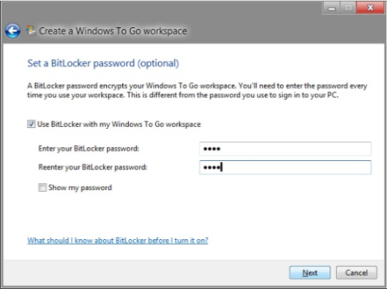
4. On the **Ready to create your Windows to Go workspace** screen, tap or click **Create** to create the Windows To Go workspace.  
   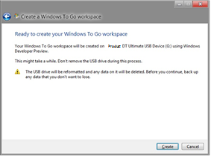

The provisioning tool starts to prepare your USB flash drive. This typically takes less than one hour.

1. On the **Choose a boot option** screen, select a boot option. If you tap or click **Yes**, the Windows Boot Manager configuration will be modified to automatically boot from your Windows To Go device when it’s connected to this host computer.  
   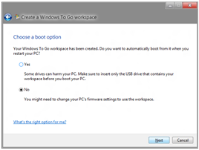

Note: If you want to change the boot option after you run the wizard, on the Windows 8 Start screen, type **Change Windows To Go Startup Options**, tap or click **Settings** to change the search scope, and then tap or click the Change Windows To Go Startup Options app to start it.  
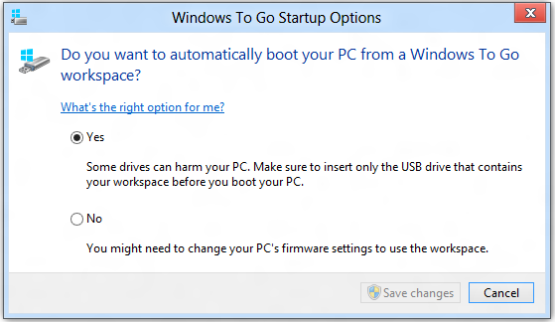

1. When provisioning is complete, tap or click **Save and restart** to reboot the host computer.

Suspending BitLocker protection on the host computer

If the host computer uses BitLocker Drive Encryption, and if you’re permanently switching the boot order in BIOS or Unified Extensible Firmware Interface (UEFI) boot device options, you must suspend BitLocker protection before you switch the boot order on the host computer. Otherwise, you’ll trigger the BitLocker recovery key screen when you try to boot back to the internal hard drive. After you switch the boot order, you’ll need to resume BitLocker protection for the internal drive.

To suspend BitLocker protection on a Windows 7–based host:

1. Click **Start**, and then click **Control** **Panel**.
2. Click **System** **and** **Security**, and then click **BitLocker Drive Encryption**.
3. In the **BitLocker Drive Encryption** dialog box, click **Suspend Protection**.  
   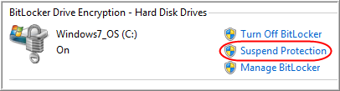

Note: To resume protection after switching the boot order, click **Resume protection** in the **BitLocker Drive Encryption** dialog box.

To suspend BitLocker protection on a Windows 8–based host:

1. On the Start screen, type **Control** **Panel**, and then tap or click the Control Panel app to open Control Panel.
2. In Control Panel, tap or click **System and Security**, and then tap or click **BitLocker Drive Encryption**.
3. In the **BitLocker Drive Encryption** dialog box, tap or click **Suspend protection**.  
   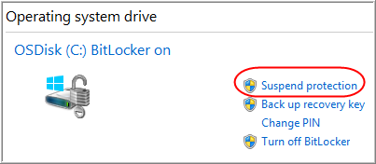

Note: To resume protection after switching the boot order, click **Resume protection** in the **BitLocker Drive Encryption** dialog box.

Updating the configuration

When you connect a Windows To Go workspace to a new host computer and reboot the host computer, Windows To Go automatically detects and applies the needed configuration updates before the Windows logon.

After logon, you may need to go to Windows Update to ensure that the Windows To Go workspace has the latest device drivers.

To check for updates:

1. Swipe in from the right edge of the screen (point to the upper-right corner of the screen if you’re using a mouse), tap or click the Settings charm, and then tap or click **Change PC Settings**.
2. Tap or click **Windows** **Update**.
3. On the right side of the screen, tap or click **Check online for updates**.

Working with IntelliMirror

If you have configured Microsoft IntelliMirror services for an IT-managed computer, your data libraries will automatically sync to the new Windows To Go workspace after logon.

For more information

Windows To Go video

<http://technet.microsoft.com/en-us/windows/jj737992.aspx>

Windows To Go: Feature Overview

<http://technet.microsoft.com/en-us/library/hh831833.aspx>

Windows To Go Step by Step

<http://social.technet.microsoft.com/wiki/contents/articles/6991.windows-to-go-step-by-step.aspx>

Windows To Go: FAQ

<http://windows.microsoft.com/is-IS/windows-8/windows-to-go-faqs>

Work Smart by Microsoft IT

<http://aka.ms/customerworksmart>

Modern IT Experience featuring IT Showcase

<http://microsoft.com/microsoft-IT>

This guide is for informational purposes only. MICROSOFT MAKES NO WARRANTIES, EXPRESS, IMPLIED, OR STATUTORY, AS TO THE INFORMATION IN THIS DOCUMENT. © 2014 Microsoft Corporation. All rights reserved.