**Results**

* + - Results of Objective 1
      * What was feasible? What not? Where? Why?
      * Maps / graphs showing OSM data coverage in different areas
      * How many cities will be “usable”?
      * 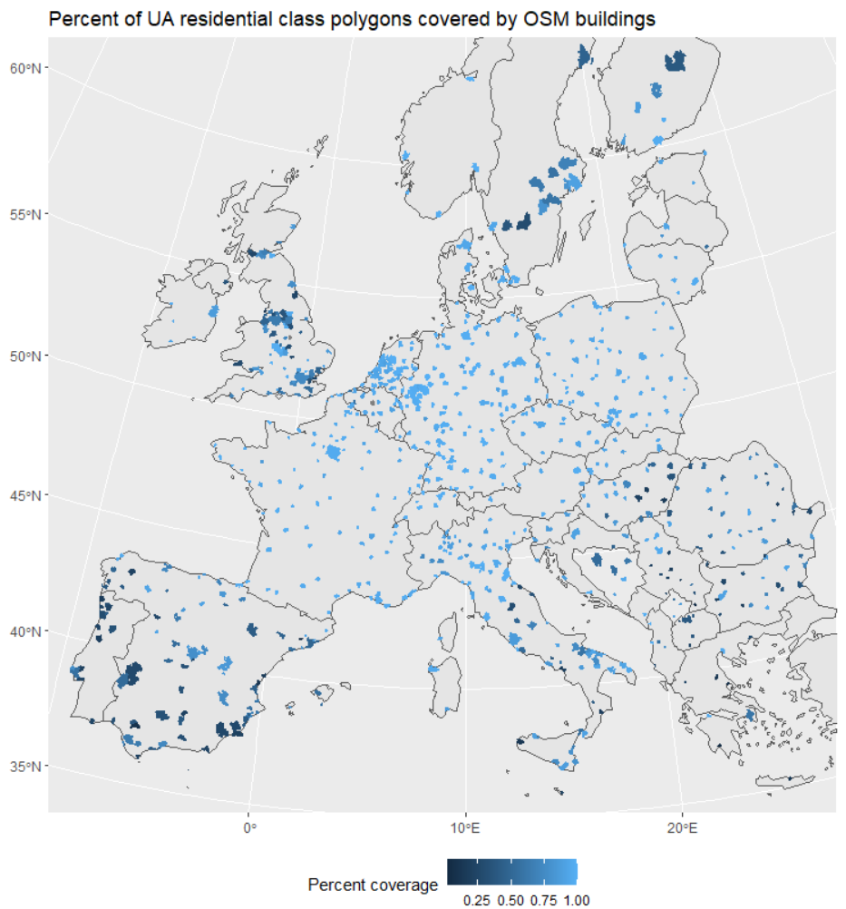
    - Result of Objective 2
      * European level
        + Detour index vs. cumulative population graphs

Clustered

By region

* + - * + Local significance?
        + Tree / graphs like in Wolff, Scheuer et al. 2020
        + Maps like in Kabisch et al. 2016
      * City scenarios
        + Base indicators

Figure X displays the local significance (LS) and detour index (DI) values that we calculated for the area surrounding the Leve-Voigt-Park (LVP) in Leipzig (see figure description).

High LS values can be found in close proximity to the LVP. Especially high LS values occur close to those park entries adjacent to streets that form axis connecting areas with high population to the LVP. The eastern part of the LVP is a good example of this, expressing high LS values at the edges that lead to the residential areas in the north- and south-east.

High DI values can be found at buildings that are located at streets which lead directly to a green space entry. Along those streets there are straight formations of buildings with high DI values as can be seen in the south of the LVP. In contrast, there occur clusters of low DI values in areas where larger detours have to be taken to reach a park entry. Such areas can be found in the north-east of the LVP. Low DI values also occur in close proximity to the LVP as an artifact of small network and Euclidean distances. In these cases, a minor difference can lead to a low DI value even though the overall traveling distance to the next green space entry in relatively small (DISCUSSION?).

Subtitles figure 1:

The network colors depict the cumulative Local Significance index (LS). A more orange color represents a larger LS value, representing i.) more people taking this path, ii.) the people taking this path are living in closer proximity to the green space, and iii.) the path is leading to a green space with a larger area.

The building colors represent average Detour Index values (DI) calculated for all green spaces that can be reached in a network distance of 500 meters. The bluer the color of a building is, the closer to one the DI value, the more direct can its residents travel to the closest green spaces. The opposite is the case if the color tends towards orange.

* + - * + Scenario 1 – Unlimited access

In this scenario we demonstrated how the LS and DI indicators would change if all barriers obstructing access to the Lene-Voigt-Park were to be removed.

We did so by assuming a park entry every 5 m on the network.

surrounding Lene-Voigt-Park.

* + - * + Scenario 2 – Green space development
        + Scenario 3 – Population increase
        + Scenario 4 – Ensemble model
      * City comparison
        + Spatial clustering
        + Statistical clustering