# hello_world

### chapter 1

how are u today

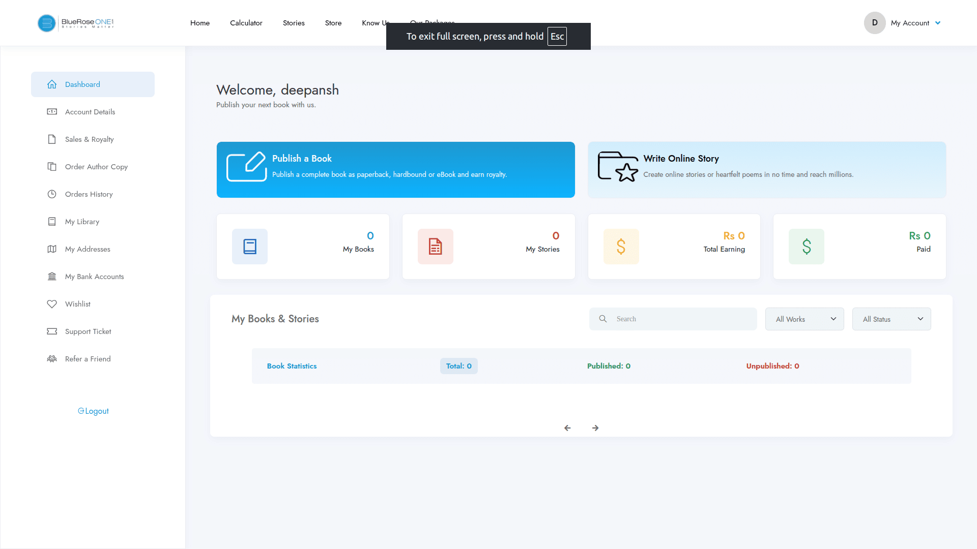

me: I am fine

Bot: what are you doing ?

me:Nothing   
Bot: what's ur plan to do?

Me: Nothing   
Bot:you are so lazy bro…!  
Me: Not more than you….  
Bot: Lets Do something …!

Me:what do you want to do ?

Bot: As you say what u want to do …/.

Me: Nothing

|  |  |  |  |  |
| --- | --- | --- | --- | --- |
| 2 | * | 1 | = | 2 |
| 2 | * | 2 | = | 4 |
| 2 | * | 3 | = | 6 |
| 2 | * | 4 | = | 8 |
| 2 | * | 5 | = | 10 |
| 2 | * | 6 | = | 12 |
| 2 | * | 7 | = | 14 |
| 2 | * | 8 | = | 16 |
| 2 | * | 9 | = | 18 |
| 2 | * | 10 | = | 20 |