Credit Scoring Frontend
Handoff documentation

Table of Contents
Architecture
1. System context
2. Tech stack at a glance
3. Folder layout
4. Two portals, one deployment
5. Request lifecycle (data fetching)
6. Component composition pattern
7. Build & deploy targets
8. Where to start as a new contributor
Deployment Guide
1. What gets deployed
2. First-time setup
2.1 Pick a <suffix>
2.2 Generate the session secret
2.3 Create the resource group
2.4 Fill in the parameters file
3. One-shot deploy from your laptop
4. Configuration is runtime-only — the image is environment-portable
5. CI/CD
Option A — GitHub Actions
Option B — Azure DevOps Pipelines
6. Custom domain + TLS (client-managed)
6.1 Bind the hostname to the Container App
6.2 Bind a managed certificate
6.3 Make it the canonical origin
7. Post-deploy verification
8. Rollback
9. Operations
Logs
Scaling
Cost ceiling
10. Tearing it all down
11. Troubleshooting
12. What's NOT in this guide
Data Flow
1. Layers at a glance
2. The shared API client
Response interceptor
3. Service layer convention
Example: score-service.ts
Naming
Catalog of services
4. TanStack Query setup
Query keys
Invalidation
5. Pagination convention
6. Form pattern
7. Adding a new endpoint — checklist
8. Where to look when something breaks
Security
1. Threat model
2. Where authority lives
3. Token storage
Request lifecycle
What this protects against
What still needs care
4. Security headers (defense in depth)
5. Secrets & environment variables
6. Logging & telemetry
7. Dependency posture
8. Reporting issues
9. Related docs

Architecture
A tour of the frontend application: how requests flow, what lives where, and how the pieces fit together. For deeper coverage of specific subsystems, see the sibling docs:
- Auth & RBAC — login, 2FA, token refresh, permission gating.
- Data flow — service layer, TanStack Query, snake/camel mapping.
- Feature map — every page → endpoints consumed.
- Security — threat model, security headers, token storage.

1. System context
The frontend is a Next.js (App Router) application that talks to a FastAPI backend over HTTPS. It serves two distinct portals from the same deployment, isolated by route group and middleware.
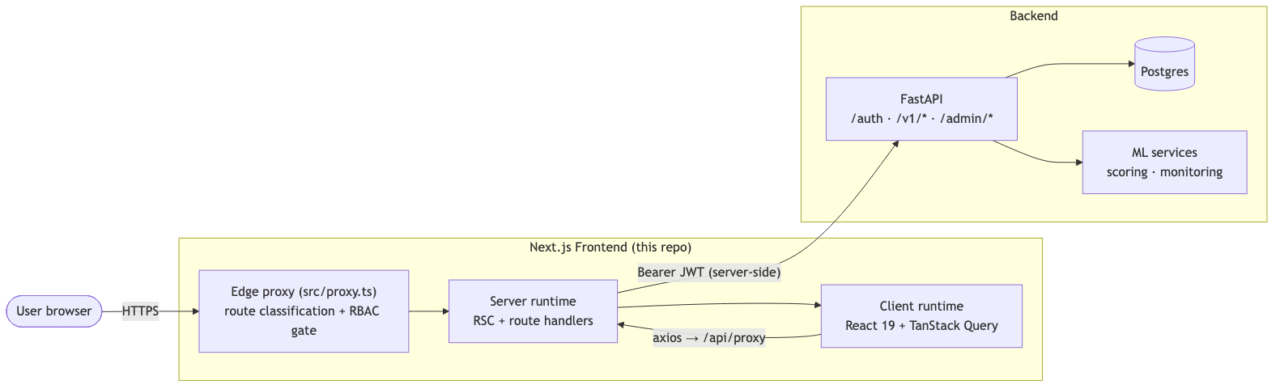
The browser never talks to the backend directly. Tokens live in an HttpOnly __Host- session cookie set by Next Route Handlers under src/app/api/auth/*; every authenticated call from the browser goes to the same-origin catch-all /api/proxy/[...path] Route Handler, which reads the cookie server-side and attaches the bearer token before forwarding to the backend. See security.md for the full token-storage story.

2. Tech stack at a glance
Layer | Choice | Notes
Runtime | Node ≥ 20 | Required by Next 16 / React 19
Framework | Next.js 16 (App Router) | Edge middleware via src/proxy.ts
UI | React 19 + Tailwind CSS 4 + shadcn/ui | Radix primitives under the hood
Server state | TanStack Query 5 | Single QueryClientProvider at the root
Client state | React Context | Auth + theme only — no global store
Forms | react-hook-form + zod | Schemas under src/lib/schemas/
HTTP | axios | Browser-side; targets same-origin /api/proxy. Bearer-attach + 401 refresh live in the proxy Route Handler, server-side.
Toasts | sonner | Top-right, rich colors
Theme | next-themes | light / dark / system
Icons | lucide-react
A Vitest unit/integration suite and a Playwright E2E suite ship with the repo — see testing.md.

3. Folder layout
src/
├── app/ # Next.js App Router
│ ├── (auth)/ # Route group: unauthenticated pages
│ │ ├── login/ # Org login
│ │ ├── admin-login/ # Admin login
│ │ ├── forgot-password/ # Password recovery: request reset
│ │ ├── reset-password/ # Password recovery: redeem token
│ │ └── layout.tsx # Auth shell (logo, copy)
│ ├── (admin)/ # Route group: platform-admin portal
│ │ ├── admin-dashboard/
│ │ ├── organizations/ # Org list + onboarding
│ │ ├── training/ # Training data + sources + uploads
│ │ ├── admin-score-requests/
│ │ ├── scoring-engine/
│ │ ├── admin-monitoring/ # Infra · risk · model-ops · compliance
│ │ ├── admin-access-control/ # Roles + permissions catalog
│ │ ├── admin-settings/
│ │ └── layout.tsx # Admin sidebar + topbar
│ ├── (org)/ # Route group: organization portal
│ │ ├── dashboard/
│ │ ├── score-requests/ # List + new + bulk + [id] detail
│ │ ├── teams/ # Org user CRUD
│ │ ├── settings/
│ │ └── layout.tsx # Org sidebar + topbar
│ ├── layout.tsx # Root layout: providers, fonts, theme
│ └── not-found.tsx # 404 / wrong-scope catch
├── components/
│ ├── ui/ # shadcn primitives (button, dialog, ...)
│ ├── shared/ # Cross-cutting (StatCard, EmptyState, RolePicker)
│ ├── auth/ # LoginShell + 2FA + recovery
│ ├── score-requests/ # Tables, override modal, batch upload
│ ├── organization/ # Provisioning, suspend, profile
│ ├── teams/ # Invite / edit user modals
│ ├── settings/ # Personal-account / security tabs
│ ├── training/ # Upload, source, status modals
│ ├── admin/ # Admin-only tables & widgets
│ └── monitoring/ # Charts, alerts, drift cards
├── contexts/ # AuthContext, ThemeContext
├── hooks/ # usePermissions, useDebounce, ...
├── lib/
│ ├── api-client.ts # axios instance pointed at /api/proxy
│ ├── *-service.ts # One file per backend domain
│ ├── auth-service.ts # /auth/* — login, 2FA, password
│ ├── server-session.ts # HttpOnly cookie helpers (server-only)
│ ├── session-storage.ts # Non-sensitive user-cache (localStorage)
│ ├── schemas/ # zod validation schemas
│ ├── constant.ts # ROUTES, API_ENDPOINTS, PERMISSION_CODES
│ └── utils.ts # formatters, helpers
├── proxy.ts # Edge middleware — RBAC + zone enforcement
└── types/ # Shared TS types (camelCase domain models)

4. Two portals, one deployment
The application serves two audiences from a single Next.js app:
Portal | Audience | Route group | Login
Organization | Lender users (credit officers, devs, viewers) | (org) | /login
Admin | Platform operators (super admin, risk analyst, model ops, …) | (admin) | /admin-login
Isolation is enforced at three layers:
- Edge middleware (src/proxy.ts) reads the HttpOnly session cookie, classifies the requested path as auth | admin | org | public, and either lets it through, redirects to the right login, or rewrites to the not-found page if a user attempts a wrong-scope route.
- Backend authorization is the hard boundary — every API call carries a JWT and the backend re-checks both userType and per-action permissions. The middleware is defense-in-depth, never the sole gate.
- Client-side usePermissions() hides UI elements the user cannot use (buttons, menu items, columns), so a user with score_requests.list but not score_requests.override doesn't see the override action.
See auth-and-rbac.md for the full sequence diagrams.

5. Request lifecycle (data fetching)
A typical authenticated read follows this path:
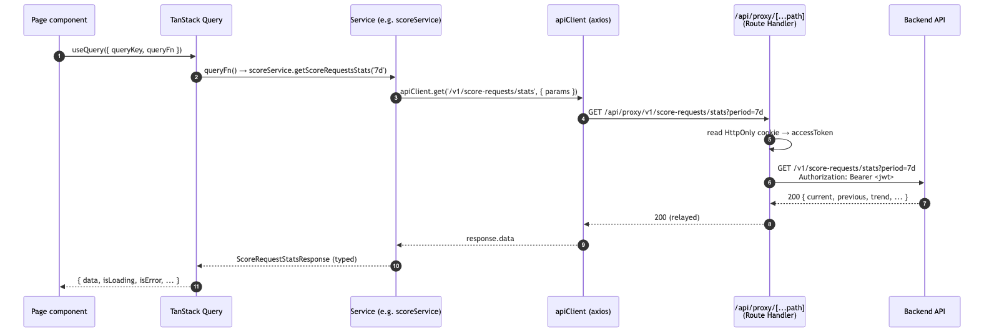
If the backend returns 401, the proxy Route Handler (1) calls POST /auth/refresh with the stored refresh token, (2) rewrites the cookie with the new access token, and (3) retries the original request once. On refresh failure the cookie is cleared and the response goes back as 401, which the browser-side axios picks up and redirects to /login. See src/app/api/proxy/[...path]/route.ts for the implementation.
For mutations, the same path applies but the page component uses useMutation and is responsible for invalidating the relevant query keys after success.

6. Component composition pattern
A typical page is a thin orchestrator that wires together hooks, services, and presentational components:
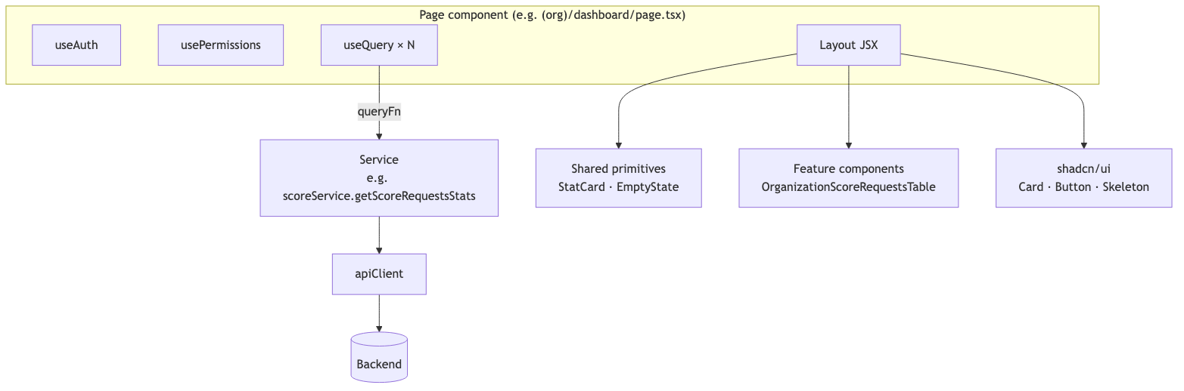
Conventions:
- Pages own data fetching. They call useQuery / useMutation directly. There is no custom-hook indirection layer — query key factories (SCORE_KEYS, MONITORING_KEYS, …) keep keys consistent.
- Services own typing and mapping. Each *-service.ts exports a single object literal (e.g. scoreService) whose methods return camelCase domain types. Snake → camel mapping happens inside the service, never leaks to the caller.
- Components are presentational where possible. Tables and cards take props, not service calls. The dashboard page composes them.
- Forms use react-hook-form + zod. Schemas live in src/lib/schemas/ and are reused between the form and any submission helper.
See data-flow.md for the service-layer convention in full.

7. Build & deploy targets
The app builds to a Next.js production bundle via npm run build. Routes split into two output kinds:
- Static (○) — pre-rendered at build time, served from CDN. Most authenticated routes still appear as static here because RSC defers data fetching to the client; the static shell renders a loading state.
- Dynamic (ƒ) — server-rendered per request (the [id] routes and the proxy middleware itself).
See deployment-guide.md for the full Azure Container Apps deployment story. The current build verifies clean on Node 20+ and produces a deploy-ready .next/ directory plus the proxy middleware.

8. Where to start as a new contributor
Read in this order:
- auth-and-rbac.md — understand who-can-do-what before reading any feature code.
- data-flow.md — internalize the service convention so new endpoints look like the existing ones.
- feature-map.md — find the page that handles the slice of the product you care about.
- The relevant *-service.ts and the page that consumes it — these two files are usually enough to understand a feature end-to-end.
For backend changes that affect the FE, see integrations.md.

Deployment Guide
How to deploy the PaySwitch Credit Scoring frontend to Azure Container Apps using the Bicep stack and helper scripts that ship in this repository.
This guide is the canonical reference for the client engineering team. It assumes only:
- An Azure subscription you can deploy into.
- A working install of Azure CLI (≥ 2.55).
- Either Docker Desktop locally, or willingness to use ACR Build so you don't need a local Docker daemon.
- The backend API is already deployed at a known URL (the FE talks to it as a separate origin).
It does not assume anything about the FE codebase that isn't already documented in architecture.md or security.md.

1. What gets deployed
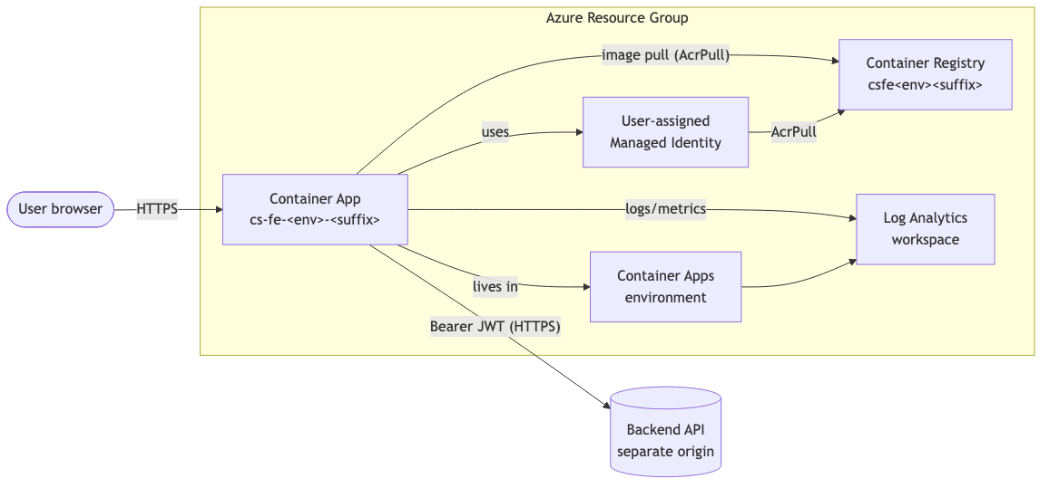
Resource | Bicep name pattern | Purpose
Log Analytics workspace | cs-fe-<env>-<suffix>-logs | Receives container logs / metrics
Container Registry | csfe<env><suffix> | Holds the FE image; private
User-assigned Managed Identity | cs-fe-<env>-<suffix>-id | Image-pull identity (AcrPull role)
Container Apps Environment | cs-fe-<env>-<suffix>-env | Shared host for revisions
Container App | cs-fe-<env>-<suffix> | The Next.js workload (port 3000)
<env> is dev, stg, or prod. <suffix> is a 3–8 char alphanumeric stem you pick once per resource group (it makes globally-unique resources like ACR / Log Analytics safe).
Source files:
- Dockerfile — multi-stage standalone Next.js image.
- deploy/azure/main.bicep — the full stack.
- deploy/azure/parameters.dev.json, parameters.prod.json — environment-specific values.
- deploy/scripts/deploy.sh — one-shot build + push + deploy.
- deploy/scripts/set-secrets.sh — rotate runtime secrets.
- .github/workflows/deploy.yml — GitHub Actions CD.
- azure-pipelines.yml — Azure DevOps CD (alternative to GHA).

2. First-time setup
You only do this once per resource group / environment.

2.1 Pick a <suffix>
Anything 3–8 alphanumeric characters that's globally unique to this stack works. A common pattern is the resource group's short name plus a few random chars (prod42, cs7w9p, …). Once chosen, never change it — the suffix appears in every resource name.

2.2 Generate the session secret
openssl rand -hex 64

Save the output. You'll paste it into the parameters file in §2.4 (and into your CI environment secret if you wire CI/CD).
The secret is read server-side only by the Next Route Handlers under src/app/api/auth/* to seal the HttpOnly session cookie. It never reaches the browser. Use a different value per environment and rotate when staff leave. See security.md §3.

2.3 Create the resource group
az login
az account set --subscription <subscription-id>

az group create \
--name cs-fe-prod-rg \
--location westeurope

Pick the location closest to your users and to the backend.

2.4 Fill in the parameters file
Copy the template for your environment and fill in the placeholders:
cp deploy/azure/parameters.prod.json deploy/azure/parameters.prod.local.json
$EDITOR deploy/azure/parameters.prod.local.json

Field | What to put in it
resourceSuffix | The 3–8 char stem from §2.1
containerImage | Initial value can be <acr>.azurecr.io/credit-scoring-fe:1.0.0. The deploy script overrides this on every run.
backendApiUrl | The backend's public HTTPS URL, no trailing slash. Server-only — never reaches the browser.
minReplicas / maxReplicas | Reasonable defaults: 1/3 for dev, 2/10 for prod
Keep the *.local.json copy out of source control (.gitignore already covers *.local.json patterns under env files; verify before committing).

3. One-shot deploy from your laptop
deploy/scripts/deploy.sh \
--resource-group cs-fe-prod-rg \
--location westeurope \
--environment prod \
--suffix prod42 \
--tag 1.0.0 \
--parameters deploy/azure/parameters.prod.local.json

What it does, in order:
- Creates the resource group if missing.
- Creates the ACR named csfeprod<suffix> if missing.
- Builds Dockerfile (no build args needed — every secret is read at runtime) and pushes the resulting image to ACR.
- Runs az deployment group create against main.bicep with the parameters file + the just-pushed image.
- Prints the public FQDN of the new revision.
Common flags:
- --use-acr-build — build inside Azure (no local Docker required). Slightly slower but lets you deploy from any machine.
- --parameters <path> — point at a different parameters file (e.g. when running from a CI runner that has the secrets injected).
You should see something like:
✓ Container App: https://cs-fe-prod-prod42.westeurope.azurecontainerapps.io
✓ Container App name: cs-fe-prod-prod42

4. Configuration is runtime-only — the image is environment-portable
Tokens never reach the browser, and the FE has no NEXT_PUBLIC_* configuration. As a result:
- The container image is the same for dev, staging, and prod. Promotion is a tag move.
- The only runtime configuration is BACKEND_API_URL, surfaced as a Container App secret.
- Rotating the backend URL is a Container App secret update — no rebuild needed:
deploy/scripts/set-secrets.sh \
--resource-group cs-fe-prod-rg \
--app cs-fe-prod-prod42 \
--backend-api-url https://api.payswitch.example.com

To redeploy with a new image tag:
deploy/scripts/deploy.sh \
--resource-group cs-fe-prod-rg \
--location westeurope \
--environment prod \
--suffix prod42 \
--tag 1.0.1 \
--parameters deploy/azure/parameters.prod.local.json

Container Apps shifts traffic to the new revision once it passes its readiness probe.

5. CI/CD
The repo ships two continuous-deployment workflows. Pick one as your source of truth and delete (or simply not configure) the other.

Option A — GitHub Actions
Files: .github/workflows/ci.yml, .github/workflows/deploy.yml.
- ci.yml runs typecheck, lint, unit tests, and (on PRs to main/develop) Playwright E2E.
- deploy.yml:
  - Push to develop → deploys to dev.
  - Push of a v* tag → deploys to prod.
  - Manual workflow_dispatch → choose env.
Auth uses OIDC federated credentials so you never store an Azure client secret in GitHub. Setup:
# 1. Create the AAD app registration (or reuse an existing one)
APP_ID=$(az ad app create --display-name cs-fe-github --query appId -o tsv)
SP_ID=$(az ad sp create --id $APP_ID --query id -o tsv)

# 2. Grant Contributor on the resource group
az role assignment create \
--assignee $APP_ID \
--role Contributor \
--scope /subscriptions/<sub-id>/resourceGroups/cs-fe-prod-rg

# 3. Add a federated credential per branch / tag pattern
az ad app federated-credential create --id $APP_ID --parameters '{
"name": "github-cs-fe-tag-prod",
"issuer": "https://token.actions.githubusercontent.com",
"subject": "repo:<org>/<repo>:ref:refs/tags/v*",
"audiences": ["api://AzureADTokenExchange"]
}'

Then in GitHub → Settings → Environments, create dev and prod environments and add:
Scope | Type | Name | Value
Repo secrets | secret | AZURE_CLIENT_ID | $APP_ID
Repo secrets | secret | AZURE_TENANT_ID | (your tenant)
Repo secrets | secret | AZURE_SUBSCRIPTION_ID | (your sub)
Repo secrets | secret | AZURE_RESOURCE_GROUP | cs-fe-prod-rg
Repo secrets | secret | AZURE_RESOURCE_SUFFIX | prod42
Env (prod) secret | secret | BACKEND_API_URL | https://api.payswitch.example.com
Env (dev) secret | secret | BACKEND_API_URL | https://api-dev.…
For prod consider enabling required reviewers in the environment settings — the workflow will pause for approval before deploying.

Option B — Azure DevOps Pipelines
File: azure-pipelines.yml. The same three stages (validate → build → deploy) using ADO native primitives.
Setup:
- Create an Azure Resource Manager service connection — workload identity is strongly preferred over secret-based auth.
variables:
azureServiceConnection: cs-fe-azure

Update the variable name in the pipeline if you call your connection something else.
- Create two variable groups in Library:
  - cs-fe-shared — AZURE_RESOURCE_GROUP, AZURE_RESOURCE_SUFFIX.
  - cs-fe-dev and cs-fe-prod — BACKEND_API_URL (mark as 🔒).
- Create matching ADO Environments named dev and prod. Attach approval gates to prod.
Triggers (same semantics as GitHub):
- Push to develop → dev.
- Push of v* tag → prod.
- Manual run with the targetEnvironment parameter.

6. Custom domain + TLS (client-managed)
Client owns the DNS record and certificate. Two-step process:

6.1 Bind the hostname to the Container App
APP=cs-fe-prod-prod42
RG=cs-fe-prod-rg
HOST=app.payswitch.example.com

# 1. Get the verification info
az containerapp hostname add \
--hostname $HOST \
--name $APP \
--resource-group $RG

This returns a validationToken. Add two DNS records at your DNS provider:
Type | Name | Value
CNAME | app | <app-fqdn>.azurecontainerapps.io
TXT | asuid.app | <validationToken>
Wait for propagation (dig or dnschecker.org).

6.2 Bind a managed certificate
az containerapp hostname bind \
--hostname $HOST \
--name $APP \
--resource-group $RG \
--environment cs-fe-prod-prod42-env \
--validation-method CNAME

Azure issues a free managed certificate (renews automatically). For a customer-supplied cert, use --validation-method TXT and upload the cert with az containerapp env certificate upload first.

6.3 Make it the canonical origin
The browser only ever calls /api/* on this Next app. The Next Route Handlers proxy server-side to the backend at BACKEND_API_URL. Moving the FE to a custom domain therefore requires no FE rebuild and no backend CORS configuration — same-origin everywhere.
CORS is no longer a deployment concern. The browser doesn't talk to the backend directly, so the backend doesn't need the FE's origin in any allow-list.

7. Post-deploy verification
After every deploy, run through this checklist:
APP=cs-fe-prod-prod42
RG=cs-fe-prod-rg
FQDN=$(az containerapp show -n $APP -g $RG \
--query 'properties.configuration.ingress.fqdn' -o tsv)

# 1. Smoke test — should be 200 (or 307 redirect to /login)
curl -fsSI https://$FQDN | head -5

# 2. Security headers — should include X-Frame-Options, HSTS, etc.
curl -fsSI https://$FQDN | grep -iE 'x-frame|hsts|strict-transport|content-type-options|referrer-policy'

# 3. Latest revision is healthy
az containerapp revision list -n $APP -g $RG \
--query '[].{name:name, active:properties.active, healthy:properties.healthState, replicas:properties.replicas}' \
--output table

# 4. Tail logs for the last few minutes
az containerapp logs show -n $APP -g $RG --tail 100

Then in a browser:
- Open https://$FQDN — you should land on /login (the proxy redirects unauthenticated requests).
- Sign in with a real backend account.
- Open DevTools → Network → confirm the login POST goes to same-origin /api/auth/login (the Next Route Handler), not directly to the backend. The HttpOnly __Host-session cookie should appear under Application → Cookies.
- Hit a wrong-scope path (e.g. /admin-dashboard as an org user) — confirm it renders the not-found page without changing the URL (proxy rewrite, see auth-and-rbac.md §4).

8. Rollback
Container Apps keeps recent revisions warm. To roll back:
APP=cs-fe-prod-prod42
RG=cs-fe-prod-rg

# List revisions, newest first
az containerapp revision list -n $APP -g $RG \
--query '[].{name:name, active:properties.active, created:properties.createdTime}' \
--output table

# Activate the previous good one
az containerapp revision activate \
--revision <previous-revision-name> \
--name $APP \
--resource-group $RG

# Send 100% of traffic to it
az containerapp ingress traffic set \
--name $APP \
--resource-group $RG \
--revision-weight <previous-revision-name>=100

Or simply re-run deploy.sh with the previous Git tag.

9. Operations

Logs
az containerapp logs show -n $APP -g $RG --tail 200 # recent
az containerapp logs show -n $APP -g $RG --follow # live stream

For longer-window queries use Log Analytics directly:
WS=$(az monitor log-analytics workspace show \
-g $RG -n cs-fe-prod-prod42-logs --query customerId -o tsv)

az monitor log-analytics query --workspace $WS \
--analytics-query "ContainerAppConsoleLogs_CL | where ContainerName_s == 'frontend' | take 100"

Scaling
Edit minReplicas / maxReplicas in the parameters file and re-run deploy.sh. Or change at runtime:
az containerapp update \
--name $APP --resource-group $RG \
--min-replicas 2 --max-replicas 20

Cost ceiling
The Bicep stack uses Basic-tier ACR and PerGB2018 Log Analytics. Set a daily quota on the workspace if you're cost-conscious; the template already caps at 1 GB/day.

10. Tearing it all down
az group delete --name cs-fe-prod-rg --yes --no-wait

This removes everything in §1, including the registry. Anything outside the resource group (DNS records, the AAD app for OIDC, …) is untouched.

11. Troubleshooting
Symptom | Likely cause | Fix
ImagePullBackOff on the Container App | Managed identity hasn't received AcrPull yet | Wait 30 s — the role-assignment is async; or az role assignment create manually.
Browser shows Unable to connect after a clean deploy | BACKEND_API_URL unreachable from the Container App | Verify the URL with curl from a sidecar / az containerapp exec; the browser never talks to the backend directly so this is always a server-side reachability issue.
Login form submits but stalls | BACKEND_API_URL Container App secret is wrong / unset | deploy/scripts/set-secrets.sh --backend-api-url … then verify with az containerapp logs show.
tsc --noEmit clean locally, fails in CI | Node version mismatch (CI is 20, local was 22) | Pin the Node engine in package.json and align CI to match.
Revision flips to "Failed" with no obvious error | Liveness probe times out (cold start > 10 s) | Bump probe initialDelaySeconds in main.bicep or set minReplicas: 1 to keep one warm.
Persisting failed: Unable to write SST file in dev | Two Next.js processes writing to the same .next/ (dev + Playwright build colliding) | Use a separate distDir for Playwright (the E2E config already does this via .next-e2e).

12. What's NOT in this guide
- The backend API: separate repository, separate deploy. The frontend's only relationship is the server-side BACKEND_API_URL. No CORS coordination is required because the browser never talks to the backend directly.
- Customer SSL termination: the azurecontainerapps.io domain comes with a wildcard cert; for customer domains, see §6.
- Application Insights: not provisioned. The Container App writes logs and metrics to Log Analytics; if richer APM is required later, attach Application Insights to the same workspace.
- Backend hardening: backend-owned concerns (rate-limiting, JWT signing-key rotation, audit logs) are out of scope for this guide.

Data Flow
How the frontend talks to the backend, where types live, and the conventions every new endpoint should follow. If you're adding a feature that touches the API, this is the doc to read first.

1. Layers at a glance
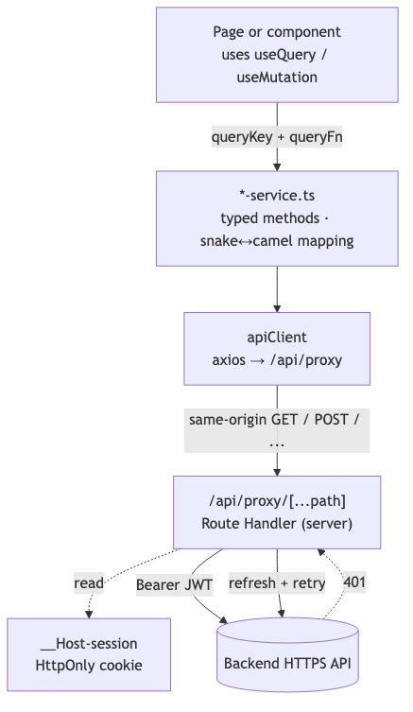
Three rules keep this clean:
- Pages call services. They never touch axios directly and never inline fetch().
- Services own types and mapping. Every method returns a camelCase domain type. Snake-case is contained to private types inside the service.
- The browser-side client is token-free. The shared apiClient only points at same-origin /api/proxy and normalizes errors — bearer-attach and 401 refresh live server-side in the proxy Route Handler.

2. The shared API client
src/lib/api-client.ts exports a default axios instance configured with:
- baseURL = "/api/proxy" — same-origin Next Route Handler that forwards to the upstream BACKEND_API_URL server-side
- timeout = 30000 ms
- Content-Type: application/json by default
- withCredentials: true so the HttpOnly session cookie travels with each request
The browser-side client is intentionally minimal: it carries no bearer-token logic and no refresh logic — those live in the proxy Route Handler at src/app/api/proxy/[...path]/route.ts (see auth-and-rbac.md §3.1).

Response interceptor
- 2xx — pass through, log in dev.
- 401 (non-auth path) — refresh already failed server-side; the interceptor redirects the browser to /login.
- No response (timeout / network error) — return a normalized ApiError with a user-friendly message.
- FastAPI 422 — peel off the detail[] array and surface the first message, exposing the full validation list under details.validationErrors.
- Anything else — normalize into ApiError { code, message, details, statusCode } with sensible HTTP-status fallbacks.
Every service method gets a typed value back or a thrown ApiError — never a raw axios error.

3. Service layer convention
One file per backend domain under src/lib/. Each exports:
- Raw API types (Api*, snake_case, private to the file).
- Public domain types (camelCase) — exported for callers.
- Mapper functions (mapX) that translate raw → domain.
- Query key factory (<DOMAIN>_KEYS) — all keys for the domain in one place.
- The service object with one async method per endpoint.

Example: score-service.ts
// 1. Raw API shape (never leaks out of the file)
interface ApiRawScoreRequest {
request_id: string;
organization_id: string;
status: string;
score_value?: number | null;
created_at: string;
// ...
}

// 2. Public domain type — re-exports the model from src/types
export type ScoreRequestItem = ScoreRequest;

// 3. Mapper
function mapScoreRequest(raw: ApiRawScoreRequest): ScoreRequestItem {
return {
id: raw.request_id,
organizationId: raw.organization_id,
status: raw.status as ScoreRequestStatus,
scoreValue: raw.score_value ?? null,
createdAt: raw.created_at,
// ...
};
}

// 4. Query keys
export const SCORE_KEYS = {
all: ["score-requests"] as const,
lists: () => [...SCORE_KEYS.all, "list"] as const,
list: (params: PaginationParams) => [...SCORE_KEYS.lists(), params] as const,
details: () => [...SCORE_KEYS.all, "detail"] as const,
detail: (id: string) => [...SCORE_KEYS.details(), id] as const,
stats: (period: ScoreDashboardPeriod) =>
[...SCORE_KEYS.all, "stats", period] as const,
};

// 5. Service
export const scoreService = {
async getScoreRequests(params?: PaginationParams)
: Promise<PaginatedResponse<ScoreRequestItem>> {
const response = await apiClient.get<ApiPaginatedScoreRequests>(
API_ENDPOINTS.SCORE_REQUESTS.BASE,
{ params: { /* snake_case query keys */ } },
);
return {
items: response.data.items.map(mapScoreRequest),
total: response.data.total,
page: response.data.page,
perPage: response.data.per_page,
totalPages: response.data.total_pages,
};
},
// ...
};

Naming
Concept | Convention
File | <domain>-service.ts (kebab-case)
Service object | <domain>Service (camelCase, e.g. scoreService)
Raw API type | ApiRaw<Thing> or Api<Thing> (snake_case fields)
Domain type | <Thing> (camelCase fields) — shared via src/types/ when reused
Mapper | map<Thing>(raw)
Query keys factory | <DOMAIN>_KEYS (SCREAMING_SNAKE)

Catalog of services
Service | File | Backend domain
authService | auth-service.ts | /auth/* — login, 2FA, password, profile
scoreService | score-service.ts | /v1/score-requests/*, /v1/score/batch/*, /v1/bureau-lookup
monitoringService | monitoring-service.ts | /v1/monitoring/*
organizationService | organization-service.ts | /admin/organizations/*, /org/profile
userManagementService | user-management-service.ts | /org/users/*
adminManagementService | admin-management-service.ts | /admin/admins/*
trainingService | training-service.ts | /admin/training-data/*, /admin/sources/*
rbacService | rbac-service.ts | /v1/permissions, /v1/roles/*
Endpoint constants live in API_ENDPOINTS (src/lib/constant.ts).

4. TanStack Query setup
A single QueryClient is created in src/lib/query-client.tsx and provided at the root layout:
queries: {
staleTime: 5 * 60 * 1000, // 5 min
gcTime: 10 * 60 * 1000, // 10 min
retry: (n, err) => {
// 4xx → no retry; otherwise up to 3 attempts
if (err?.statusCode >= 400 && err.statusCode < 500) return false;
return n < 3;
},
refetchOnWindowFocus: false, // opt-in per query when needed
},
mutations: { retry: false },

These are defaults — individual useQuery calls override them when polling cadence demands it. The dashboard, for example, sets refetchInterval: 60_000 for the today period and 5 * 60_000 otherwise.

Query keys
There are two coexisting patterns:
- Per-service factories — SCORE_KEYS, BATCH_KEYS, MONITORING_KEYS, RBAC_KEYS, etc., colocated with the service. Prefer this pattern for new code.
- The legacy queryKeys object in query-client.tsx — kept for callers that haven't been migrated yet. New features should not extend it.

Invalidation
Mutations follow this pattern:
const mutation = useMutation({
mutationFn: (payload) => orgService.suspendOrganization(id),
onSuccess: () => {
queryClient.invalidateQueries({ queryKey: ORG_KEYS.list() });
queryClient.invalidateQueries({ queryKey: ORG_KEYS.detail(id) });
toast.success("Organization suspended");
},
});

A handful of mutations also call queryClient.setQueryData() for optimistic updates — search for setQueryData in the repo to see examples.

5. Pagination convention
Lists across the API share the same wire shape:
{ "items": [...], "total": 184, "page": 1, "per_page": 20, "total_pages": 10 }

The shared TS contract lives in src/types/api-type.ts:
export interface PaginatedResponse<T> {
items: T[];
total: number;
page: number;
perPage: number;
totalPages: number;
}

export interface PaginationParams {
page?: number;
perPage?: number;
search?: string;
status?: string;
risk?: string;
decision?: string | string[]; // arrays are comma-joined on the wire
}

A list endpoint gets a method shaped like:
async getThings(params?: PaginationParams): Promise<PaginatedResponse<Thing>> {
const response = await apiClient.get<ApiPaginatedThings>(API_ENDPOINTS.THINGS.BASE, {
params: {
page: params?.page,
per_page: params?.perPage || TABLE_ITEM_PER_PAGE,
// domain-specific filters …
},
});
return {
items: response.data.items.map(mapThing),
total: response.data.total,
page: response.data.page,
perPage: response.data.per_page,
totalPages: response.data.total_pages,
};
}

TABLE_ITEM_PER_PAGE (10) is the default page size for table views.

6. Form pattern
Forms use react-hook-form with zod resolvers. Schemas live in src/lib/schemas/ so they can be shared between the form, any draft state, and tests.
// src/lib/schemas/team-management.ts
export const inviteUserSchema = z.object({
email: z.string().email(),
fullName: z.string().min(1),
roleId: z.string().min(1),
});
export type InviteUserPayload = z.infer<typeof inviteUserSchema>;

// In the modal component:
const form = useForm<InviteUserPayload>({
resolver: zodResolver(inviteUserSchema),
defaultValues: { email: "", fullName: "", roleId: "" },
});

const submit = form.handleSubmit(async (values) => {
await mutation.mutateAsync(values);
});

Schemas in src/lib/schemas/:
- admin-management.ts — invite/edit admin
- batch-scoring.ts — bulk upload payload
- developer-training-management.ts — training upload
- organization-management.ts — org profile + provisioning
- settings-management.ts — change password, 2FA, personal account
- team-management.ts — invite/edit org user

7. Adding a new endpoint — checklist
Walk through this when wiring a new endpoint.
- Add the endpoint constant in API_ENDPOINTS (src/lib/constant.ts).
- Define the raw API type (Api*) inside the relevant *-service.ts.
- Define / export the domain type (camelCase). Reuse types from src/types/ if applicable.
- Write the mapper (mapX) — only if snake/camel translation is needed.
- Add the query-key entry to the service's _KEYS factory.
- Add the service method — receive typed params, return the typed response.
- Consume from the page with useQuery / useMutation, using the new key.
- Invalidate on related mutations.
- Run npx tsc --noEmit to confirm types align end-to-end.
Don't skip the mapper layer even when fields look identical — the API has changed shape under us before, and centralizing the mapping has prevented widespread regressions every time.

8. Where to look when something breaks
Symptom | Likely culprit
401 loop / repeated redirects to /login | Server-side refresh in app/api/proxy/[...path]/route.ts failing — refresh token expired or backend rejected refresh
Numbers off / wrong on a dashboard | Stats endpoint period mismatch, or stale query key
"Validation error" with no specifics | FastAPI 422 — open the network tab, check details.validationErrors[0]
Mutation succeeded but list didn't update | Missing invalidateQueries in onSuccess
Type error on a mapped field | Raw API shape changed; update Api* and the mapper
403 on a page that should work | User missing the permission code; check PERMISSION_CODES and usePermissions().permissions
For permission-related issues, auth-and-rbac.md covers the full RBAC story.

Security
The frontend's security posture and the threat model it's designed against. The hard authority on every privileged action is the backend — the FE's job is to fail safely, not to act as a primary authorization boundary.
For runtime auth & RBAC mechanics, see auth-and-rbac.md.

1. Threat model
The application targets:
Threat | Mitigation in place
Cross-site scripting (XSS) | React escapes all rendered values by default. We never use dangerouslySetInnerHTML. CSP forbids the page being framed (frame-ancestors 'none'). No third-party scripts beyond what next/script includes.
Clickjacking | X-Frame-Options: DENY + Content-Security-Policy: frame-ancestors 'none' (set in both next.config.ts and src/proxy.ts).
MIME sniffing | X-Content-Type-Options: nosniff.
Mixed content / downgrade attacks | Strict-Transport-Security: max-age=63072000; includeSubDomains; preload.
Referrer leakage | Referrer-Policy: strict-origin-when-cross-origin.
Powerful-API abuse | Permissions-Policy denies camera, mic, geolocation, payment, usb, FLoC.
Wrong-scope navigation | Edge proxy classifies routes; admin paths rewrite to not-found for org users (no path leak).
Token theft via XSS | Tokens live in an HttpOnly __Host- cookie set server-side; JavaScript cannot read them. See §3.
CSRF on state-changing API calls | API uses Authorization: Bearer <jwt> headers, not cookies, so the classical CSRF vector doesn't apply.
Brute-force login / 2FA bypass | Enforced by the backend (rate limits, lockouts, TOTP). FE simply renders the response.
Inactivity → account hijack | 10-minute idle timer auto-logs the user out (see auth-and-rbac.md §3.2).
Out of scope for the FE: account takeover via password reset, DDoS, key compromise on the backend, infra hardening. Those belong to the backend / ops team.

2. Where authority lives
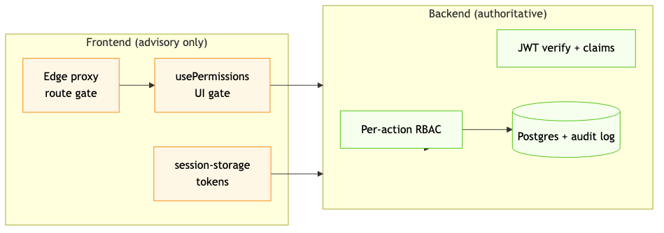
A 403 from the backend is the ground truth. The FE may also hide the same action because usePermissions().can(...) returns false, but that's UX — it must never be relied upon as a security boundary.

3. Token storage
Tokens live in a single HttpOnly, Secure, __Host- prefixed cookie set by Next Route Handlers under src/app/api/auth/*. They never reach JavaScript on the client. Concretely:
What | Where | Visible to JS?
Access token | __Host-session cookie payload | ❌
Refresh token | __Host-session cookie payload | ❌
User profile + userType | Same cookie + a non-sensitive localStorage cache for instant re-hydration | User profile yes (no tokens)

Request lifecycle
- Browser → POST /api/auth/login (Next Route Handler).
- Route handler → backend /auth/login. Captures access_token + refresh_token server-side.
- Route handler sets the __Host-session cookie with HttpOnly; Secure; SameSite=Strict; Path=/.
- Response to the browser contains only { user, userType } — no tokens.
- Subsequent backend calls go via /api/proxy/[...path]. The proxy reads the cookie server-side, attaches Authorization: Bearer <accessToken>, forwards to the backend, and returns the response. On 401 it refreshes once + retries.
Source files:
- src/lib/server-session.ts — cookie helpers (server-only).
- src/app/api/auth/login/route.ts, /2fa/verify, /refresh, /logout, /me.
- src/app/api/proxy/[...path]/route.ts — catch-all backend proxy.

What this protects against
- XSS exfiltration — JavaScript cannot read the cookie. Even a successful XSS can issue requests as the user (via the same-origin cookie) but cannot lift the bearer token off the page.
- Cookie-snooping at rest — the cookie is opaque on disk; the backend signs the JWT inside, the FE never decodes it.
- CSRF — SameSite=Strict blocks cross-site requests from carrying the cookie. Combined with the same-origin-only proxy, classical CSRF is structurally impossible.

What still needs care
- An XSS payload can still make requests as the user because the browser will include the cookie automatically. The cookie isolates the secret material, not the user's authority. Continue to keep XSS out (input handling, no dangerouslySetInnerHTML, CSP).
- The cookie is __Host--scoped, so it only travels to the FE origin. The proxy attaches the bearer to the upstream backend server-side, so the backend never sees the cookie at all.

4. Security headers (defense in depth)
Two layers ensure every response carries the same headers — if the proxy matcher ever lets a path through unprocessed, the framework-level headers in next.config.ts still apply.
Header | Value | Set by
Strict-Transport-Security | max-age=63072000; includeSubDomains; preload | next.config + proxy
X-Frame-Options | DENY | next.config + proxy
Content-Security-Policy | frame-ancestors 'none' | next.config
X-Content-Type-Options | nosniff | next.config + proxy
Referrer-Policy | strict-origin-when-cross-origin | next.config + proxy
Permissions-Policy | camera=(), microphone=(), geolocation=(), payment=(), usb=(), interest-cohort=() | next.config + proxy
X-DNS-Prefetch-Control | off | next.config
The CSP currently ships frame-ancestors 'none' only. A nonce-based script-src policy was evaluated but would require 'unsafe-inline' / 'unsafe-eval' to make Next.js's runtime work, which negates most of its value; the other high-value headers (HSTS, X-Frame-Options, X-Content-Type-Options, Referrer-Policy, Permissions-Policy) provide the bulk of the protection. See next.config.ts for the comment explaining this trade-off.

5. Secrets & environment variables
Variable | Sensitivity | Notes
BACKEND_API_URL | Server-only | Read by Next Route Handlers; never reaches the browser.
All FE configuration is server-only — no NEXT_PUBLIC_* variables. The image is therefore environment-portable: the same tag promotes from dev → prod with only a runtime env-var change. The backend remains the keeper of all upstream secrets (DB credentials, ML model keys, JWT signing keys).

6. Logging & telemetry
- Request/response logging is on only when NODE_ENV === "development" (see src/lib/api-client.ts). Production builds do not log requests or response bodies.
- No analytics or third-party trackers are wired in. If observability is added later, it must be reviewed against PII risks (loan amounts, applicant names, scoring decisions) before shipping.
- The backend produces all audit / compliance logs.

7. Dependency posture
- All runtime dependencies are pinned in package.json (^ allows patch + minor — keep tightening before releases).
- Run npm audit --omit=dev before each release. There are no known high/critical advisories at the time of writing.
- The vendor list is intentionally short: shadcn/ui (vendored, not a runtime dep), Radix primitives, TanStack Query, axios, react-hook-form, zod, sonner, lucide, qrcode.react, next-themes, date-fns. No tracking SDKs, ads, or experimentation libraries.

8. Reporting issues
Security issues should not be reported via GitHub Issues. Contact the platform-security lead at PaySwitch directly. A formal disclosure policy will accompany the deployment guide.

9. Related docs
- auth-and-rbac.md — runtime authentication, refresh, RBAC.
- data-flow.md — how data flows between FE and BE.

