Unified Code for Collocation Multistep Methods in Solving Systems of Ordinary Differential Equations

Fatokun Johnson O.  
*Department of Mathematics,*  
Faculty of ScienceAnchor University, Lagos, Nigeria

jfatokun@aul.edu.ng

Okwharobo Solomon M.

*Department of Mathematics,*  
Faculty of ScienceAnchor University, Lagos, Nigeria

[solomon.okwharobo@student.aul.edu.ng](mailto:solomon.okwharobo@student.aul.edu.ng)

*Abstract*— *This research presents a solver developed using Flutter for solving stiff systems of ordinary differential equations (ODEs) through a unified implementation of collocation multistep methods. The application provides solutions to differential equations and offers a comprehensive analysis of Linear Multistep Methods (LMM), including error constants, zero stability checks, and convergence assessments. Numerical examples demonstrate the solver’s accuracy and functionality across various scenarios. Detailed analyses of methods such as Quade’s method, Adams-Bashforth, Adams-Moulton, and Backward Differentiation Formula confirm the theoretical results with computational outputs. The results establish the solver’s effectiveness and robustness, making it a valuable tool for numerical analysis in practical applications, capable of solving both non-stiff and stiff differential equations*.

Keywords— Ordinary Differential Equations, Stiff Systems, Numerical Methods, Linear Multistep Methods, Collocation Methods, Flutter.

# Introduction

## Overview

Mathematical models in a vast range of disciplines, from science and technology to sociology and business, describe how quantities change. This leads naturally to a language of ordinary differential equations (ODEs). Ordinary Differential Equations (ODEs) are a type of differential equation that involves an unknown function and its derivatives. Quantities that change continuously in time or space are often modeled by differential equations.

When everything depends on just one independent variable, we call the model an ordinary differential equation (ODE) [1].

ODEs are of paramount significance in mathematical modeling because they provide a concise and powerful way to describe how a quantity changes concerning time or another independent variable. The ability to capture the rate of change of a variable makes ODEs essential in understanding dynamic processes, predicting future states, and optimizing system behavior.

In many important cases of differential equations, analytic solutions are difficult or impossible to obtain and time-consuming. The mathematical modelling of many problems in physics, engineering, chemistry, biology, and many more give rise to systems of ordinary differential equation. Yet, the number of instances where an exact solution can be found by analytical means is very limited [2].

In many important cases of differential equations, analytic solutions are difficult or impossible to obtain and time-consuming. Hence the need for an approximate, or a numerical method.

In contemporary scientific and engineering research, the formulation of complex mathematical models often leads to the generation of differential equations that defy closed-form solutions. This persistent challenge has underscored the growing significance of approximate, or numerical, methods in tackling intricate mathematical problems. Among these methods, numerical techniques for ordinary differential equations (ODEs) stand out as indispensable tools, providing a robust means to compute numerical approximations to the solutions of these challenging equations.

This necessity becomes even more pronounced when dealing with stiff systems of differential equations, where rapid variations in solution components pose additional complexities. Classical analytical methods, while powerful and elegant, encounter limitations when confronted with intricate mathematical formulations. Numerical methods step in precisely where analytical methods fall short, offering a practical avenue to obtain solutions when exact expressions are elusive [2].

Various advanced numerical techniques, such as implicit methods, exponential integrators, and collocation multistep methods, have proven effective in addressing the challenges posed by stiff systems. These methods excel in capturing the dynamics of stiff ODEs by incorporating strategies that adapt to the varying time scales inherent in the system. Implicit methods, for instance, allow for larger time steps, enhancing stability in the presence of stiffness.

With the advent of powerful computing technologies, numerical methods for ODEs have witnessed significant advancements. High-performance computing allows researchers and engineers to tackle more complex problems, simulate intricate physical phenomena, and explore the behavior of systems over extended time-frames. These simulations not only aid in understanding complex systems but also contribute to the optimization and design of real-world applications.

## Problem statement

The effective analysis and numerical solution of ordinary differential equations (ODEs) are essential in modeling real-world phenomena across various scientific and engineering disciplines. Existing numerical methods, particularly Linear Multistep Methods (LMMs), are widely used for solving ODEs, but their implementation and analysis present significant challenges, especially for stiff systems and diverse problem scenarios like boundary value problems (BVPs) and initial value problems (IVPs).

Current software solutions, such as MATLAB, Wolfram Mathematica, SciPy, and GNU Octave, have limitations in supporting LMMs specifically and often suffer from issues related to proprietary access, customization, and user interface. These constraints hinder the development of robust and efficient tools for ODE solving.

The proposed unified code aims to address these challenges by providing a specialized solver for systems of ODEs using collocation multistep methods, implemented as a desktop application using Flutter. This tool will enhance the accuracy and efficiency of LMM-based solutions, support both BVPs and IVPs, and contribute significantly to computational mathematics education and research.

## Paper structure

The remainder of this paper is thus: section 2 gives a brief overview of literature focusing on energy consumption, optimization as well as other related works. Section 3 discusses the methodology of the research, stating and describing the hardware requirements, software requirements, system requirements, architectural design as well as the working procedures in this project. Section 4 presents the results and testing of the proposed solution, while section 5 concludes the paper.

# Overview of literature

A brief background regarding previous works on consumption of electricity, embedded systems, and related works is presented here. Consumption of Electricity

According to the International Energy Agency, global average energy use per person increased by 10% between 1990 and 2008. In 2008, total global energy consumption amounted to about 132,000 TWh, with energy consumption in Africa increasing by 70% [2]. However, Nigeria's overall electricity usage is 24.72 billion kWh per year, according to World Data Info. This equates to an average of 123 kWh per person. Furthermore, the Nigerian Power Regulatory Commission (NERC) recently increased domestic electricity tariff prices from 30.23 Naira to 62.33 Naira per kWh, effective September 1, 2020. With this rise, purchasing electricity will be more expensive, and if not properly utilized, consumers may suffer significant losses. Humans need energy to achieve various tasks on a daily basis and its importance cannot be overemphasized [18, 19]. Energy plays a very essential role in bettering productivity, income as well as competition via supporting industrial investment facilitation, alongside productive activities, agriculture, and commerce [2, 20,21,22].

A study by Adamu, Adamu [3] revealed that based on the energy ladder theory, a series of closely interrelated socio-economic factors which is responsible for the transition of energy as well as the level to which such factors are effective, actually vary across countries. Thus, it has been recommended that government alongside relevant stakeholders in the energy sector should adopt and implement cost-effective measures of optimizing energy consumption in Nigeria, thereby ensuring proper usage of electricity as well as maintaining cleaner energy [3, 5, 6]. Figure 1 illustrates the energy consumption rate in Nigeria per annum (1980-2016).

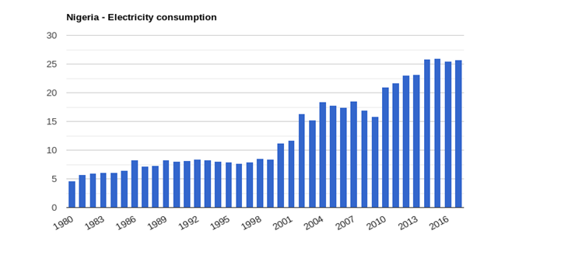

Figure 1: Annual electricity consumption rate in Nigeria (1980-2016)

## Embedded Systems

Properties such as real-time processing, low power consumption, low maintenance, and high availability, makes smart lighting systems to be considered as embedded systems, and embedded systems play a significant part in IoT. An embedded system is a sort of computer system that executes a set of pre-defined programs and is typically utilized as part of a larger electrical or mechanical system [10]. It usually starts with simple MP3 players and progresses to more complicated hybrid car systems [24]. Embedded systems are not standalone devices; instead, they are frequently employed as part of a larger, more complex equipment. For small size devices, a graphical user interface is not required. The major distinction between a computer and an embedded system is that a computer may do many jobs that are defined by the user. However, an embedded system is utilized to fulfil a certain duty that has been pre-defined by the producers. Interestingly, one of the most significant features of an embedded system is that it must adhere to all real-time limitations [9, 25].

## Related Works

Hwang and Yu [26] developed a remote monitoring and control system via a Java Media Framework (JMF), which is a multimedia extension API for Java that is used to perform real-time monitoring. The researchers performed their experiment by the use of the Zigbee network. Corroboratively, Alex and Starbell [27] constructed a system aimed at reducing the power consumption rate of streetlights by around 30% when compared to previous designs. This method is completely automated and does not require any human intervention. It also makes use of ZigBee to allow the control station in monitoring the system's functioning. Kim, Lee [28] developed a smart LED light system that incorporates both infrared and ultrasonic sensors. The authors' approach was to continually monitor human motion, with the output data from the sensors determining the smart LED light's On/Off state. Despite the amazing contributions by previous researchers in developing embedding systems to solve various energy issues [19, 21, 29], most of the existing systems, were unable to continually verify the motion of an object by using each sensor separately, thus a gap which the current paper addresses via the Arduino component. Furthermore, the proposed technology employs a PIR sensor that transmits data to an MCU board, which then transmits the data to the LED control layer.

Subramanyam, Reddy [30] developed a model which provides a smart street lighting system powered by solar energy. Apart from managing and monitoring lamps, the system also provides security for late-night workers. The smart light system adopted the ZigBee technology and provides a user interface for controlling and monitoring streetlights. Solar panels, LDRs, and IS sensors are used in the system, which helps to cut power usage and costs. The developers designed this device to operate in two modes: automatic and manual. When the system is in auto mode, the LDR is used to turn on and off the lights. The LDR senses light intensity and controls the light through relays. In a recent review focused on solar usage in Nigeria, the authors informed that due to the large population of Nigeria, there is a need of vast energy for sustenance [17]. This of which has resulted to overdependence on natural gas and crude oil for energy. It was also revealed that such overdependence has placed the country in a constant energy consumption crisis when such resources are unavailable [2, 7, 31]. However, though solar energy might be a kind of solution to power consumption issues, yet it has its disadvantages as it is prone to affect the climate change. Notwithstanding, the cost of acquiring a solar system is not affordable for the average Nigerian population. Thus, there is still a need to introduce more practical and cost-effective systems that can help in energy consumption optimization so as to save more energy and avoid solar combustion.

Consequently, Raj and Khan [32] attempted to save energy and observed that smart networks can help monitor energy usage in DC electrical equipment. Lamps are powered by AC, although LEDs can be powered by DC. Using the right protocols, these lights can also be dimmed. The scientists also claimed that replacing standard bulbs with LEDs can save more than 44% of energy. Magno, Polonelli [33] developed a low-cost, sensor-based smart lighting system that uses a PIR sensor. The use of LEDs in this lighting system allows to manage light intensity and reduce power usage [2, 12]. When impediments are detected, the brightest light can be dimmed using a PIR sensor. According to the authors, the system's greatest benefit is the exchange of energy and power. Corroboratively, Alex and Starbell [27] developed a GSM-based remote-control system that was integrated with a ZigBee network of devices and sensors to build an Intelligent Street Lighting System. It was developed using wireless technology and a network of sensors for simplicity of maintenance and control of the system. LED lamps are used in the system, which helped in saving energy while also increasing the bulb's light span. Moreover, in a recent study, Zou, Pan [19] began by analyzing system performance, which included the system's throughput and transmission time. They discovered that high transmission power was the cause of neighbor channel interference, and that when transmission power is increased, the improvement in throughput decreases. They also considered various communication characteristics and requirements of several light control systems. All of these actions aided them in learning and comprehending the controller's capabilities.

In a study which focused on solving the challenges of energy wastage in the lighting of China offices, the authors made use of Arduino as a major controller alongside an infrared inductive sensor and a light sensor with the use of Wi-Fi network for communication [12]. The study proposed the realization of office lighting environment detection as well as solving issues of fixing adjustments of office light. Maksimovic [34] developed a system that monitored and determined the existence of fire in a building, demonstrating the Raspberry Pi's capabilities in home automation. They also built a prototype sensor Web node on the Raspberry Pi, based on RESTful services, with the goal of developing a system that uses fast critical event signaling and remote access via the Internet to detect data using Fuzzy Logic. The authors asserted that integrating the offered technique with the Raspberry Pi allows for an infinite number of sensor node applications.

Similarly, Ferdoush and Li [35] built a wireless sensor network system employing Raspberry Pi, xBee, Arduino, and other open-source software applications. The system features comprise good packaging, low cost, scalable, and easy to adjust requirements, easy maintenance, and easy distribution. It is important to note that the possibility of these features is because the gateway node of the Wireless Sensor Network, database, and web server are all integrated into a single Raspberry Pi. Corroboratively, Baraka, Ghobril [36] built and implemented a smart home that was both energy efficient and remotely controlled using home automation techniques. This smart home was designed to provide protection and comfort to its residents, and it had sensors and actuators that collected data from the house environment in order to operate it. The authors used an Arduino microcontroller to communicate with an Android application that served as the user interface. The house was networked with wireless ZigBee and wired X10, resulting in a cost-effective solution.

Though, the past works that focused on Arduino for several issues such as smart home, street lighting management, object monitoring, mobile health application, amongst others revealed that it is cost effective and promotes clean energy [11-14, 37-39], yet little is known on how it can be used in managing electricity as well as optimizing energy consumption, especially in Nigeria.

The next section shall discuss the methodological approach used to carry out the study.

# METHODOLOGY

This section serves as the backbone of this project, providing a comprehensive understanding of the algorithms approach used to analyze linear multistep methods (LMMs) and solve ordinary differential equations (ODE). It outlines the systematic procedures, techniques, and tools utilized throughout the solver-project lifecycle, shedding light on the intricacies of our analysis and solution methodology. It provides clarity on the selection of LMMs, the formulation of numerical algorithms, the validation of results, and the integration of computational techniques into a cohesive framework.

The proposed system's block diagram is presented in Figure 2 below; the system is supposed to turn on lights when the PIR sensor detects motion and switch them off when no motion is detected.

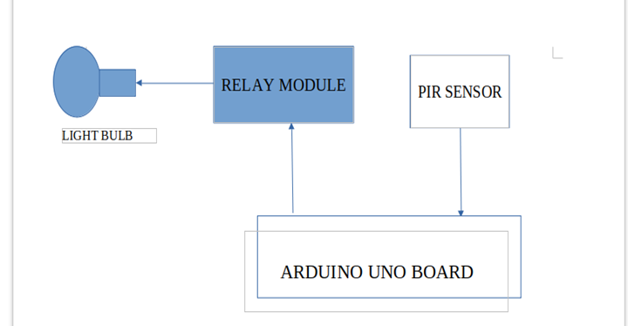

Figure 2: Block diagram of the proposed system

## Hardware Requirements

* Windows operating software

## Software Requirements

* Visual Studio Code and Visual Studio
* Dart and Flutter

A notable aspect of this solver is the utilization of Flutter, Google’s open-source UI software development kit, for building desktop applications. Flutter was chosen as the development framework due to its versatility and efficiency in creating cross-platform applications that run seamlessly on various operating systems, including Windows, macOS, and Linux [3].

The decision to adopt Flutter for desktop app development is driven by several advantages. Flutter’s single codebase allows for targeting multiple platforms, such as iOS and Windows, although the focus will be on Windows for this project. This approach simplifies development, ensures consistency across platforms, and eliminates the need for maintaining separate codebases. Flutter’s rich set of widgets and tools enables the creation of visually appealing and interactive UIs, which is especially useful for visualizing numerical data and interacting with an ODE solver. Moreover, Flutter’s high-performance rendering engine, Dart language optimization, and ahead-of-time compilation ensure smooth and responsive user experiences even with complex computations [3].

The development of the solver is divided into two modules, the first module which involves the development of the algorithms and UI for the analysis of the linear multistep method, and the second module which involves using the method to solve a particular problem.

## Module 1: Analysis of Linear multistep method

The general *k - step* linear multistep method takes the form [4]

The properties such as **consistency, zero-stability, and convergence are investigated, and LMM error constant and Order are calculated.**

**Consistency Analysis Algorithm:** Consistency is a vital attribute of linear multistep methods (LMMs) for solving ordinary differential equations (ODEs). A consistent LMM ensures the local truncation error (LTE) tends to zero as the step size decreases. The consistency of an LMM can be verified by evaluating the LTE or using specific consistency conditions:

If both and are zero, then the LMM is consistent[1,2,6]. The consistency analysis algorithm uses the principle. This algorithm involves initializing coefficients, verifying the total number, calculating ​ and ​, and confirming their values approach zero.

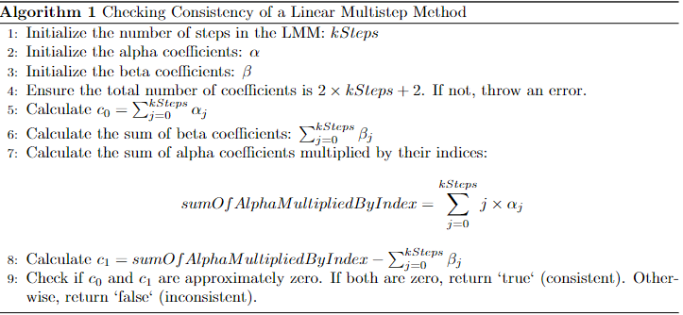

Figure 1: Algorithm for checking consistency of LMM

**Zero-Stability Analysis Algorithm:** Zero-stability of an LMM requires satisfying the Dahlquist root condition: the roots of the characteristic polynomial

must lie within or on the unit circle, with any root of magnitude one being simple[2,5,6]. The Durand-Kerner method is employed to find the polynomial's roots, checking their magnitudes to determine zero-stability. The algorithm involves initializing coefficients, forming the characteristic polynomial, solving for roots using the Durand-Kerner’s method, and verifying their magnitudes.

**Convergence Analysis Algorithm:** Convergence for LMMs requires both consistency and zero-stability. The algorithm integrates the previously discussed consistency and zero-stability checks. First, it confirms zero-stability by evaluating the roots of the characteristic polynomial. Then, it checks consistency using the consistency analysis algorithm​. If both checks are satisfied, the method is convergent, meaning numerical solutions will approach exact solutions as the step size decreases.

**Determination of Order and Error Constant Algorithm**: The order of an LMM indicates how quickly the truncation error decreases as the step size approaches zero. The algorithm calculates the order and error constant by evaluating the linear difference operator and ensuring specific conditions on its coefficients. It iteratively determines the order by checking if the coefficients up to are zero and identifies the error constant as the first non-zero coefficient ​. The process involves initializing coefficients, performing calculations, and determining the order and error constant for the LMM.

..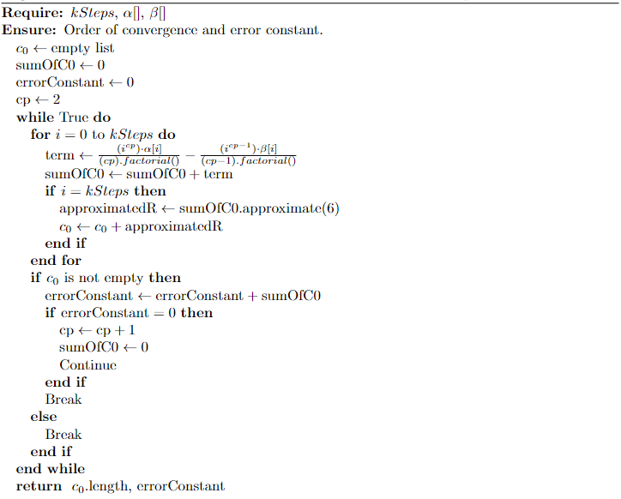

Figure 2: Algorithm for determining order and error constant

## Module 2: Application of Linear Multistep Method in Solving ODEs

## 

This module focuses on the application of linear multistep methods (LMMs) in solving ordinary differential equations (ODEs), particularly for initial value problems (IVPs) and boundary value problems (BVPs).

In the process of employing linear multistep methods, it is crucial to ascertain the characteristics of the Ordinary Differential Equation (ODE) problem at hand. This entails discerning whether the problem exhibits stiffness or non-stiffness and determining the most appropriate approach, be it implicit or explicit. Explicit methods typically find utility in non-stiff scenarios, offering straightforward implementations, whereas implicit techniques are favored for stiff problems owing to their inherent stability.

**Explicit Method Algorithm:** Explicit linear multistep methods (LMMs) calculate new values in a sequence using known data, avoiding the need to solve complex systems of equations. These methods are particularly useful for non-stiff problems [8,7,9] due to their simplicity and computational efficiency. Figure 3 is an outline of the explicit linear multistep algorithm used for solving ordinary differential equations (ODEs), derived from the provided code. When starter values are required, the fourth-order Runge-Kutta method is employed to generate these initial values. The algorithm for the fourth-order Runge-Kutta method is described below. Following the generation of starter values, the explicit linear multistep method proceeds to compute subsequent values based on the specified coefficients and step sizes. The algorithm iterates through the coefficients to calculate the next value, updating the variables accordingly. The process continues until the desired number of steps is reached, generating a numerical solution to the ODE.

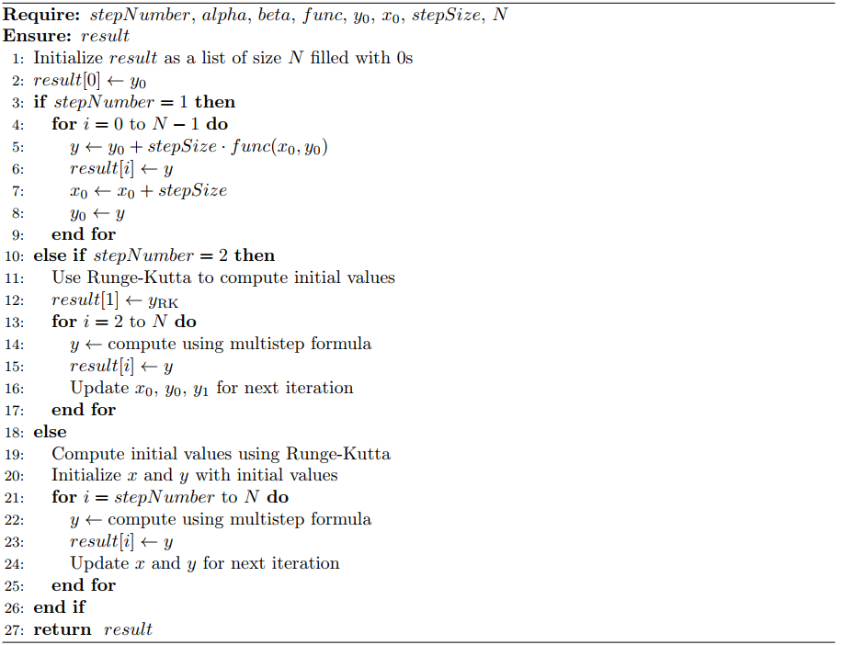

Figure 3: Algorithm for JFMS - explicit solver

**Implicit Method Algorithm:** In solving stiff problems the Implicit method algorithm is employed, if the ODE is of a linear type like (y’ = 3xy) then the Implicit linearization method is used, otherwise the prediction-evaluation-correction-evaulation algorithm is used.

The explicit solver is also adopted in solving stiff linear differential equations, and this solver is called the **Implicit Linearization Solver.**

1. The bulb’s other terminal was connected to the IN2 relay module’s NO (Normally Open) contact.
2. The relay’s COM (Common) contact was linked to the mains supply’s other wire.
3. The relay module’s IN2 pin was linked to the Arduino’s digital I/O pin 7.
4. Next, the VCC pin of the relay module was connected to one of the Arduino’s 5V pins, and the ground pin of the relay module was linked to one of the Arduino’s GND pins.
5. The compiler verifies the Arduino IDE written automated lighting software before uploading it to the Arduino board’s microcontroller.

# RESULT

A lighting automation system prototype was created. Figure 6 depicts the entire prototype design. The Arduino board and the primary power source were connected to all the wiring and connections. The PIR sensor was additionally calibrated to change its timing from 5 seconds to 1 minute, as well as the range from 2m to 5m.

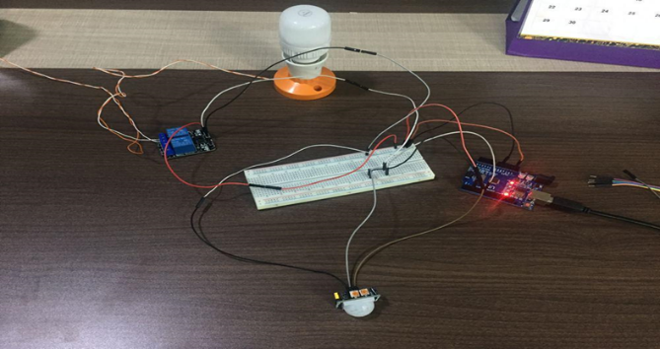

Figure 6: Prototype of the Proposed System

As seen in Figure 7 below, when a person enters the range of the sensor, the light turns on and stays on for nearly a minute instead of 5 seconds before turning off. Moreover, the sensor sensitivity has also been improved, and it can now detect motion from a distance of up to 5 meters.

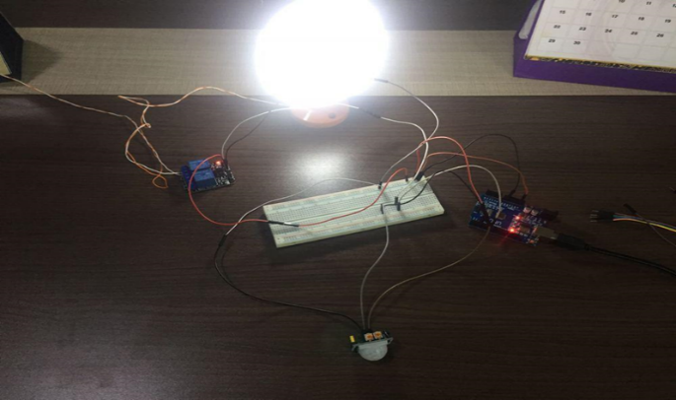

Figure 7: Condition when motion is detected

However, when the PIR sensor detects no movement, the lights remain turned off. Figure 8 demonstrates this. The system will thereafter return to the initial state.

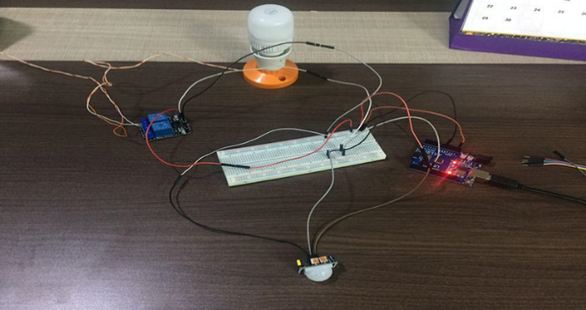

Figure 8: Condition when no motion is detected

# DISCUSSION

Thus, the lighting system can be constructed using LED lights instead of the traditional filament bulb, which consumes energy, as well as save maintenance costs and extend the life of LED bulbs, because the lights are turned on and off automatically, a significant amount of energy can be saved.

In comparison to previous systems, this is less expensive, easier to install and maintain, and more efficient. It also has more versatility than existing systems in the market, as new modules and components may be added in the future. Advancement in technology has of recent improved smart home systems ubiquity, thus leading to a more appreciated living standard [11]. Thus, relative affordability issues connected to commercial automated home systems is prevalent mostly among average and low-income earners. Notwithstanding, the emergence of cost-effective microcontrollers such as the Arduino as proposed in this study and others in literature has helped in enabling a smooth and cost-effective implementation of affordable smart home systems [11-16], thence integrating most of the existing features associated with commercial systems. Most of the previous systems designed specific Arduino based systems, however the work proposed in this paper can be used in several places.

## Study Limitations

The study also has some limitations despite its novel contribution, thus fostering the drive for future work. The motion detection range of the PIR sensor is limited. Thus, small things, such as bugs, may be missed by the PIR sensor. Unwanted objects may trigger the motion detector; for example, a motion detector placed outside may be constantly triggered by bugs and other small objects. Some PIR sensor devices have a short shutoff (timer) (such as 30 seconds), therefore, if more "on time" is needed, it is preferable to get a model with an adjustable timer. Environmental elements such as fireplaces, heaters, and even direct sunshine may also affect the PIR sensors.

## Future Work

Because of the adaptability of the microprocessor employed, the system is significantly more scalable. As a result, further modules and components can be simply added in the future to meet the needs of a larger scale of consumers.

# CONCLUSION

The main goal of this paper was to reduce electricity consumption in offices, homes, schools, and other locations by designing a simple system that will help control lights, thereby increasing the lifetime of light bulbs and lowering monthly bills, as well as reducing the stress on people who have to go around the entire building switching off lights.

The architectural concept of a lighting system was successfully realized in this study utilizing the Arduino UNO microcontroller and the associated hardware and software. When the PIR sensor detects motion, the system turns on the lights, and when no motion is detected, it turns them off. The proposed system has also been tested in real world situations and may be tested on a wider scale in the near future. Also, it can be simply deployed in places where light is required only when people are present, such as restrooms, toilets, corridors, balconies, garages, among others.

##### Acknowledgment

Special thanks to all authors of the work for their selfless contributions accordingly.

##### References

[1] Multistep methods — fundamentals of numerical computation. Accessed: 2023-09-03.

[2] J. D. Lambert. The initial value problem for ordinary differential equations. In D. Jacobs, editor, The State of the Art in Numerical Analysis, pages 451–501. Academic Press, New York, 1977.

[3] Flutter. (n.d.). *Flutter documentation*. Retrieved from https://flutter.dev/docs.

[4] J.S. Lazarus J.O. Fatokun, S.I. Okoro. A class of power series collocation multistep methods with legendre interpolant for the integration of initial value problems. Anchor University Journal of Science and Technology, 143:1–156, 2022. This document presents a new approach for the derivation of a class of collocation linear multistep methods for the integration of some initial value problems of ordinary differential equations.

[5] Deborah .I.A, J.O. Fatokun(2021). Development of a generalized online computer program for mathematical analysis of linear multistep methods. Anchor University Journal of Science and Technology, 1 , 4

[6] John Butcher. General linear methods for ordinary differential equations. Mathematics and Computers in Simulation, 79(6):1834–1845, 2009. Applied and Computational MathematicsSelected Papers of the Sixth PanAmerican Workshop July 23-28, 2006, Huatulco-Oaxaca, Mexico.

[7] John C. Butcher. Numerical Methods for Ordinary Differential Equations. John Wiley, 2003.

[8] John S. Butler. Numerical Analysis Book - Chapter 05 - IVP Consistent Convergence Stability. Online, 2022.

[9] George D. Byrne, Alan C. Hindmarsh, Kenneth R. Jackson, and H. Gordon Brown. A comparison of two ode codes: Gear and episode. Computers & Chemical Engineering, 1(2):125–131, 1977.

[10] Oyetoke OO, Adedapo A. ’Embedded Systems Engineering, the Future of Our Technology World; A Look Into the Design of Optimized Energy Metering Devices’. International Journal of Recent Engineering Science (IJRES) volume18, pp1 December. 2015.

[11] Gunputh S, Murdan AP, Oree V, editors. Design and implementation of a low-cost Arduino-based smart home system. 2017 IEEE 9th international conference on communication software and networks (ICCSN); 2017: IEEE.

[12] Li Z, Li J, Li X, Yang Y, Xiao J, Xu B. Design of office intelligent lighting system based on Arduino. Procedia Computer Science. 2020;166:134-8.

[13] Okorie P, Ibraim AA, Auwal D, editors. Design and Implementation of an arduino based smart home. 2020 International Congress on Human-Computer Interaction, Optimization and Robotic Applications (HORA); 2020: IEEE.

[14] Satapathy LM, Bastia SK, Mohanty N. Arduino based home automation using Internet of things (IoT). International Journal of Pure and Applied Mathematics. 2018;118(17):769-78.

[15] Krishnamurthi K, Thapa S, Kothari L, Prakash A. Arduino based weather monitoring system. International Journal of Engineering Research and General Science. 2015;3(2):452-8.

[16] Vaghela M, Shah H, Jayswal H, Patel H. Arduino based auto street light intensity controller. Invention Rapid: Embedded Systems. 2013;3:1-4.

[17] Agbo EP, Edet CO, Magu TO, Njok AO, Ekpo CM, Louis H. Solar energy: A panacea for the electricity generation crisis in Nigeria. Heliyon. 2021;7(5):e07016.

[18] Dawn S, Shree Das S, Gope S, Dey B, García Márquez F-P. Global power and energy scenario during COVID-19 pandemic: Lessons from lockdown. International Journal of Electrical Power & Energy Systems. 2022;137:107757.

[19] Zou W-Q, Pan Q-K, Wang L, Miao Z-H, Peng C. Efficient multiobjective optimization for an AGV energy-efficient scheduling problem with release time. Knowledge-Based Systems. 2022;242:108334.

[20] Furszyfer Del Rio DD, Sovacool BK, Griffiths S. Culture, energy and climate sustainability, and smart home technologies: A mixed methods comparison of four countries. Energy and Climate Change. 2021;2:100035.

[21] Li W, Yigitcanlar T, Erol I, Liu A. Motivations, barriers and risks of smart home adoption: From systematic literature review to conceptual framework. Energy Research & Social Science. 2021;80:102211.

[22] Aliero MS, Qureshi KN, Pasha MF, Jeon G. Smart Home Energy Management Systems in Internet of Things networks for green cities demands and services. Environmental Technology & Innovation. 2021;22:101443.

[23] Huynh D-T, Chen M, Huynh T-T, Hai CH. Energy consumption optimization for green Device-to-Device multimedia communications. Future Generation Computer Systems. 2019;92:1131-41.

[24] Barua A, Hoque MM, Akter R. Embedded systems: Security threats and solutions. American Journal of Engineering Research. 2014;3.

[25] Mohanta B, Das P, Patnaik S, editors. Healthcare 5.0: A Paradigm Shift in Digital Healthcare System Using Artificial Intelligence, IOT and 5G Communication. 2019 International Conference on Applied Machine Learning (ICAML); 2019 25-26 May 2019.

[26] Hwang S, Yu D. Remote monitoring and controlling system based on ZigBee networks. International Journal of Software Engineering and Its Applications. 2012;6(3):35-42.

[27] Alex RS, Starbell RN. Energy efficient intelligent street lighting system using ZIGBEE and sensors. International Journal of Engineering and Advanced Technology (IJEAT). 2014;3(4):2249-8958.

[28] Kim D, Lee J, Jang Y, Cha J, editors. Smart led lighting system implementation using human tracking us/ir sensor. ICTC 2011; 2011: IEEE.

[29] Li C, Zhang Y, Sun Q, Luo Y. Collaborative caching strategy based on optimization of latency and energy consumption in MEC. Knowledge-Based Systems. 2021;233:107523.

[30] Subramanyam B, Reddy KB, Reddy PAK. Design and development of intelligent wireless street light control and monitoring system along with gui. International Journal of Engineering Research and Applications (IJERA). 2013;3(4):2115-9.

[31] Sepulveda LFM, Diniz PS, Diniz JOB, Netto SMB, Cipriano CLS, Araújo AC, et al. Forecasting of individual electricity consumption using Optimized Gradient Boosting Regression with Modified Particle Swarm Optimization. Engineering Applications of Artificial Intelligence. 2021;105:104440.

[32] Raj KB, Khan MM, editors. Sustainable Smart Cities and Their ICT Practices. Proceedings of Second International Conference on Smart Energy and Communication: ICSEC 2020; 2021: Springer Nature.

[33] Magno M, Polonelli T, Benini L, Popovici E. A low cost, highly scalable wireless sensor network solution to achieve smart LED light control for green buildings. IEEE Sensors Journal. 2014;15(5):2963-73.

[34] Maksimovic M. Transforming educational environment through green internet of things (g-iot)2017.

[35] Ferdoush S, Li X. Wireless sensor network system design using Raspberry Pi and Arduino for environmental monitoring applications. Procedia Computer Science. 2014;34:103-10.

[36] Baraka K, Ghobril M, Malek S, Kanj R, Kayssi A, editors. Low cost arduino/android-based energy-efficient home automation system with smart task scheduling. 2013 Fifth international conference on computational intelligence, communication systems and networks; 2013: IEEE.

[37] Mumtaz Z, Ullah S, Ilyas Z, Aslam N, Iqbal S, Liu S, et al. An automation system for controlling streetlights and monitoring objects using Arduino. Sensors. 2018;18(10):3178.

[38] Sabbir AS, Bodroddoza KM, Hye A, Ahmed MF, Saha S, Ahmed KI, editors. Prototyping Arduino and Android based m-health solution for diabetes mellitus patient. 2016 International Conference on Medical Engineering, Health Informatics and Technology (MediTec); 2016 17-18 Dec. 2016.

[39] Rath DK. Arduino based: Smart light control system. International Journal of Engineering Research and General Science. 2016;4(2):784-90.