AI-AUGMENTED BACKEND DEVELOPMENT WITH
NODE JS AND MONGO DB

Project Title : AI BLOGNEST API ( GENERATE HIGH-QUALITY, CONTEXT-AWARE BLOG CONTENT USING AI )
Team ID : SWTID-2026-8471
Team Leader : KARTHIKEYAN R
Team member : ARUN KUMAR A
Team member : VISHNU PRASAD D
Team member : SRI SATHIYAN J
Team member : MOHITHKUMAR K
Pure Backend Application | REST API | MongoDB | Mongoose | Express.js | JWT | bcrypt | Gemini AI
Document Item | Details
Project Name | AI BlogNest API
Application Type | Backend-only REST API
Primary Interface | Postman / Thunder Client
Backend Runtime | Node.js
Web Framework | Express.js
Database | MongoDB
ODM | Mongoose
Authentication | JWT
Password Security | bcrypt
AI Integration | Google Gemini API

Document Purpose: This document describes the project problem, proposed solution, requirements, architecture, data model, setup, implementation flow, AI integration, API endpoints, and testing approach for the AI BlogNest backend.

AI BlogNest - Generate High-Quality Blog Content Using AI
Description
AI BlogNest is a secure, modular backend REST API designed to simplify blog creation, content management, and AI-assisted writing. The application uses Node.js and Express.js for server-side routing, MongoDB as the persistent data store, and Mongoose ODM for schema definition and validation. Google Gemini is integrated for context-aware blog generation and concise summarization. The system is intentionally headless: there is no frontend and all features are consumed through API endpoints.

Scenario-Based Case Study
Background
- A content creator manages multiple blog posts and needs a single backend for drafts, publishing, categories, tags, comments, and AI-assisted writing.
- Manual writing can be time-consuming, while generic AI prompts can produce responses that interpret ambiguous topics incorrectly.
Problem
- Difficulty managing drafts and publishing states consistently.
- Need for authenticated and role-based access to blog operations.
- Need for secure password storage and protected API routes.
- Need for AI-generated content that remains relevant to the requested topic.
- Risk of ambiguous terms being interpreted with the wrong meaning.
- Need for repeatable JSON response formats for Postman/API consumers.
Solution
- Provide a centralized REST API for user, blog, comment, and AI operations.
- Use JWT authentication and role-based authorization for protected resources.
- Use bcrypt for password hashing and never return passwords in API responses.
- Use Gemini through a dedicated service layer with context-aware prompting.
- Use topic, category, keywords, and user context to resolve ambiguity.
- Validate and structure AI output before returning it to the API client.
Outcome
The backend provides a consistent API workflow from authentication to blog creation, publishing, retrieval, and AI content generation. Data integrity is enforced with Mongoose validation, protected routes use JWT and roles, and AI calls are separated into a dedicated service for maintainability.
1. Software and Hardware Requirements
Requirement | Purpose
Windows / macOS / Linux | Cross-platform development environment.
Node.js | Runtime for server logic and REST API execution.
npm | Dependency and script management.
Express.js | HTTP routing and API middleware framework.
MongoDB | NoSQL database for users, blogs, comments, and metadata.
Mongoose | ODM for schemas, validation, references, indexes, and queries.
bcrypt | Secure password hashing.
jsonwebtoken | JWT creation and verification.
Google Gemini API | AI blog generation and summarization.
Postman / Thunder Client | API testing and request verification.
Visual Studio Code | Source-code editing and terminal use.

Hardware Requirements
Component | Minimum / Recommended
Processor | Intel Core i5 / AMD Ryzen 5 or equivalent
RAM | 8 GB minimum; 16 GB recommended
Storage | At least 1 GB available project workspace
Network | Internet access required for MongoDB Atlas and Gemini API

Functional Requirements
- User registration and login.
- JWT-based protected API access.
- Role-based authorization for Admin, Editor, Author, and Reader.
- Create, read, update, and delete blog posts.
- Blog lifecycle support: draft, pending, scheduled, and published.
- Categories, tags, search, and filtering.
- Comments with moderation states.
- Blog likes.
- AI blog generation endpoint.
- AI summarization endpoint.
- Centralized error handling and consistent JSON responses.

Epic:-1 PROJECT ARCHITECTURE
AI BlogNest follows a layered backend architecture. Incoming API requests pass through routing and middleware, then reach controllers that coordinate Mongoose models or the Gemini service. The result is returned to the client as structured JSON.
Component | Definition
API Interface | Postman or Thunder Client sends HTTP requests and receives JSON responses.
Express Server Gateway | Handles HTTP methods, JSON parsing, CORS, security middleware, and routing.
Authentication & Role Middleware | Validates Bearer JWT tokens and checks role permissions for protected routes.
Controller Layer | Processes requests, validates application rules, calls models/services, and formats responses.
Database Interface | Mongoose maps application objects to MongoDB collections and enforces schemas.
Gemini AI Service | Encapsulates AI generation and summarization requests and response handling.
Central Error Middleware | Converts failures into consistent API error responses.

High-Level Request Flow
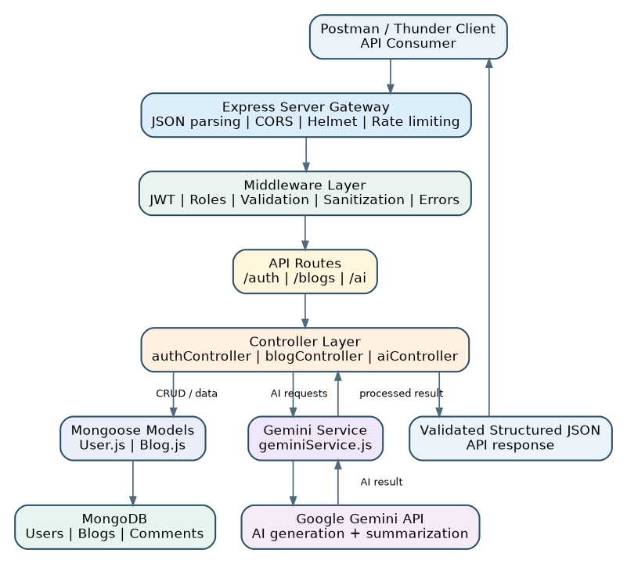
Figure 1. AI BlogNest Project Architecture - Request, Data and AI Flow
Postman / Thunder Client
↓
Express Route
↓
Middleware (Validation / JWT / Role)
↓
Controller → Mongoose / Gemini → JSON Response

Backend-Only Principle
There is no HTML or UI view layer. The project is a headless API. The interface is the routing network that connects HTTP paths to controller logic. This matches the supplied project specification, which treats the routing layer as the interface for a pure backend service.

2. Project Structure
src/
├── config/
│ └── db.js
├── controllers/
│ ├── aiController.js
│ ├── authController.js
│ └── blogController.js
├── middleware/
│ ├── authMiddleware.js
│ └── errorMiddleware.js
├── models/
│ ├── Blog.js
│ └── User.js
├── routes/
│ ├── aiRoutes.js
│ ├── authRoutes.js
│ └── blogRoutes.js
├── services/
│ └── geminiService.js
├── app.js
└── server.js
.env
.gitignore
package.json
package-lock.json
README.md
File / Folder | Responsibility
config/db.js | MongoDB connection using Mongoose.
controllers/authController.js | Registration and login workflows.
controllers/blogController.js | Blog CRUD, publishing, comments, likes, search/filter operations.
controllers/aiController.js | AI request validation and response packaging.
middleware/authMiddleware.js | JWT authentication and role authorization.
middleware/errorMiddleware.js | Centralized API error processing.
models/User.js | User schema, roles, secure password representation.
models/Blog.js | Blog, lifecycle state, tags, comments, likes, and references.
routes/*.js | HTTP endpoint definitions.
services/geminiService.js | Google Gemini integration and context-aware prompting.
app.js | Express application and middleware configuration.
server.js | Database startup, server startup, and shutdown handling.

3. Data Model and Entity Relationships
The underlying document structure contains User and Blog data with logical references. Comments can be embedded inside the Blog document so the project can retain the required folder structure without introducing another model file.

Visual ER Diagram
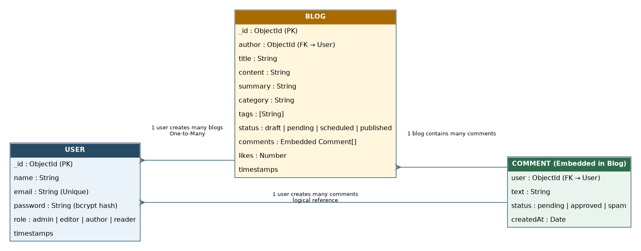
Figure 3. Entity-Relationship (ER) Diagram - User, Blog and Embedded Comments
Entity | Important Fields | Relationship / Notes
User | _id, name, email, password, role, timestamps | One User can author many blogs and comments.
Blog | _id, title, content, summary, author, category, tags, status, likes, comments, timestamps | author references User._id.
Comment | user, text, status, createdAt | Embedded within Blog; user references User._id.

Blog Lifecycle
State | Purpose
Draft | Work in progress; editable by the permitted author.
Pending | Submitted for editorial review.
Scheduled | Prepared for a planned publication time if supported.
Published | Visible through public published-blog retrieval routes.

Key Structural Mappings
- User to Blog: One-to-Many.
- User to Comment: One-to-Many.
- Blog to Comment: One-to-Many.
- Blog author is determined from authenticated user context for protected create operations.
4. Roles, Responsibilities and MVC Pattern
Role | Responsibilities
Admin | Full management privileges, role administration, moderation, and protected system operations.
Editor | Reviews pending content, manages editorial workflow, publishing status, and comment moderation.
Author | Creates blog posts, manages permitted own drafts/posts, and participates in the content workflow.
Reader | Consumes published content, creates comments, and interacts with published posts according to API rules.

MVC-Style Backend Architecture
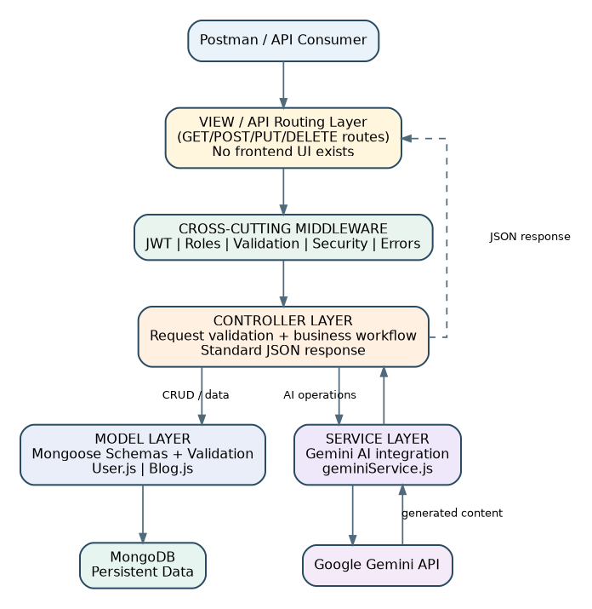
Figure 4. MVC-Style Backend Architecture - Headless API
Layer | Responsibility
Model Layer | Defines Mongoose schemas, references, validation, defaults, and indexes.
Controller Layer | Receives request data, delegates operations, checks permissions, and returns standard JSON.
Routing Layer | Defines REST API paths and maps them to middleware/controller handlers.
Service Layer | Contains external Gemini AI integration so AI-specific logic is separated from controllers.

Backend Interface: Because this is a headless application, there is no user-facing View layer. Postman/Thunder Client acts as the practical API consumer during testing.

Authorization Principle
Authentication answers "Who is calling?" using the JWT. Authorization answers "What may this role do?" using the role in the authenticated user context. Protected routes should reject missing tokens, invalid tokens, expired tokens, or insufficient permissions.

Epic2: Project Setup and Configuration

Project Initialization
- Create the project folder and open it in Visual Studio Code.
- Initialize the Node.js project with npm init -y.
- Create the specified src structure and root configuration files.
- Install the required dependencies.
- Create .env and .gitignore.
- Configure MongoDB URI, JWT secret, Gemini API key, and port in environment variables.
Typical installation command:
npm install express mongoose bcrypt jsonwebtoken dotenv cors express-validator helmet express-rate-limit morgan @google/genai
npm install --save-dev nodemon
Recommended scripts:
"scripts": {
"start": "node src/server.js",
"dev": "nodemon src/server.js"
}

Environment Configuration
PORT=5000
MONGODB_URI=your_mongodb_connection_string
JWT_SECRET=your_long_random_secret
GEMINI_API_KEY=your_gemini_api_key
GEMINI_MODEL=gemini-3.5-flash
NODE_ENV=development

Epic4: Database Configuration
MongoDB is the primary persistence layer. Mongoose is used to define schemas, validate fields, maintain references, and execute database operations. The application should establish a successful database connection before normal API traffic is accepted.

Database Connection Responsibilities
- Read the MongoDB URI from process.env.MONGODB_URI.
- Connect using Mongoose.
- Log a successful connection.
- Log and handle connection errors.
- Avoid starting a fully operational API when database initialization fails.
- Handle graceful shutdown by closing the database connection.

Mongoose Validation and Indexing
Model | Validation / Indexing
User | Required name/email/password, unique lowercase email, role enum, password exclusion from output.
Blog | Required title/content/category as defined by API contract, status enum, author reference, tags, timestamps.
Comments | Required user/text, moderation status, timestamp.
Indexes | Useful indexes for title, category, tags, status, author and search/filter workloads.

Database Relationship View
USER | 1 ───────< | BLOG
USER | 1 ───────< | COMMENT
BLOG | 1 ───────< | COMMENT

Epic3: Backend Development

User Flow Diagram
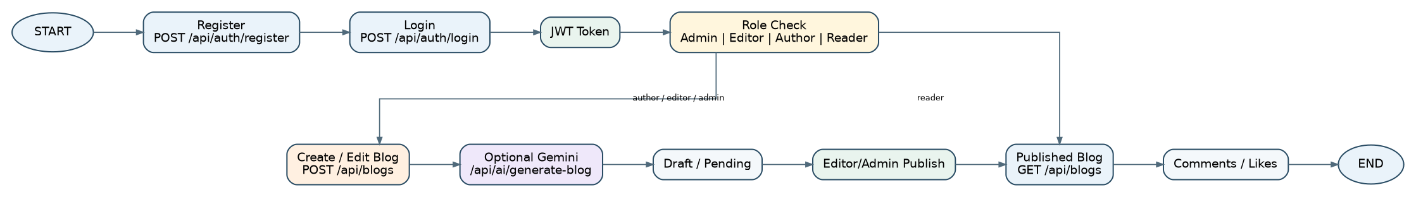
Figure 2. AI BlogNest User Flow - Registration, Authentication, Blog Workflow and Publishing

Authentication Workflow
POST /api/auth/register
POST /api/auth/login
Registration validates the request, checks duplicate email, hashes the password using bcrypt, and stores a safe user record. Login compares the supplied password with the stored hash and returns a signed JWT containing non-sensitive identity information such as userId and role.

Blog CRUD Workflow
POST /api/blogs
GET /api/blogs
GET /api/blogs/:id
PUT /api/blogs/:id
DELETE /api/blogs/:id
Operation | Expected Behavior
Create | Authenticated permitted role creates a blog; author is derived from req.user where applicable.
Read | Public listing exposes published content; protected views may expose additional states according to role.
Update | Permitted user can update allowed fields; ownership and role rules are enforced.
Delete | Only permitted owner/admin/editor workflow can remove content.
Publish | Publishing changes status to published only when the current role is authorized.

Consistent API Response
{
"success": true,
"message": "Operation completed successfully",
"data": {}
}
{
"success": false,
"message": "Human-readable error message"
}

5. Google Gemini AI Integration
The Gemini integration is isolated in src/services/geminiService.js. The AI controller handles API input/output, while the service handles the external Gemini request, context-aware prompt construction, parsing, and AI-specific failures.

AI Endpoints
POST /api/ai/generate-blog
POST /api/ai/summarize

Context-Aware Generation
The system must support all valid topics rather than being specialized for one technology. The model receives the topic, category, keywords, and other relevant context. Ambiguous terms should be resolved using the complete context instead of a hardcoded dictionary of special cases.
Input Signal | Role in Interpretation
Explicit description | Strongest indication of intended meaning.
Category | Defines the domain, such as Programming, Travel, Science, or Business.
Keywords | Provide supporting semantic context.
Topic wording | Primary content subject.
Overall context | Used when other fields do not fully resolve meaning.

Ambiguity Rule: When context clearly identifies the intended meaning, generate content for that meaning. When the topic remains genuinely ambiguous, the API should request clarification rather than randomly selecting a meaning.

Originality and Repetition Control
Repeated requests for the same topic should not deliberately return a hardcoded or stored copy. The generation prompt can request fresh wording, examples, section arrangement, and practical scenarios while preserving the same intended topic and factual meaning. Variation should be controlled, not random nonsense.
6. AI Output, Validation and Security

Structured AI Output
{
"success": true,
"message": "Blog generated successfully",
"data": {
"title": "...",
"summary": "...",
"content": "...",
"category": "...",
"tags": ["..."]
}
}
Where supported by the selected Gemini SDK/API mode, request structured JSON output and validate the returned object before sending it to the client. Invalid or incomplete AI results should be handled as controlled server errors rather than returned as malformed API data.

AI Relevance Checks
- Title, summary, sections, examples, and conclusion refer to the same intended topic.
- The category and keywords are respected.
- Ambiguous terminology is resolved from context.
- Unrelated information is not introduced merely to lengthen the article.
- The AI does not silently change the subject.

Security Controls
Control | Purpose
bcrypt | Hash passwords before persistence.
JWT | Authenticate protected requests and carry non-sensitive role identity.
Helmet | Adds common HTTP security headers.
CORS | Controls permitted cross-origin API access.
Rate Limiting | Protects API and especially AI endpoints from excessive requests.
Validation | Rejects malformed request data before business/database operations.
Sanitization | Reduces risky input patterns and injection/XSS exposure.
Centralized Errors | Prevents inconsistent failure handling and accidental stack-trace leakage.

Epic5: Project Executions and API Testing
Install Postman or use Thunder Client. Start the backend using npm start. Verify the database connection and then execute the API flow in sequence.

1. User Registration
POST http://localhost:5000/api/auth/register
Content-Type: application/json

{
"name": "Blog Author",
"email": "author@example.com",
"password": "Author@123"
}

2. User Login
POST http://localhost:5000/api/auth/login
Content-Type: application/json

{
"email": "author@example.com",
"password": "Author@123"
}
Copy the JWT token from the login response and use it as a Bearer token for protected requests.

3. Create Blog
POST http://localhost:5000/api/blogs
Authorization: Bearer <JWT_TOKEN>
Content-Type: application/json

{
"title": "Introduction to Artificial Intelligence",
"content": "Artificial intelligence is a field of computing that focuses on systems that perform tasks associated with human intelligence.",
"category": "Artificial Intelligence",
"tags": ["AI", "Machine Learning", "Technology"],
"status": "draft"
}

4. Publish Blog
Use the publish/status endpoint implemented in blogRoutes.js. The exact path is determined by the project route definition. Send the new status as published with a role-authorized token.

PATCH <PUBLISH_OR_STATUS_ENDPOINT>
Authorization: Bearer <JWT_TOKEN>
Content-Type: application/json

{
"status": "published"
}

5. Fetch Published Blogs
GET http://localhost:5000/api/blogs

7. AI API Test Cases and Expected Behavior
Test Topic | Category / Context | Expected Interpretation
Java Architecture | Programming; JVM, JDK, JRE | Java programming language
Java Culture and Geography | Travel; Indonesia, island | Java island
Apple in Modern Technology | Technology; iPhone, Mac | Apple technology/company
Apple Nutrition | Health; fruit, vitamins | Apple fruit
Mercury and Its Orbit | Astronomy; planet, Sun | Mercury planet
Mercury Toxicity | Science; heavy metal, toxicity | Mercury element

Generate Blog Request
POST http://localhost:5000/api/ai/generate-blog
Authorization: Bearer <JWT_TOKEN>
Content-Type: application/json

{
"topic": "Cloud Computing for Modern Applications",
"category": "Technology",
"keywords": ["cloud", "scalability", "deployment"]
}

Summarize Blog Request
POST http://localhost:5000/api/ai/summarize
Authorization: Bearer <JWT_TOKEN>
Content-Type: application/json

{
"content": "Paste the blog content to summarize here."
}

UAT / Verification Checklist
- Registration stores a bcrypt hash rather than a plaintext password.
- Login returns a valid JWT for correct credentials.
- Protected endpoints reject missing or invalid tokens.
- Role restrictions prevent unauthorized publishing or modification.
- Blog CRUD operations persist correctly in MongoDB.
- Published blogs are returned by the public retrieval route.
- Gemini generation produces topic-relevant structured content.
- Ambiguous terms are interpreted using context.
- Summarization preserves the original subject.
- Gemini failures return an appropriate error instead of HTTP 200 success.
- Validation and rate limiting operate as expected.

Conclusion: AI BlogNest combines traditional blog management with Generative AI through a modular backend architecture, secure authentication, role-based workflow, MongoDB persistence, and context-aware AI content creation

