EKS Blueprint
Detailed Level Design Document
Multi-account EKS cluster provisioning, security, and operability baseline
Prepared for: Platform / Infrastructure Engineering
Date: 3 August 2026
Status: Draft for review

Table of Contents

1. Overview & Purpose
The EKS Blueprint is a repeatable pattern for provisioning an Amazon EKS cluster into a workload team's own AWS account, with the foundational plumbing already wired up: cluster networking, essential add-ons, identity, encryption, monitoring, and backup. The goal is that a workload account receives a cluster that is secure and operable on day one, without the workload team needing to re-solve problems that are common to every cluster.
In simple terms: the platform team owns the pattern and the guardrails; the workload team gets a working cluster with sensible defaults and can focus on deploying their applications rather than building cluster plumbing from scratch.

1.1 Key Design Principles
- Private-only networking — all cluster and API traffic traverses AWS PrivateLink; there is no public endpoint.
- No standing human IAM principals in the workload account — access is brokered through SSO and a single static assumable role.
- Encryption everywhere — a customer-managed KMS key protects the cluster, nodes, ECR, CodeCommit, and backups.
- Add-ons are deployed, not left to workload teams to build — VPC-CNI, CoreDNS, kube-proxy, EBS CSI, GuardDuty, CloudWatch Observability, Load Balancer Controller, external-dns, cert-manager, pod identity agent, and PCA are pre-configured.
- Least-privilege networking — node-to-cluster and VDI-to-cluster security groups only permit the exact ports required.
- Everything is backed up — control plane configuration and EBS volumes are protected by AWS Backup.
- Container supply chain is centralized — images are pulled through a cache from a shared, centrally governed account.

1.2 High-Level Architecture
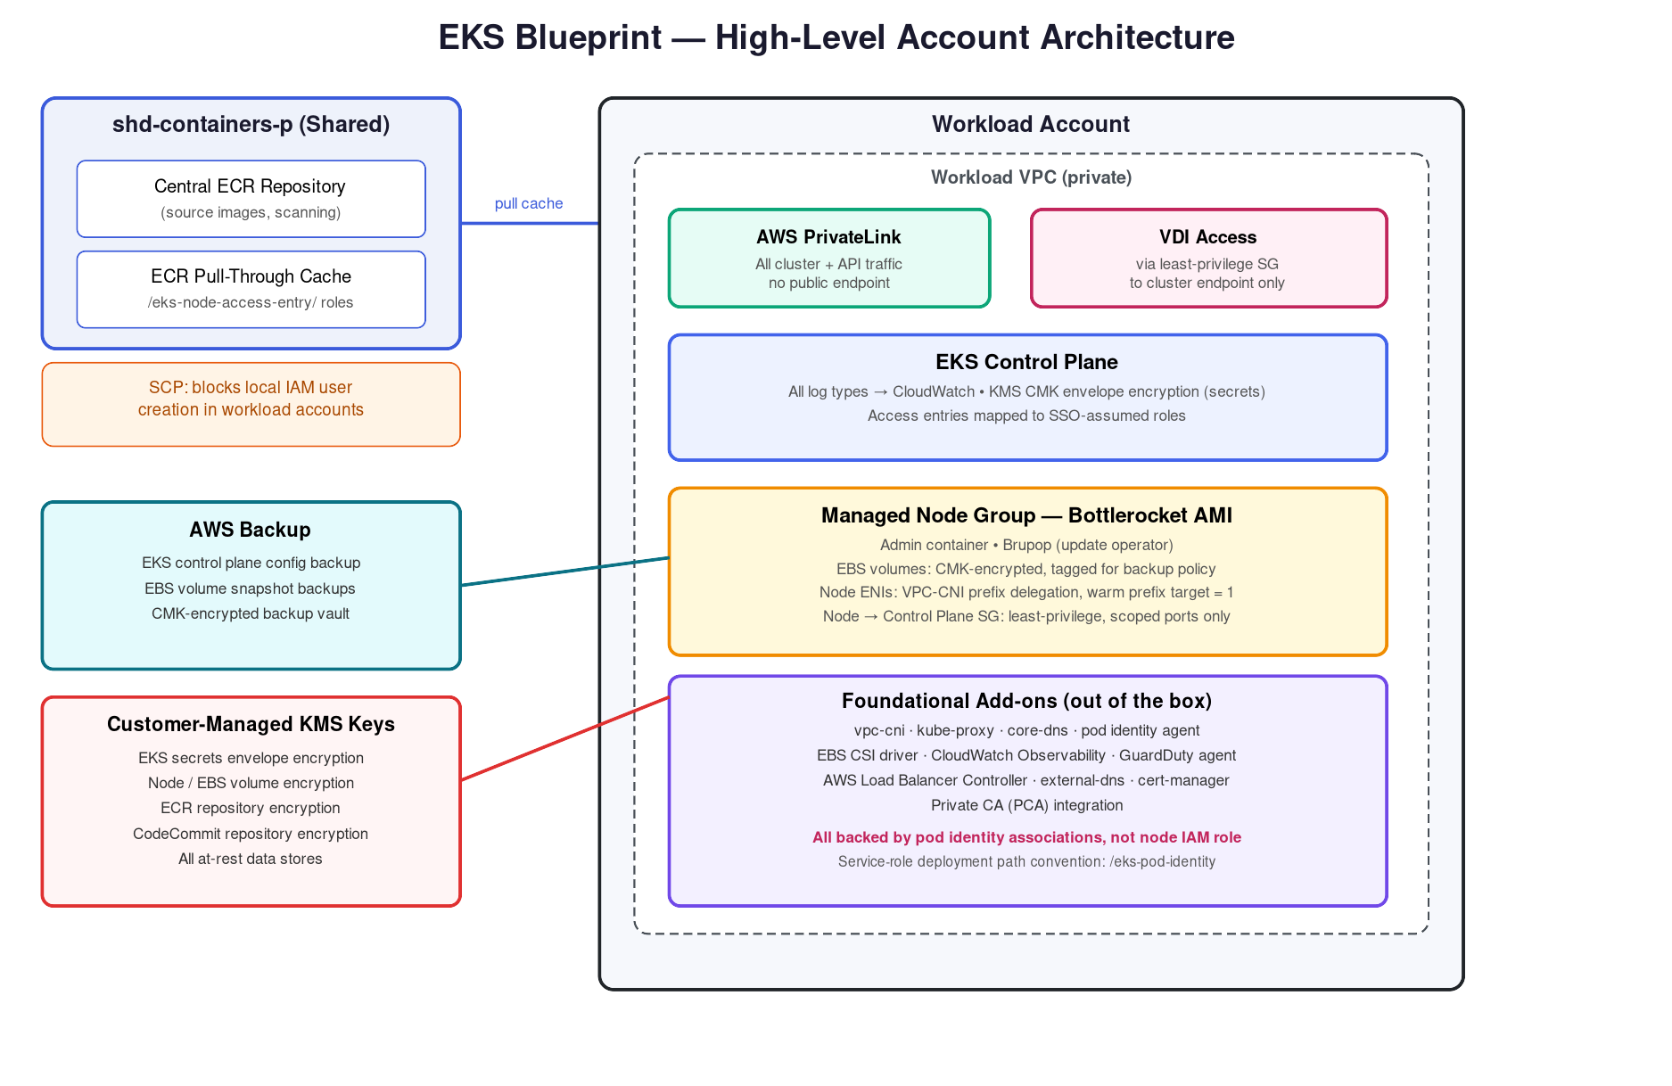
Figure 1 — Account and component architecture: shared services account, workload account, PrivateLink boundary, node group, add-ons, backup, and KMS.

2. RBAC & Access Model
Access to the cluster is designed around a single static IAM role per environment, rather than individual IAM users or roles created per person. A user authenticates through SSO as a 'WorkloadConfig' user, whose permission set only allows them to assume the static role — it grants no other permissions. That static role is what actually appears in the cluster's EKS access entries, mapped to a Kubernetes RBAC group with the appropriate permissions (e.g. read-only, namespace admin, cluster admin).
In simple terms: think of the static role as a single 'front door key' to the cluster. SSO decides who is allowed to pick up that key; the access entry decides what the key opens once inside.
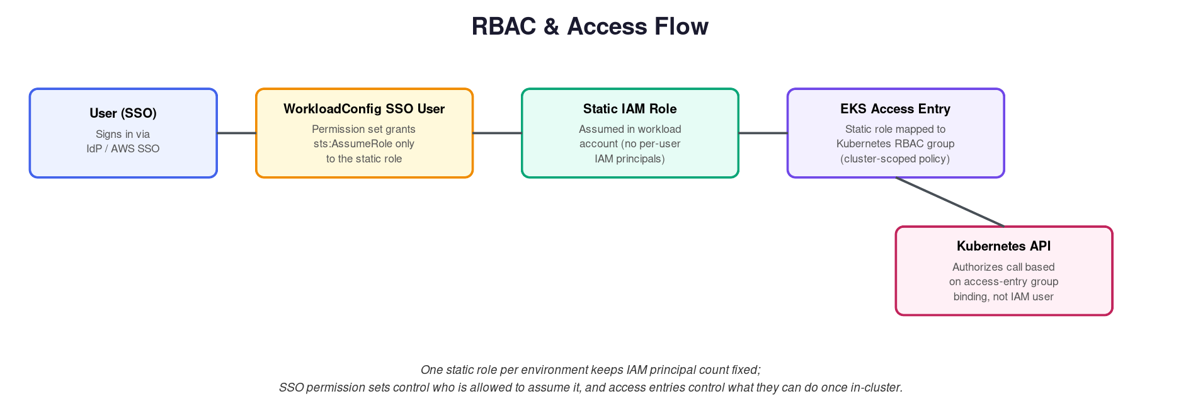
Figure 2 — SSO user assumes a static role, which is bound to an EKS access entry mapped to a Kubernetes RBAC group.

2.1 Why This Model
- Keeps the IAM principal count fixed regardless of team size or turnover — access changes happen in SSO group membership, not in AWS IAM.
- Cluster-side authorization (access entries → RBAC groups) is centrally auditable and independent of how many people can assume the role.
- Removes the need to create per-user IAM roles inside every workload account.

2.2 Service-Role Mapping (Pod Identity)
Workloads and add-ons that need to call AWS APIs use EKS Pod Identity rather than long-lived node IAM credentials. Each service account is associated, via a Pod Identity Association, with a specific least-privilege IAM role. The Pod Identity Agent (a DaemonSet) intercepts credential requests from the pod and vends short-lived credentials for the mapped role only.
- Manifests defining a service account + its pod identity association are deployed under a consistent path convention: /eks-pod-identity/<cluster>/<namespace>/<service-account>.yaml — this keeps pod, service account, and role association auditable in one location.
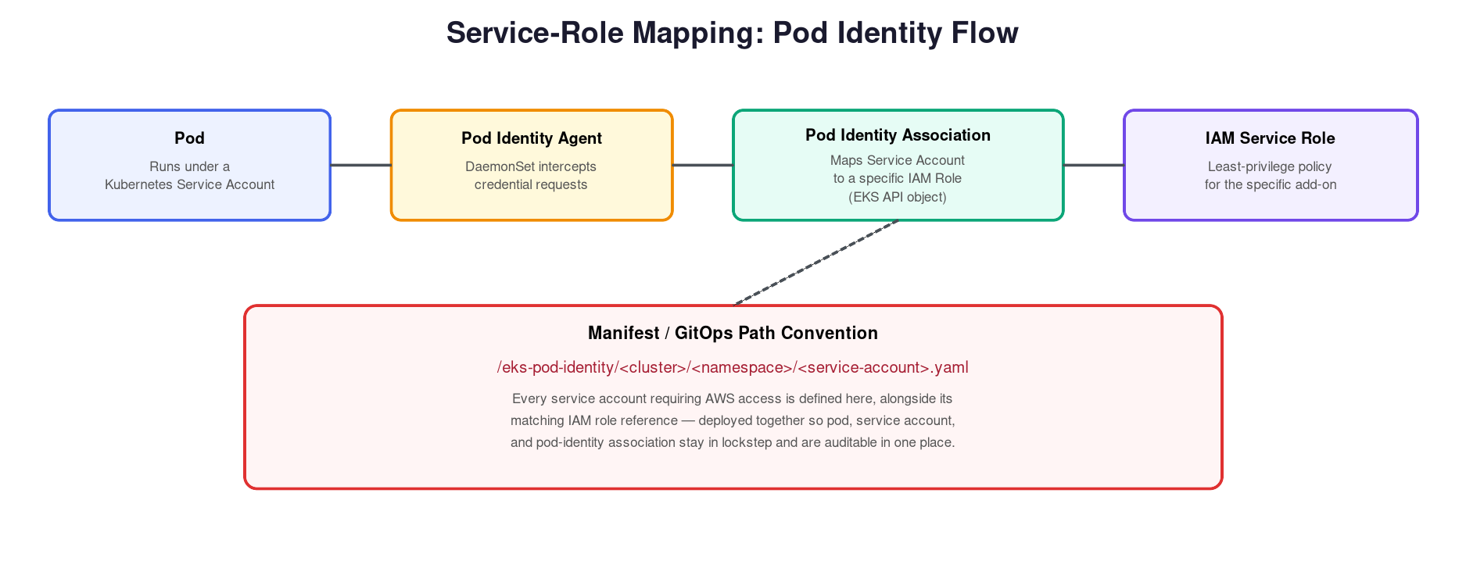
Figure 3 — Pod identity flow: service account → pod identity agent → pod identity association → IAM role.

3. Monitoring & Alerting
All EKS control plane log types (API server, audit, authenticator, controller manager, scheduler) are enabled and streamed to CloudWatch Logs. This gives full visibility into cluster API activity, including who did what, and is the primary source for audit and troubleshooting.
The CloudWatch Observability add-on is deployed on every cluster to collect node, pod, and container-level metrics and logs (Container Insights), feeding CloudWatch dashboards and alarms without the workload team having to stand up their own metrics pipeline.
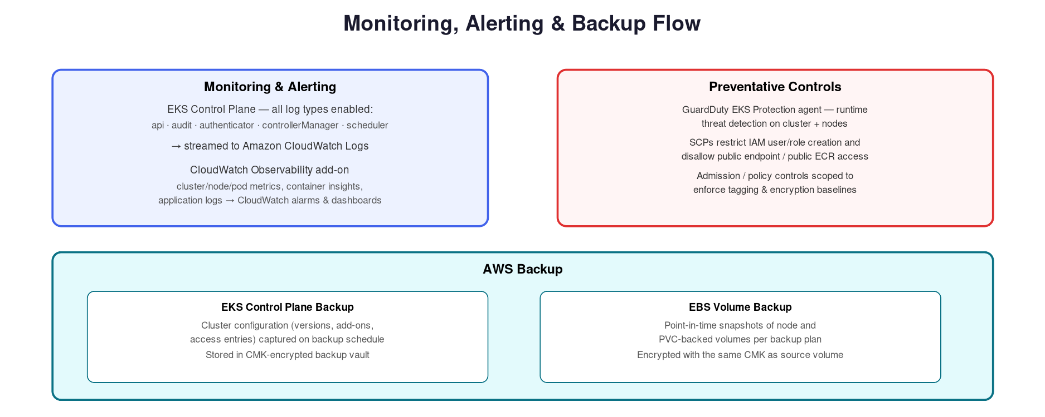
Figure 4 — Monitoring, preventative controls, and backup flow.

4. Preventative Controls
- GuardDuty EKS Protection agent runs on every cluster for runtime threat detection at the cluster and node level.
- Service Control Policies (SCPs) prevent creation of local IAM users in workload accounts, forcing all human access through the SSO / static-role model.
- SCPs also protect the shared container repository account, restricting who can create the /eks-node-access-entry/ pull-through roles used by workload accounts.
- No public EKS API endpoint is exposed — all access is via PrivateLink, closing off the most common attack surface for EKS clusters.

5. Encryption
A customer-managed KMS key (CMK) is used consistently across the blueprint rather than relying on AWS-managed keys, so the workload team retains control over key policy, rotation, and access auditing.
Resource | Encryption Detail
EKS cluster secrets | Envelope encryption of Kubernetes Secrets using the CMK
Worker nodes / EBS volumes | Root and data volumes encrypted with the CMK; tagged for backup policy discovery
ECR repository | Images encrypted at rest with the CMK, including the shared pull-through cache
CodeCommit repository | Repository contents encrypted with the CMK
AWS Backup vault | Control plane and EBS snapshot backups encrypted with the same CMK as the source resource
All data at rest in the blueprint's footprint — cluster, nodes, container images, source repositories, and backups — resolves back to this single CMK, simplifying key management and audit.

6. Cluster Add-ons
The blueprint pre-installs and configures the add-ons a workload team would otherwise need to source, secure, and operate individually. Each is deployed with a pod identity association (see Section 2.2) rather than broad node-level permissions.
Add-on | Purpose | Design Notes
VPC-CNI | Pod networking | Prefix delegation enabled; warm prefix target set to 1 to balance IP density with warm-pool cost
kube-proxy | Service networking / iptables rules | Deployed as standard managed add-on
CoreDNS | In-cluster DNS resolution | Deployed as standard managed add-on
Pod Identity Agent | Vends IAM credentials to pods | Underpins all other add-ons' AWS access; see Section 2.2
EBS CSI Driver | Persistent volume provisioning | Requires EBS volumes to carry the blueprint's standard tag set so the driver can discover and manage lifecycle
AWS Load Balancer Controller | Provisions ALB/NLB from Kubernetes Ingress/Service objects | Requires target subnets and security groups tagged per the kubernetes.io/cluster/<name> and kubernetes.io/role/elb convention; deployed via Helm chart
CloudWatch Observability | Metrics, logs, Container Insights | See Section 3
GuardDuty (EKS Protection agent) | Runtime threat detection | See Section 4
external-dns | Automates Route 53 record creation from Kubernetes objects | Scoped IAM role limited to the workload account's managed hosted zone(s)
cert-manager | Automates TLS certificate issuance/renewal | Integrated with Private CA (PCA) as the issuing authority
Private CA (PCA) | Internal certificate authority | Issues certificates consumed by cert-manager; avoids public CA dependency for internal endpoints

6.1 Node Operating System — Bottlerocket
Worker nodes run Bottlerocket, a minimal, purpose-built container OS, rather than a general-purpose Linux AMI. This reduces the node's attack surface (no shell, no package manager by default) while still allowing controlled access when needed.
- Admin container — enabled on-demand for break-glass troubleshooting access to the host; not running by default.
- Brupop (Bottlerocket Update Operator) — manages rolling OS updates across the node group via its Helm chart. Note: Brupop's controller depends on an externally reachable IP/endpoint for its update coordination — this dependency must be accounted for in the network design (see Section 7) so update checks aren't silently blocked by the private-only networking posture.

7. Networking & Security Groups
Two security-group relationships are explicitly modeled as least-privilege rather than left as broad defaults: node-to-cluster connectivity, and VDI-to-cluster connectivity. Both allow only the specific ports required and nothing else.
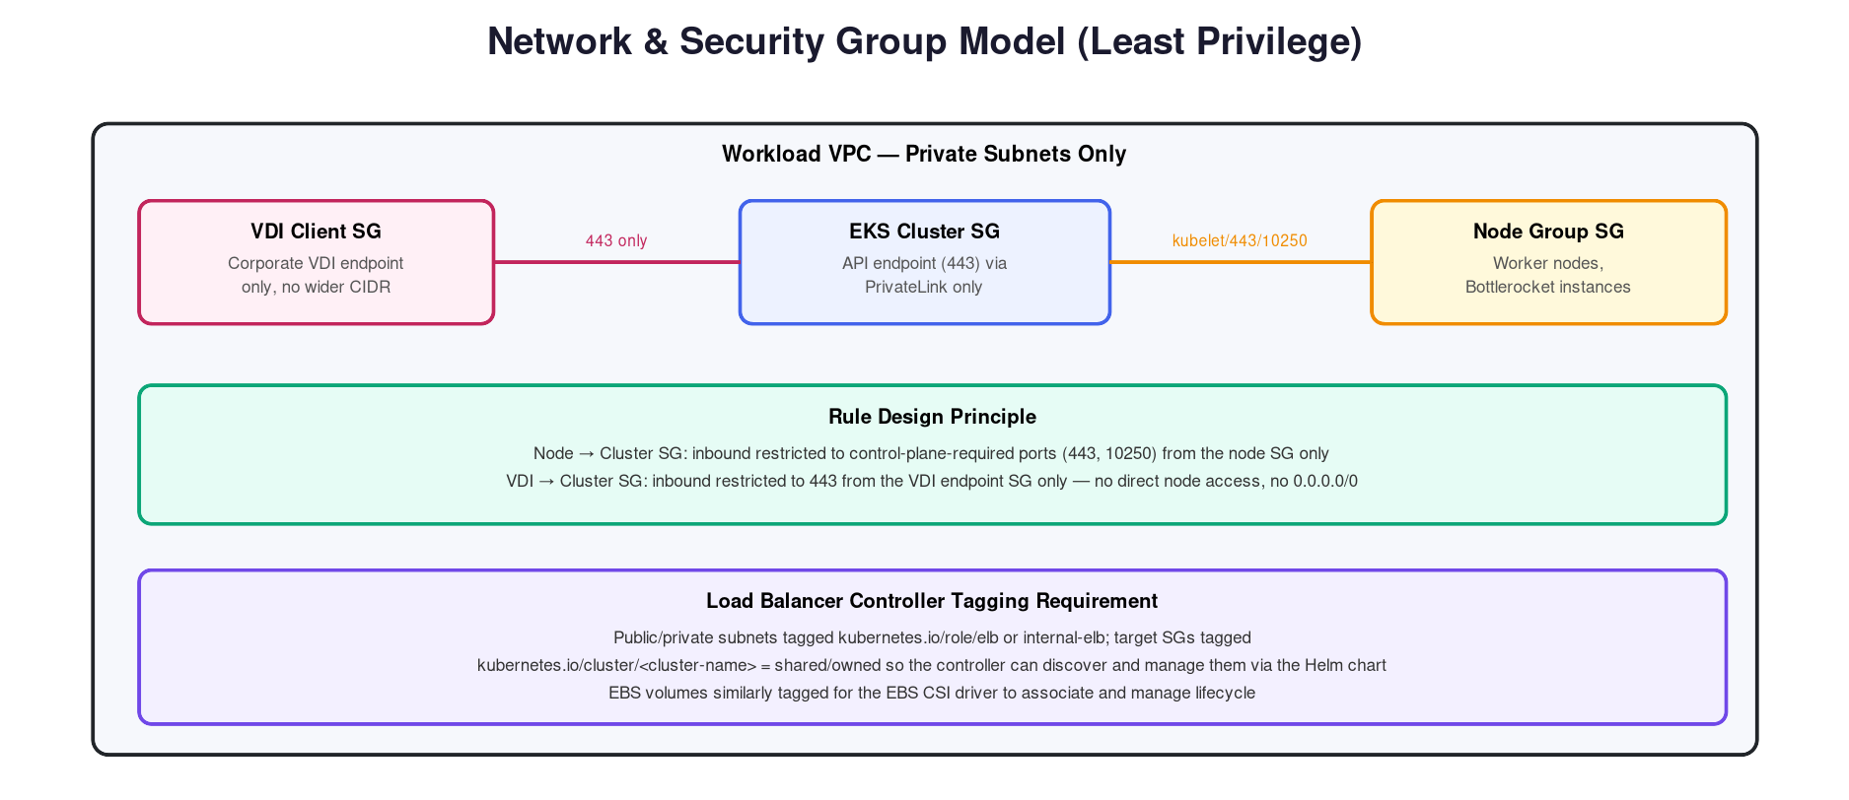
Figure 5 — Security group boundaries for VDI access, the cluster control plane, and worker nodes.

7.1 Node → Cluster
- Inbound to the cluster security group is restricted to the ports required for kubelet and API communication (443, 10250) and only from the node group security group.

7.2 VDI → Cluster
- Inbound to the cluster security group from the VDI security group is restricted to 443 only — no direct network path to worker nodes.

7.3 Tagging Requirements
- Load Balancer Controller: subnets tagged kubernetes.io/role/elb (public) or kubernetes.io/role/internal-elb (private); security groups tagged kubernetes.io/cluster/<cluster-name> = shared or owned so the controller Helm chart can discover and manage them.
- EBS CSI Driver: EBS volumes tagged per the blueprint's standard convention so the driver can associate volumes with their owning PVC/StorageClass and so AWS Backup can select them by tag.

8. Backup & Recovery
Backup is handled through AWS Backup rather than bespoke scripts, giving a single, centrally auditable backup plan per cluster.
- EKS control plane — cluster configuration (Kubernetes version, add-on versions/configuration, access entries) is captured on a backup schedule so a cluster can be reconstituted from a known-good configuration state.
- EBS volumes — node and PVC-backed volumes are snapshotted per backup plan; snapshots inherit CMK encryption from the source volume (see Section 5).
See Figure 4 (Section 3) for how backup fits alongside monitoring and preventative controls.

9. Shared Container Repository
Container images are not pulled directly from public registries by workload clusters. Instead, images are sourced from a centrally governed shared services account (shd-containers-p) and consumed by workload accounts through an ECR pull-through cache. This keeps a single, scanned, governed set of base images rather than each workload account independently pulling from the internet.
- Workload accounts are granted access via roles under a consistent path convention: /eks-node-access-entry/ — these roles are scoped to pull-through cache access only.
- Creation of new users/roles against the shared repository is protected by Service Control Policies (SCPs), so pull-through access can only be granted through the governed process, not by ad hoc IAM changes in either account.

10. Appendix — Full Add-on & Control Checklist
Area | Control
RBAC | SSO WorkloadConfig user → assume static role → EKS access entry → RBAC group
Monitoring | All EKS log types enabled; CloudWatch Observability add-on
Preventative | GuardDuty EKS Protection; SCPs blocking local IAM user/role creation
Encryption | CMK for cluster, nodes/EBS, ECR, CodeCommit, and backups
Load Balancer Controller | Subnet/SG tagging + Helm chart deployment
EBS CSI Driver | EBS volume tagging requirement
PCA | Internal CA integrated with cert-manager
external-dns | Automated Route 53 record management
GuardDuty | Runtime threat detection agent
VPC-CNI | Prefix delegation enabled; warm prefix target = 1
cert-manager | Automated certificate issuance/renewal via PCA
CoreDNS / kube-proxy | Standard managed add-ons
Pod Identity Agent | Underpins all AWS-facing service roles
Bottlerocket | Minimal-footprint node OS with on-demand admin container
Brupop | OS update operator; dependent on external IP reachability
Service Roles | Pod ↔ service account ↔ pod identity association under /eks-pod-identity/
Security Groups | Least-privilege node→cluster and VDI→cluster rules
Backups | AWS Backup for control plane config and EBS volumes
Shared Repository | Pull-through cache from shd-containers-p via /eks-node-access-entry/ roles, SCP-protected

