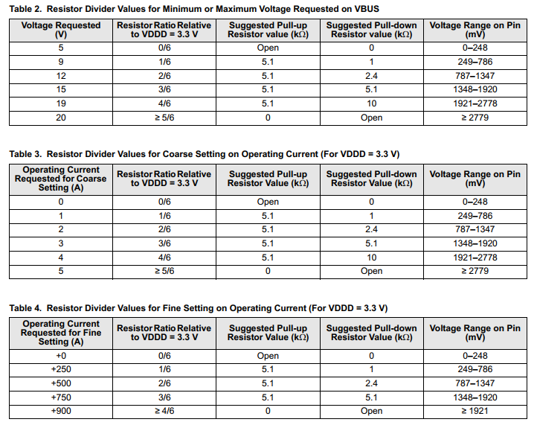

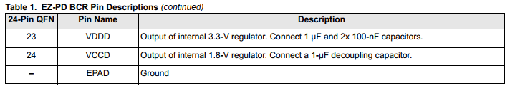

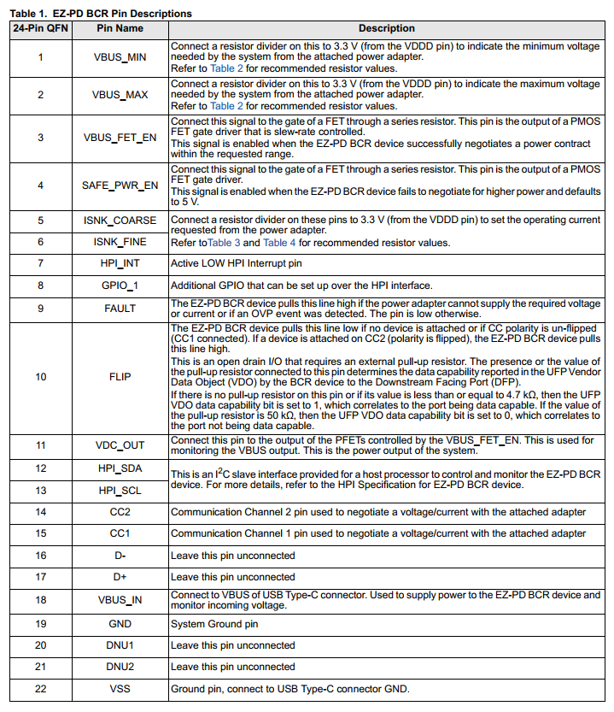

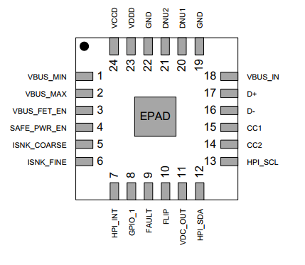

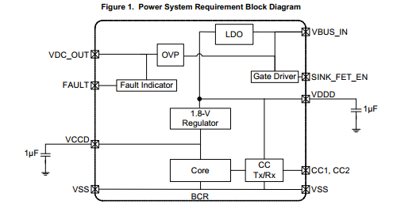

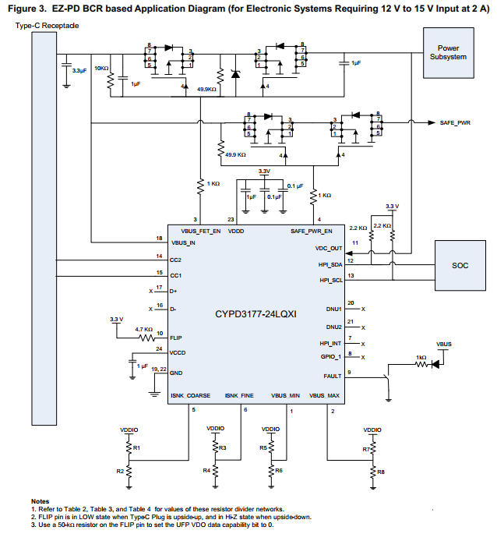

The CYPD3177 is a USB Type-C Power Delivery (USB-PD) controller.

USB-C / USB-PD → Handles power negotiation over a USB-C connection.
Controls charging → Can manage how much power a device receives or provides.
Supports high power → Can negotiate different voltage and current levels.
Power negotiation → The charger and device communicate to agree on the appropriate power.
Protection features → Helps protect against problems such as overvoltage and overcurrent.
Works with external power circuitry → It controls the power system rather than directly providing the high output power itself.
In one sentence:

The CYPD3177 manages USB-C power delivery by communicating with the connected device and controlling the power system to provide the appropriate voltage and current.

Voltage | Can request 5 V, 9 V, 12 V, 15 V, or 20 V
Current | Can request up to 5 A with USB-PD
Maximum power |  | Up to 100 W (20 V × 5 A)
Normal USB-C charging |  |  | Supports 5 V at 0.5 A, 0.9 A, 1.5 A, or 3 A

