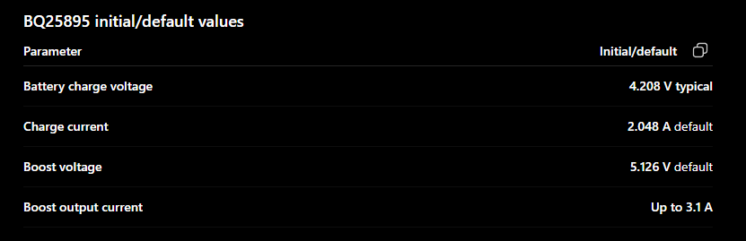

The BQ25895 is a single-cell Li-ion/LiPo battery charging IC with power-path management.

Charges a 1-cell lithium battery → Handles charging safely and automatically.
USB input support → Can charge from USB power sources.
Fast charging → Supports relatively high charging currents.
Power-path management → Can power the system while simultaneously charging the battery.
Input current limiting → Prevents drawing too much current from the USB adapter.
Battery protection features → Includes charging safety timers, temperature monitoring support, and voltage/current regulation.
I²C interface → A microcontroller can monitor and configure charging settings.
Boost mode → Can use the battery to generate a 5 V output for powering USB devices.
In one sentence:

The BQ25895 is a smart battery charger that safely charges a single-cell lithium battery,
powers the system, and can even boost the battery voltage to 5 V when needed.

