9.2.2.1 Programming The Output Voltage

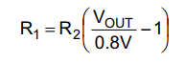

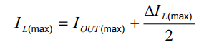

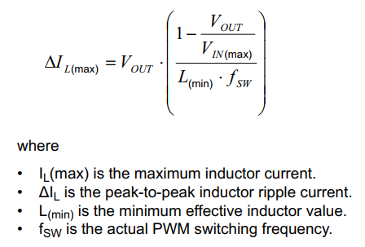

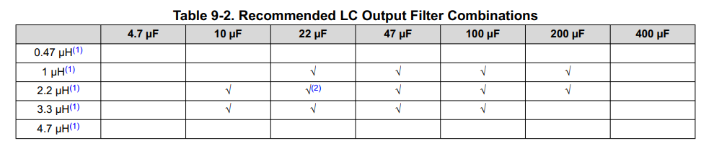

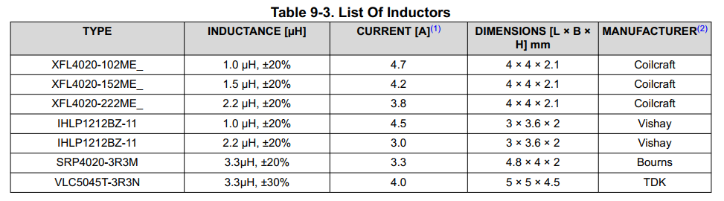

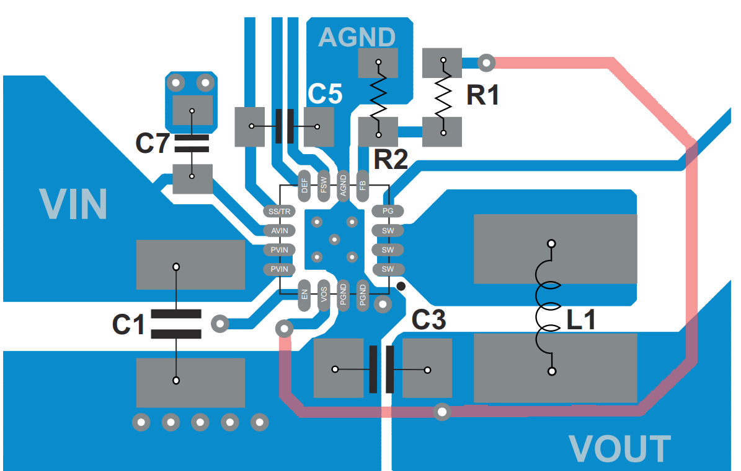

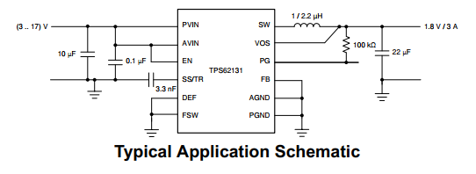

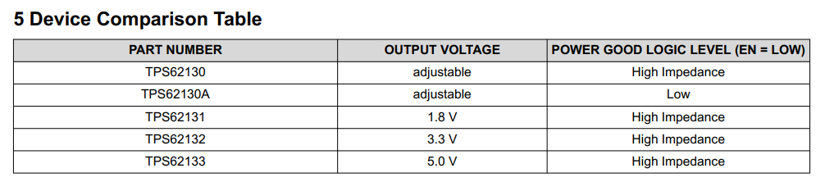

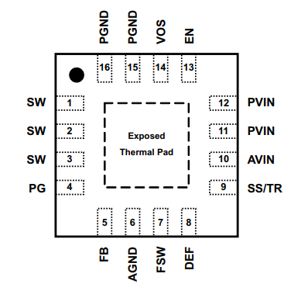

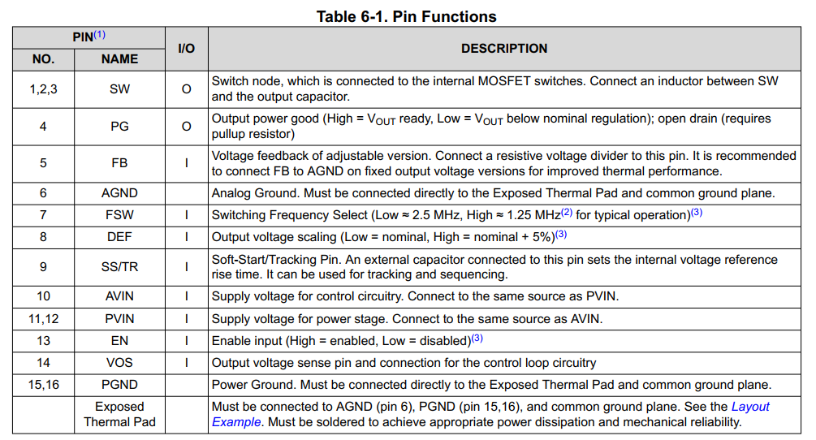

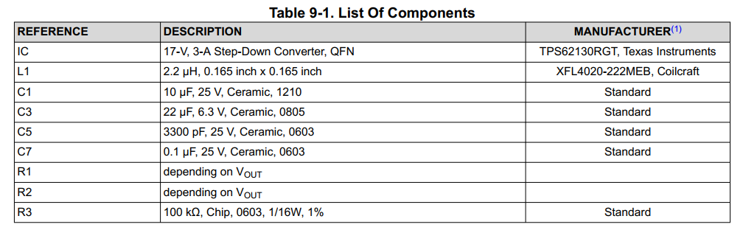

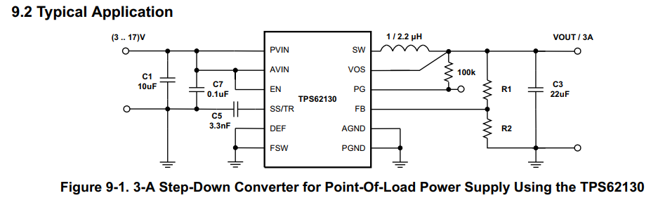

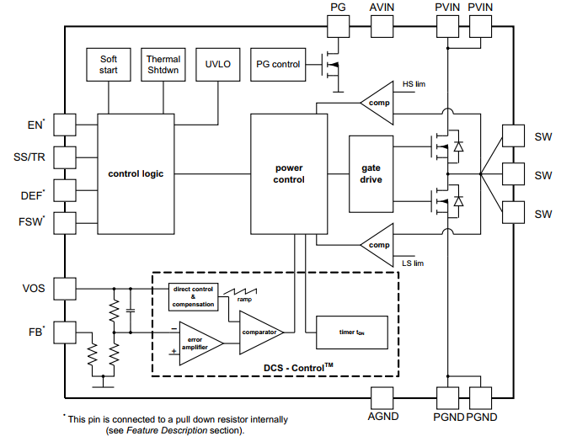

TPS62133 key features
Buck converter → Converts a higher DC voltage to a lower DC voltage.
Up to 3 A output → Can supply up to about 3 A to a load.
Adjustable output voltage → You can set the output, such as 3.3 V or 5 V.
3–17 V input → Accepts a fairly wide range of input voltages.
High efficiency → Wastes less power as heat.
Synchronous design → Uses internal MOSFETs, reducing the need for external components.
Overload/short-circuit protection → Limits current if the load demands too much.
Overtemperature protection → Protects itself if it gets too hot.
Soft-start → Gradually increases the output voltage when turned on.
Power Good signal → Lets your circuit know when the output voltage is stable.
In one sentence:

The TPS62133 takes an input voltage of 3–17 V and efficiently converts it to a lower, regulated voltage while protecting itself from excessive current and temperature.

