2. Hardware resistor on ICHG pin

The BQ25690 also lets you establish the default charge current using a resistor connected to ICHG. TI provides discrete settings:

ICHG resistor Default charge current
4.64 kΩ 100 mA
6.04 kΩ 500 mA
8.25 kΩ 1.0 A 10k+47k
10.5 kΩ 1.5 A 10k+500R
13.7 kΩ 2.0 A
16.9 kΩ 2.5 A
27.4 kΩ 3.3 A

So if you're building your 1S Li-Po + USB-C PD design and want 2 A charging without relying on firmware, use:

ICHG → 13.7 kΩ → GND

The resistor is referenced to the default 10 mΩ battery sense resistor. If you use a 5 mΩ sense resistor, TI says to set the RBAT_SNS bit so the programmed current remains properly scaled.

For your design

If you're using the BQ25690 with 1S Li-Po, 2 A charging, and 5 V/3 A reverse/boost output, I'd configure it roughly as:

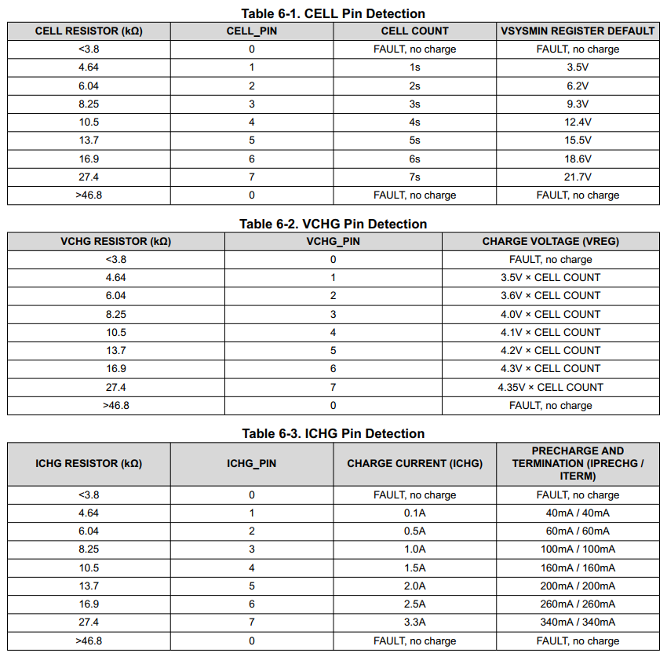
CELL = 4.64 = 4.7k+330k = 1s
VCHG = 13.7k = 15k+150k = 4.2V
ICHG = 8.25k = 10k+47k = 1A

