Transfer safety review
Barrier Atlas incident review
Transfer leak investigation
Barrier-based systemic cause analysis
Field | Value
code | I-07
description
what Happened | Transfer hose failed during a supervised transfer
date | 2026-10-13T09:00
time Zone
incident Type
category
tier
unit

Barrier-based systemic cause analysis
Analysis · Complete
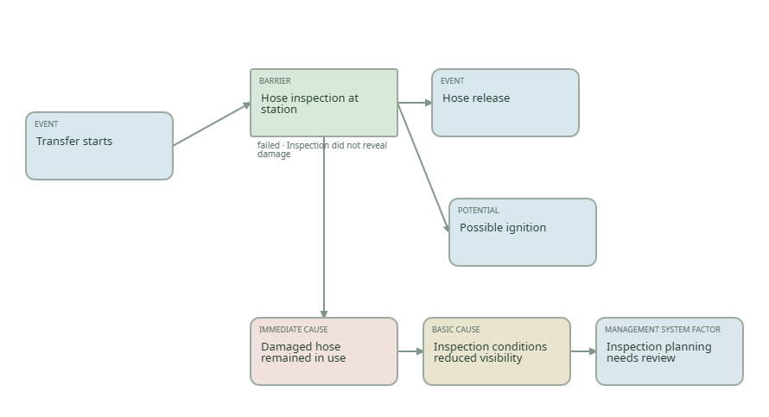
Node | Kind / appearance | Failure state
Hose release | event
Hose inspection at station | barrier | failed
Transfer starts | event
Possible ignition | potential

From | To
Hose inspection at station | Hose release
Hose inspection at station | Possible ignition
Transfer starts | Hose inspection at station

Hose release
Hose inspection at station
failure Short: Inspection did not reveal damage
failure Detail: Documented physical inspection finding
Case barriers: Pre-transfer hose inspection
Documents: Hose condition checklist
Immediate cause | Basic cause | Management system factor
Damaged hose remained in use | Inspection conditions reduced visibility | Inspection planning needs review

Transfer starts
Possible ignition
Transfer investigation timeline
Timeline · Draft
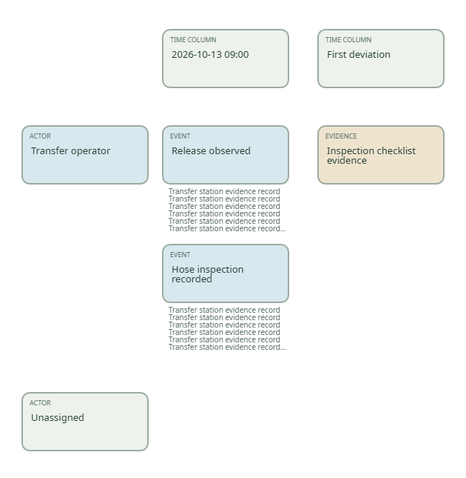
Time | Qualitative description
2026-10-13 09:00
First deviation | First deviation

Time / actor | Event / evidence | Location / confidence
2026-10-13T10:00 / Transfer operator | Inspection checklist evidence: | /
2026-10-13T09:00 / Transfer operator | Release observed: | Transfer station evidence record Transfer station evidence record Transfer station evidence record Transfer station evidence record Transfer station evidence record Transfer station evidence record Transfer station evidence record Transfer station evidence record / Witness confirmation and inspection notes Witness confirmation and inspection notes Witness confirmation and inspection notes Witness confirmation and inspection notes Witness confirmation and inspection notes
2026-10-13T09:00 / Transfer operator | Hose inspection recorded: | Transfer station evidence record Transfer station evidence record Transfer station evidence record Transfer station evidence record Transfer station evidence record Transfer station evidence record Transfer station evidence record Transfer station evidence record / Witness confirmation and inspection notes Witness confirmation and inspection notes Witness confirmation and inspection notes Witness confirmation and inspection notes Witness confirmation and inspection notes

Inspection checklist evidence
Actor: Transfer operator
Timeline: 2026-10-13T10:00
Documents: Hose condition checklist
Release observed
location: Transfer station evidence record Transfer station evidence record Transfer station evidence record Transfer station evidence record Transfer station evidence record Transfer station evidence record Transfer station evidence record Transfer station evidence record
confidence: Witness confirmation and inspection notes Witness confirmation and inspection notes Witness confirmation and inspection notes Witness confirmation and inspection notes Witness confirmation and inspection notes
Actor: Transfer operator
Timeline: 2026-10-13T09:00
Hose inspection recorded
location: Transfer station evidence record Transfer station evidence record Transfer station evidence record Transfer station evidence record Transfer station evidence record Transfer station evidence record Transfer station evidence record Transfer station evidence record
confidence: Witness confirmation and inspection notes Witness confirmation and inspection notes Witness confirmation and inspection notes Witness confirmation and inspection notes Witness confirmation and inspection notes
Actor: Transfer operator
Timeline: 2026-10-13T09:00
Transfer operator
Unused observer
Recommendations
Recommendation / owner | Target / completion | Details
Improve hose inspection conditions / Transfer starts | 2026-11-01 / Open | Review the documented inspection finding

