Name & Roll No:-
Arjun Jaiswal-28
Armaan Ahmed-29
Arnav Milmile-30

BIG DATA ANALYTICS IN HEALTHCARE
Topic 10: Big Data in COVID-19 Tracking and Prediction

TA-1(Topic-10)
1. Introduction
The rapid spread of COVID-19 at the end of 2019 exposed the world's lack of preparedness around both the medical and non-medical aspects of collecting and using health data. The pandemic represented a watershed moment for Big Data Analytics in Health Care, compelling organizations and governments to begin using technologies that had previously only been utilized in finance and technology. The scope and rapidity of the outbreak created an urgent need to abandon outdated manual reporting processes.

Traditional methods of managing epidemics take far too long. Reports of case counts are created and processed through numerous bureaucratic hoops before they are shared with the public,it can take several days before a laboratory test result is known and while a health department is preparing to publicly publish their surveillance data, the outbreak is already in a different state. COVID-19 brought these deficiencies to light. Within weeks of the outbreak, health departments were dealing with millions of records on a daily basis (hospital admissions, genomic sequencing, social media activity, and mobility patterns). No spreadsheet or legacy database is capable of managing those volumes of information effectively.

Various nations and scientific research organizations relied on the use of tools such as Apache Hadoop and Apache Spark as well as cloud service providers to combine these data sets. The data sets came from sources such as national health registries, genomic databases, contact tracing applications, and mobility reports provided by businesses including but not limited to Google and Apple. In addition, the WHO and the ECDC are also key contributors to these outdata streams. In addition to building this infrastructure, machine learning models were also created to help identify areas of rapid spread of the virus identify locations that were at high risk for future outbreaks and predict the results of interventions including but not limited to quarantining order / closure of business and public gatherings and vaccination campaigns.

2. Problem Statement
The pandemic put a spotlight on the need for more accurate and timely data. Health officials trying to manage this rapidly changing situation found themselves overwhelmed by the volume of data as well as having data that is often inconsistent, delayed and fragmented.

One of the most significant challenges to data management was the time it took for data to be collected and reported. In many cases, there were delays of several days or even weeks before case and death data reached the appropriate decision-makers. Because of this, it was not uncommon for health officials to receive information that was already outdated at the time they received it. As a result, health officials used reactive management systems to address an emergency that was overtaking the ability of these systems to report the actual number of cases and deaths.

Health officials also faced issues concerning inconsistencies in the quality of health data among countries. Some countries had reliable health registration systems as well as widespread testing,while other countries were not as fortunate. This created a global picture of the health impact of COVID-19 that was patchy at best, and made it difficult to aggregate and/or compare data. Standard epidemiological models did not account for the irregularities in the data provided by many countries, therefore they were not applicable in such cases.

The amount of data was another significant challenge faced by health officials in 2020, there were millions of records documenting daily cases, terabytes of genomic sequence,billions of geospatial location data points associated with individuals’ use of smartphones and an avalanche of real-time posts on social media. None of th e traditional systems used to collect and report data were able to process this amount of information efficiently. Specifically, spreadsheets and conventional databases struggled to accommodate the large volume of data coming in from multiple sources.

Perhaps most importantly, the need was not just for reporting, it was for prediction. Instead of just viewing last week’s case count presented in large screens, public health systems now had predictive modelling that would help them understand where the virus is going to go when admis sions to various hospitals will be exceeded in 2-3 weeks and how a change in policy (such as closing schools) would affect transmission rates They were able to leverage structured and unstructured data on an unprecedented scale and utilize the Big Data Analytic capabilities thereof

3. Data Used
3.1 Types of Data
The process of tracking and estimating COVID-19 depended on an especially wide range of data than what is traditionally used by health surveillance systems:

- Epidemiological Data: The number of confirmed daily cases, hospitalizations, ICU admissions, total recoveries, and deaths that the National & Regional Health Services reported each day
- Genomic and Sequencing Data: Because so many scientists around the world have created SARS-CoV-2 whole genome sequences that they have put in publicly accessible databases these genomic sequences could be used to identify the emergence of new variants, and how they are changing.
- Mobility Data: After permission was given to collect anonymized location data from mobile devices, this data could be used as a proxy for estimating transmission risk by identifying where (commuting, travelling, and the level of density in public spaces) and when (during what hours) people were most likely to infect others.

- Online Data: The analysis of Twitter posts, Google search trends, and news articles for signs of new symptoms, and increasing concern in society, allowed researchers to identify places where the spread of the virus was increasing.
- Demographic and Socio-Economic Data: The researchers used demographic and socio-economic data (i.e., like density of a population, age, income level and pre-existing medical conditions) as variables in their models to improve prediction estimates.
- Healthcare Supply and Capacity Data: The data the researchers received about hospital supply ( number of beds, number of ventilators, proportion of beds in/number of large hospitals occupied, number of staff) were also used to identify when hospitals would likely be at or near their point of accepting new patients.

Environmental Data: The researchers also sought to find environmental data (i.e., temperature, humidity and air quality data) to help determine if any of these variables had any effect on the rate of transmission of the virus.
3.2 Data Sources
Data Source / Repository | Description and URL
WHO COVID-19 Dashboard | Global case and death data daily country-level reporting. https://covid19.who.int
Our World in Data (OWID) | Open-source global dataset covering cases, vaccinations, mortality, and testing. https://ourworldindata.org/covid-cases
Johns Hopkins CSSE | One of the first global dashboards, aggregated national data. https://coronavirus.jhu.edu
GISAID EpiCoV Database | Global repository for SARS-CoV-2 genome sequences and variant tracking. https://www.gisaid.org
Google COVID-19 Community Mobility Reports | Anonymized aggregated mobility data by region. https://www.google.com/covid19/mobility/
Apple Mobility Trends | Mobility data based on Apple Maps usage across countries. https://covid19.apple.com/mobility
COVIDcast (Carnegie Mellon) | US-level indicators including symptoms, mobility, and doctor visits. https://delphi.cmu.edu/covidcast/
European CDC (ECDC) | Epidemiological data for EU/EEA member states. https://www.ecdc.europa.eu/en/covid-19/data
Worldometer COVID-19 | Near real-time case and mortality data from multiple national sources. https://www.worldometers.info/coronavirus/

4. Tools and Techniques
4.1 Apache Hadoop
Hadoop was really important for storing and processing a lot of data during the COVID-19 pandemic. It helped big health agencies store amounts of data about the virus like where people were getting sick and how the virus was spreading. Hadoops file system, called HDFS made it possible to store all this data on computers so if one computer stopped working the whole system did not stop.

Hadoop did a lot of the work like figuring out how many cases of the virus there were in different areas each week. It also helped look at the viruss material to see how it was changing. The people who made Hadoop also made tools like Apache Hive, that made it easy for health experts to ask questions about the data without needing to be computer experts. This was really helpful because it meant that people who were not programmers could still get the information they needed from the data. They could just ask a question. Get an answer without having to write a lot of complicated code. Hadoop and these other tools were really useful, for health experts who were working with COVID-19 data.
4.2 Apache Spark
Where Hadoop was good at processing batches of data it was not fast. And speed was very important during a pandemic where things could change quickly. Apache Spark solved this problem. Its way of computing data in memory made it much faster for repeated calculations, which was crucial for updating machine learning models every day as new data came in.

Research teams used Sparks ML-lib library to create and regularly update their models for predicting outbreaks. Spark Streaming helped them get case reports and social media updates in real-time so their dashboards could show the latest information with little delay. In a pandemic knowing something today of three days later can mean lives saved.

Research teams used Sparks MLlib library to build and update their outbreak forecasting models. They used Spark Streaming to get case reports and social media signals. This helped them make dashboards that showed the developments with minimal delay. The difference between knowing something today versus three days, from now in a context can translate directly into lives saved.
4.3 Machine Learning and Predictive Modelling
Different forms of ML models were implemented to assist in various aspects of addressing the pandemic:
- Time-series Models: This has been accomplished through the use of LSTM networks and the Facebook Prophet model, which have both been widely utilised to enable forecasting of case counts, hospitalisation rates, and mortality rates over a 7-30 day time period. These modelling techniques were better able to capture temporal dependencies in outbreak data that were missed by simpler statistical techniques
- Classification Models: In the identification of high-risk geographic zones, as well as predicting which admitted patients are going to need ICU care, Random Forest and Gradient Boosting classification models were trained so that earlier resource allocation decisions could be made.
- Epidemiological Hybrid Models: Dynamic parameter estimation using a combination of traditional compartmental models (such as SIR and SEIR) and Machine Learning allowed for simultaneous inference of the effective reproduction number (Rt) using both mobility data and the case counts.
- Natural Language Processing: Using Transformer-based models (particularly BERT-type models) to analyse social media and clinical notes allowed for the detection of unreported clusters of symptoms and to identify potential super spreading events prior to these data being reported in official statistics.
4.4 APIs and Data Pipelines
In order to obtain data in a real-time format, we relied on using APIs extensively. The COVID-19 Tracking Project, or Our World in Data or Johns Hopkins CSSE published their REST APIs that many teams utilized to obtain updated statistics that could be pulled directly into their analytics systems. Google and Apple provided access to their mobility datasets via the use of their respective cloud storage APIs. The Carnegie Mellon COVID cast API has allowed researchers to access over one hundred different COVID related indicators, which could easily be imported into R or Python.

Behind the scenes, the daily data refreshes were managed by automated ETL pipelines, which are running on AWS, Google Cloud and Azure.These pipelines do not require any manual intervention, which is a crucial component of how we scale because no team can manually download and process hundreds of data sources each morning.
4.5 Visualization and Dashboard Tools
Even though many systems and methods have been developed to analyze data, each is only useful if you can interpret their output and take relevant action.
Data visualization software, such as Tableau, Power BI and custom D3.js applications can produce heat maps to illustrate where disease is found on a regional or geographical scale, epidemic curves to illustrate the progress (or spread) of an infection, and hospital resource availability charts.
For example, during 2020, the Johns Hopkins Coronavirus Resource Center dashboard became one of the most frequently visited sites globally. This dashboard allowed users to see, on a single site, the degree and extent of the global impact of the virus. It clearly demonstrated that a well-designed_big data_ visualization can aid not only specialists in understanding what they see, but also can provide valuable information to others trying to gain insight into what's going on in the world.

5. Working Process
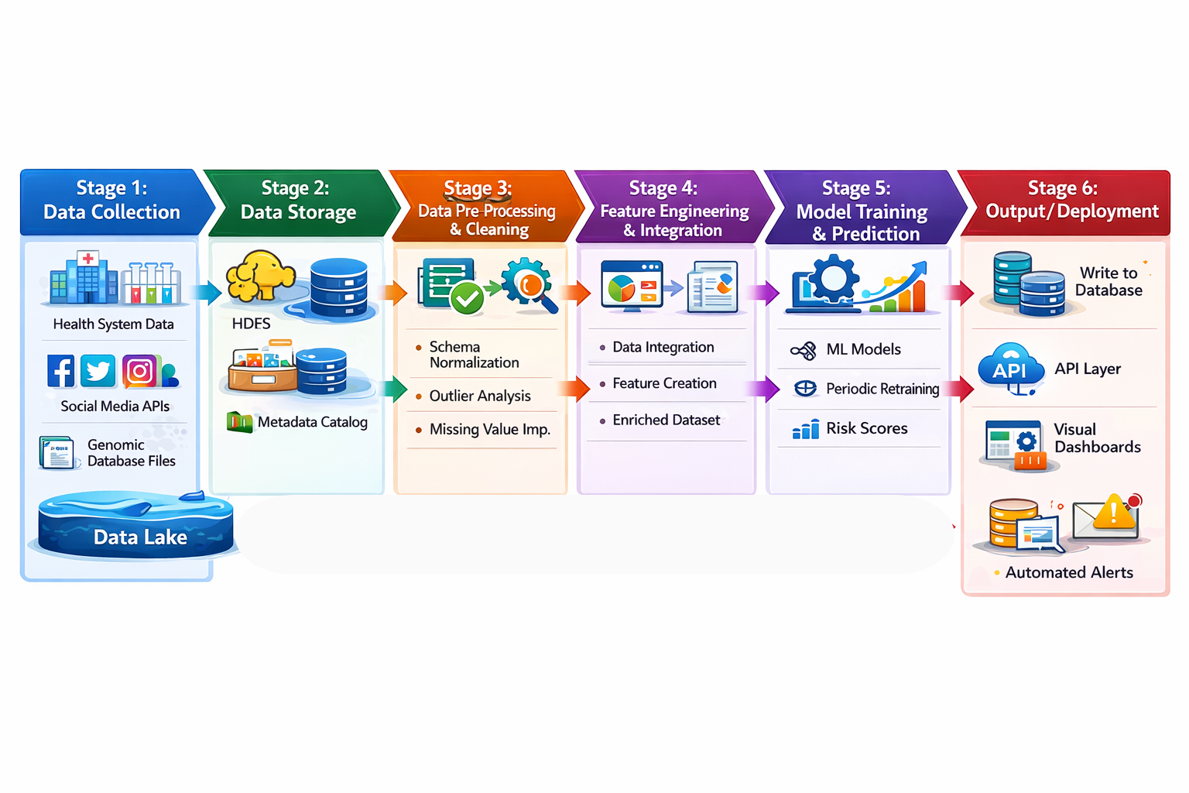
Stage 1 – Data collection – data from many different sources is streamed into a central warehouse (data lake) containing data feeds from health system, laboratory report uploads, day-and-night data feeds from social media application programming interfaces (APIs) and the download of bulk genomic database files. These data streams can have diverse file structure types, including Comma Separated Values (CSV), JavaScript Object Notation (JSON), FASTA, and Extensible Markup Language (XML) therefore, the ingestion layer must provide sufficient flexibility to process various file structures.
Stage 2 – Data storage – ingested data will be sent to files stored in the Hadoop File System (HDFS) or object storage system such as Amazon S3 or Google Cloud Storage. Structured database files containing tabular data such as case counts and demographic data will be stored in Hive tables whereas unstructured database files such as genomic sequences and social media posts will be stored as raw data until a later date for data processing. There is a metadata catalog to provide information about where the data was obtained from and how long the data has been stored in addition to information about the quality level of the data.
Stage 3 – Data pre-processing and cleaning – This is the most time-consuming processes to carry out in this data pipeline. Many spark jobs are completed for process normalizing different types of schema that can be from different countries and may contain date formatting issues, case definition discrepancies by jurisdiction conducting outlier analysis for identification of stated errors(sudden/retroactive increases in case counts) and imputing missing values. In addition, genomic sequences would require alignment as well as filtration through quality control processes prior to data analyses.
Stage 4 - Feature Engineering & Integration: After cleaning datasets that are in different locations and formats, we join them together to create analysis-ready feature matrices. In addition, we merge time series of case counts with mobility indices, demographic variables, and vaccination rates at the regional level. This integration step is what gives our analytical efforts their greatest power,we discover insights that none of our data sources could provide by themselves.
Stage 5 - Model Training & Prediction: We use historical data windows to train ML models, and as we receive new data daily, we periodically retrain those models. Ensemble methods that use multiple types of modeling to generate outputs are employed to improve reliability and account for uncertainty. Model outputs include forecasted case counts with confidence intervals, hospitalization projections, and regional risk scores.
Stage 6 - Output & Deployment: We write forecast results to a relational database with the intent that they be available through APIs to the downstream visualization layers. Visual dashboards are built from these APIs and provide each of the following downstream audience members with the most up-to-date information: the public health official, the clinician, the general public. When forecast values exceed pre-determined thresholds (for example, when ICU occupancy is expected to exceed 80% within 14 days) automated alerts will trigger for downstream audience members.
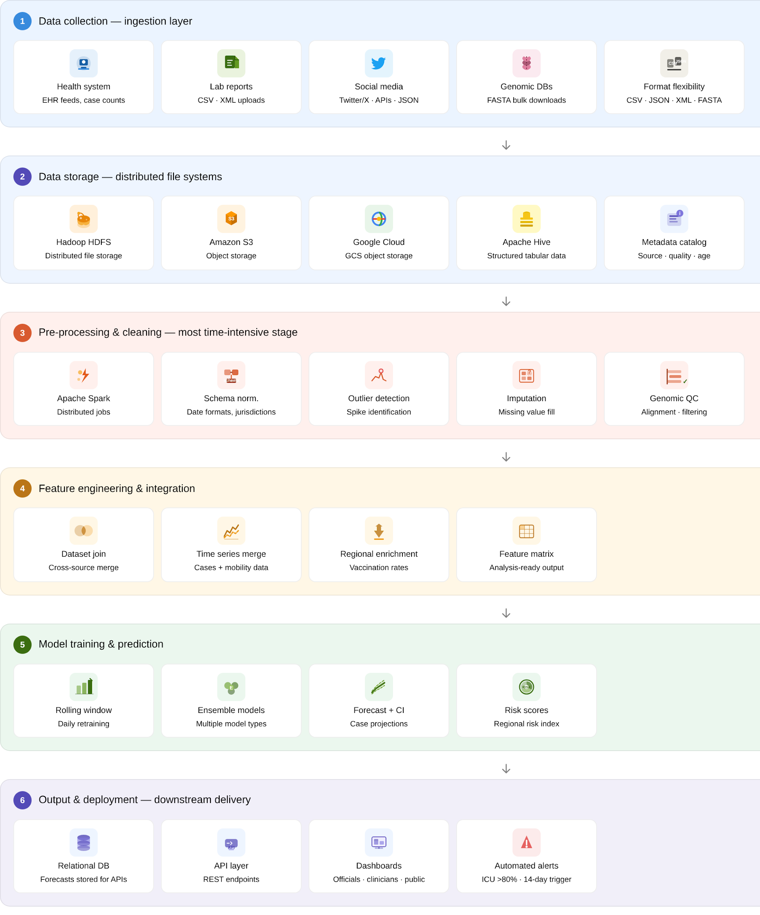

6. Results and Impact
6.1 Early Warning & Hotspot Detection
Based on the early warning successes, we were able to verify that Big Data-based monitoring can identify outbreak hotspots 5 to 14 days in advance of occurrences being confirmed by traditional monitoring processes. Comparative analyses published in both the Lancet Digital Health and Nature Communications validate this capability. An example of the above would include BlueDot, which monitored data from both airline ticket purchases and global health tracking systems and issued alerts re garding a novel respiratory disease in Wuhan on December 31, 2019 — nine days before there was an official public health notice from the World Health Organization. The difference of nine days in this example wasn't minor,these nine days can serve as the comparative time frame for response to an outbreak and assist in determining if the outbreak is containable.
6.2 Tracking Variants
During the time of the COVID-19 pandemic, GISAID (the primary global repository of SARS-CoV-2 genomes) received over 15 million submissions of sequencing data from across the globe. Traditional sequencing and analysis methods would have been impossible for processing this massive influx of genomic data, including variant identification (Alpha, Delta, and Omicron) due to their rapid appearance in the population before being identified using traditional methods in weeks instead of years. This rapid acquisition of variant intelligence was utilized to guide a virus vaccine use decision process and provided intelligence necessary for supporting border policies.
6.3 Healthcare Resource Optimization
Hospitals in the US, UK, and Germany deployed ML-based surge prediction models to prepare for capacity peaks before they arrived. In documented cases, these models provided 10 to 14 days of advance noti ce before ICU saturation — enough time to source additional ventilators, bring in temporary staff, and redirect patients to less burdened facilities. With reactive management, none of that is possible. This proactive capacity planning is credited with reducing preventable deaths in multiple major healthcare systems.
6.4 Policy Evaluation
Researchers have utilized mobility data from Google and Apple to analyze people's changes in behavior following the implementation of lockdowns and the closing of schools, rather than merely relying on estimates of compliance. The authors of articles in the Science and PNAS journals have employed these mobility indicators to quantify the extent to whi ch specific interventions reduced transmit ssion, giving authorities valid evidence upon which to modify their restrictions in an ongoing manner. Evidence-based decision-making regarding the frequency with which these restrictions will be adjusted up to this point has never been done so expeditiously.
6.5 Vaccine Development Oversight
Vaccine deployment status across multiple countries has been monitored through an integrated dashboard linking vaccine registry data to hospital admissions data. The integrated services allow governments to ass ess the actual effectiveness of the vaccines at a population level on a weekly basis. In contrast, traditional assessments would take months. The speed with which governments can determine which vaccines resist new viral strains will provide governments with a way to implement public health solutions at a higher rate than at any time in history.
7. Conclusion
The COVID-19 pandemic has put big data in health care through a real-world test. The pandemic forced the big data capabilities that existed prim arily as theories, or in limited, controlled research settings (e.g., real-time epidemiologic surveillance, global cross-source integration of data, ML-based outbreak forecasting) into actual operational capability. For the most part, these capabilities proved successful and in many cases even surpassed the traditional systems that were operating along-side them.

From this experience we are able to derive several critical lessons learned. First, infrastructure must be constructed prior to emergency situations, the amount of time it takes to establish the data syste ms, train the models and configure the pipelines makes reactive deployments too slow when every day counts. Second, creating data standards is equally important, the differences in how countries have defined and reported COVID-19 cases created a massive amount of preprocessing work that consumed both time and resources that could have been devoted to the actual analysis of the data. Finally, privacy and governance frameworks need to have the same innovation pace as the underlying technology the use of mobile device location data and contact tracing.. applications raises legitimate questions regarding civil liberties, which must be addressed promptly to avoid eroding public trust and affecting access to the data by which these systems rely.

The infrastructure, tools, and shared repositories developed from 2020 to 2023, and the cross-institutional relationships formed, create a real platform on which future generations will prepare for pandemics. The answer to the question about how big data will help manage epidemics has already been answered. The har-der question is if the systems created during the COVID-19 response will receive sustained funding and governance to remain in place so they can be used again when needed.
References
[1] World Health Organization (WHO). COVID-19 Dashboard. https://covid19.who.int

[2] Ritchie, H. et al. Our World in Data — COVID-19 Dataset. https://ourworldindata.org/covid-cases

[3] Johns Hopkins University CSSE. COVID-19 Data Repository. https://coronavirus.jhu.edu

[4] GISAID Initiative. EpiCoV SARS-CoV-2 Genomic Sequences. https://www.gisaid.org

[5] Google LLC. COVID-19 Community Mobility Reports. https://www.google.com/covid19/mobility/

[6] Delphi Research Group, Carnegie Mellon University. COVIDcast Epidata API. https://delphi.cmu.edu/covidcast/

[7] European Centre for Disease Prevention and Control (ECDC). COVID-19 Data. https://www.ecdc.europa.eu/en/covid-19/data

[8] Brownstein, J.S. et al. BlueDot — AI-driven global disease surveillance. 2020. https://bluedot.global

[9] Flaxman, S. et al. (2020). Estimating the effects of non-pharmaceutical interventions on COVID-19 in Europe. Nature, 584(7820), 257–261.

[10] Worldometer. COVID-19 Coronavirus Pandemic. https://www.worldometers.info/coronavirus/
Github link:
https://github.com/blackalpha8109/covid-data-analysis-dashboard.git

