RubishGram
Documentation

Kyriakou Aikaterini 2034, Foufikos Evangelos 1975

November 2019

- General Description

RubishGram is a web application which aims to fight climate breakdown by calculating each user's emissions of carbon dioxide. The application sets a specific monthly budget of carbon dioxide that can be spent by every user and keeps track of various kinds of emissions, such as transport or food. Therefore, the user is led to control and reduce the waste in order to save the environment.

- User Guide
- Connect to RubishGram
1.1 Login Page
1.2 Sign Up Page
- Main Menu
2.1 Add Emission
2.2 Check Emissions
2.3 Check Current Budget
2.4 Settings
2.5 Log out

- Application Description
1. Connect to RubishGram
In order to connect to the application the user has to choose between the “Sign In” and “Sign Up” options.
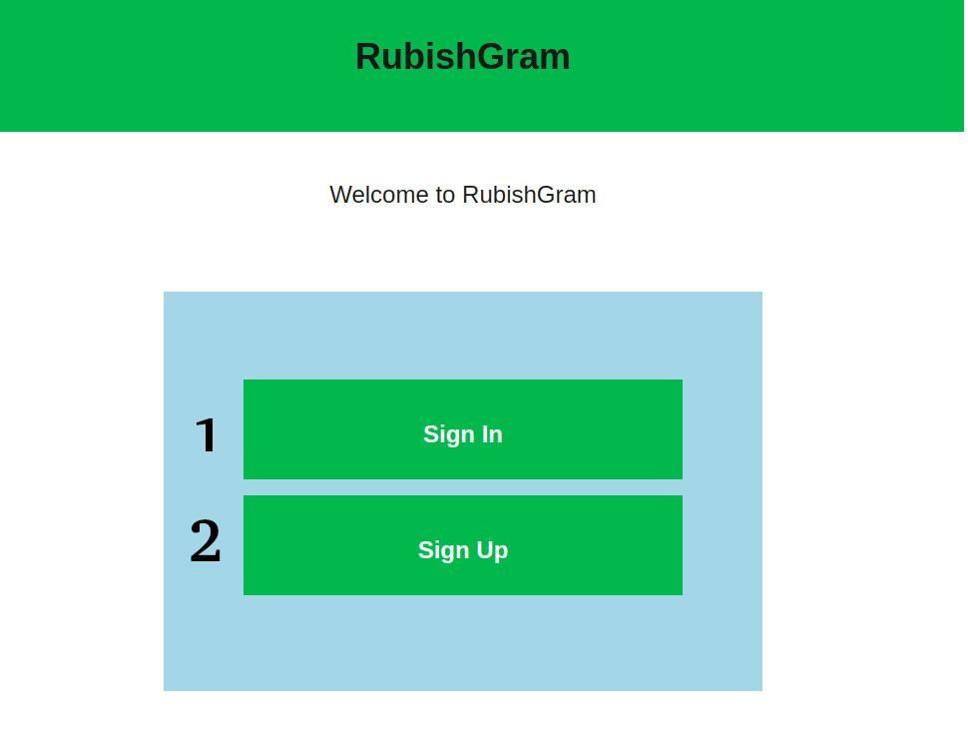

Notes: (1) Click on Sign In leads to Login Page (1.1)
(2) Click on Sign Up leads to Sign Up Page (1.2)
Link: http://83.212.111.226:8080/RubishGram/index.html

1. 1 Login Page
In case the user has already created an account for RubishGram it is necessary to fill the username and password in order to connect to the application.

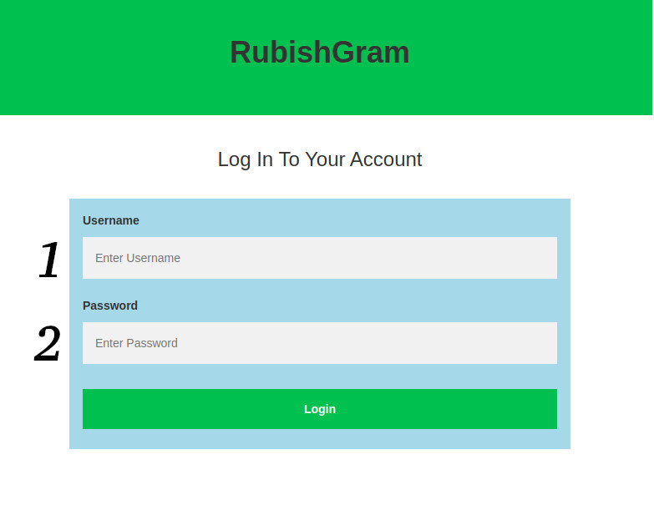

Notes: (1) Enter username you created for RubishGram
(2) Enter correct password that matches your username.
Link: http://83.212.111.226:8080/RubishGram/login.html?

1.2 Sign Up Page
If user does not have an account for RubishGram it is necessary that he creates one by filling the following fields.
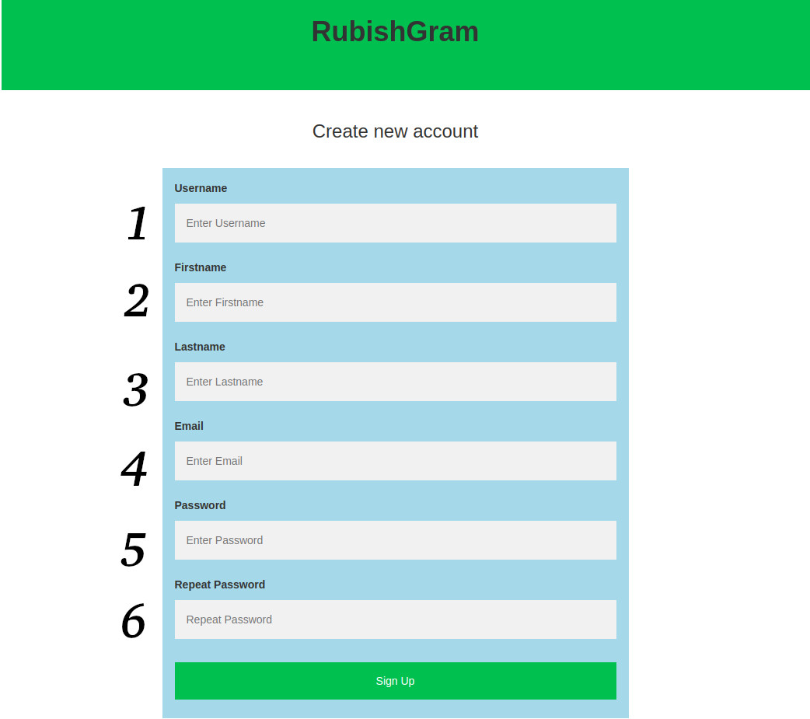

Notes: (1) Enter a new username
(2) Enter your firstname
(3) Enter your lastname
(4) Enter your email
(5) Create a password for you account
(6) Confirm password
Link: http://83.212.111.226:8080/RubishGram/register.html

2. Main Menu
In the home page of RubishGram the user can choose one from all the available actions following.
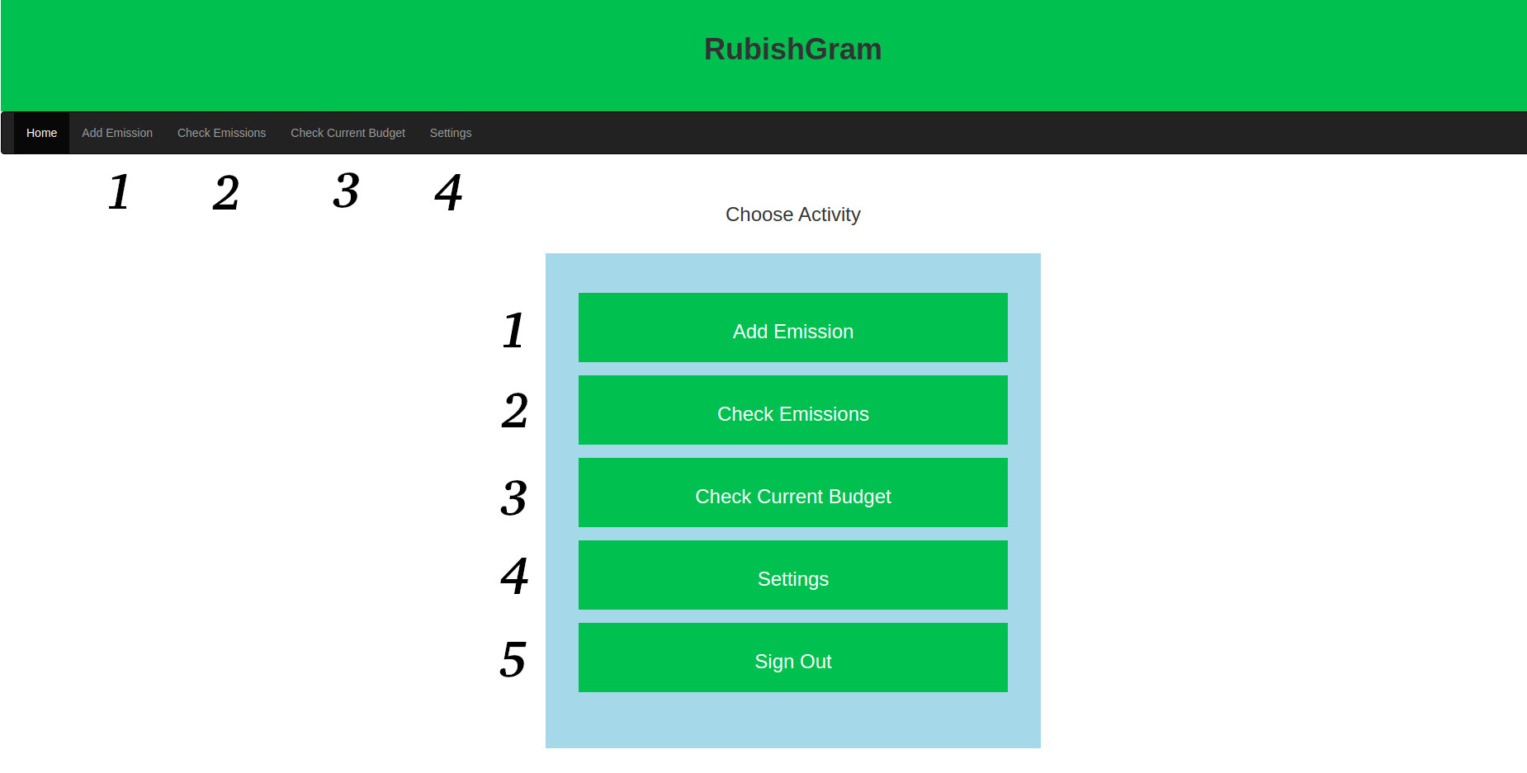
Notes: (1) Leads to “Create a new emission” Page (2.1)
(2) Leads to “Check all emissions” Page (2.2)
(3) Leads to “Check current budget” Page (2.3)
(4) Leads to “Settings” Page (2.4)
(5) Logs out of the current account and leads to “Connect to RubishGram” Page (1).
Link: http://83.212.111.226:8080/RubishGram/main.html

2.1 Add Emission
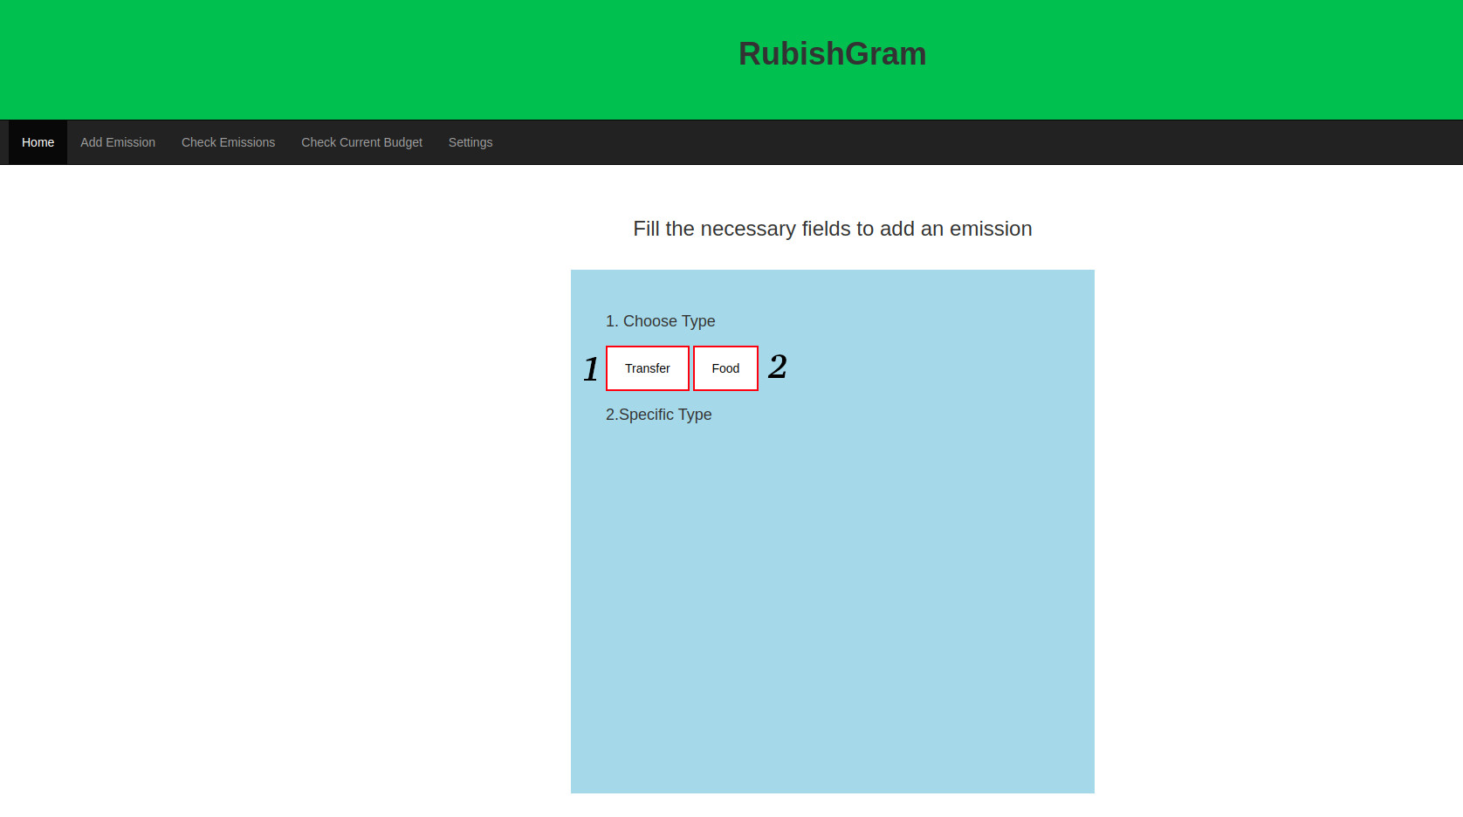
By choosing the specific option the user is able to add a new carbon emission to his/her account. In order to do this, the first step is to choose the Emission Type between “Transfer” and “Food”.
- Step 1 – Choose Emission Type
Notes: (1) Choose “Transfer” as emission type.
(2) Choose “Food” as emission type.

- Step 2 – Choose Specific Type
  - Transport Case

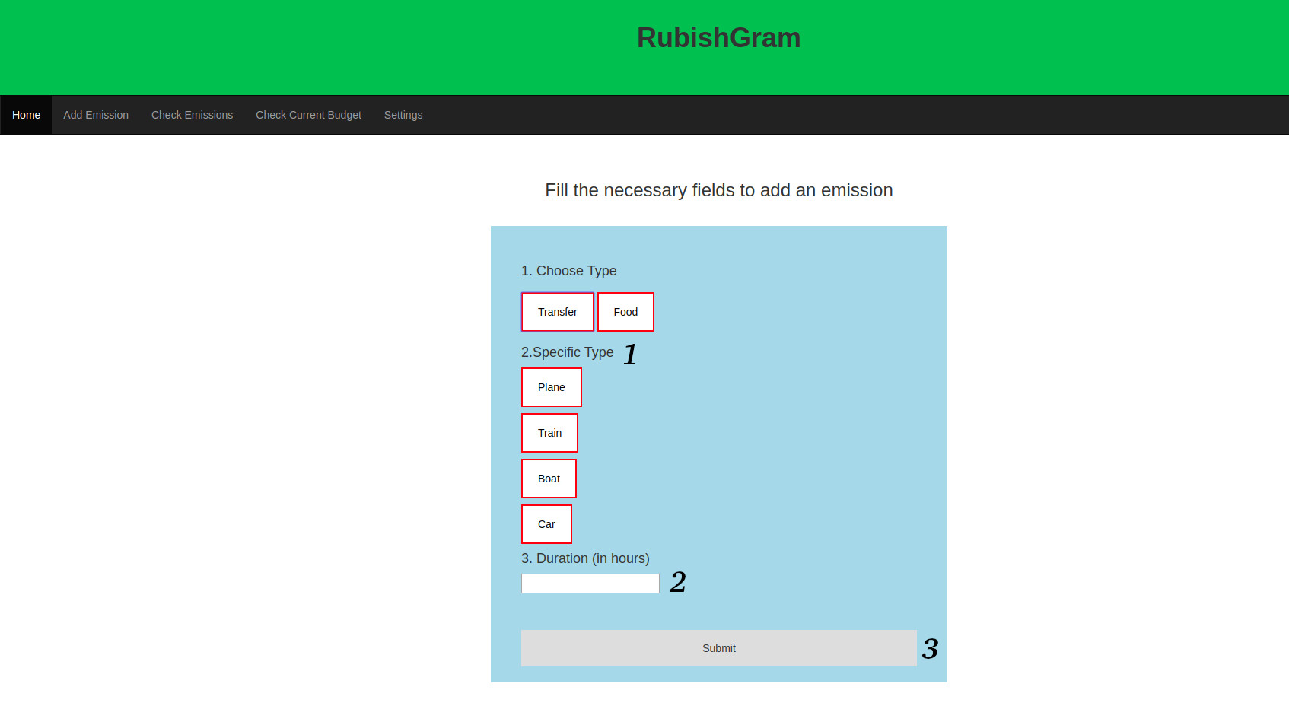
Notes: (1) Choose specific type of emission between “Plane”, “Train”, “Boat” and “Car”
(2) Fill the duration of the transport in hours.
(3) Click on “Submit” button to add your emission.

  - Food Case

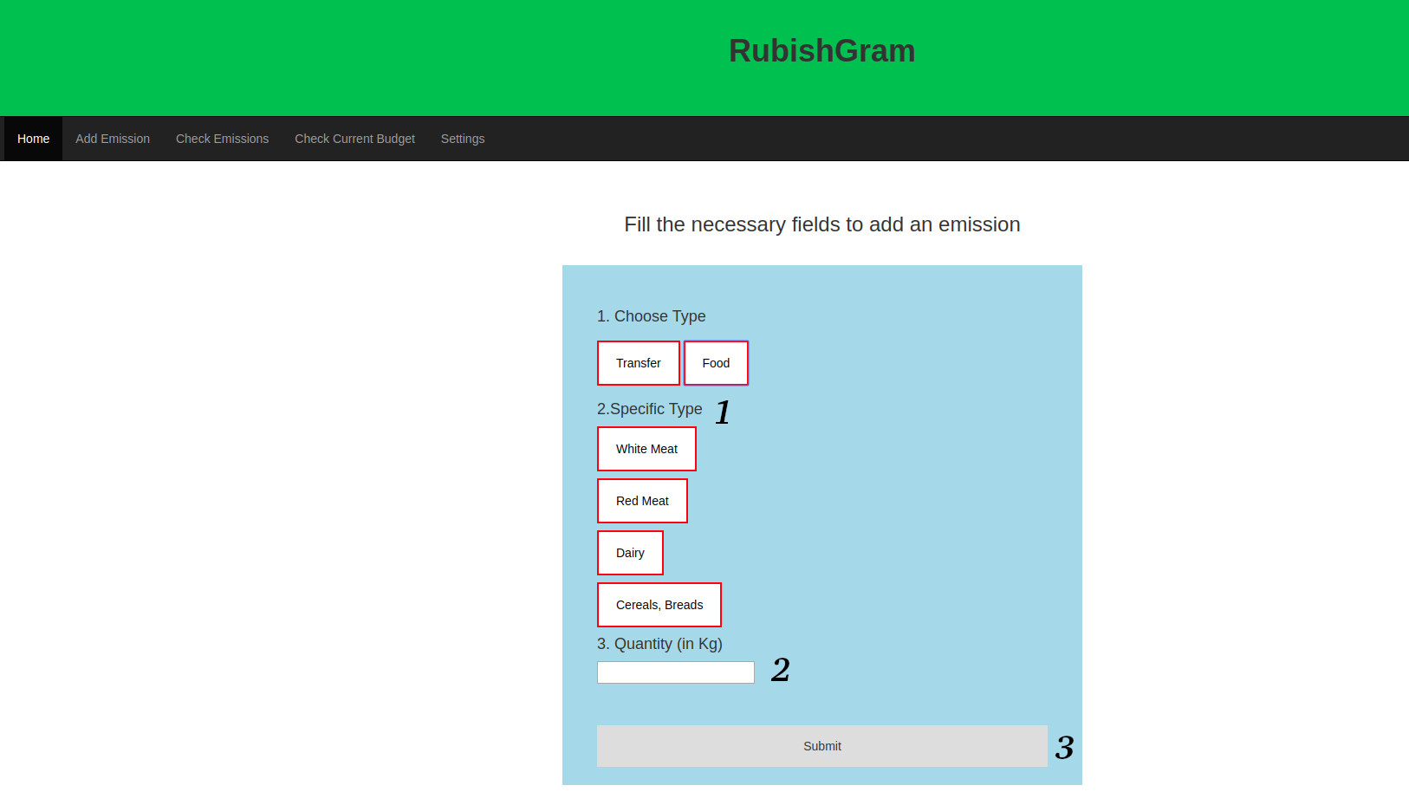

Notes: (1) Choose specific type of emission between “White meat”, “Red meat”, “Dairy” and “Cereals, Breads”.
(2) Fill the quantity of the food in Kilograms
(3) Click on “Submit” button to add your emission.

Link: http://83.212.111.226:8080/RubishGram/add_emission.html

2.2 Check all emissions
By choosing the action “Check all emissions” in the Main Menu (2) the user is able to check all of his emissions in carbon dioxide divided by categories and items.
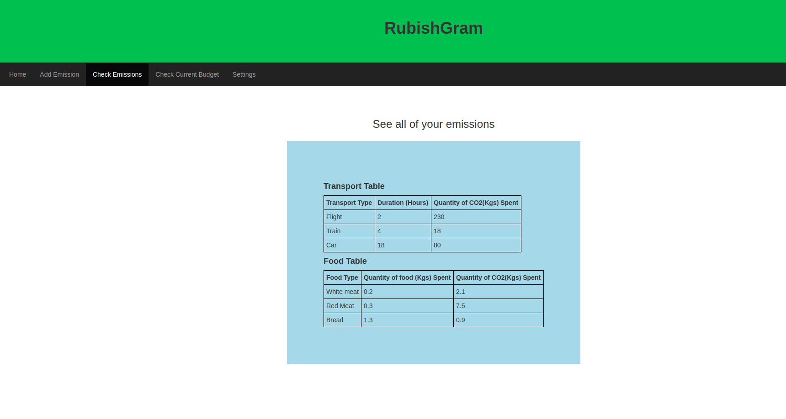
Link: http://83.212.111.226:8080/RubishGram/allEmissions.html

2.3 Check current budget
In this section the user is able to check the total budget, a diagram with the current month’s emissions divided by category and also the remaining carbon budget.
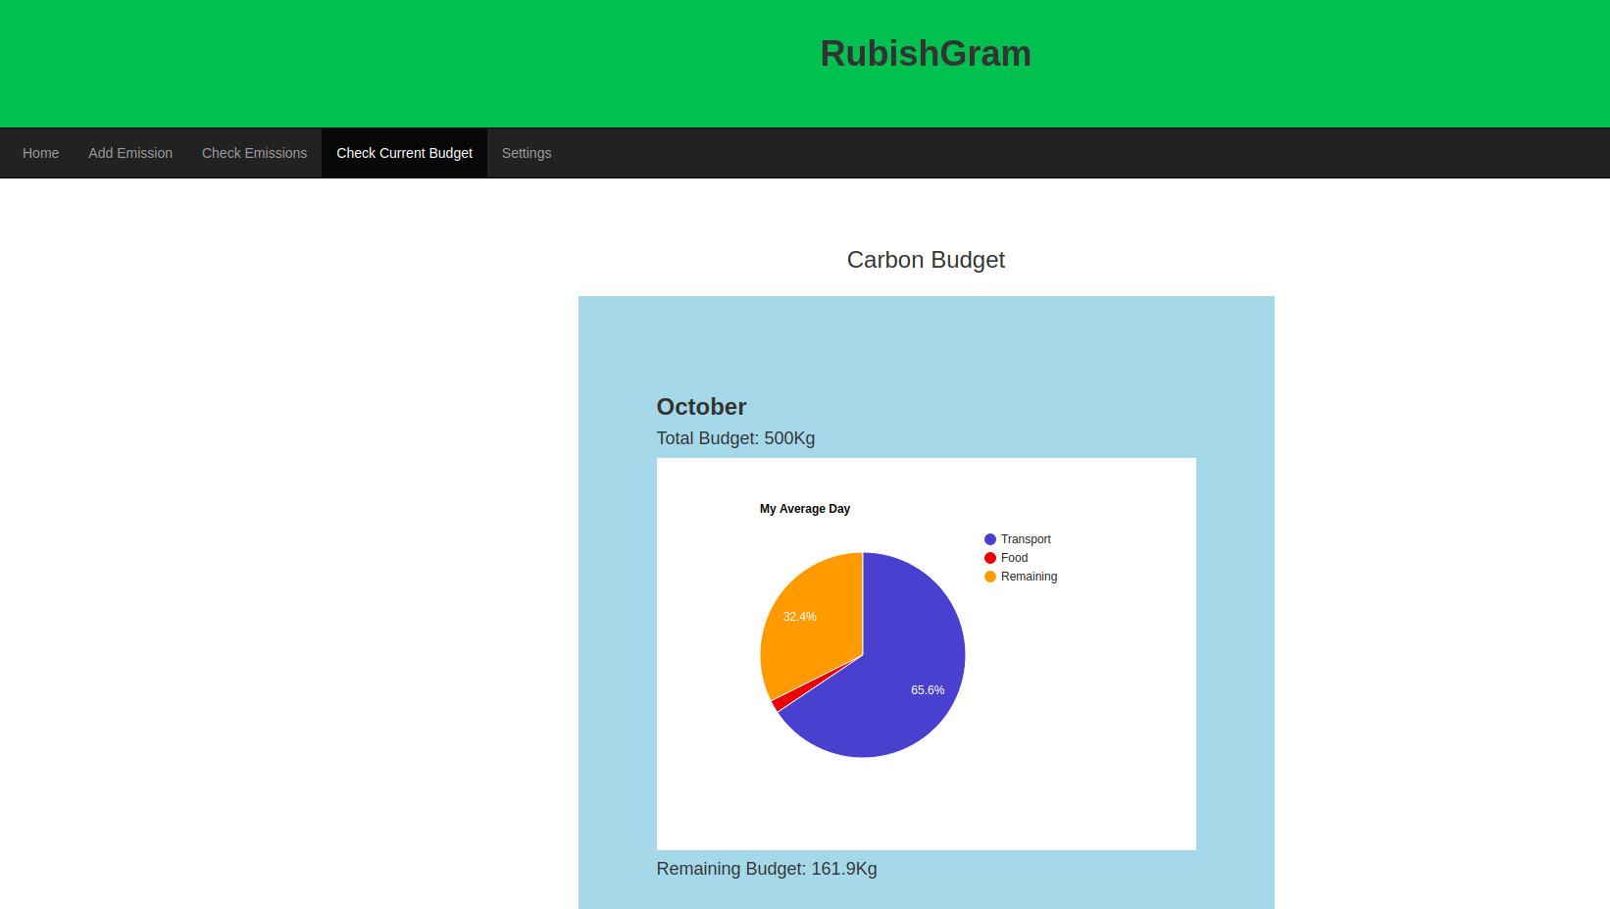
Link: http://83.212.111.226:8080/RubishGram/overview.html

2.4 Settings
In the Settings section the user can change one of the following fields.

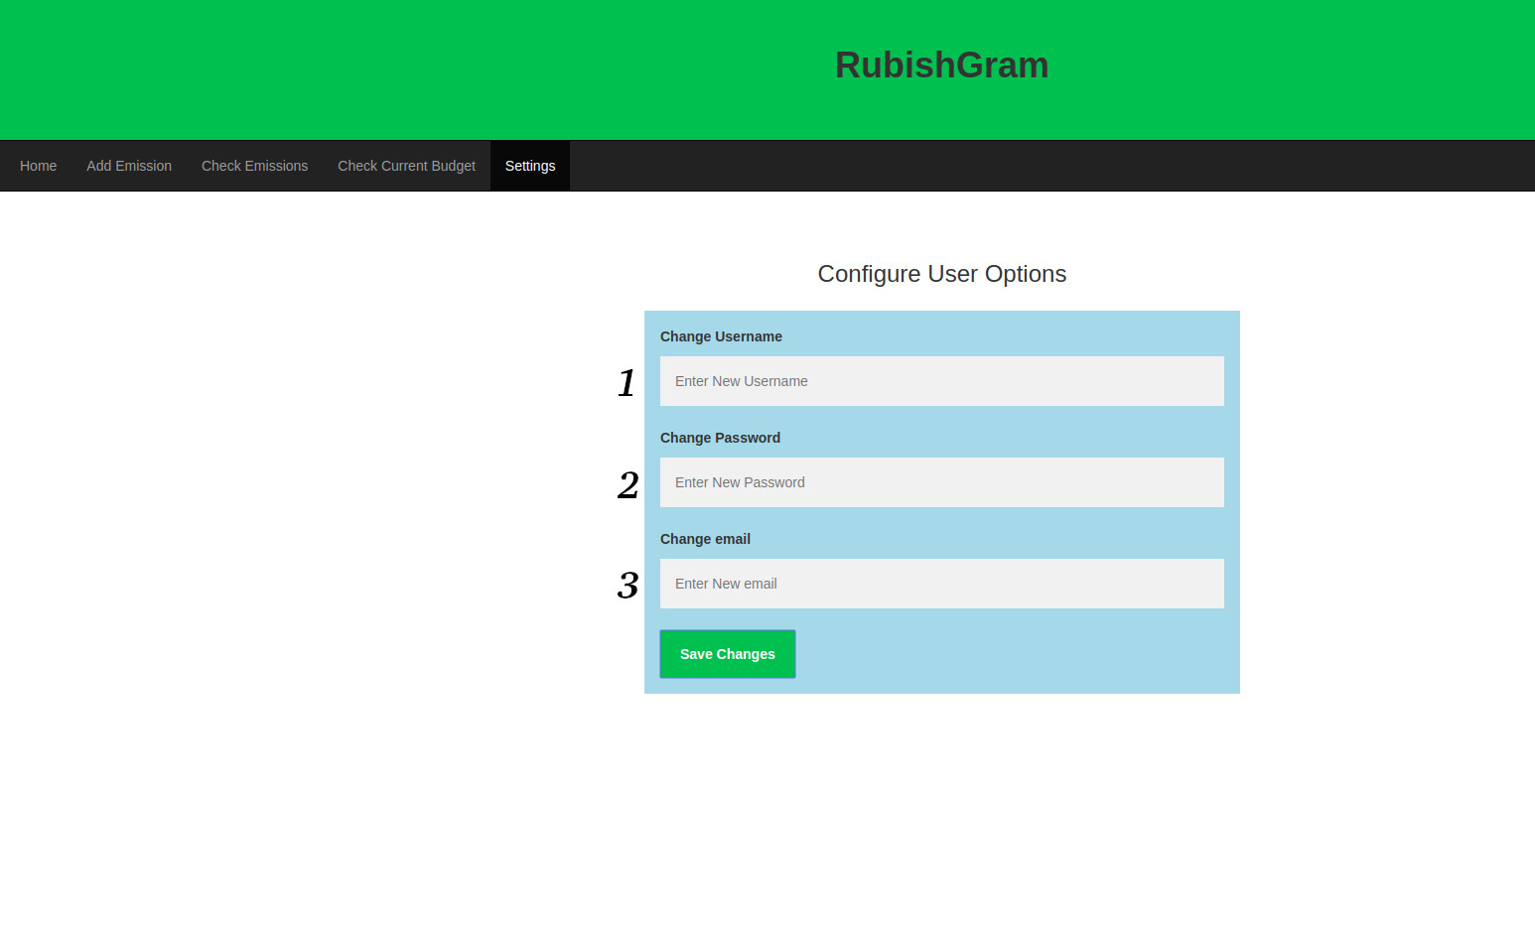
Notes: (1) Change current username.
(2) Change current password.
(3) Change current email.
Link: http://83.212.111.226:8080/RubishGram/settings.html

