Software Requirements Specification (SRS)
IPL Cricket Analytics Dashboard — Developed Using Microsoft Power BI

1. Introduction

1.1 Purpose
This document delineates the software requirements for the design and development of an interactive analytical dashboard dedicated to the Indian Premier League (IPL). Implemented through Microsoft Power BI, the proposed solution is intended to facilitate a comprehensive examination of team performance, individual player contributions, match-level outcomes, venue-specific patterns, and comparative analyses across successive tournament seasons.

1.2 Objectives
The principal objectives governing the scope of this project are enumerated as follows:
- To conduct a systematic analysis of historical IPL data spanning the seasons from 2008 through 2025.
- To establish a robust comparative framework for evaluating teams and individual players across multiple performance metrics.
- To derive and present analytical insights pertaining to both batting and bowling disciplines.
- To furnish end users with interactive filtering mechanisms and drill-down capabilities that support granular exploration of the underlying data.
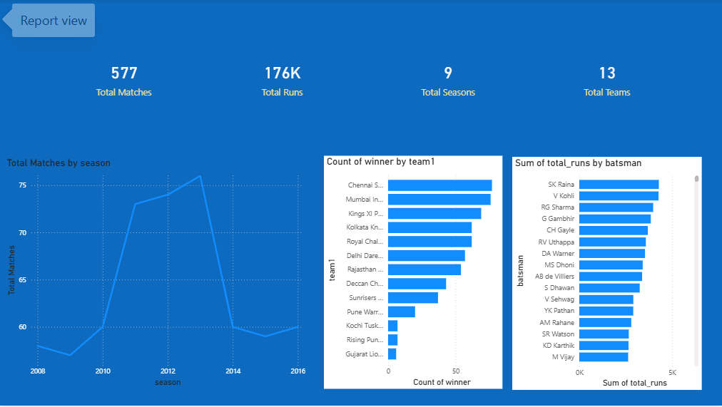
Figure 1: Overview Dashboard — Seasonal Trends, Team Wins, and Leading Run-Scorers.

2. System Requirements

2.1 Hardware Specifications
The minimum hardware configuration required for the satisfactory operation of the dashboard comprises a dual-core processor, a minimum of four gigabytes of random-access memory (RAM), and no less than two gigabytes of available secondary storage.

2.2 Software Specifications
The software environment necessitates the Microsoft Windows operating system (version 10 or 11) in conjunction with Microsoft Power BI Desktop, which is available without cost under its standard licensing terms.
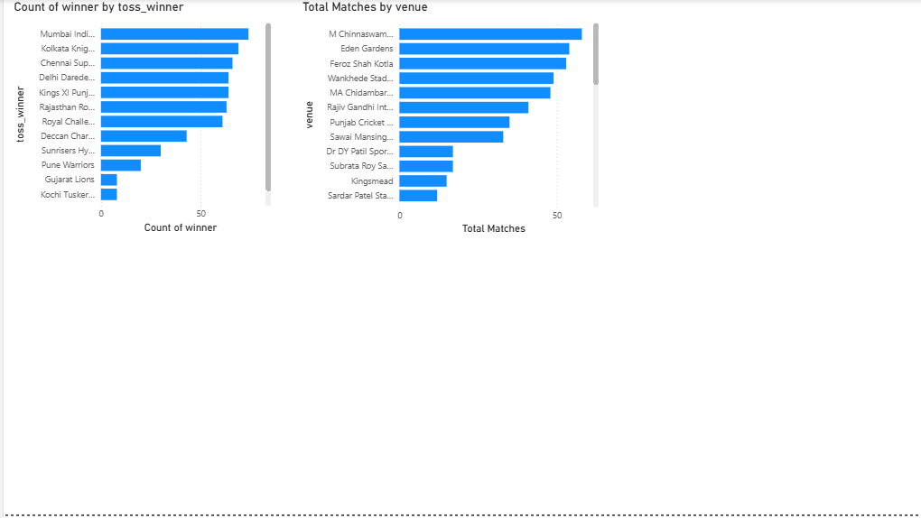
Figure 2: Toss-Outcome Correlation and Venue-wise Match Distribution.

3. Conclusion
The IPL Historical Analytics Dashboard effectively transforms voluminous and otherwise opaque cricketing data into coherent and actionable insights. The project serves as a demonstrative exposition of proficiency in Power BI data modelling, the application of Data Analysis Expressions (DAX) for computed measures, principles of aesthetically refined dashboard design, and the practice of interactive data storytelling. Collectively, these elements substantiate the dashboard’s value as both an analytical instrument and an academic artefact.

