Installing a BlackBerry ComponentPack SDK/RTE as a development and build environment in Eclipse
(Author Cristian Malinescu – Senior Developer, June 17, 2009)

Requirements:
- Java 6 SDK – installed, required by default in Eclipse Galileo
- Eclipse Galileo SDK – installed, please start with RC4
- Any BlackBerry ComponentPack – installed
- EJDE project structure/artifacts from the P4 depot path //depot/main/EclipsePlugin-1.1.1

Setup:
Default:
Do the steps mentioned in $EJDE_PROJECT/ee-files/howto.txt for getting a default environment loaded each time you start EJDE plugin in debug mode.

UI:

I. Install a new BB CPack – equivalent feature from EJDE 1.1.

1. Launch the EJDE plugin in debug mode
2. Open Window->Preferences page and navigate to Java->Installed JREs section

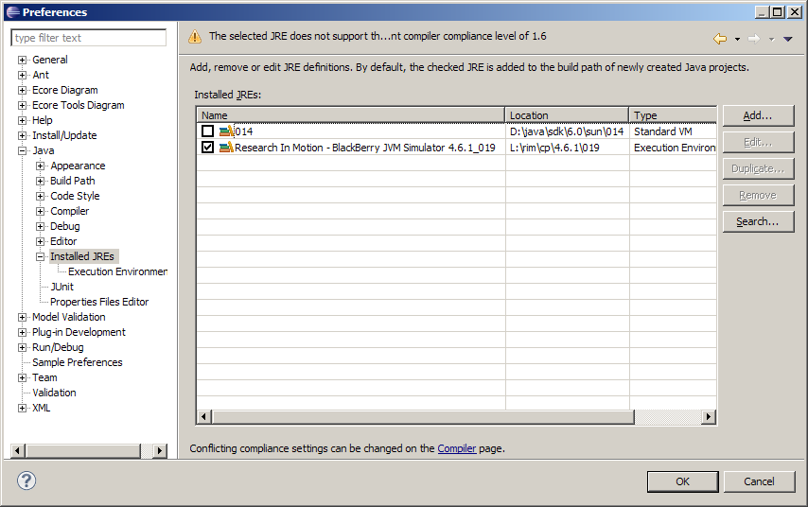

3. Clink on Add button and select the ‘Research In Motion – BlackBerry Java/OS Simulator’ option, click on Next. On the next page click on the File button.

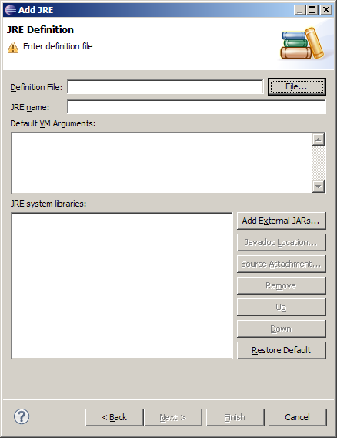

4. Navigate your file system and look for a file named BlackBerry.ee in the installation location of one of your CPacks of choice (precondition: the ee file should have been previously installed as per instruction at the beginning of this document).

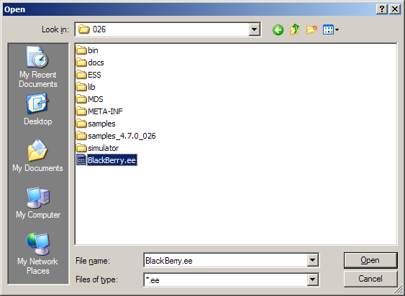

5. The new BlackBerry environment UI should look like this one, click the Finish button.

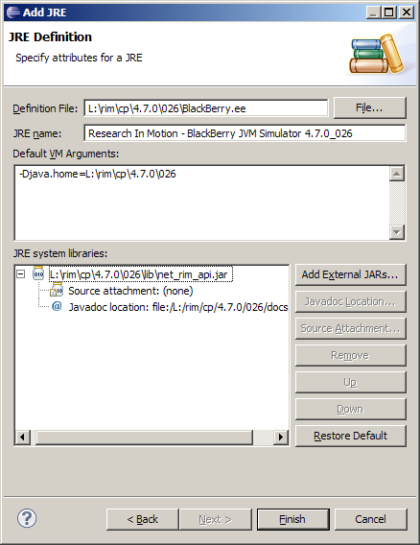

The next page should look like this one:
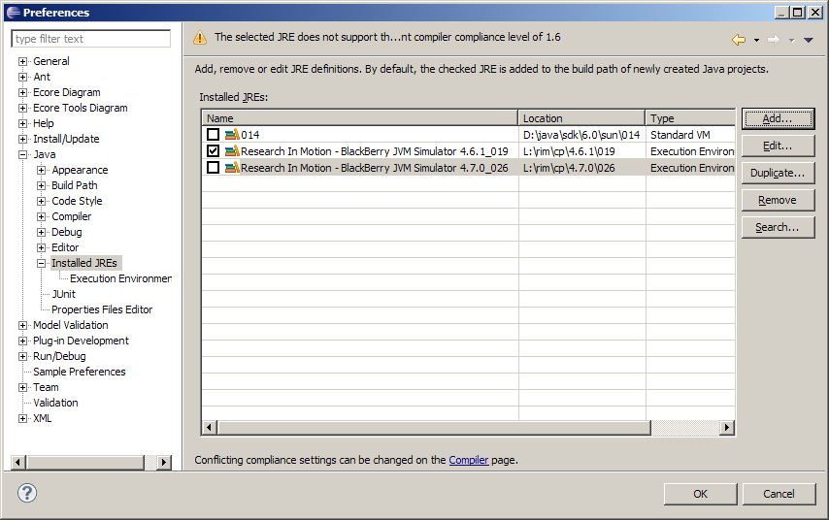

II. Change Project level BB CPack:

After creating a new BB Project with the wizard the workspace should look like this:

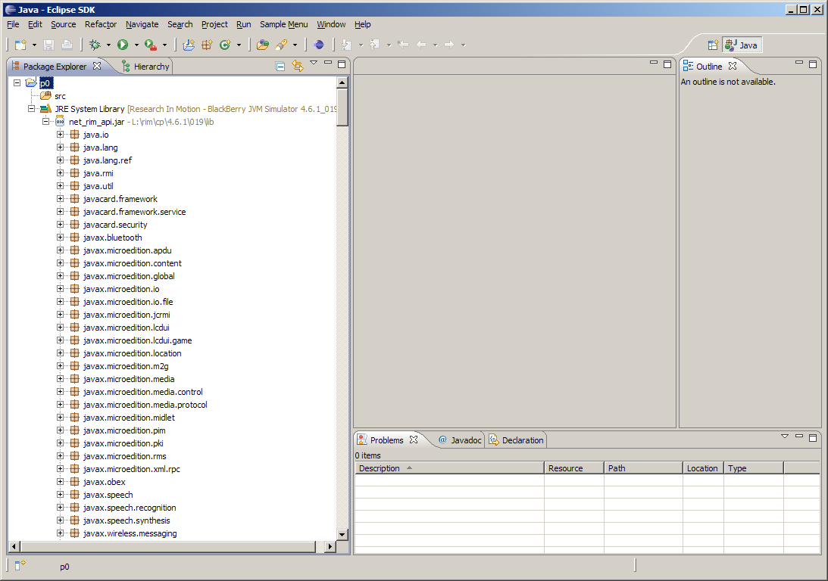

1. Right click Project Properties.
2. Navigating to Java Build Path->Libraries you should see this:

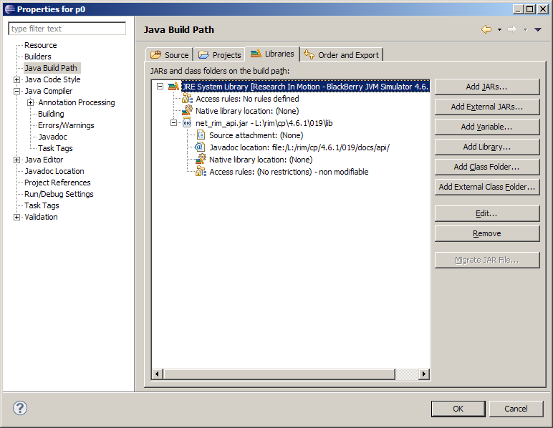

3. Click Edit button. You should see this page:

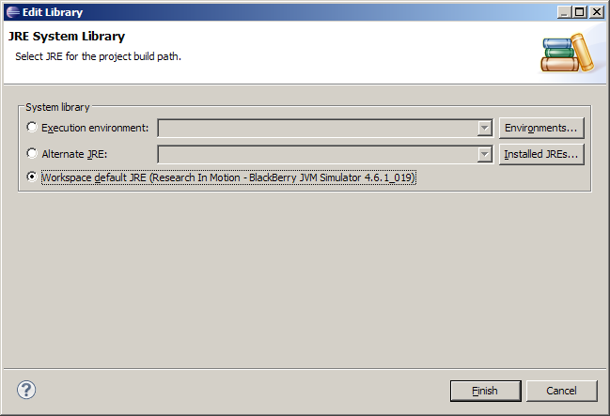

- Change the selection to the Alternate JRE: option:

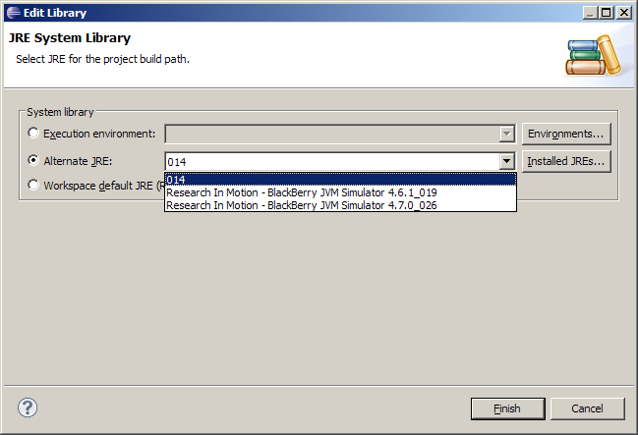

You can chose an existing BB CPack or you can go back to the screen to define a new one if clicking Installed JREs …

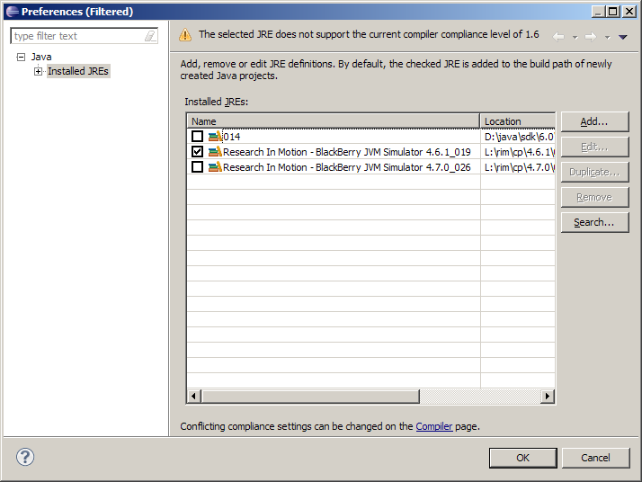

If choosing another option like for example:
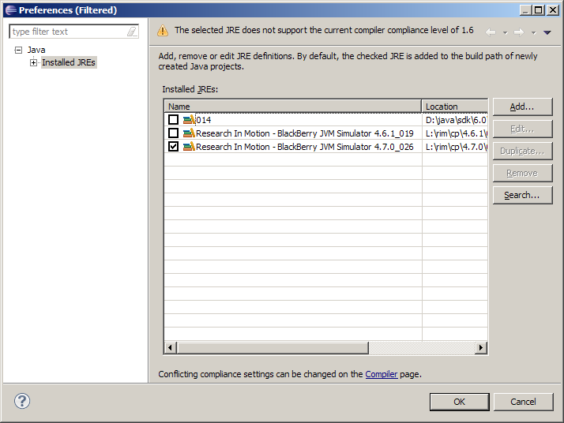

Eclipse is going to update the Project classpath requirements automatically:
