Saturnring User Guide
Beta document – work in progress.

Table of Contents
Saturnring User Guide 1
Synopsis 2
Portal Operations: Admin 2
Portal Operations: User 11
Saturnring API 13

Synopsis

This document illustrates the usage of the Saturnring portal as an administrator and as a user.

Portal Operations: Admin

Navigating to the portal address (usually http://saturnringipaddress_or_dnsname/admin) will display the following page.

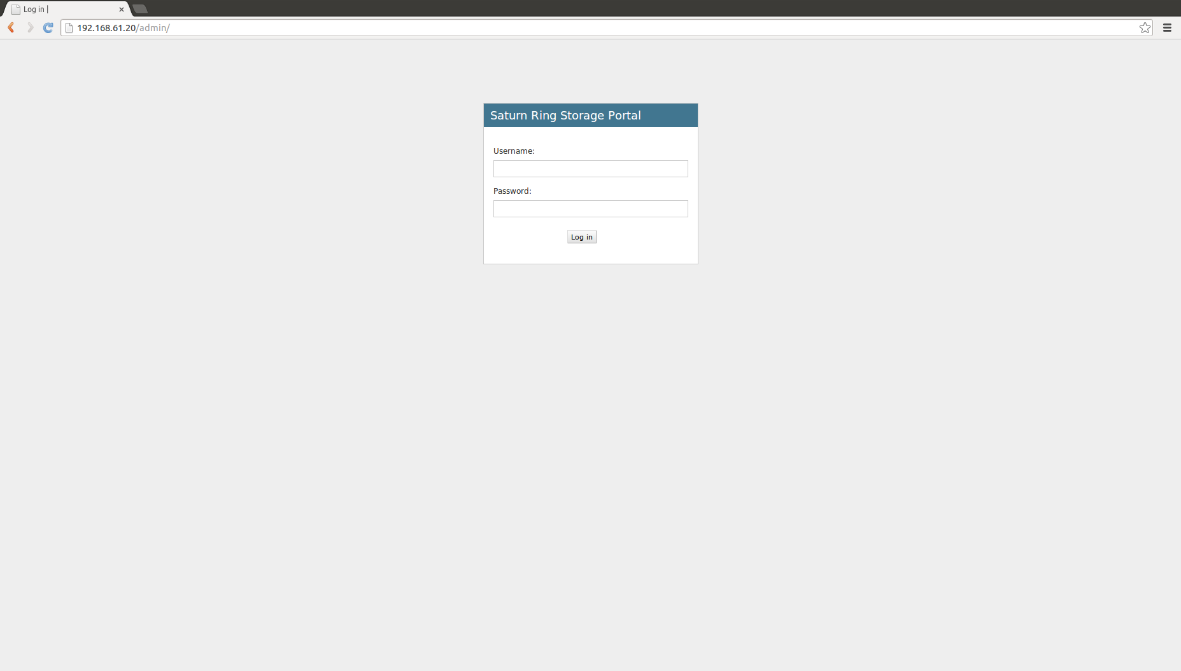
Fig 1: Login Screen

After supplying admin/superuser credentails the screen shown in Fig. 2 should show.
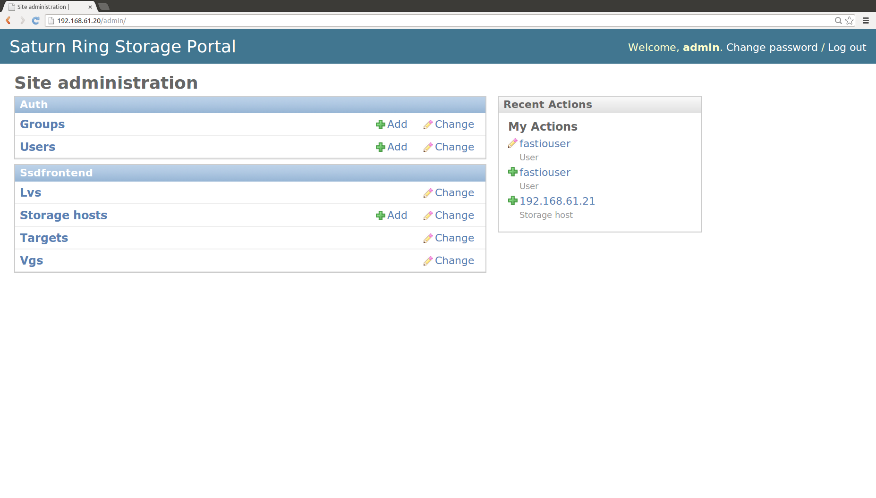
Fig. 2 is the Django admin interface.

There are 2 sub-categories of links. The Auth category is for user management (Groups,users) and the SSDfrontend (Lvs-logical volume information, Storage hosts, Targets and Vgs – volume groups) is the category to manage storage. There is also a recent actions pane.
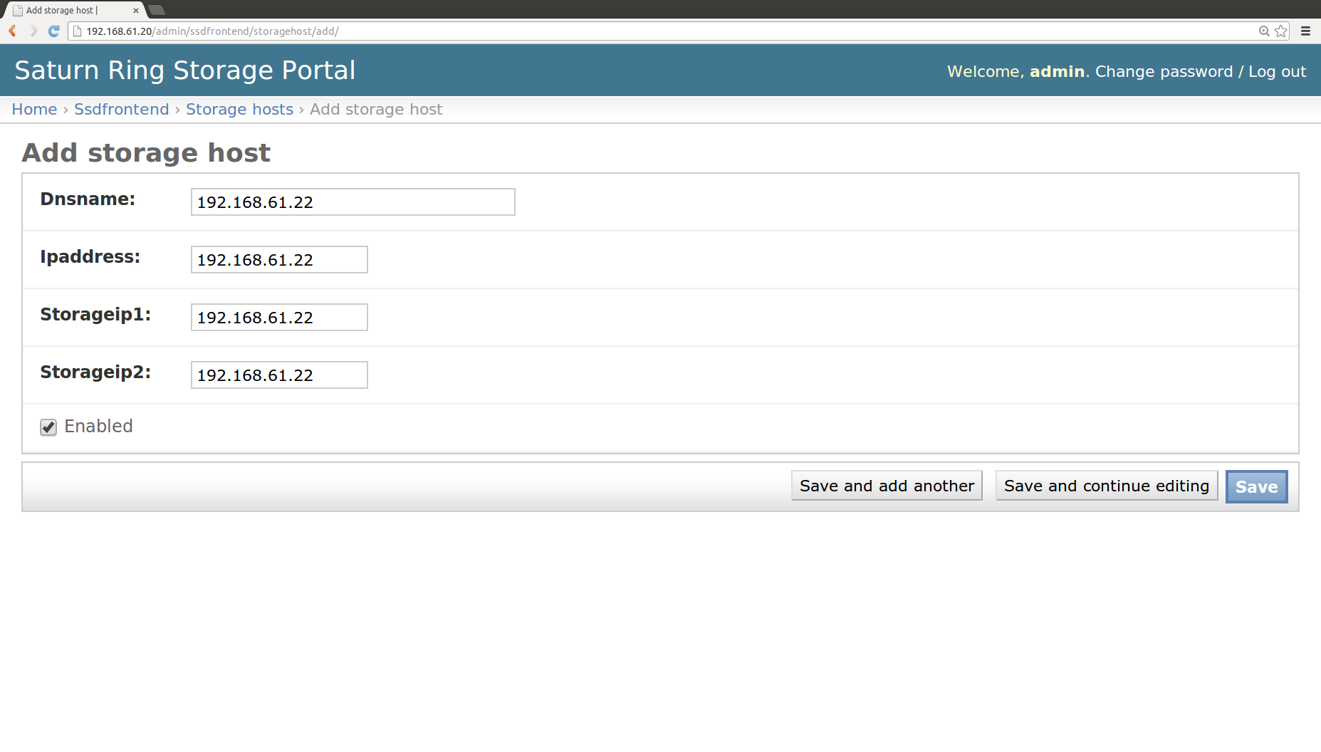
Fig.3: Adding a new iSCSI saturnring server

Home > Ssdfrontend > Storage hosts > Add storage host

1. Log into the saturnring server and copy SSH keys for Saturning to access the iSCSI server
For example:
vagrant ssh saturnring
cd ~/saturnring/ssddj/config
ssh-copy-id -i saturnkey vagrant@192.168.61.21

2. Log into the saturnring portal as admin superuser and add the new iscsi server.
For this simple example, Dnsname=Ipaddress=Storageip1=Storageip2=192.168.61.22. Failure to save indicates a problem in the configuration steps (11-13). Saturnring will not allow a Storagehost being saved before all the config is right. This is probably a good thing.

The storage Ips can be used to specify iSCSI portals over different VLANs, perhaps in order to do iSCSI multipath setups etc.

3. Make a "initial scan" request to the Saturnring server so that it ingests the storage made available by iscsiserver1 at IP address 192.168.61.21 (Networking is defined in the Vagrantfile):
curl -s -X http://192.168.61.20/api/vgscan -d "saturnserver=192.168.61.21"
Confirm in Home >Ssdfrontend>Vgs that the new volume group is now available to Saturnring
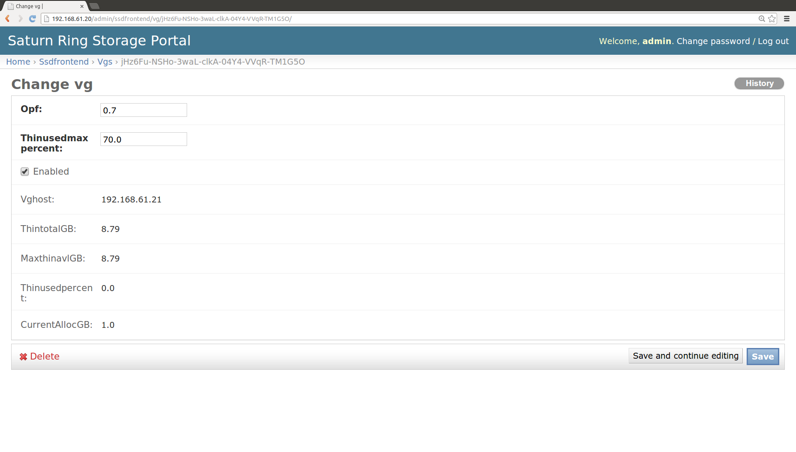
Fig 4: Changing Volume group properties

There are 2 very important properties here

1. Opf: This is the over provisioning factor. While using thin provisioning this floating number (0.0-) indicates how much overprovisioning will be allowed before Saturnring stops provisioning more targets on the VG. For example, if there is a 100GB volume group and opf is set to 5.0 then Saturn will allow allocation to targets totalling 5.0x100GB = 500GB. Off course the underlying assumption is that the actual storage used is less than 100GB.

2. Thinusedmaxpercent: This property is the percentage of actual storage blocks used. As soon as more than this percent of blocks are used, Saturnring will stop provisioning more targets on the VG. In the above example, with thinusedmaxpercent set to 70%, Saturnring will not provision more targets on the VG if more than 70GB is actually used (summed over all targets previously provisioned on the VG).

Thin provisioning can get you into trouble (what if the overprovisioned targets need more than the available actual storage?) . For the safe non-over provisioned storage, set Opf to 1.0, and thinusedmaxpercent to ~95%.
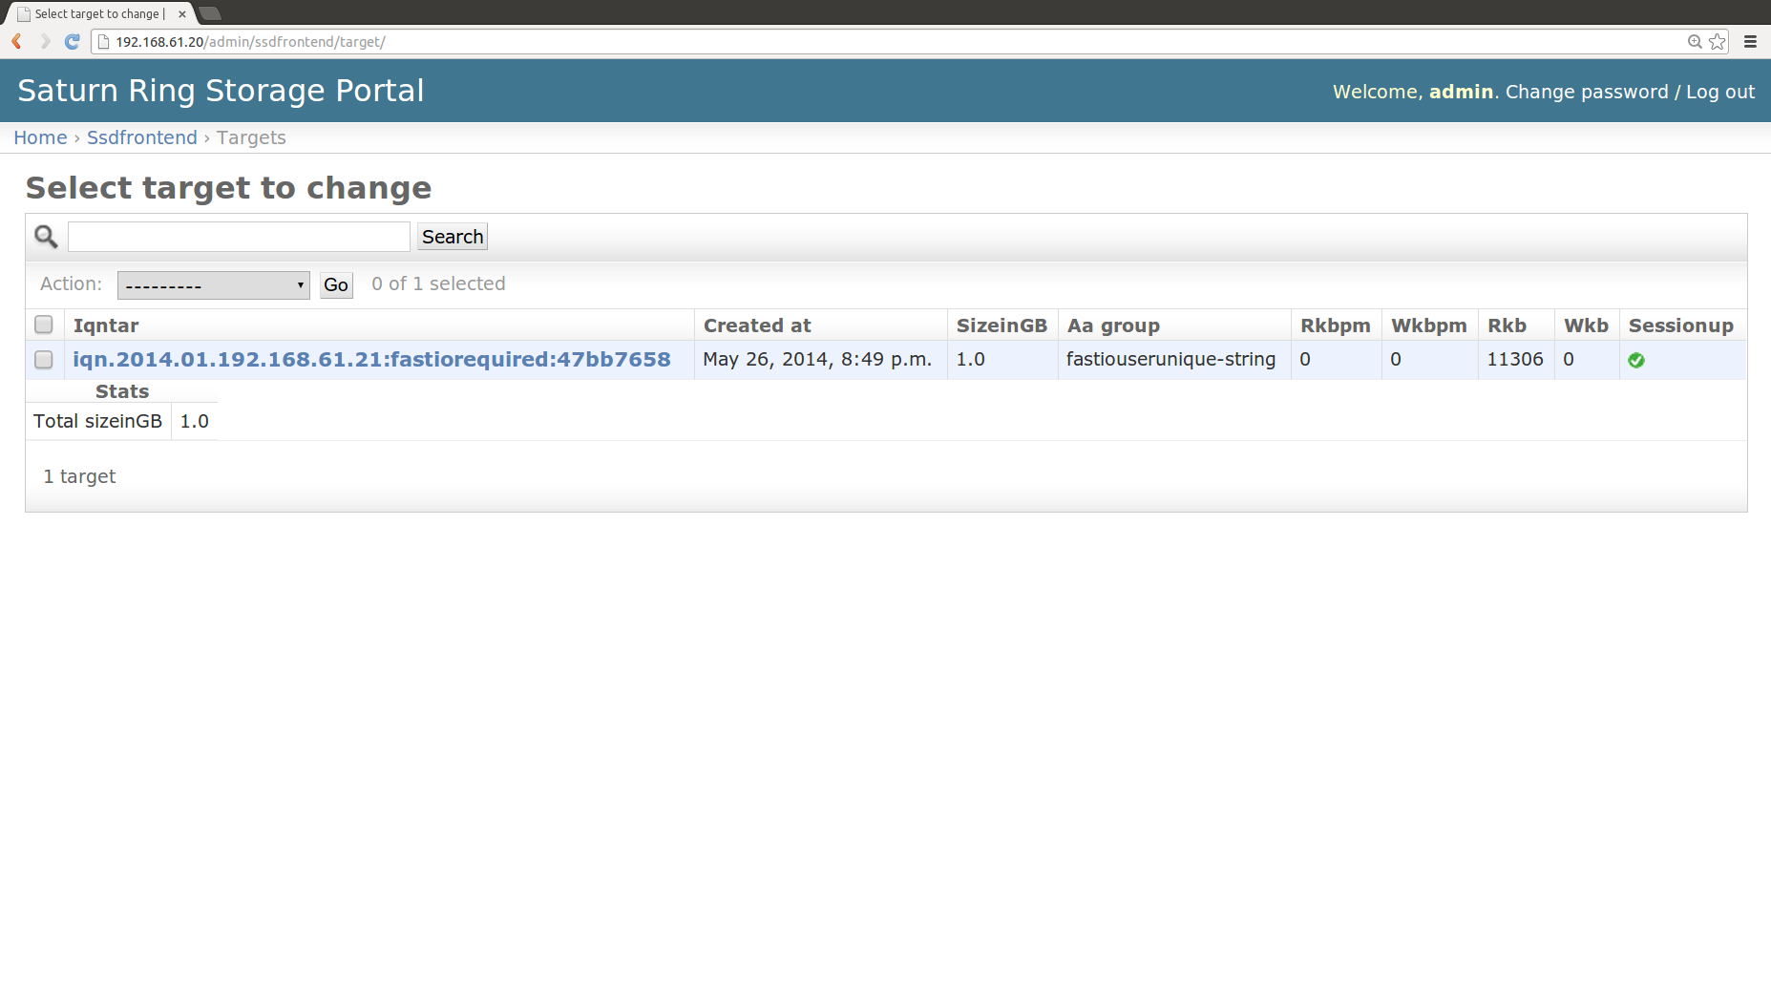
Fig. 5: Targets (admin view)

By navigating to Home>Ssdfrontend>Targets the admin can get a bird's eye view of all targets across all iSCSI servers provisioned in the iSCSI system. The admin can also delete targets from this view (provided the Sessionup property is false, i.e., there is no active iSCSI session on that target).

Clicking on any of the target IQNs will show the properties of that target.
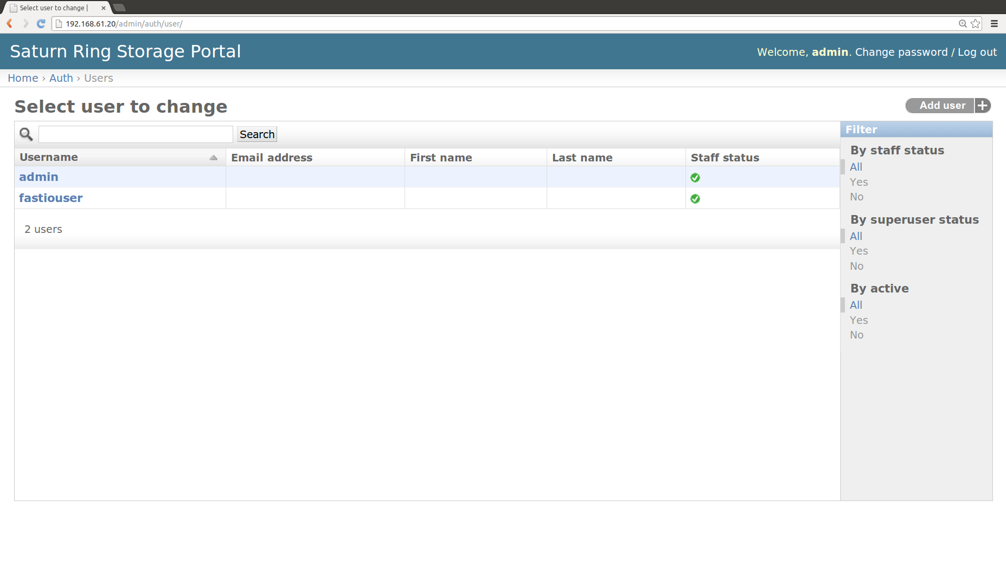
Fig. 6: Users (admin view)

The admin can perform user management by navigating to Home>Auth>Users. Users may be added/deleted, passwords can be reset, quotas can be changed etc.

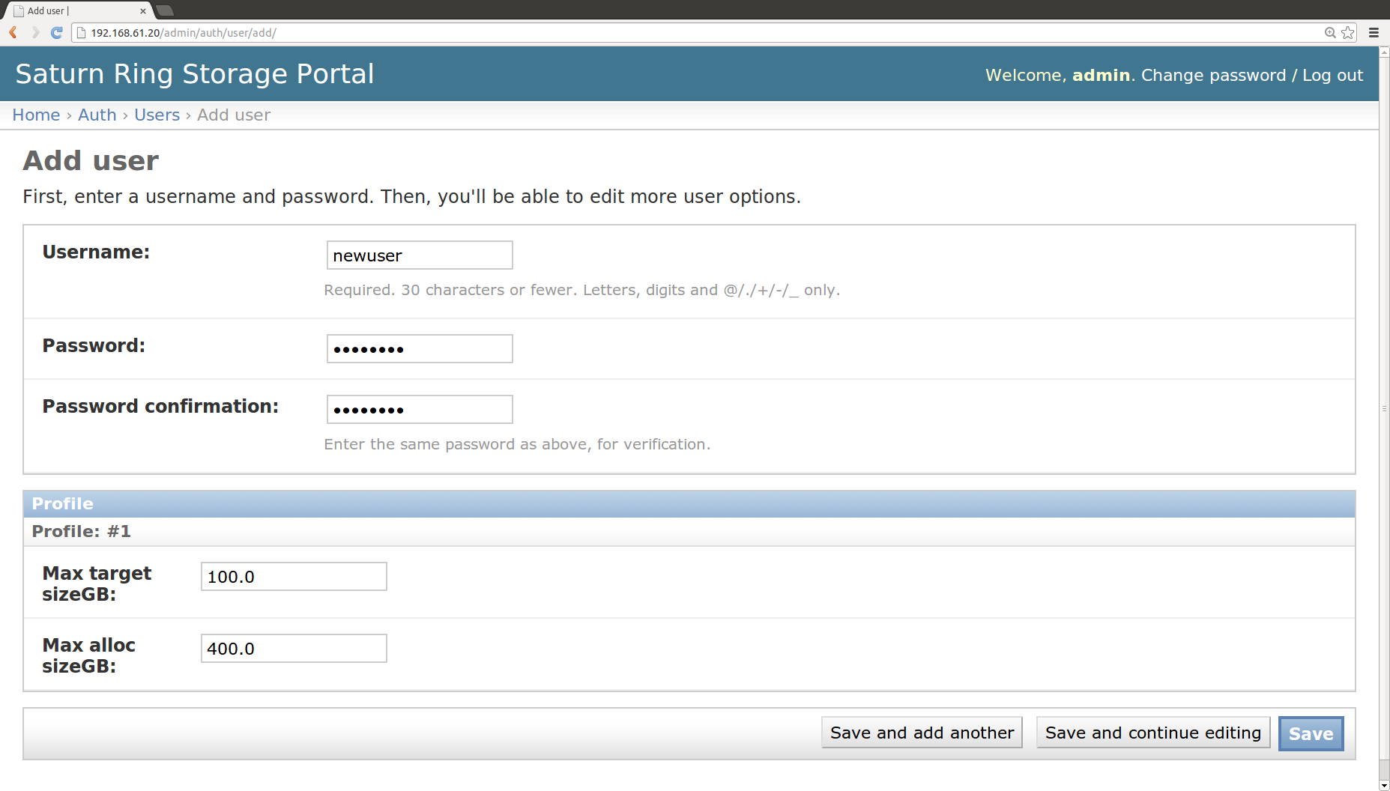
A new user is added using the “Add user” button at the top right of the page. Fig. 7 shows a new user being added. Please do not change the quotas in this screen (leave the defaults), quotas are correctly changed in the next screen (Fig. 8)
Fig. 7: Adding a new user
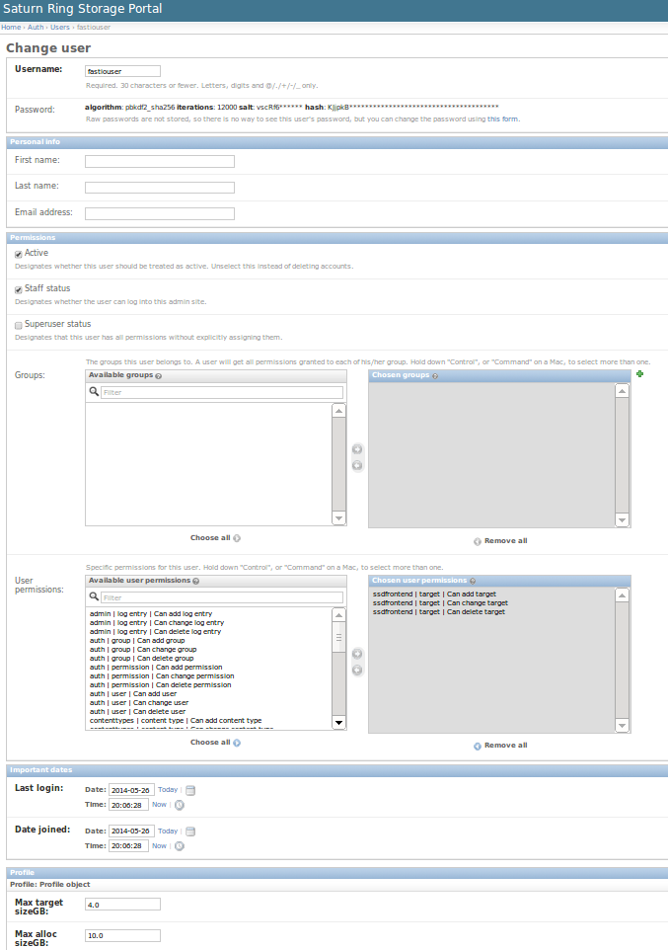
Staff Status: Enable this checkbox
User permissions
ssdfrontend|target|Can add target
ssdfrontend|target|Can change target
ssdfrontend|target|Can delete target

Quotas

Fig 8: Setting user properties
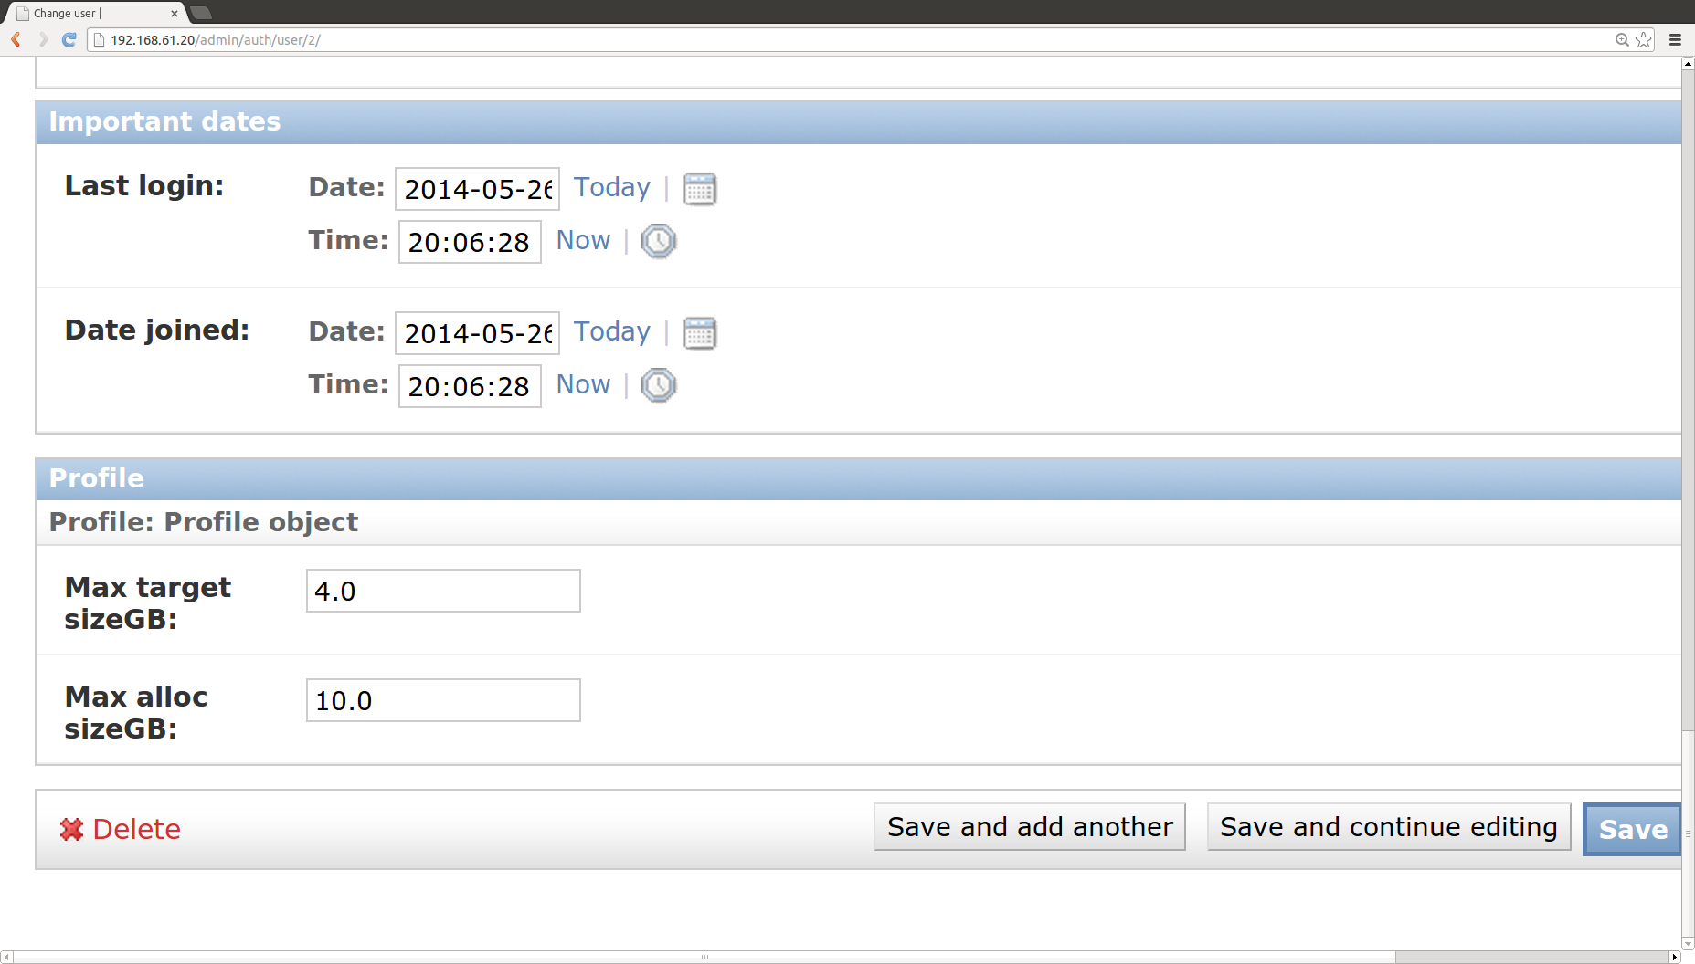
Fig 9: Setting quotas

Fig 9. shows a zoomed-in version of Fig 8. showing how quotas can be managed. There are two parameters here. Max target sizeGB caps the maximum size of any iSCSI target the user can request from Saturnring whereas the Max alloc sizeGB is the total storage a user can allocate, across the
Saturnring cluster (sum of all users' targets).

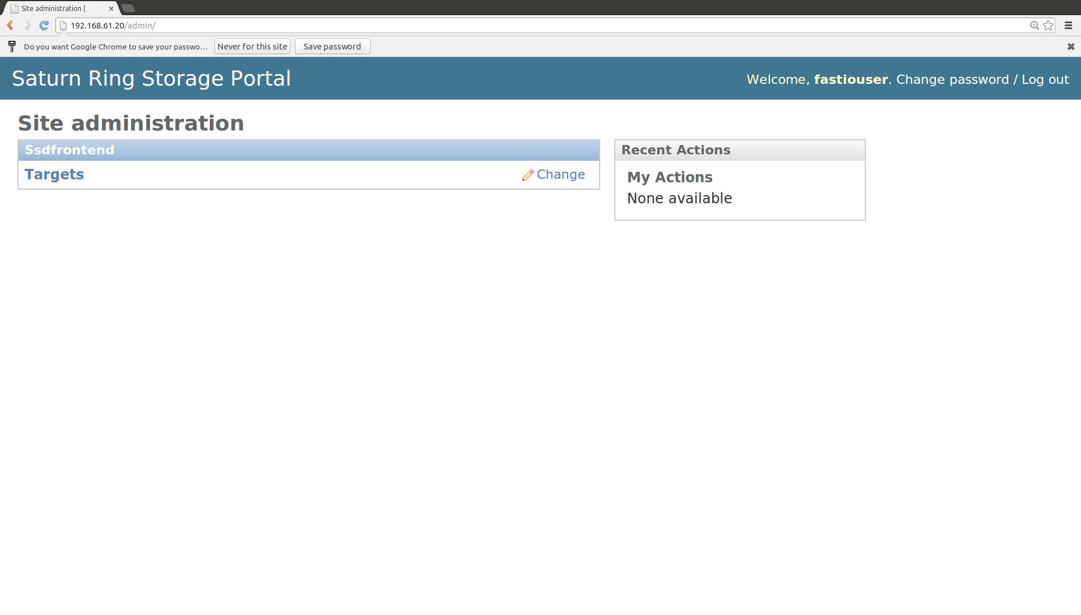
Portal Operations: User

A user may log into the portal using her credentials. The initial screen just has a single link to Targets provisioned and owned by the user:

Fig 10: User logged-in view
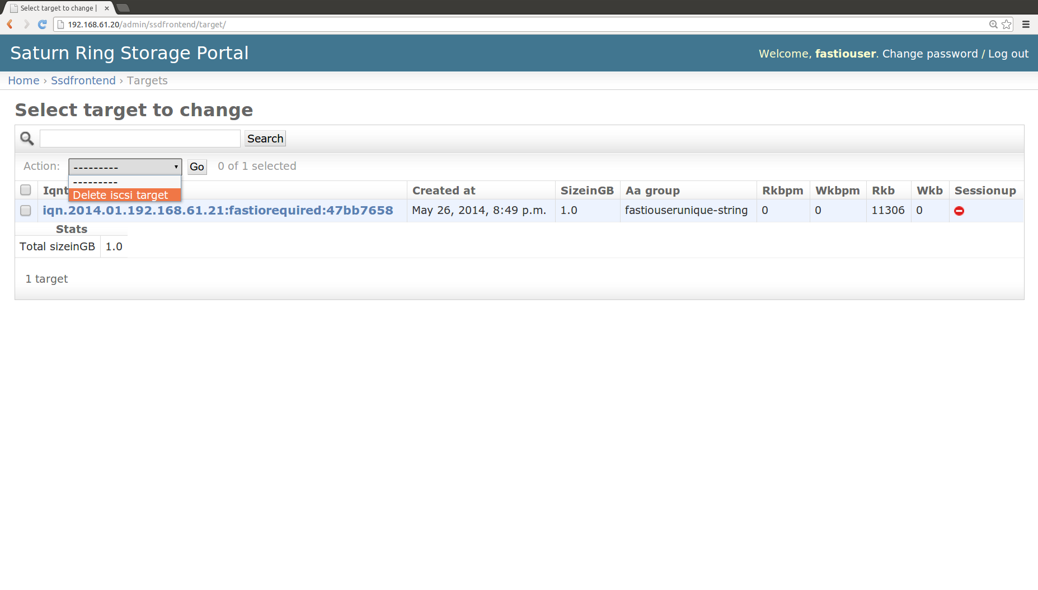
Fig 11: Deleting a target

The user can delete any of her targets by checking the box against the target and then clicking on Action->Delete iscsi target. Deletion results in the irreversible removal of the LVM logical volume backing the storage, so please be sure before issuing the command.

Saturnring API
The HTTP API is very sparse by design – keep things as simple as possible. Its only use for the end user is to provision storage. The API can be invoked via any HTTP client, illustrated here via curl

Provisioning example

#User defines these variables
##################################################
SIZEINGB=1.0
SERVICENAME="fastiorequired"
SATURNRINGUSERNAME="fastiouser"
SATURNRINGPASSWORD="fastiopassword"
ANTI_AFFINITY_GROUP=${SATURNRINGUSERNAME}"unique-string"
SATURNRINGURL="http://192.168.61.20/api/provisioner/"
##################################################
IQNINI=`cat /etc/iscsi/initiatorname.iscsi | grep ^InitiatorName= | cut -d= -f2`
RTNSTR=$( unset http_proxy && curl -s -X GET "${SATURNRINGURL}" --user "${SATURNRINGUSERNAME}":"${SATURNRINGPASSWORD}" --data clientiqn="${IQNINI}"'&'sizeinGB="${SIZEINGB}"'&'serviceName="${SERVICENAME}"'&'aagroup="${ANTI_AFFINITY_GROUP}" )
echo $RTNSTR | python -mjson.tool

Corresponding provisioner response...
{
"aagroup__name": "fastiouserunique-string",
"already_existed": 0,
"error": 0,
"iqnini": "iqn.1993-08.org.debian:01:ba70a129ba3",
"iqntar": "iqn.2014.01.192.168.61.21:fastiorequired:aead642d",
"sessionup": false,
"sizeinGB": 1.0,
"targethost": "192.168.61.21",
"targethost__storageip1": "192.168.61.21",
"targethost__storageip2": "192.168.61.21"
}
To be continued...

