  

THEME : INNOVATION OF PUBLIC TRANSPORTATION &OPTIMIZATION

SUBMITTED BY : V.JAYAPRAKASH

Name of Institution: Ganesh college of Engineering Address of Institution : Ganesh college of Engineering,

Attur main road,

Mettupatti (P.O), Valapady (T.K), Salem (D.T), 636 111.

District : Salem State : Tamilnadu Pin : 636111

E-mail :pp6537099@gmail.com

Contact no : 9047688057

j

The population of cities around the world is growing rapidly. The World Health Organization notes that the ma- jorityoftheworld’spopulationtodaylivesincities,and thisproportionwillincreaseconsiderablyoverthenext few decades [1]. As boundaries of cities are stretched to accommodatethegrowingpopulation,majorchallengesarise for maintaining a sustainable transportation infrastructure.

Broadly, there are two forms of transportation, privateand public. Private transportation – predominantly personal cars – offers ownership, comfort and convenience. On the downside, cars incur high cost, both CAPEX and OPEX.Thelattercomprisinginsuranceandregistrationcosts,which are high, and costs for fuel, maintenance, parking, etc. In addition, private transportation is subject to peak road con- gestion;TheDepartmentofTransportandRegionalServices of the Australian Government estimates the social costs of congestion in Australia to reach a staggering $20*.*4 billionby 2020 [2]. The use of personal cars also contributes significantly to greenhouse gas emissions [3].

Public transportation – predominantly trains – is efficient (carries more passengers simultaneously), low cost, reliable and has lower energy and Carbon footprint than private transportation [4]. However, it can have low spatio-temporal coverageinsuburbia,andsuffersfromthelast-mileproblem,

i.e. access to and from the train station is often not very convenient.Thesefactorscombinedhaveresultedinpeople.

* .Useofpersonalcars,i.e.privatetransportation,forjourneytowork increases with distance from inner Melbourne attributed largely tolow spatio-temporal coverage of public transportation in the suburbia. The“Others” in the figure represents the fraction of people who work fromhome, walk or cycle to work. Similar trend is observed for other capitalcitiesinAustralia.Source:AnalysisofAustralianCensusofPopulationand Housing 2011 place of usual residence.
* choosing personal cars (in Australia) as the dominant mode of transport, as shown in Fig. 1.
* Building on recent trends in vehicle sharing, in this paper we envision a new mobility model, termed **“Personalised PublicTransportation”**,whichoffersthebestoftheworlds of private and public transportation, namely *convenience*like private transportation (with fewer externalities), and*cost* approaching public transportation. We believe that this mobilitymodel,coupledwithitskeyoperationalfeatures, is a promising approach for transforming the transportation sector to be more sustainable.
* Therestofthispaperisorganisedasfollows.InSectionII, wegiveanoverviewoftoday’svehiclesharingschemes.We describe the Personalised Public Transportation Service in Section III. An analytical formulation to quantify some ofthe benefits of the proposed mobility model is developed in Section IV, and the results are presented in Section V. We conclude the paper in Section VI.
* VehicleSharing
* A concept that is growing in popularity is vehicle sharing, of both bikes and cars. Examples of a few bike sharing ser- vices include New York City’s CitiBike [5] and Melbourne Bike Share [6]. Zipcar [7] and Car2Go [8] are car sharing services, which are based in North America and Europe.
* These services operate by providing access to a fleet of cars onanas-neededbasis24/7.Thecarsaredistributedwithin a service zone and users reserve it for a specific duration. They are not explicitly charged for costs associated with maintenance, insurance, fuel, etc.

Vehicle sharing in general, and car sharing in particular, are positive initiatives in the direction towards sustainable transportation, as evidenced by statistics reported by the various service operators. For example, in Australia, every GoGet car takes 9 private cars off the road, and people on averagedrive20%lessafterbecomingaGoGetmember[11]. Nevertheless, one of the major limitations of these services (aswellasthatofthebikeshareservices)isthattheyusually have dense coverage in and around the city/downtown area, where users have alternate means of transportation such as trains and trams, but have little or no coverage in suburbia. This is shown in Fig. 2 for Melbourne. A consequence ofthis is that the ‘last-mile’ problem remains largely unsolved, which is important for mitigating some of the strains asso- ciated with private transportation. Nonehere

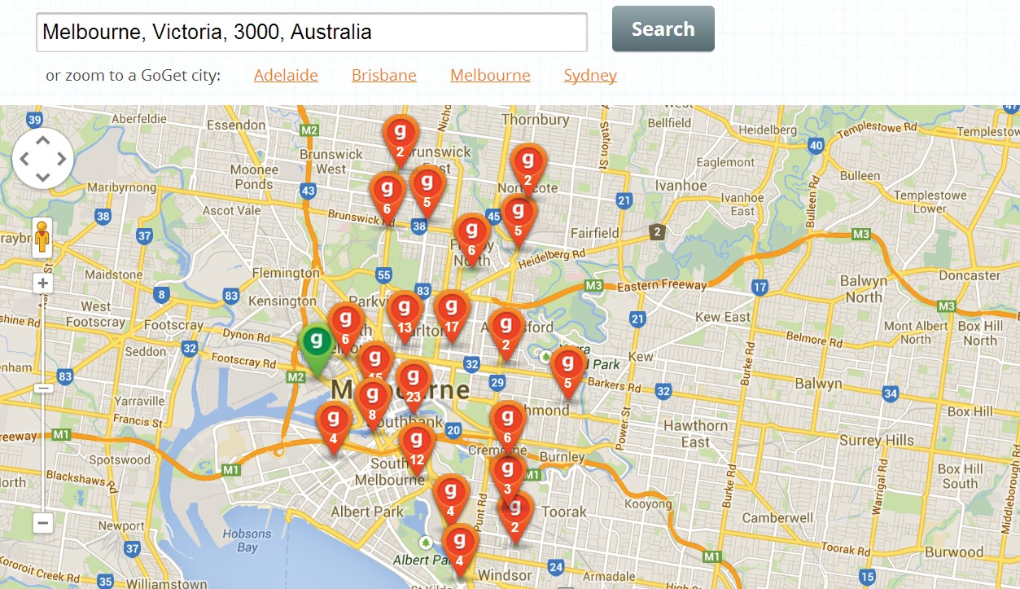

Fig. 2.Availability of GoGet shared cars in Melbourne is dense in andaround downtown as indicated by the red and green icons. There is little orno coverage in suburbia.

Further,amajorityoftheseservicesdonotallowone-way trips, and require cars to be returned to a dedicated parking position1 (usually from where it was picked up) [12]. There arefinancialimplicationsfornotdoingso.Finally,theircosts arenotinexpensivecomparedtoothercarrentalsortaxis(for certain usage patterns), and the cars cannot be kept at home overnight (for a small premium).

1. PersonalisedPublicTransportationService

Building on the idea of vehicle sharing, we envision Personalised Public Transportation Service (PPTS), a prac- ticalandefficientmobilitymodelforfuturegenerations of transportation. PPTS allows leasing of vehicles using a service similar to cell-phone services, where the vehicle is “personalised”, akin to the use of private cars, but can be “shared” across users at different points in space and time. Thefleetofvehicleswouldbeoperatedandmanagedvia a cloud computing service, i.e. the vehicle is virtualised, analogoustocomputers,whicharevirtualisedinadatacentre likeinfrastructure,enablingcloudcomputingprinciplesto

1Car2Goisrelaxingthisconstraint.

*A.KeyFeatures*

## WenowdescribethekeyfeaturesandattributesofPPTS:

* 1. **Superior coverage:** First and foremost, PPTS isaimed at providing coverage in both urban and suburban regions. Positioning PPTS vehicles within walking distance of households would be highly attractive from the residents point of view. Further, as governments continue to make significant investments to augment the capacity and spatio- temporal coverage of the public transportation network (e.g. trains [13]), we believe that PPTS can be instrumental in mitigatingthelast-mileproblembyencouragingresidents to use PPTS as a means to get to the train stations, thereby enabling a large part of their journey to be made on public transport. Overcoming the last-mile problem, however, isnot the only goal of PPTS, as discussed next.
  2. **Greater convenience:** PPTS offers remarkable convenience and ease of use by being flexible in the policies governingvehiclepickupsanddropoffs.Vehiclescan be‘leased’and‘released’atanypointinspaceandtime. A distinguishing feature of PPTS compared to existing schemes is that vehicles can be kept at home overnight, if desired,forasmallpremium.Thus,PPTSvehiclescould beavailableatthedoorstep.Userswillhavetheoption to undertake one way trips, in addition to making roundtrips. Vehicle reservations can be made on the web or via intelligentsmartphoneapps.Theseattributesensurethat any ‘anxiety’ effect when it comes to the availability of vehicles will be eliminated, thus providing on par or better convenience than traditional vehicle sharing schemes.
  3. **Multimodal fleet of electric vehicles (EVs):** Existing vehicle sharing schemes are, for the best part unimodal, meaning they are either bike sharing schemes or car sharing schemes.PPTSwillencompassmultimodalvehicles,i.e. 2-,3-and4-wheelers,asshowninFig.3.Wewillcall these vehicles E-Bikes, E-Scooters and E-Cars respectively. Furthermore, PPTS will employ small form-factor vehicles. This notion is not outlandish, as exemplified by cars such as Renault Twizy [14], Nissan Land Glider [15], and Google’s autonomous car [16].

4.Ourmotivationforchoosingsmallform-factorvehicles is the following: (1) Their energy footprint is considerably lower than regular cars. For example, the 4-wheeler Nissan Land Glider has 1/2 the frontal area and 1/2 the drag coefficientofaregularcar,meaningitusesonly1/4of the energy [17], making a compelling case for adoptingsuch vehicles forenvironmental sustainability. (2)Thesmall size allows the existing road infrastructure to be used more efficiently by allowing lanes to be shared with other similar vehicles. This significantly reduces expenditure for augmentingroadinfrastructuresuchasforaddinglanesto

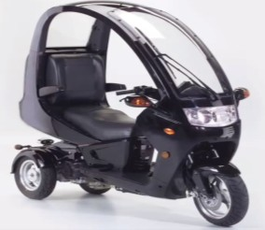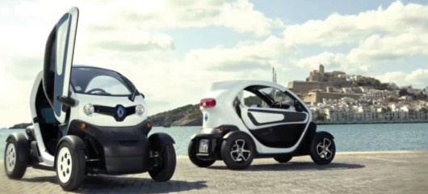

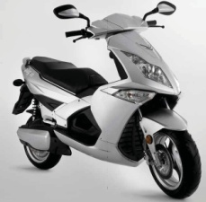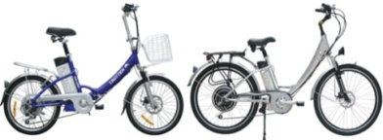

### Fig.3.Multi-modalfleetofelectricvehiclesenvisionedbythePersonalisedPublic Transportation Service comprising 2- (E-Bike), 3- (E-Scooter) and4-wheelers (E-Cars).

catertomorecars.(3)Forthesamerealestate,parking lotscannowaccommodatemorecars,therebyreducing the investment needed for upgrading parking facilities. (4) Travel times can be cut substantially, up to 50% by some estimates[18].OurreasonsforusingEVsaredescribednext.

* 1. **Compellingpricing:**PPTSvehiclescanbeleased and released using plans similar to cell-phone services. We envisagetwotypesofpricingstructures–subscription- basedandpay-as-you-go-plans.Theformerpermitsdaily, weekly, monthly or yearly subscription. Subscription for an E-ScooterallowstheuseofallE-Bikesinthefleet,for examplewhenanE-Scooterisnotdesiredorunavailable. Similarly,subscriptionforanE-CarallowstheuseofE-Bikes andE-Scooters.Pay-as-you-goplansemployper-minuteor per-hourpricingwithaccesstovehiclessimilartothatof subscription-basedplans.Anadequatelysizedmultimodal fleetthereforeprovidesflexibilityinthechoiceofvehicles andempowerscompetitivepricingtobeofferedtocustomers. Another aspect contributing to compelling pricing is EVs, whichcansubstantiallycutoperationalexpensesgiventhe soaringpetrolcosts.Studieshaveshownthatthecostper km of an (retrofitted) EV in cities is ≈2 cents/km, while apetrolcarincurs≈12c/km[19].Weexpectthecostper kmofsmallform-factorEVstobeevenlower.Further, theyincurlowermaintenancecostsaswellduetofewer mechanicalparts.EconomiesofscaleandfallingLi-Ion batteryprices[20]willacceleratethereductionofcapital costs.Thesefactorsinconjunctionwithreal-timevehicle trackingandanalytics,robustoptimisationtechniques andproactiveuserincentives(e.g.todropvehiclesoffat chargingstations)willassistinloweringrepositioningcosts

ofthevehicles,whichisknowntobehigh

* 1. **Efficient fleet management:** As mentioned earlier, PPTS applies cloud computing principles – i.e. managingthe association of users to shared resources such as virtual machines in data centres, which has proven to be extremely efficient – for managing the association of users to vehicles. This can be done to maximise societal benefits, such as mitigatingroadcongestion,minimizing contention for parking spots at vehicle charging stations/malls, maximising the use of public transportation when feasible, etc. This platform also gives the ability to explore the role of predictive analytics given the usage patterns so as to maximise convenience and minimise costs.
  2. **Generations of PPTS:** The first generation of PPTS will comprise a multimodal fleet of small form-factor EVs,as described above. There is growing interest in autonomous cars as witnessed by a number of manufacturers (BMW,GM, Mercedes-Benz, etc.) testing various driverless proto- types [21]. Google has recently announced an autonomous EV car that does not have a steering wheel [16]. Several states in the US have already passed legislation that allows driverless cars to share the roads. As these vehicles gain traction, future generations (second, third, ...) of PPTS will incorporate them into their fleet. These vehicles can drive themselves to the doorstep of customers as and when a reservation is made, thereby dramatically enhancing conve- nience. In addition, no parking is required at the destination. Thecostsassociatedwithrepositioningthevehicleswill be slashed owing to the absence of human involvement. Autonomous vehicles are game-changing trends, which will be embraced by PPTS to boost the value proposition of the service. Optionally, generation zero of PPTS will rely on petrol-based smart cars such as Daimler’s Fortwo [22].

1. An Optimisation Model for Quantifyingthe Benefits of PPTS

* We now develop a *macro-level* multi-commodity capaci- tated flow model to evaluate the benefits of the Personalised PublicTransportationService.Whilemoresophisticatedand larger scale models such as the system-optimal dynamic traffic assignment [23] have been studied, our intention here is to get a first-order insight into the benefits of PPTS. To this end, we describe the formulation below.
* Consider the simple three node network shown in Fig. 4. The triangular nodes in the figure are the origin/destination of traffic demands (for e.g. city suburbs), while the arcs representtheroadsinterconnectingthesuburbs.Wequantify the benefits of PPTS relative to the dominant mode of transportationtoday,namelyregularprivatecars,usingthree metrics – travel cost, energy footprint and Carbon footprint. Forillustrativepurposes,weassumethatPPTSisunimodal,
* i.e.itonlyhascarswithhalfthefoot-printofprivate cars. Our formulation, though, is generic and models the multimodal version of PPTS.
* WeincorporatePPTSinthenetworkshowninFig.4 by using an augmented network as shown in Fig. 5. This network*G*(**N***,***A**),where**N**and**A**arethesetsofnodes andarcs,consistsofthreenodetypes–theorigin/destination demandnodes(denotedbytriangles,sameasFig.4),andtwo nodes each attached to the demand nodes, which represent transport Mode 1 (denoted by squares), namely private cars, and transport Mode 2 (denoted by circles), namely PPTS cars,respectively.Theaugmentednetworkalsoconsistsof

Demand

nodeB

B

A

C

For this multi-commodity capacitated flow model, let the decisionvariable*frij*betheflowamountofrequest*r*∈**R** on arc (*i,j*) ∈ **A***r*. The linear program to minimise the total travel cost of travel requests is formulated below:

DemandnodeA

DemandnodeC

min∑

∑ *Crij*

*frij*

(1)

Fig.4.AsamplethreenodenetworkcomprisingthreedemandnodesA,B and C, and roads interconnecting the demand nodes.

s.t.

*r*∈**R**(*i,j*)∈**A***r*

* Flowbalanceconstraintsforeachrequestandnode:

∑*frij*+∑*Drji*=∑*frji*+∑*Drij,*

M1,B

Demand

BnodeB

M1,A

TransportMode1

*i*∈**N**

*i*∈**N**

*i*∈**N**

*i*∈**N**

∀*r*∈**R***,j*∈**N***r* (2)

* Flowcapacityconstraints:

DemandnodeA

M1,C

A

M2,B

∑ ∑ *αruvijfruv*≤*Lij,* ∀(*i,j*)∈**A**(3)

Demand

nodeC

*r*∈**R**(*u,v*)∈**Q***ij*

M2,A

DemandtotravelfromA to B satisfied viatransport mode 2

TransportMode2

C

M2,C

* Non-negativityconstraints:

*frij*≥0*,* ∀*r*∈**R***,*(*i,j*)∈**A***r* (4)

The above objective function is a *simplistic* representation oftravelbehaviour.Thesolutionobtainedhereisconsidered

Fig.5.Theaugmentednetworkcomprisingthreedemandnodes(A,BandC)andtwotransportModes,namelyMode1(privatecars)andMode2 (PPTS cars).

three arc types – arcs that connect demand nodes and trans- port nodes (denoted by dashed lines), arcs interconnecting transport Mode 1 nodes (denoted by solid lines), and arcs interconnectingtransportMode2nodes(denotedbythin lines). In this example, if there is a travel demand from A to B, then a feasible route using PPTS could be*A*→ (*M*2*,A*)→(*M*2*,B*)→ *B*, as shown in the figure. On the other hand, if there is a travel demand from A to C, then a feasiblerouteusingprivatecarscouldbe*A*→(*M*1*,A*)→ (*M*1*, B*)→(*M*1*, C*)→*C*.

Let**R**bethesetofalltravelrequests.Foreachrequest

*r*∈**R**, we define a set of nodes,**N***r*⊆**N**, whichrequest*r* can visit, and the set of arcs,**A***r*,on which the request canflow.Thedemandforrequest*r*isgivenby*Drij*,where *i,j*∈**N**andexactlyoneofthepairsof*i*-*j*isstrictlypositive (theothersarezero),i.e.eachrequestisademandtotravel exactlyoneorigin-destinationpair.Thecostofoneunitflow of request *r* ∈ **R** along arc (*i,j*)∈ **A***r*is given by *Crij*.

Since a PPTS car shares the same physical road as a private car but is half the size of a private car, the per unit consumptionofMode2onanarcinFig.4ishalfthat of Mode 1. We capture this notion in our model via the definition of an arc capacity *Lij*,and a consumption factor *αruvij*, as defined below.

Foranarc(*i,j*)∈**A**, its capacity*Lij*is the maximum number of vehicles(of the Mode represented by the arc) that canflowonthatarc.Theparameter*αruvij*istheamountof arc(*i,j*)∈**A**’scapacityconsumedbyoneunitofrequest *r*∈**R**travellingalongarc(*u,v*)∈**Q***ij*,wheretheset**Q***ij*⊆ **A***r*isthe set of arcs(*i,j*)∈**A**that represents the same physical road arc in the unaugmented network.

tobe‘systemoptimal’,sinceoptimaldecisionsaremade ata‘system’level.Themodelcanbeusedtocarryout quickevaluationofthebenefits,ifany,ofintroducingnew formsoftransportintothenetwork.Forexample,ithelps answer the following questions: How can the benefit of trips withsmallcarsbemeasured?Howcantravelrequestsbe optimallydistributedusingamultimodalsetofvehicles,etc.? Onecouldarguethatthebenefitsofintroducinganew formoftransportcanbeevaluatedbasedontravelsurvey data. But travel survey data is only a sample of the popula- tion’s travel, and does not reflect the demand volume. Evenif the benefits can be inferred via the sample of population’s travel, it is not clear how one would select a trip to adopt a new transport mode. The multi-commodity capacitated flow modelpresentedhereovercomesthisbarrierbyprovidinga

system-viewcost-optimalselection.

Itiswithoutdoubtthatthemodelpresentedherecan be improved. Including practicalities such as a more so- phisticated transport mode-choice selection is a prospective extension, but will imply trading faster computation for accuracy. Coupling the model presented here with a traffic simulation model is also an avenue for further research.

1. NumericalResults

The benefits of PPTS will be evaluated for metropolitan Melbourne shown in Fig. 6 under a peak morning traffic condition.MetropolitanMelbournehasapopulationof≈ 4 million and there are thirty one Local Government Areas (LGAs). An LGA is a collection of suburbs, as shown bythe circles in the figure. The arcs represent the primary connections (roads) interconnecting the LGAs. The peak morning (7am to 9am) traffic of more than 800,000 car trips puts immense pressure on Melbourne’s tollways, freeways and main arterial roads.

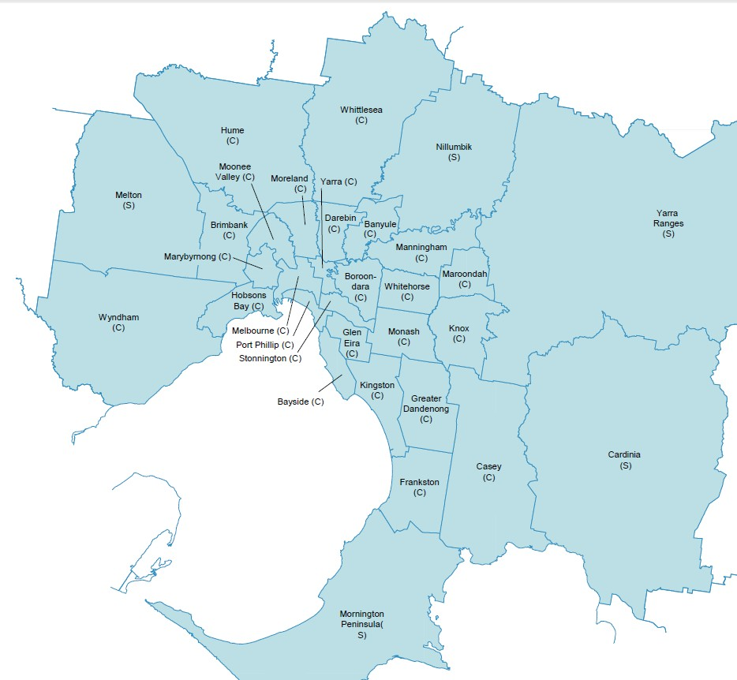

MillPark

Broadmeadows

Tullamarine

Ardeer

Bay Road

PoliceRoad

Large

capacity

Medium capacity

Fig.6.LocalGovernmentAreas(LGAs)andprimaryconnectionsbetweenLGAsofmetropolitanMelbourne,Victoria,Australia.

Theorigin-destinationtraveldemanddataforthepurposes of this study is sourced from the Victoria Integrated Survey of Travel and Activity (VISTA) database [24], and demand modelling commissioned by the Department of Transport. Detailed input data is not presented in this paper for confi- dentiality reasons, but may be provided upon request.

We demonstrate the benefits (cost, energy footprint, and CO2emissions) of PPTS via a series of evolutionary phases of travel behaviour, described as follows:

* + - Phase1:Tripsmadeusingregularcars(e.g.Mazda3).
    - Phase2:TripsmadeusingDaimler-Benz’sSMART Fortwo smart cars.
    - Phase 3: Subscription to use SMART Fortwo via PPTS (this is Gen 0 of PPTS), and
    - Phase 4: Subscription to EVs (e.g. Renault Twizy) via PPTS (this is Gen 1 of PPTS).

These progressive phases help demonstrate the transitional benefitsarisingfrom:owningaregularprivatecartoowning a small footprint car, car ownership culture in general to a subscription-based culture envisioned by PPTS, and using non-EVs to using EVs within PPTS.

For phases 1 and 2, parameters factored into the cal- culation of travel costs (i.e. *Crij*’s)include the purchase, registration,maintenance,insuranceandfuelcostsofthecar. These values are obtained from the manufacturers’ websites as well as RACV, a popular car insurance company in Melbourne [25]. Travel costs for phases 3 and 4 are derived from estimates of the annual subscription fee and fuel costof PPTS for Gen 0. We note that the energy footprint and CO2emissionsforaregularcarare60kWh/100kmand

0.19 kg/km, for SMART Fortwo, the quantities are 30 kWh/ 100km and 0.1 kg/km, and for an EV, they are 22 kWh/100 km and 0.08 kg/km. These values are obtained from [22], [26], [27], [28].

TableIsummarizesthebenefits(savings)ofeachevolu- tionaryphasefor5%and10%adoptionpercentages.The benefits are relative to all trips made using private cars (the dominant mode today). The adoption percentages are intro- ducedbyspecifyinganadditionalconstraintinthemulti- commoditycapacitated flowmodeldevelopedin Section IV. It can be seen from Table I that the travel cost decreases as peoplebehaviourmovesfromphase1tophase4,sincesmart cars and PPTS with EVs cost less per km than regular cars. Total savings of 4.6% can be obtained for a *single* morning peaktripif5%ofusersmigratetoPPTSwithEVs.This increasesto8.5%with10%adoptionrate.Significantsavings inenergyandCarbonfootprintcanalsoberealisedfora

*single*trip,asshowninthetable.

To put these percentages into perspective and give the readerasenseoftheannualsavingsintermsofthemonetary benefits, we note from RACV’s estimate that the weeklycost for using a regular car (e.g. Mazda 3) is ≈$170 [29]. The cost per trip therefore is $17 assuming an average user makes10tripsaweek(2tripsperweekday).The4.6% costsavingduetoeven5%ofusersadoptingPPTSwith EV over the 800,000 trips per day and 48 weeks per year translates to hundreds of millions of dollars per annum. The corresponding energy savings is in the order of hundreds of GWh per annum, and the total reduction in Carbon footprint is in the hundreds of Megatonnes per annum.

TABLEI

Savingsarisingfrom5%and10%adoptionofdifferenttravelchoices.

|  |  |  |  |  |
| --- | --- | --- | --- | --- |
| **5%adoption ofdifferentservices** | **100%**  **private cars** | **95%privatecars**  **+5%Smartcars** | **95%privatecars+5%smartcars via PPTS** | **95%privatecars+5% EVs via PPTS** |
| Totalcost | 0 | 2.7% | 3.5% | 4.6% |
| Energyfootprint | 0 | 2.5% | 2.5% | 3.2% |
| CO2footprint | 0 | 7.5% | 7.5% | 8.8% |

1. Savingsdueto5%adoptionofeachtransportphasew.r.t100%ownershipofprivatecars.
2. Savingsdueto10%adoptionofeachtransportphasew.r.t100%ownershipofprivatecars.

|  |  |  |  |  |
| --- | --- | --- | --- | --- |
| **10%adoptionofdifferentservices** | **100%**  **private cars** | **90%privatecars**  **+10%Smart cars** | **90%privatecars+10%smartcars via PPTS** | **90%privatecars+10%EVsviaPPTS** |
| Totalcost | 0 | 4.9% | 6.4% | 8.5% |
| Energyfootprint | 0 | 5.0% | 5.0% | 6.4% |
| CO2footprint | 0 | 13.1% | 13.1% | 15.4% |

THANK YOU!