**ReallyGoodChess Change Overview**

**New Piece (Frog)**

* Based on checkers pieces
* Can only move diagonally
* Only moves one space at a time when not performing a “jump”
* Can “jump” a piece, capturing it and moving to the next square past it
* Can only move vertically on its current “forward” direction
* Once it hits the opposite, it switches its “forward” direction
* Happens to also switch “forward” direction when it hits the left or right side of the board
* Should be designated by the ☊ symbol
* Bonus: Can apparently curve hop enemies. Not exactly intended, but cool nonetheless. Screenshot of the curve hop in the screenshot section

**New Player Type (SmartPlayer)**

* Prioritizes moves based on score
* Score is determined as followed
* Captures nothing – Random int between 0 and 49
* Captures Pawn – 50 + random int between 0 and 9
* Captures King – 60 + random int between 0 and 9
* Captures Frog – 70 + random int between 0 and 9
* Captures Knight – 80 + random int between 0 and 9
* Captures Bishop – 90 + random int between 0 and 9
* Captures Rook – 100 + random int between 0 and 9
* Aggressive with no caution
* Will beat the BasePlayer fairly quickly

**Additional Changes**

* Fixed win conditions for situations where a player has no moves available (such as when a players final piece is a pawn with a piece in front of it and no capture options)
* This win condition counts the remaining pieces from each team so as to avoid any faulty victories or losses

**Notable Issues**

* I was unable to get MS Gothic to work for the console, so testing was done primarily with letters instead of symbols
* This unfortunately means I was unable to check if the symbol I used for Frog is functioning correctly
* Due to Frogs position on the board and single space movement, the SmartPlayer matches tend to end before it can do anything. For screenshots, I just replaced all Pawns with Frogs for results

**Screenshots**

Frog capture (all question marks are Frogs here)

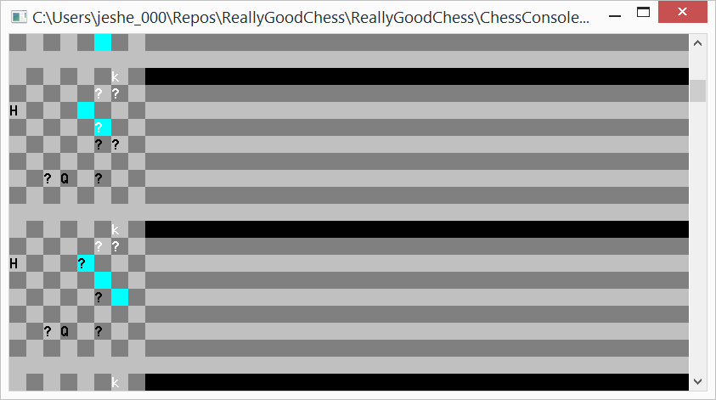

Frog Curve Hop (curve capture)

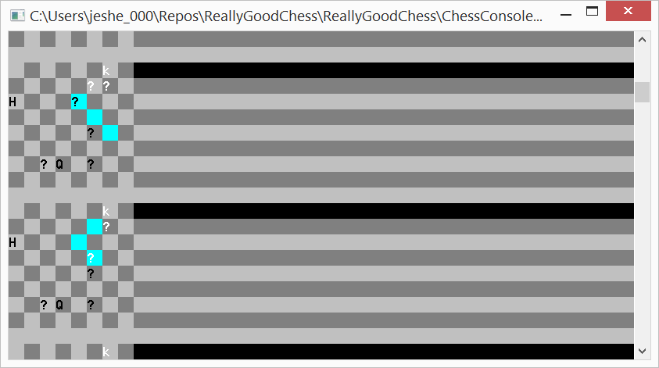

Normal Victory (The letters are different due to how piece characters are flipped for opposite players. q is a Black Knight, V is Black Pawn, and B is a White Bishop here)

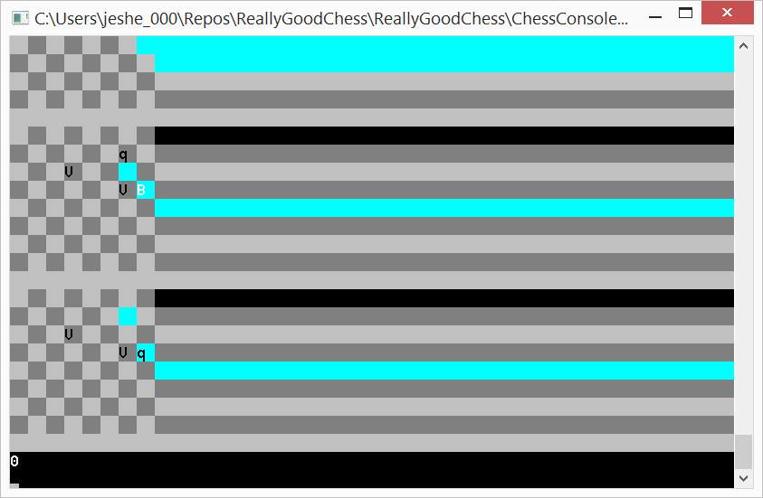

Deadlock Victory (V is a Black Pawn here, so the pieces are unable to move; White has more pieces, therefore White wins)

