Last reviewed: 26/02/2026
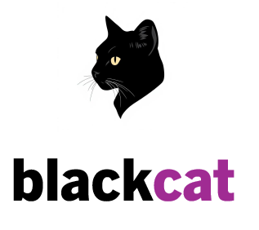

Our pricing is based per user and per service, we believe pricing should be fair for all our customers.
As you see with our pricing, the more your business grows the more money overall you will save.

Start-up Business
1 – 9 Employees
£19.99 per user/mo
Includes
- This includes all our services, both on-site and remote support, supporting IT software, Identity Access Management, managing existing IT infrastructure, General IT queries and requests, IT incidents with priority access to our service desk via email, phone and web portal.
Excludes
- If additional services are needed such as email hosting, these will be charged separately based on what you require and what you use.

Small Business
10 – 49 Employees
£12.99 per user/mo
Includes
- This includes all our services, both on-site and remote support, supporting IT software, Identity Access Management, managing existing IT infrastructure, General IT queries and requests, IT incidents with priority access to our service desk via email, phone and web portal.
Excludes
- If additional services are needed such as email hosting, these will be charged separately based on what you require and what you use.

Medium Business
50 – 249 Employees
£10.99 per user/mo
Includes
- This includes all our services, both on-site and remote support, supporting IT software, Identity Access Management, managing existing IT infrastructure, General IT queries and requests, IT incidents with priority access to our service desk via email, phone and web portal.
Excludes
- If additional services are needed such as email hosting, these will be charged separately based on what you require and what you use.

Interested in our services? We’re more than happy to answer any questions you may have Please contact us below…
hello@blackcatsupport.co.uk
and lets get the ball rolling.

