**Passport Photo**   
  
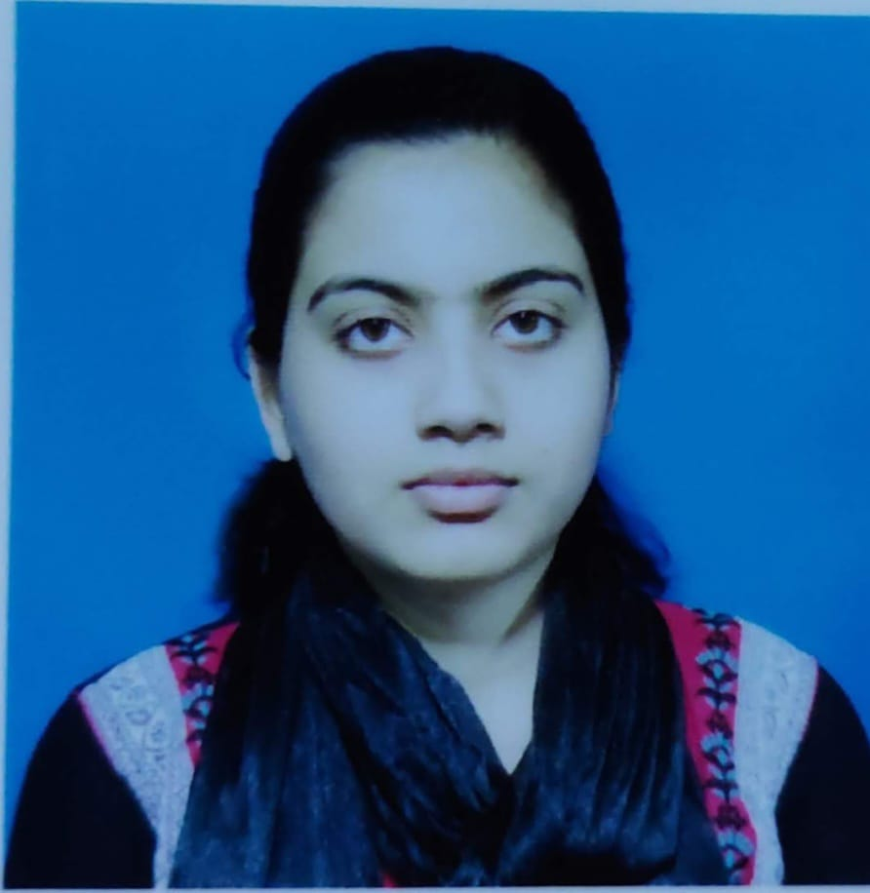  
  
**Aadhaar Card**   
  
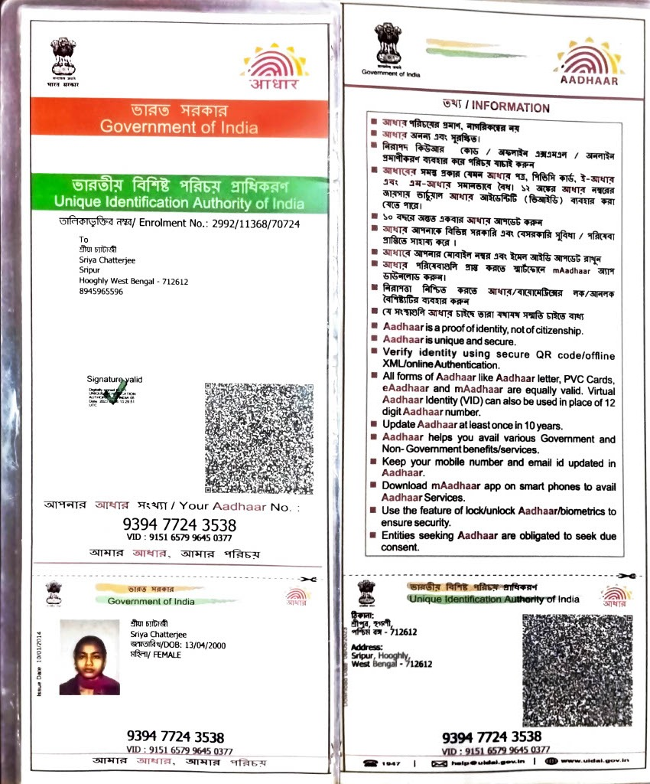

**Nominee Aadhaar  
  
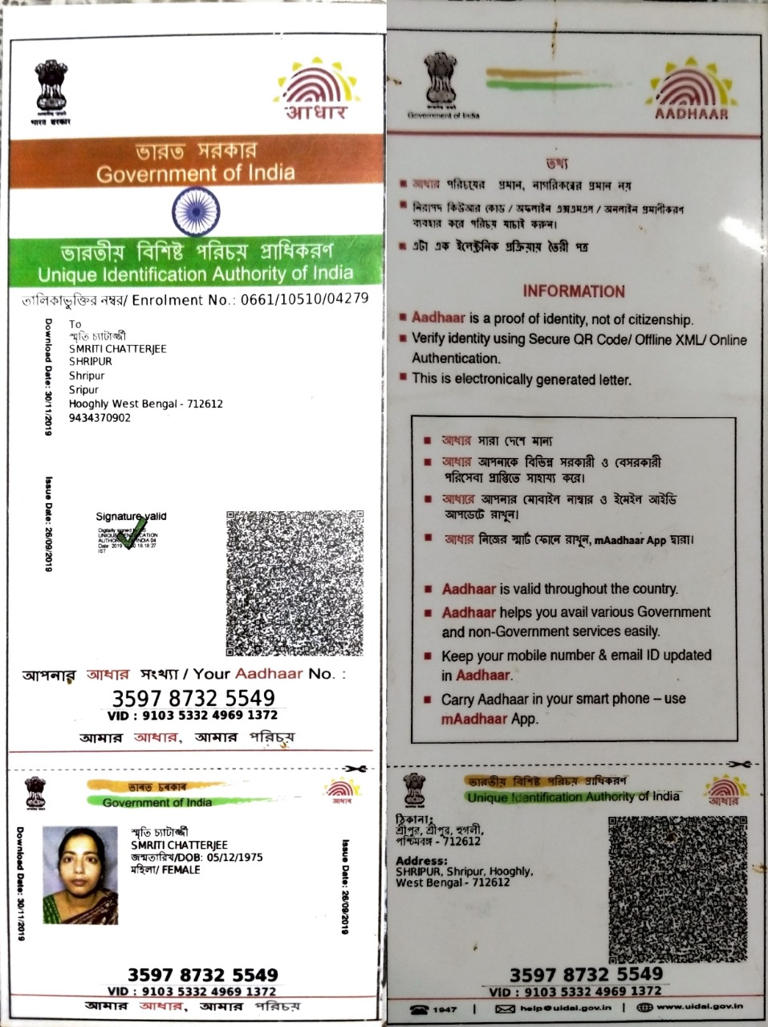**

**Nominee Relation = Mother  
  
 Childs Name = Sriya Chatterjee  
  
 Age = 24**