**Marketing**

Inhalt

Basics 3

Market interactions / decision making areas 3

CCA and USP 3

MIDNIGHT PICTURE / decision making areas 4

Marketing for services 4

Service characteristics 4

7-P-Model 4

B-to-B-Marketing 6

Comparison B2B to B2C 6

Steps of business buying-process 6

Buying center 6

Organisational Frames & Marketing 7

Organisational Perspectives / 4 frames of marketing 7

Marketing Organisation (hierarchical structures) 7

Matrix organisation 7

Customer & Consumer Behaviour 8

Conditions (psychological) 8

AIDA Principle 8

Activation 8

Involvement 8

Knowledge 8

Emotions 8

Motives 8

Image 8

Target of Customer Behaviour 8

Marketing research 9

Information needs (What?) 9

Information sources (Where?) 9

Information collection (How?) 9

Strategic & Operative Marketing 10

Segmentation 🡪 Targeting 🡪 Positioning 10

Key questions of customer selection 10

Segmentation 10

Targeting 10

Positioning 11

Basic dynamic strategy concepts 12

Learning curve effect & economies of scale 12

The product life cycle model (PLC) 13

Analysing the strategic situation 15

SWOT 15

BCG-Portfolio 15

McKinsey Portfolio Strategy 16

Strategic Business Units (SBU) 17

Ansoff´s Product-Market Strategies / Ansoff matrix 17

DeWIT & Meyer‘s Inside-Out / Outside-In Strategies 17

Blue Ocean / Red Ocean Strategy 18

Product 19

The product value concept 19

6 steps of product innovation process 19

Branding 20

Why pay customers more for brands? 20

Value of brands from customer point of view 20

Brand value calculation 20

Sender Brands 20

The Country-of-Origin Effect 21

Price 23

What is a price? 23

Pricing strategies 23

Price building 24

Price-oriented or price-related quality perception 26

Place 27

Distribution Channel Management / forms of direct and indirect distribution 27

Franchising 27

Promotion 28

Promotional Tools 28

Matching target groups and tools 28

Push and Pull 29

Advertising 29

Planning process 29

Objectives / Targets 29

Budget – methods 29

Advertising agency – briefing 30

Media plan 30

Message design / Eye tracking 30

Control 32

# Basics

## Market interactions / decision making areas

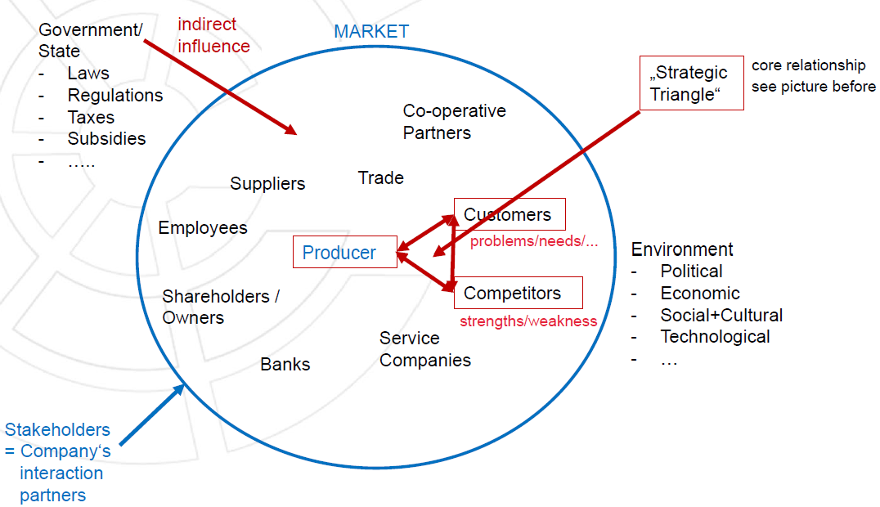

* + Strategic triangle (3C) = company + customers + competitors
  + indirect: no hierarchy of government (not on top but on same level as company); government gives incentives (e. g. subsidies) not forces; decision stays with company
  + direct: direct influence by state

## CCA and USP

* comparative competitive advantage (CCA) = do sth better than the others
* unique selling proposition (USP) = offer sth no one else has (monopolist)

## MIDNIGHT PICTURE / decision making areas

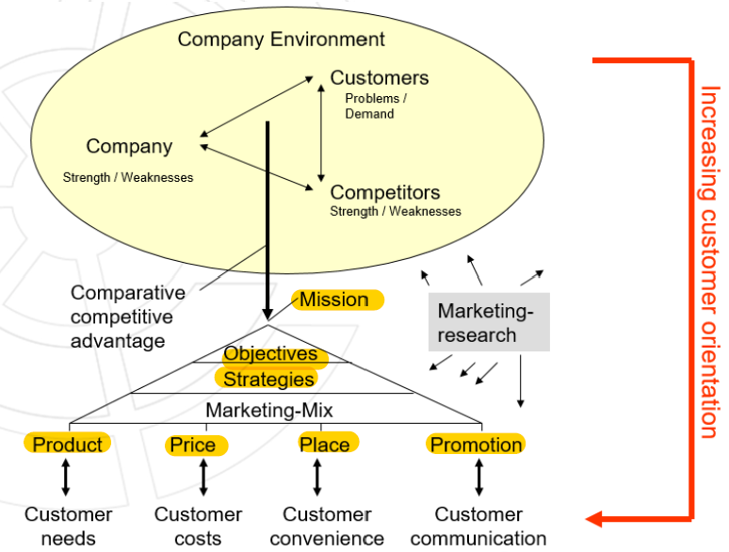

## Marketing for services

### Service characteristics

* + Immaterial *perishable
  + Individual *simultaneous production and consumption
  + integration of customer in process
  + transfer of property often only side effect
  + 3 service quality dimensions: Resources🡪Process🡪Result
  + Difficulty for customer to evaluate the service quality before buying
* Main challenge: reduce the subjective consumer´s buying risk
* Customers use substitute criteria for buying decision 🡪 3 additional marketing mix instruments

### 7-P-Model

* + Product, Price, Promotion, Place (4P) + Personnel, Process, Physical Facilities (instead of only Product)

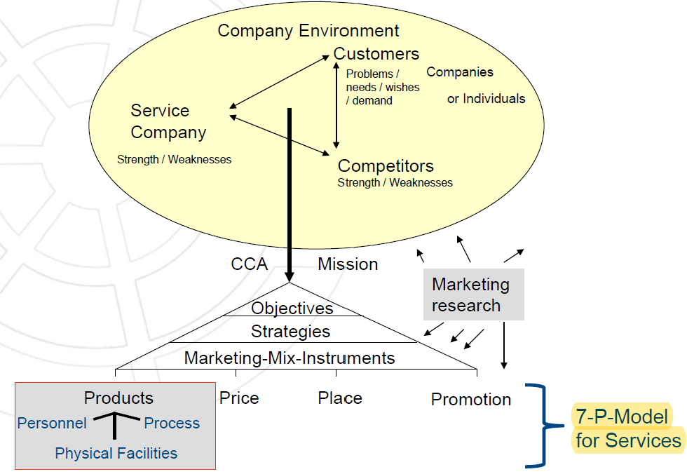

## B-to-B-Marketing

### Comparison B2B to B2C

|  |  |  |
| --- | --- | --- |
|  | **B-to-B** | **B-to-C** |
| Key question | How can we help our customers to deliver excellent products to their customers? | How can we deliver excellent products to our customers (= consumers)? |
| Market structure | Concentrated, few buyers, oligopolistic | Dispersed, pure competition |
| Size of purchase | Extremely large | Small |
| Buyer behaviour | Functional involvement, rational, stable relationships, professionalism/expertise | Family involvement, social/emotional motives, less loyal, less trained/experienced |
| Buying influences | Committees, technical experts, management | Individual, family and friends |
| Decision-making | Distinct, observable, group decision | Vague mental stages, individual decisions |
| Supplier relation | Long-term | Single purchases |

### Steps of business buying-process

1. Problem recognition
2. General need description
3. Product specification
4. Supplier search & pre-selection
5. Proposal solicitation
6. Supplier selection
7. Order-routine specification
8. Performance review

### Buying center

* + Definition: temporary group of experts in a buying company involved in one or several stages of a specific buying process
  + Typical roles: Initiators, Users, Influencers, Deciders, Approvers, Buyers, Gatekeepers, Issue Promotor (initiator), Process Promotor (control), Power Promoter (Approval), Relationship Promotor
  + Selling center = temporary team of experts from the selling company that tried to match the experts of the buying center in expertise or rank at each interaction

# Organisational Frames & Marketing

## Organisational Perspectives / 4 frames of marketing

* + Sense: identify problems 🡪 What needs to be changed?
  + 4 perspectives to analyse organisations
  + Analyse organisations – 4 perspectives
    - Structure (rational) 🡪 Organisation
    - Behaviour (emotional) 🡪 Motivation, Satisfaction, Leadership style
    - Power (political) 🡪 Interests, Control, Conflicts, Power, Influence, Coalitions, Intrigues, Agenda setting
    - Culture (symbolical) 🡪 Roles, Jargon, Symbols, Rituals, Ceremonies, Events, Heroes, Values, Myths, Stories, Jokes
* Application

1. Analysing company’s problems (if something goes wrong)

2. Assessing job offers (personal marketing)

3. Marketing/Sales: Understanding companies buying behaviour

## Marketing Organisation (hierarchical structures)

* + Functional (= according to activities)
  + Object oriented (= according to products)
  + Customer oriented (= according to customer groups)
  + Regional

## Matrix organisation

* + Mixture of three criteria (function + product + customer group)

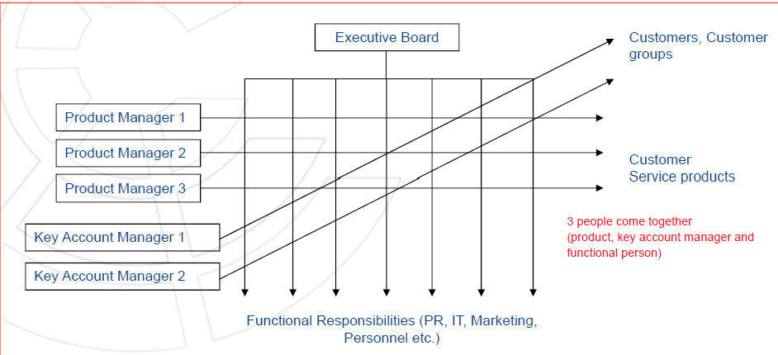

* + If there are too many products: group products or weight products
  + Role of product manager
  + Role of key account manager: customer (groups)

# Customer & Consumer Behaviour

## Conditions (psychological)

* Activation / Flow *Values *Involvement
* Attitudes *Knowledge *Image
* Emotions *Personality *Motives
* Lifestyle

## AIDA Principle

* Attention: Information Reception
* Interest: Information Reflection
* Desire: Evaluation + Decision
* Action: Behaviour (more information seeking, testing, buying)

## Activation

* + Loud *Fast moving *Colourful
  + Cute *Erotic *Cognitive dissonance (unusual insights)

## Involvement

* + Low (Pen, dishwasher tabs)
  + High (House, Mobile phone)

## Knowledge

* + Prominence of brand or product around the world

## Emotions

* + Choose characteristics & their opposite
  + Measure emotional image profiles using semantic differentials
  + 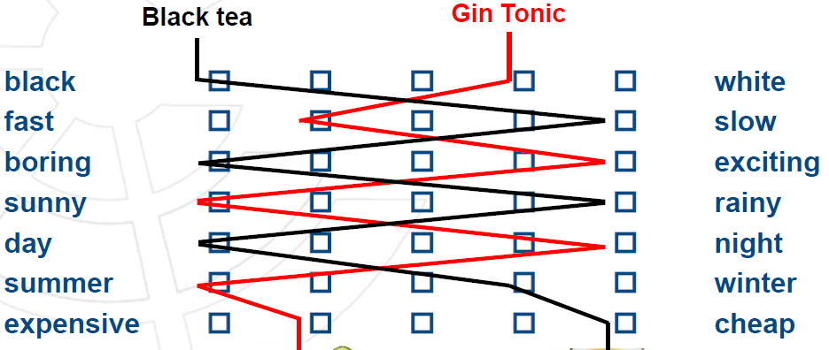

## Motives

* + What lays behind the choice
  + “directed” emotions

## Image

* + Based on two dimensions for certain industries
  + Combine as many dimensions as possible 🡪 find a gap
  + E. g. car industry Prestige, Sportive, Safety, Quality, Price, …

## Target of Customer Behaviour

1. Marketing Research
2. Segmentation – Targeting – Positioning
3. Marketing Promotion Design

# Marketing research

## Information needs (What?)

* + Product, Price, Promotion, Place (+ Physical Facilities, Personnel, Process for Services)

1. Strengths/Weaknesses = Company data internal + competitive data
2. Market research = Competitive data + customer information
3. Opportunities/Threats = Customer information + environmental data
   * Customer data
     + Market Potential, Volume, Growth (total or per segment)
     + Relevant Customer Segments
     + Customer and consumer behaviour
     + Market Segmentation
     + (Psychological) Conditions
     + AIDA

## Information sources (Where?)

* + Customers *ministry *Statistics
  + Competitors *fairs, exhibitions *suppliers
  + associations *cookies

## Information collection (How?)

* Primary vs. secondary
  + Primary: surveys, panels, focus groups, observations (first hand)
  + Secondary: statistics, studies, publications (second hand)
    - + quicker, easier, cheaper
    - - quality, reliability, outdated, not answering all questions
  + Research approaches
    - Survey *Panel *focus group
    - Expert interviews *experiment *test store
    - Online tracking *garbage analysis
* Contacting methods
  + Mail *Email *Telephone
  + Personal *Social Media *Big Data/Cookies
* Samling plan
  + Unit / Size / Procedure
  + Probability vs. non-probability vs. convenience
* Research instruments
  + Questionnaire *Guidelines
  + Online tools *mechanical instruments

🡪 with open or closed questions

* Confirmatory or exploratory study
  + confirmatory: try to check a theory/hypothesis, more quantitative (closed questions)
  + exploratory: uncover possible relationships, open questions, no assumption/hypothesis, more qualitative (interviews)
* Qualitative or quantitative analysis
* Internal vs. external sources

# Strategic & Operative Marketing

## Segmentation 🡪 Targeting 🡪 Positioning

* + Segmentation: based on customer groups
  + Targeting: Full vs. Niche vs. Differentiated
  + Positioning: on positioning map with two characteristics

## Key questions of customer selection

* + Who are potential future customers?
  + Which segments do we want to approach?
  + What are the core values for these segments?
  + How can we communicate our values to potential customers?

## Segmentation

* + Definition
    - Splitting market into separate segments = potential target markets / potential consumers
    - Every segment is internally homogenous and externally heterogenous (cluster principle)
    - Two steps: segments identification + evaluation
  + Objectives
    - Reach high degree of identity between product and buyer
    - Mark off the relevant market
    - Determine the relevant segments
    - Search in untouched segments
  + Criteria
    - Demographical (age, marital status, gender, children, place)
    - Socio-economical (profession, education, income, society level)
    - Psychological (lifestyle, attitudes, involvement, motives, benefits)
    - Behavioural (shopping locations, price behaviour, brand loyalty, heavy vs light user, wealth)

## Targeting

* + Deciding which segments to address
  + Possibilities
    - No meaningful segments 🡪 cover whole market with basic product = FULL MARKET COVERGE
    - Number of meaningful segments 🡪 serving a part or all segments with a differentiated product and/or marketing mix = DIFFERENTIATED MARKETING OR serving only one segment = CONCENTRATED MARKETING
* Types
  + Niche marketing = concentrated marketing
    - One Product for one segment
    - Reasons: size of company, specific competitive advantages for group, competitors neglect of niche, extraordinary attractiveness
    - E. g. Ferrari
  + Product specialization
    - Focus on one product for all customer groups
    - Reason: competitive advantage based on functional specialisation
    - E. g. IT solutions
  + Total market coverage
    - Many different products for all customer groups = full supplier
    - Reasons: lower risk, cover almost all need
    - E. g. Galeria, Amazon
  + Segment specialization
    - concentration on one segment with variety of products
    - Reasons: exact knowledge of one customer group, ability to develop and offer different products for this target group
    - E. g. Golfino
  + Selective specialization
    - selective customer group + selective products
    - Reasons: company chooses a profitable segment (niche), less or no competitors
    - E. g. Baiersdorf, Henkel

## Positioning

* + Development and communication of product positioning strategy
  + Product Positioning / Image Positioning
    - = designing the company´s product and marketing mix to fit a given place in the consumer´s mind and pursuing marketing research in order to establish position of competitors´ products in any given market segment
    - Two components: design + communication
  + Decision
    - To compete = offer a similar product to competitors
    - To attempt = fill in a gap in the market
  + Positioning map
    - Identify 2 or 3 relevant dimensions from customer point of view
    - Put them on two axes
    - Put all competitors in the map
    - Find a gap
    - Repeat with different dimensions
    - Question: How does the company want to be seen by the customers in respect to their relevant image dimensions?
  + Positioning strategy
    - Objective: represent the positioning object in the mind of the target customer in such a way, that it will be preferred by as many target customers as possible
    - What to position
      * + Brands
        + Products / services
        + Company units or whole companies
        + People, celebrities, ideas
* How to position
  + - * + Market niches close to ideal positioning points
        + Towards unique position away from competitive positioning
* How to achieve
  + - * + Product design = objective quality
        + Communication = ads, PR, sales, promotion etc.
  + Use of positioning
    - Description: as indication of structure and definition of product market regarding amount and position of competitors‘ products
    - Explanation: if individual significance of relevant characteristics and specific distances concerning their character - between the observed product and the ideal product - are considered
    - Decision-making: as basis for a segment-specific marketing mix that is considered to come into operation

## Basic dynamic strategy concepts

### Learning curve effect & economies of scale

* Reasons for Learning curve effect
  + Quantity degression cost
  + Product reengineering
  + Technical process
  + Rationalization
  + Process reengineering
* Reasons for economies of scale
  + Savings per unit on fixed & overhead costs
  + Savings on reduced supply prices

Ein Bild, das Tisch enthält.

* + - Requirements: management 🡪 change, adaptation, improvement
    - Platform strategy: looks the same from the inside, different from the outside (e. g. cars)

### The product life cycle model (PLC)

* Definition
  + - * product experiences different phases
      * start: product idea; end: removal from market
      * differentiated into development cycle (internal: innovation process) and market cycle (external: sales in markets)
* According to the market phases
  + - * different marketing measurements must be taken
      * measurements of competitors either need to be recognised or expected

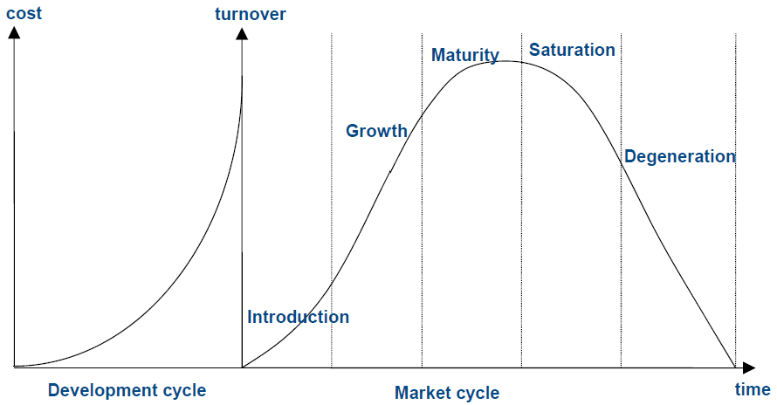

* attractive to prolong the life cycle in the saturation phase
  + target: keep turnover high / make it not fall down
  + How to
    - Price: lower, low-rate financing, individual discounts
    - Product: look for reasons for decline, innovation / adaption, wishes / needs of customers
    - Promotion: new campaign, new message
    - Place: different channels / countries 🡪 Internationalisation

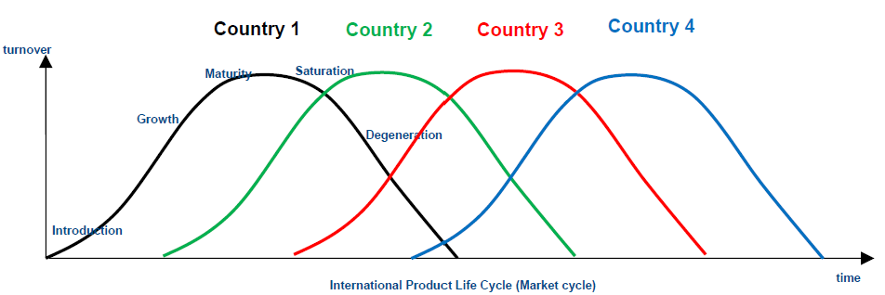

* Attractive to prolong the life cycle
  + development & research very costly 🡪 more profit within longer time
  + economies of scale = lower cost per piece over time / the more pieces are produced
  + learning curve

#### Introduction phase

* + Product unknown = high market resistance
  + Low turnover
  + No or few customers
  + Offers only in basic version
  + High costs for: production, distribution network, advertising, sales promotion
  + Marketing activities: introduction of product, building up sales and distribution channels 🡪 no profit

#### Growth phase

* + Increasing growth of turnover, due to
    - delayed impact of early advertising activities
    - growing product acceptance by larger segments
  + still high advertising costs
  + growing profit
  + more competitors 🡪 product imitations
  + Marketing-activities: improvement of quality, creation of consumers´ preferences

#### Maturity phase

* + still growing turnover
  + sustainment advertising
  + profits decrease
  + many competitors
  + Marketing-activities: small variations of product (e. g. face lift), increase loyalty of customer groups for product or/and brand

#### Saturation phase

* + stagnating or slowly decreasing turnover
  + search for new markets
  + growing frequency of use
  + slowly decreasing profit
  + end of this phase = decreasing profitability
  + number of competitors stagnating or reducing
  + Marketing-activities: reduce the drop of turnover and sales quantity, extension of the PLC if possible
    - Increasing frequency of use (promotion, extension of sales units, increase of distribution channels)
    - Development of new product applications (enlarge-ment of suitability, new application for existing product)
    - Winning new customers (approach competitors´ consumers = aggressive, address new customer groups or countries)

#### Degeneration phase

* + increasing danger of loss (neg. profit)
  + further decline of turnover
  + less contractors
  + numbers of customers decrease
  + Marketing activity: product elimination (Tools: Portfolio / ABC)
* Typical challenges and difficulties of applying the PLC Model
  + unknown duration of product cycle
  + course is not known beforehand (flat, steep, long, short)
  + duration of phase depends on product and is always different and therefore cannot be foreseen

## Analysing the strategic situation

### SWOT

* + - Strengths, Weaknesses, Opportunities, Threats
    - Potential analysis (Resources, activities, offers) +

Competitive analysis = SW

* Base: Comparison with competitors (better or worse); e. g. price, customer care, design, function, security, image
* Relative Market Share = Competitive Advantage = Where on EoS-Curve / Learning Curve?
  + - Market analysis (industry development, technology, customer segments) + environmental analysis (PEST) = OT
      * Market growth = Where on PLC?
    - Result: competitive position
    - Visualize the results: create a map of products
      * Two variables: Market Share + Market Growth
      * 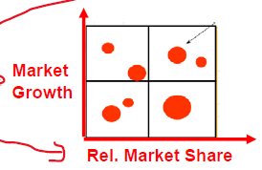

### BCG-Portfolio

* + - Market share + Market growth
    - Question marks, stars, poor dogs, cash cows
    - Shows strategies for products
    - Good: Stars, (Cash Cows) / Bad: Poor Dogs
    - Good portfolio: products in every category / bad portfolio: only poor dogs and stars
    - Relationship BCG to PLC
    - 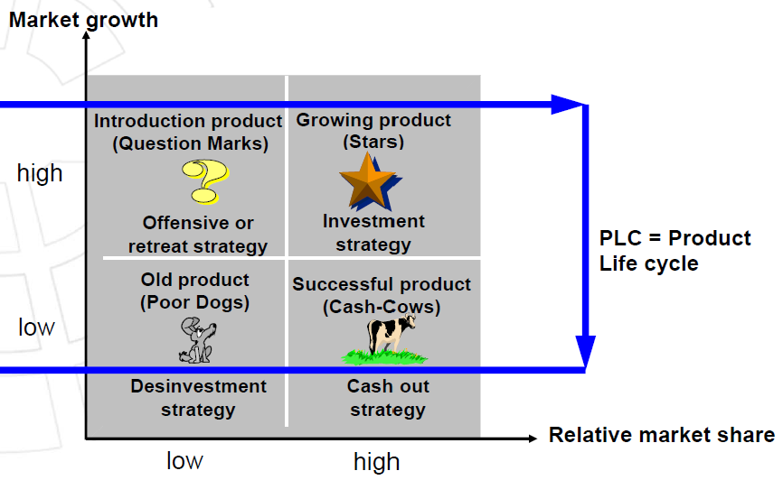

## McKinsey Portfolio Strategy

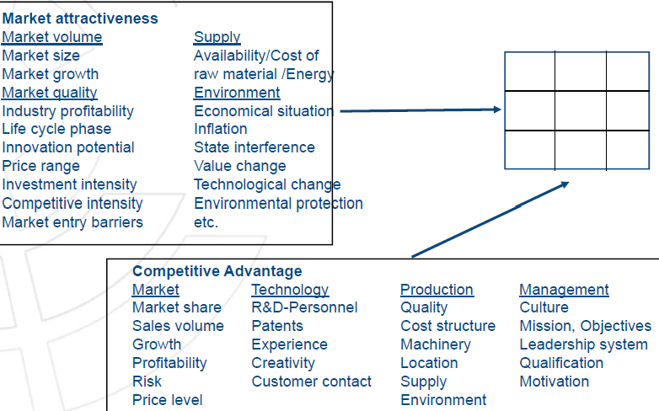

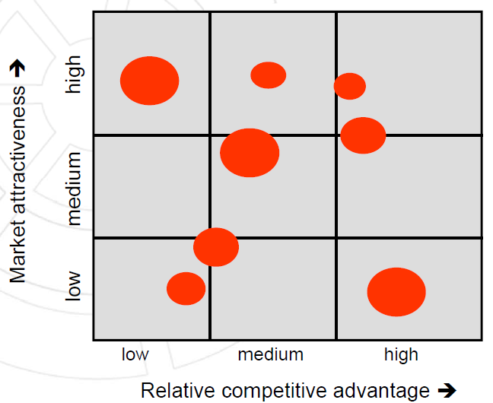

* Based on market attractiveness and competitive advantage
* Main advantage to BCG: all variables from SWOT can be weighted and included into portfolio matrix 🡪 visualized for strategic decision making

## Strategic Business Units (SBU)

* + relatively autonomous division of large company operating as indepen-dent enterprise with responsibility for particular range of products/activities
  + 4 principles
    - Market principle = external customers and competitors
    - Cluster principle = internal homogenous, external heterogenous
    - Leadership principle = entrepreneurial, independent
    - Synergy principle = positive relationship

## Ansoff´s Product-Market Strategies / Ansoff matrix

* + Two variables: Are markets/products existing or new?

Ein Bild, das Tisch enthält.

## DeWIT & Meyer‘s Inside-Out / Outside-In Strategies

* Inside-out
  + Resource-based
  + inner strengths & capabilities of organisation will make organisation prevail
  + effective use of company resources and core competencies as main driver of shareholder value
  + belief: company achieves greater efficiencies and adapts more quickly to changing circumstances with this approach
* Outside-in
  + Market-based
  + customer value creation, customer orientation and customer experiences are keys to success
  + listening and providing value to customers and helping them get their jobs done better than competitors
  + providing a seamless customer experience
  + organisational culture is market-oriented and customer-oriented
  + targeted customer segments as source of inspiration and development
  + belief: if the customers aren’t satisfied with the solutions offered, the business will suffer and the shareholder value will diminish

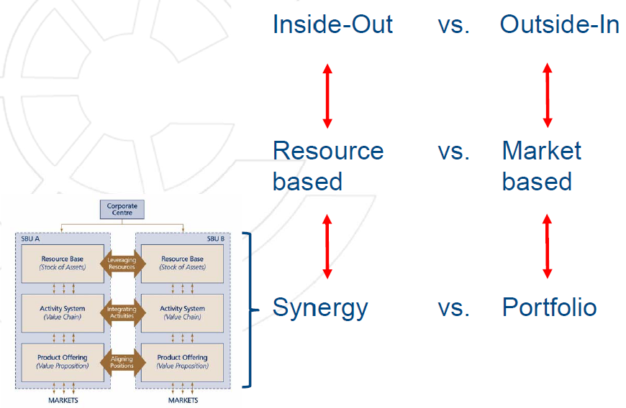

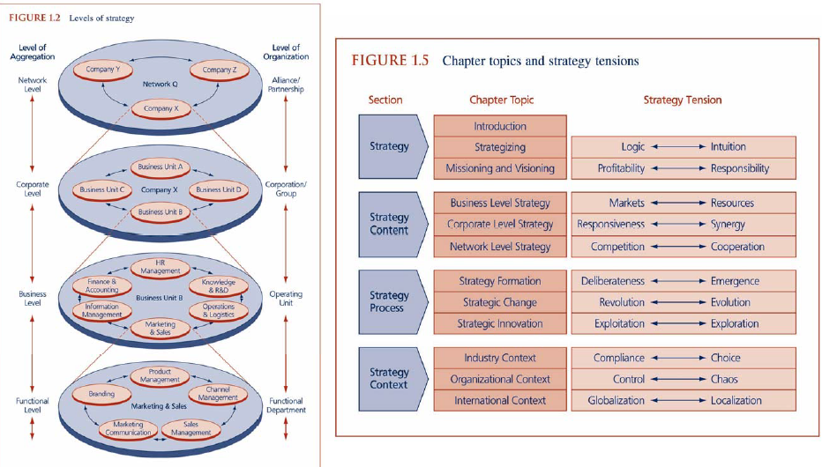

## Blue Ocean / Red Ocean Strategy

* + Red Ocean
    - markets with strong rivalry
    - focus on differences to others: CCA, USP, target groups, customer experience, branding, price
    - much assertiveness needed
    - last mover
  + Blue Ocean
    - Entering new markets / no competitors
    - Newly created by companies
    - Pioneers
    - First mover

# Product

## The product value concept

* + Values have different levels
  + Core value = purpose or functionality
  + Additional values (integrated in product, cannot be put away) = brand, packaging, quality, characteristics, styling, ergonomics
  + Additional values (on top; often offered by other companies together with product) = Installation, after sales service, financing, warranty

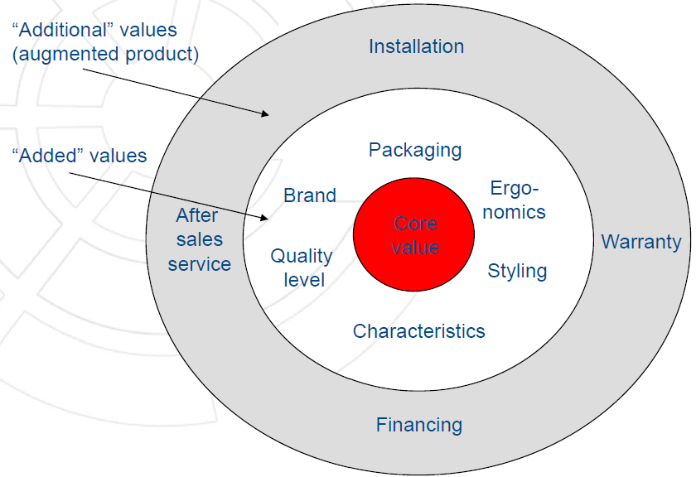

## 6 steps of product innovation process

1. Problem recognition
2. Search for ideas
3. Selection / Evaluation
4. Strategy development
5. Operational management
6. Market entry

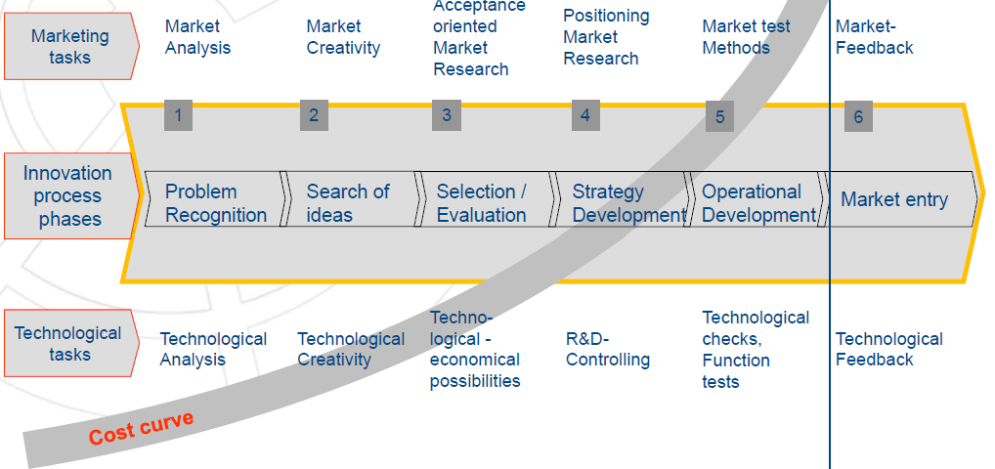

# Branding

## Why pay customers more for brands?

* + Customers know product already 🡪 easier choice / sweet memories from childhood
  + Customers know what they get
  + Brands stand for quality / specific value
  + High recognition in society / connection to society level / status symbol

## Value of brands from customer point of view

* + Branded goods
    - Stable good quality profile
    - Ubiquity (overall availability, can get it everywhere)
    - Image (identification)
  + Values of branding
    - Security, risk reduction
    - Less cognitive effort, easier decision making
    - Demonstration consumption
    - Brands signal membership of certain social group
    - Brands become substitutes for cultural values

## Brand value calculation

* + No unique formula 🡪 different calculations / mostly secret
  + 3 ingredients
  + Brand equity
    - Financial evaluation based on mixed approaches
    - Ex.: Cash value of all assumed future profits of the brand
    - Ex.: Accumulated investment costs of the brand building (e. g. costs for ads)
  + Goodwill / Image value (customer view)
    - Immaterial value of the brand through its added value (mostly evaluated by piece, but quantifiable as „brand equity“)

## Sender Brands

* + Use of common company-related image dimensions (= added values) (e. g. Henkel) 🡪 also put Henkel Logo in ads
    - Company behind brand present its own identity on top of the product brand
    - + customers trust competence 🡪 transfer/relate to other product brands in same industry
    - - competence not stretched to other branches (e. g. Henkel = household chemicals vs. Schwarzkopf = hair products)
  + Region can stand for certain characteristics (e. g. Rioja in Spain)
  + No sender brand = no joint company value communicated to customers (e. g. Beiersdorf)

## The Country-of-Origin Effect

* + History
    - Mid/End of 19th century:
      * Germany = industrial development country; floods the more developed British market with cheap, low quality copies of British brand products (electrical-and household appliances, chemical products)
      * Reasons: Agriculture based, low wages, little R&D, little investment & innovation
    - World exhibition in Philadelphia 1876:
      * German juror criticised low quality German products „cheap and bad“ [Few exceptions 🡪 Beck’s]
    - Great-Britain August 23th 1887:
      * Revision of „Merchandise Marks Act“ forces German producers to label export products as “Made-in-Germany”
    - Great Britain February 3rd 1916:
      * In the course of the world war I the law was extended to import products from Austria/Hungary
    - After the introduction in England
      * British households discover German products among their daily used articles
      * After quality improvements: “cheaper, more attractive and artfully made” or “easier and quicker in delivery”
    - In Germany:
      * criticism of the juror in Philadelphia shows effects at home: Investments in academic and practical education, Investment in R&D, Innovation and modern production machinery 🡪 Much improved product quality
    - “Made in Germany” used as quality seal:
      * Germans attach „Made-in-Germany“ on all export
      * products as well as on homeland products to use the meanwhile positive brand effect
    - Today
      * German Quality Association: Reliable, durable, affordable, craftmanship, manufacturing quality
      * taking customer and employee perspective into account
  + **„CoO-Label“ serves as added value similar to a sender brand**
  + Specific stable quality characteristics, that can be added to the product, service or “offer” -value
  + image dimensions relevant for customer often are oriented towards **country specific stereotypes** and are influenced by up-to-date **news**
  + Which factors contribute to a country image?
    - economic power
    - technological progress
    - perceived wealth index (Income level, rich individuals etc.)
    - legal stability (intellectual property laws etc.)
    - modern government form and structure (working democracy)
    - industrial history
  + When does the CoO effect work?
    - only if target group holds significant competence perception about CoO
    - Research: How do certain customers react on country of origin?
      * Age, gender, social status, education level, ethno-centrism etc.
    - How important is the country for certain product categories?
      * Influence of tradition and quality / competence attribution
    - Level of development and degree of globalisation
      * important influence of news broadcasting

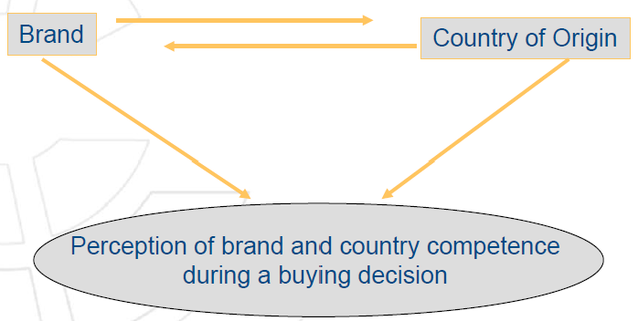

# Price

## What is a price?

* + Agreement between buyer and seller = contract
  + As marketing mix instrument: only price OFFER

## Pricing strategies

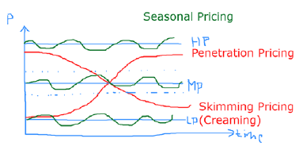 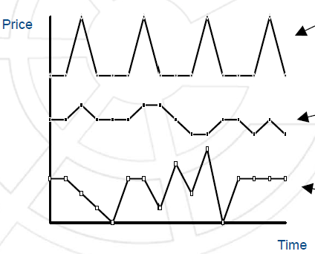

Seasonal

Pulsating

Flexible

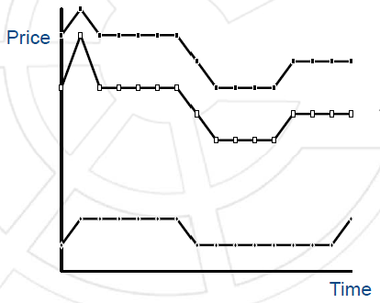

Leadership

Follower

Fighter

* + Fixed (middle to long-term basis)
    - High
    - Medium
    - Low

🡪 Specific price level over time

* + Flexible / Dynamic
    - Penetration (foot-in-the-door = low introduction price that increases; typical for followers / late to market)
      * For monopolists on mass markets or late to market
      * Low introduction price = sales increase
      * Low fix costs per unit because of economies of scale
      * Low profit range keeps competition from market
      * Price increase when target market is reached

🡪 Used to quickly build market share

* + - Skimming (high introduction price that decreases; typical for market leaders / first to market
      * High short term profit
      * Slow building of production capacities
      * Fast return on development costs
      * Margin for price reduction
      * Price differentiation over time
      * High quality image because of high introduction price
      * Positive image effects because of price reductions
      * Profit margins invite competition

🡪 used to maximize short term ROI

🡪Price follower strategies describe typical competitive price developments over time

* + - Seasonal (e. g. fruits, tourism)
    - Pulsating (used to establish long-term price changes, e. g. electronics market)
    - Flexible (quick reaction to market developments)

🡪 React flexible on market or environmental changes

* + Price differentiation
    - Customer groups; e. g. students, insurances
    - Time = of sale or consumption; e. g. movie tickets, airline tickets
    - Regional (international) = region or sales location; e. g. import products, cars, airport shops

🡪 draws on differing price acceptance by customers

🡪 same product is offered at different prices

* + - Marketing mix instruments (PPP)
  + Price competition strategies
    - Leadership = achieves highest price (preference strategy)
    - Follower = defines price just below price leader
    - Fighter = offers lowest price (mass market strategy)

🡪 rely on supplier dominance (superior power position)

* + Price following strategies

## Price building

* + Cost based = direct costing
    - Procedure
      * Separation of fixed and variable costs
      * Estimation of the price response function (PRF)
      * Calculation of optional sales revenues
      * Contribution margin = sales revenues - variable total cost
      * profits = contribution margin - fixed costs
      * Defining a minimum profit
      * If profit > minimum profit: final adjustment of offering price
    - Advantages
      * Easy to handle
      * Few information needs
      * Based on price ethics
      * Base for price argumentations to customers
      * Based on company situation
    - Disadvantages
      * Sales volume depends on price
      * Imprecise distribution of overhead costs
      * inflexible
    - Calculation

Production material + materials overhead = material costs

+ manufacturing wages + manufacturing overhead + special direct manufacturing costs = manufacturing costs

+ administration overhead costs + sales overhead costs + special direct costs sales = cost of sale

+ imputed profit = cost base price

🡪 necessary but not sufficient for market-oriented pricing

* + Competitive
    - Information base: competitive prices + quality and image differences
    - Price building: adjusting to industry price 🡪 price leader, follower or fighter
  + Customer based
    - Information base: value perceptions and price acceptance, structure of customers, psychological information and specialties
    - Price-Response-Functions / Elasticity
      * Shows sales in response to sales prices (market reaction)
      * Elasticity
        + Defines how sales quantities react to relative price changes
        + 0 = totally inelastic = no changes in quantity
        + -1 = green = same reaction
        + – forever = totally elastic

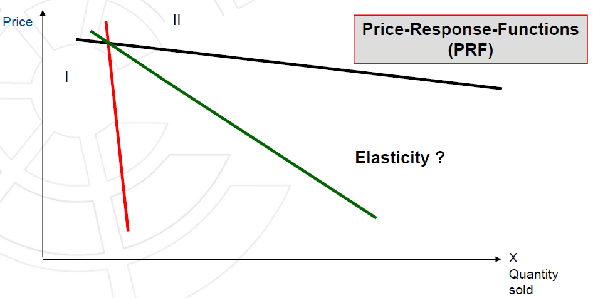

Red = changes in price hardly effect the quantity sold 🡪 necessary products (e. g. medicine) = not elastic

Black = changes in price significantly effect the quantity sold 🡪 luxury products (e. g. vacation, jewellery) = elastic

Green = mixture of both

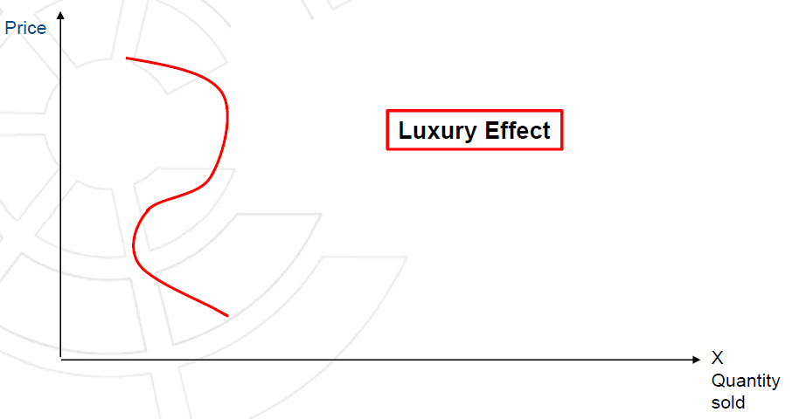

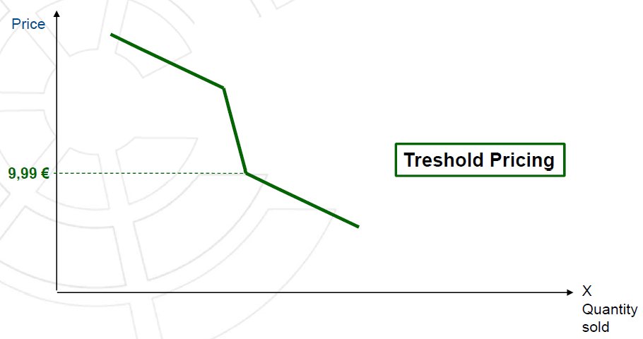

Threshold pricing: psychological fixing of prices to entice a buyer up to a certain threshold at which the buyer will be lost anyway

e. g. $9,99 / $10,99

choose the lowest price before losing customers

* + Mix = target costing / design-to-cost

## Price-oriented or price-related quality perception

* + Customers tend to evaluate quality according to price
  + Effect of price-oriented quality perception increases
    - more difficult the quality judgement before purchase
    - Bigger the quality differences
    - Less information available on quality
    - Insecure the customer
    - Bigger the buying risk
    - Bigger the time pressure

# Place

## Distribution Channel Management / forms of direct and indirect distribution

* + Direct
    - Internal
      * CEO / Management
      * Sales Force
      * Outlet
      * Internet
    - External (also Internet)
      * Sales Representative (works for only one firm)
      * Commissioner
      * Agent (works for different firms)
  + Indirect = Trade (also Internet)
    - Wholesale
    - Retail
    - Export/import trade

## Franchising

* + Combines advantages of direct and indirect distribution
  + vertical contract-based form of distribution
  + franchisor grants franchisees right to distribute his products or services
  + strictly defined rules and regulations 🡪 franchise handbook
  + Franchisor = producer
    - Responsibilities
      * Brand and business building
      * Workable business concept handbook
      * Investing in international branding
    - Advantages
      * Direct customer contact
      * Full control over marketing mix
      * Receives up-front fee and monthly % payments
      * No investment in distribution system
  + Franchisee = distributor
    - Responsibilities
      * Invest in local facility
      * Set up and run local operation
      * Pay the up-front fee and monthly fees
    - Advantages
      * Participation in successful brand
      * No own creative skills needed, only op management
      * Easier access to bank loans
      * Business processes already defined
  + Examples: TUI, 7Eleven, Dunkin Donuts, McDonald´s, Schülerhilfe, Kamps, Subway

# Promotion

## Promotional Tools

* Multi-Channel-Options
  + Advertising (online / offline)
  + Sales promotion and events
  + Dialog / Direct marketing / Mailings
  + Fairs & Exhibitions
  + Conferences & Training seminars
  + Product Placement (not acceptable / illegal in Germany)
* For products/services
* Internet
  + Media, sales and delivery channel at the same time
  + Company website, online advertisement etc.
* Promotion of products/services or company as a whole
* Promoting the company as a whole
  + Corporate Identity
  + Public Relation / Newsletters (positive topics of public interest)
  + Sponsoring (with detailed return)
  + Lobbying
* Sponsoring
  + Typical areas: Sports, Culture (Arts, Music, Festivals), Science (foundations)
  + Main aspect is “reciprocity”: The sponsored person/institution has to engage in clearly defined activities in return
  + Name or show the logo of the sponsor …
    - on printed devices (brochures, flyers, programmes roll-ups)
    - on shirts
    - on caps
    - in interviews (e. g. TV-Interviews after soccer games)

## Matching target groups and tools

* Target groups: consumers, employees, sales force, shareholder, trade, suppliers, financial markets, trend setters, media, communities
* Tools: Advertising, PR, Sales promotion, Sponsoring

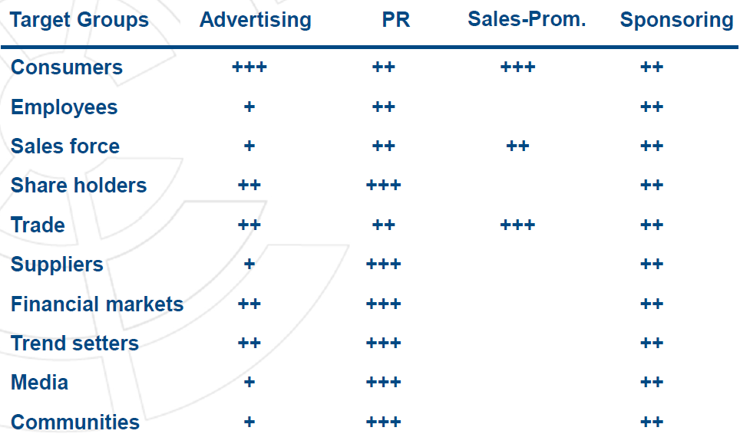

## Push and Pull

* Push
  + Sales promotion
  + Activities directed to sales force, Trade partners, Customers
  + “below-the-line”
* Pull
  + Advertising
  + Mass-media communication (influencers)
  + Address customers only
  + “above-the-line”
  + Motivate different players (incentives, events, trainings, contests etc.)

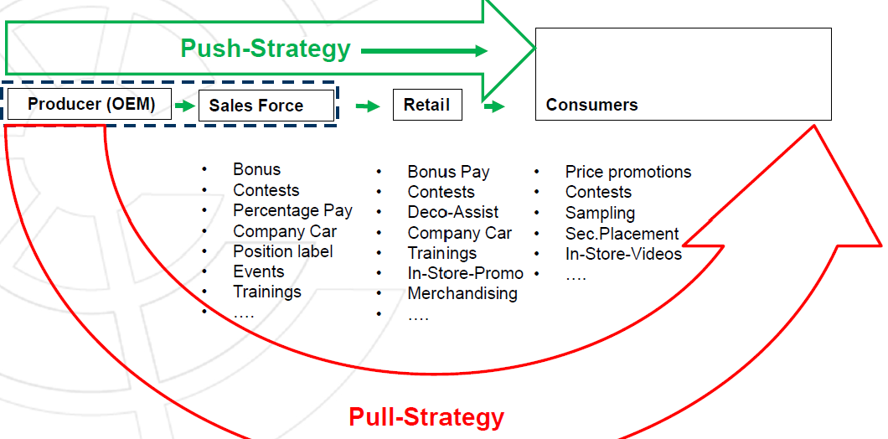

* Best: combination of push and pull strategy = products are available when the customers require them in the shops

## Advertising

### Planning process

* + Identify and analyse targets
  + Define objectives
  + Create platform
  + Determine budget
  + Develop media plan
  + Create messages
  + Execute campaign
  + Evaluate advertising effectiveness

### Objectives / Targets

* + Relate Information (Information strategy / Reason-why-campaign)
  + Build and maintain trust and confidence (Trust strategy)
  + Create a positive attitude (Image strategy)

### Budget – methods

* + Affordable method 🡪 management defines amount they can afford 🡪 - difficult planning, only reactive
  + Percentage of sales method 🡪 promotional expenditure are certain % of sales 🡪 + simple 🡪 - interdependence sales / promotion are changed
  + Competitive-Parity method 🡪 budget defines by generating a “share of voice” parity with competitors 🡪 + simple 🡪 -/+ collective wisdom
  + Objective and task method (goal-oriented, typical for market entry) 🡪 budget defined by specific objectives and cost estimates for measures planned 🡪 + management has to commit on target budgets, - estimations difficult (unclear advertising response function = shows effect of budget of ads spent on the % of market share)

### Advertising agency – briefing

* + Situation
    - Current situation: Market volume / Market segments, Competitors (products, advertising), company products, current relative positioning, current communication concept
    - Future requirements: Product positioning, Communication strategy (Target groups, goals concerning consumer behaviour, budget for media and design, timing strategy)
* Give them all the information from the midnight picture
  + Questions
    - Why do we advertise?
    - For which product?
    - Which result do we want to achieve?
    - Who should be addressed?
    - Where should be advertised?
    - How is the budget?
    - Which media should be used?
    - What should be communicated?
    - When should be advertised?

### Media plan

* + Based on different media (Facebook, LinkedIn, Instagram, newspaper, radio, magazine) and Time (week 1, 2 etc.) 🡪 plan for activities + total costs
  + Key figures: OTH = opportunity to hear = how many and which people are listening, OTS = opportunity to see = how many and which people could see, Reach, circulation (how many print copies), frequency (how often, e. g. weekly), number of contacts, contact costs

### Message design / Eye tracking

* + Eye-tracking
    - Put equipment on people´s head & let them walk through shops
    - Result: areas looked at (red = most / yellow =some / green = few)
  + Step 1: Scanning for visual keys (right brain) 🡪 images, headlines, keywords, direction of reading
  + Step 2: Reading (left brain) 🡪 transform syllables, words, sentences into information
  + Step 3: Reacting 🡪 e. g. eye movement tracker
    - Eye-tracking results: psychologically ideal structure of flyers, ads etc.

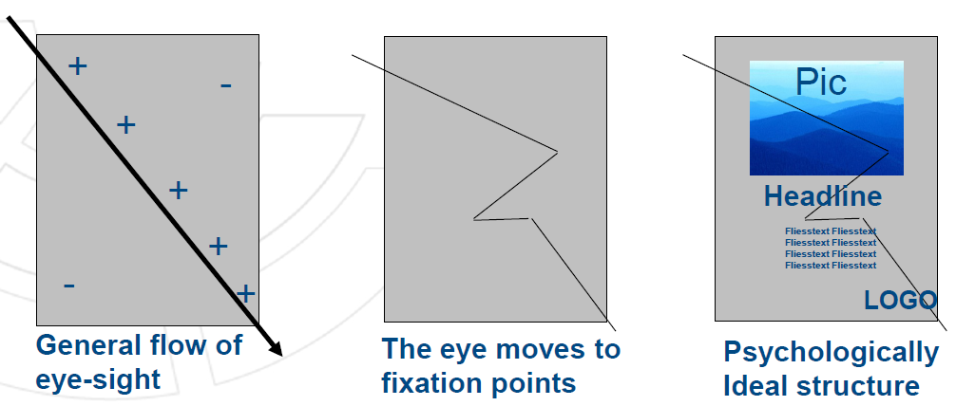

* + - * + Direction of vision (upper left to under right)
        + Fixation points: eyes stay there for a few seconds
        + Ideal: Picture first (attention), Headline (interest), Text (desire), Logo (action)
* Global advertising campaign
  + Differences based on culture (e. g. beauty ideals, language, direction of reading / eye-movement)
* Mailing / Letters
  + Design: address and logo of sender – address of recipient – headline – personal situation – text – signature – P.S.

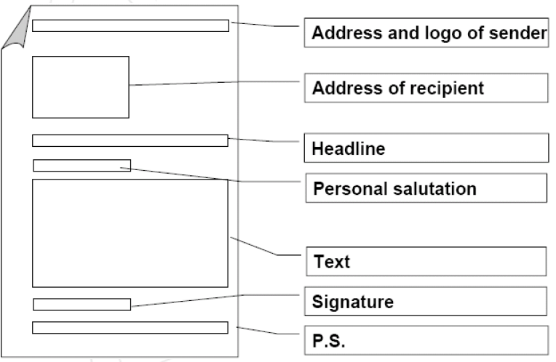

* + Design based on AIDA principle
    - Headline: Attention 🡪 most important benefit 🡪 reader is interested and continues reading
    - First Paragraph: Interest 🡪 enlarge most important benefit 🡪 reader thinks about product
    - Main Part: Desire 🡪 tell readers specifically what they get, back uo statements with proof (testimonials, scientific proof, experts), tell readers what they lose if they do not act 🡪reader develops set of expectations, credibility is increased, human tendency to defer action
    - Closing: Action 🡪 rephrase prominent benefit and call for action 🡪 reader is ordering/buying the product
    - P.S.: Action 🡪final key message (restate the offer for immediate action) 🡪 reader of only reads headline and P.S.
* KISS-principle
  + Keep It Short and Simple
  + Short: short words (1-3 syllables), short sentences (average 12 words), short paragraphs (1-2 sentences).
  + Simple: no jargon, no complicated technical terms, no technical details
  + Always keep in mind target group!
* Bill boards and city lights

### Control

* What was addressed in advertising?
  + Cognitive, emotional or behavioural level?
  + Attention, Interest, Desire or action?
* Options
  + Recall
    - Unaided recall: open questions
    - Aided recall: list of options
  + Recognition
    - Showing the ad
  + Panel Research