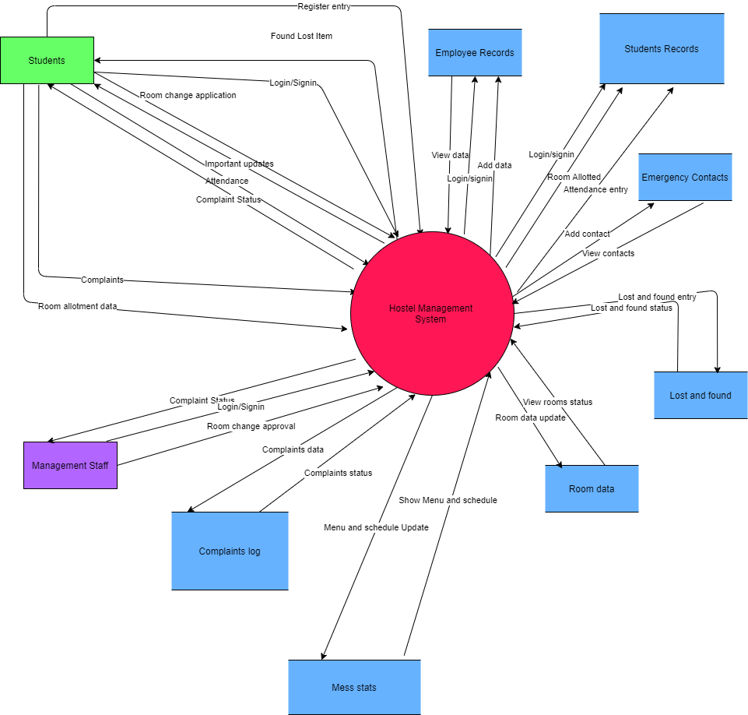



CONTEXT DIAGRAM /LEVEL 0 DFD

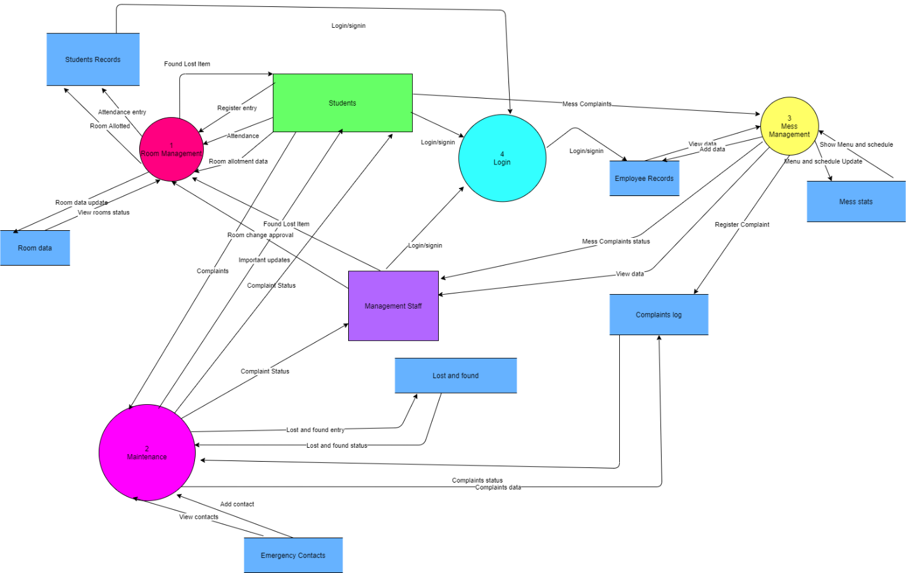



Level 1 DFD

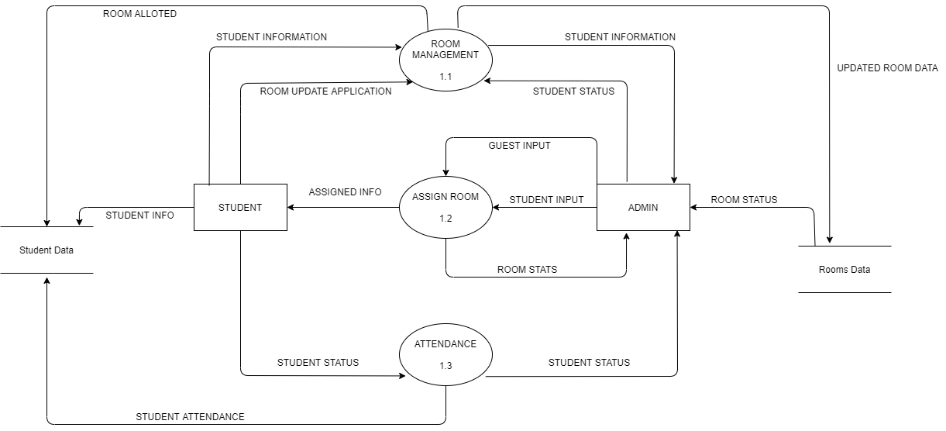



Level 2 Room Management DFD part

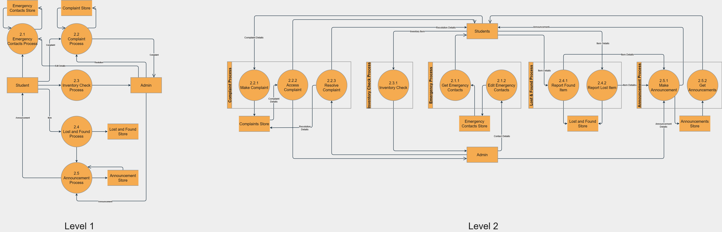

Level 2 DFD Maintenance part

Level 3 DFD Maintenance part

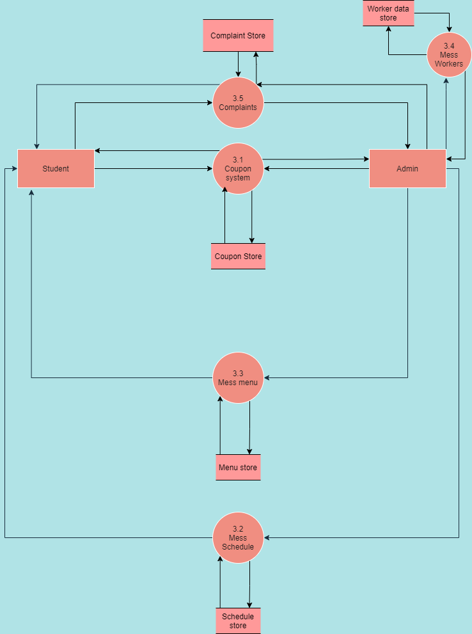

Level2 Mess Management DFD

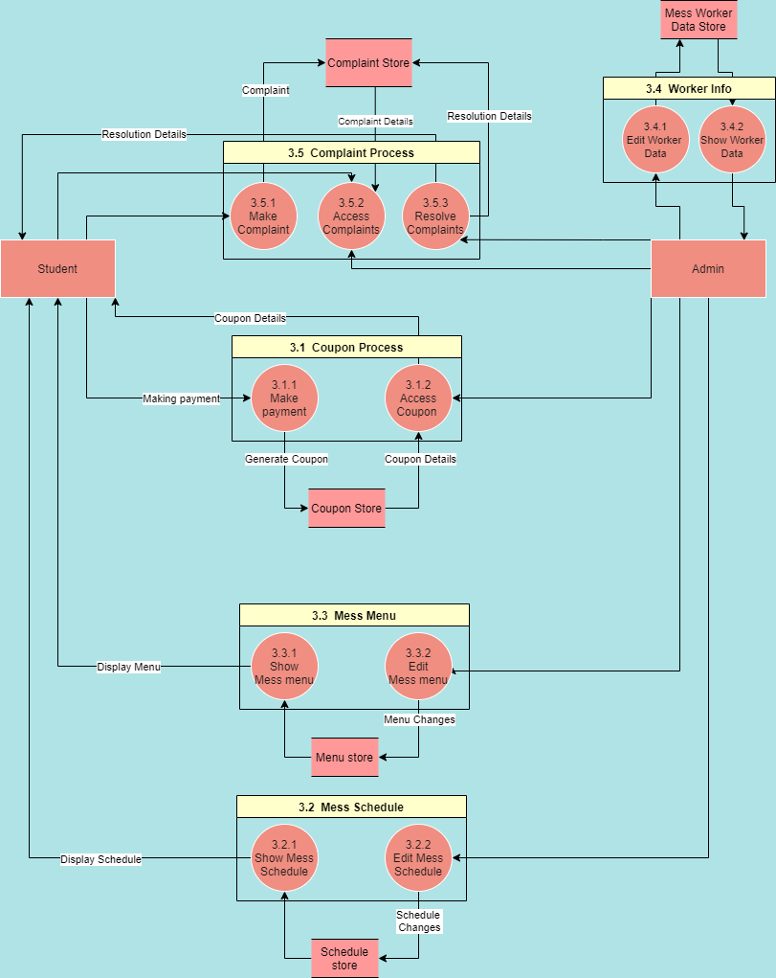

Level 3 Mess Management DFD

Processes Identified

1. Room Management
   1. Attendance data management
   2. Allocation of new rooms to freshers (Make random allotments)
      1. Lottery allotment
      2. Refresh room allocation data
      3. Room stats/Hostel stats
   3. Room Data update
      1. Room change applications
      2. Data update (contact info)
      3. Guest allotment if required
2. Maintenance
   1. Room Inventory Check
      1. Purchase
      2. Provide (and check availability)
   2. Announcement Section
   3. Lost and found
   4. Call (For Emergency ONLY) [Contacts of IMPORTANT PEOPLE]
   5. Room specific complaints(plumber,electricity...)
      1. Register Complaint
      2. View complaint status
      3. Rating
3. Mess Management
   1. Digital access to coupon whenever coupon system is applied
      1. Payment
      2. Coupon
   2. Mess schedule
   3. Mess menu
   4. mess workers related data(part functionality can be implemented)
      1. Add/Remove/Edit worker data
      2. Show worker data
   5. Complaints
      1. Register Complaint
      2. Access Complaint
      3. Resolve complaint

Additional requirements

Reporting bugs,suggesting app modifications

**Data stores**

Employee records

Student records

Rooms data

Lost and found

Emergency contacts

Mess stats (schedule and menu)

Complaints log

**Source/sinks**

Students

Management