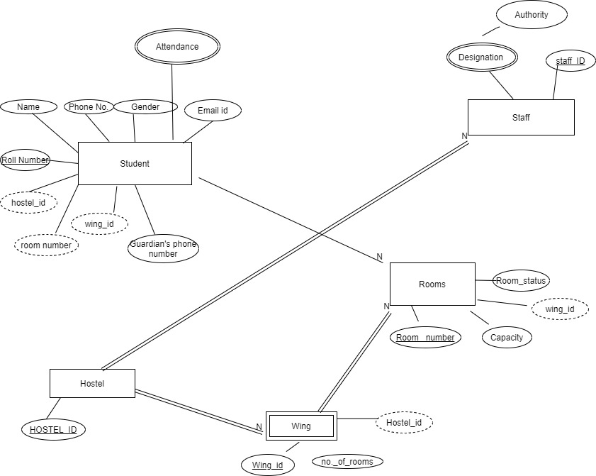

Entity relationship diagram for Room Management submodule.

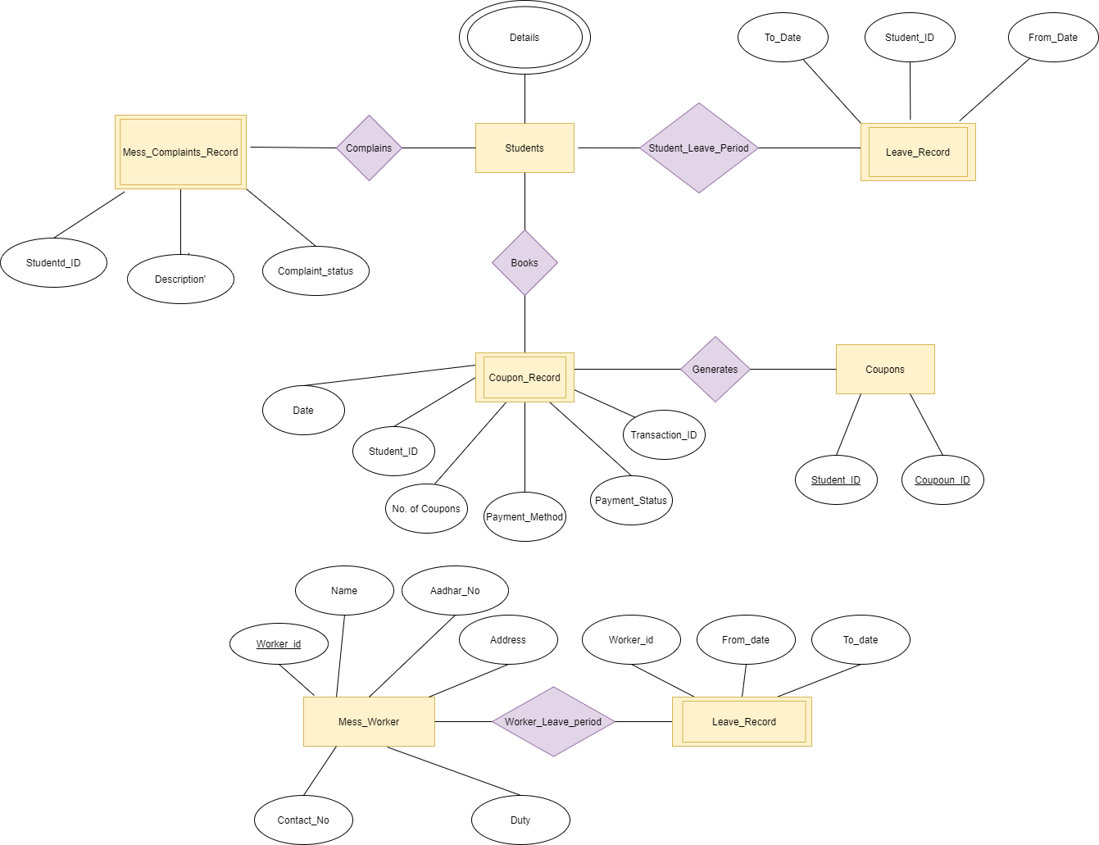

Entity relationship diagram for Mess management subtopic

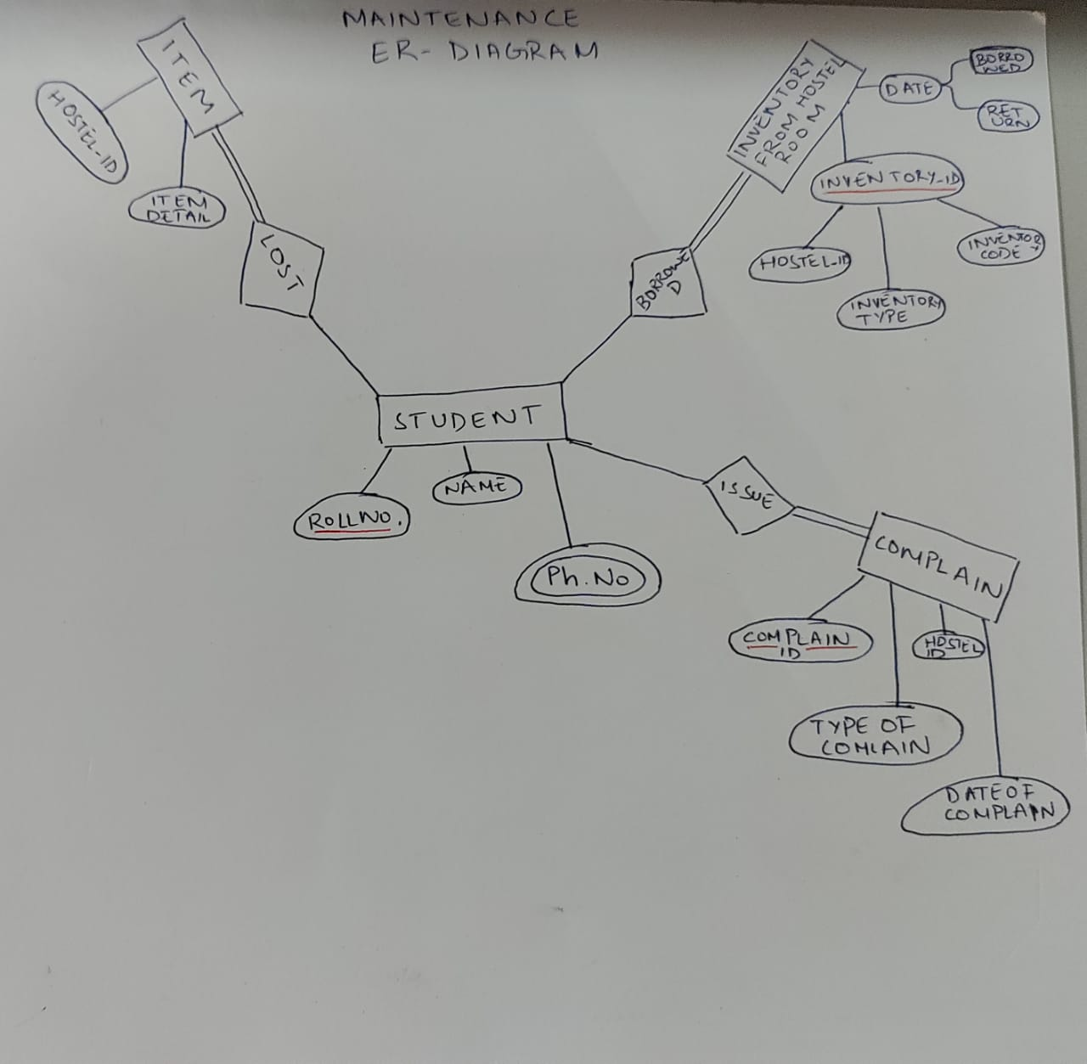

Entity Relationship diagram for Maintenance subtopic