**ISD Lab Group 3 Project**

Design submission for Room Management

Created by

|  |  |
| --- | --- |
| Rishabh Sahu | 19ucs129 |
| Bhavya Sehgal | 19ucs155 |
| Mayank Raj | 19ucs151 |
| Paawan singal | 19ucs153 |
| Siddhant Gupta | 19ucs106 |
| Abhishek singhal | 19ucs127 |
|  |  |
| Akshit Sethi | 19ucs104 |
| Warul Sinha | 19ucs119 |
| Tanay Makharia | 19ucs122 |
| Manan Pulinkumar Gandhi | 19ucs130 |
| Kush Gandhi | 19ucs131 |
| Jhanvi Thakuria | 19ucs132 |

**Index**

|  |
| --- |
| DFD |
| ERD |
| Class diagram |
| Database Schema: |
| MENU DESIGN |
| GUI DESIGN |
|  |

# **DFD**

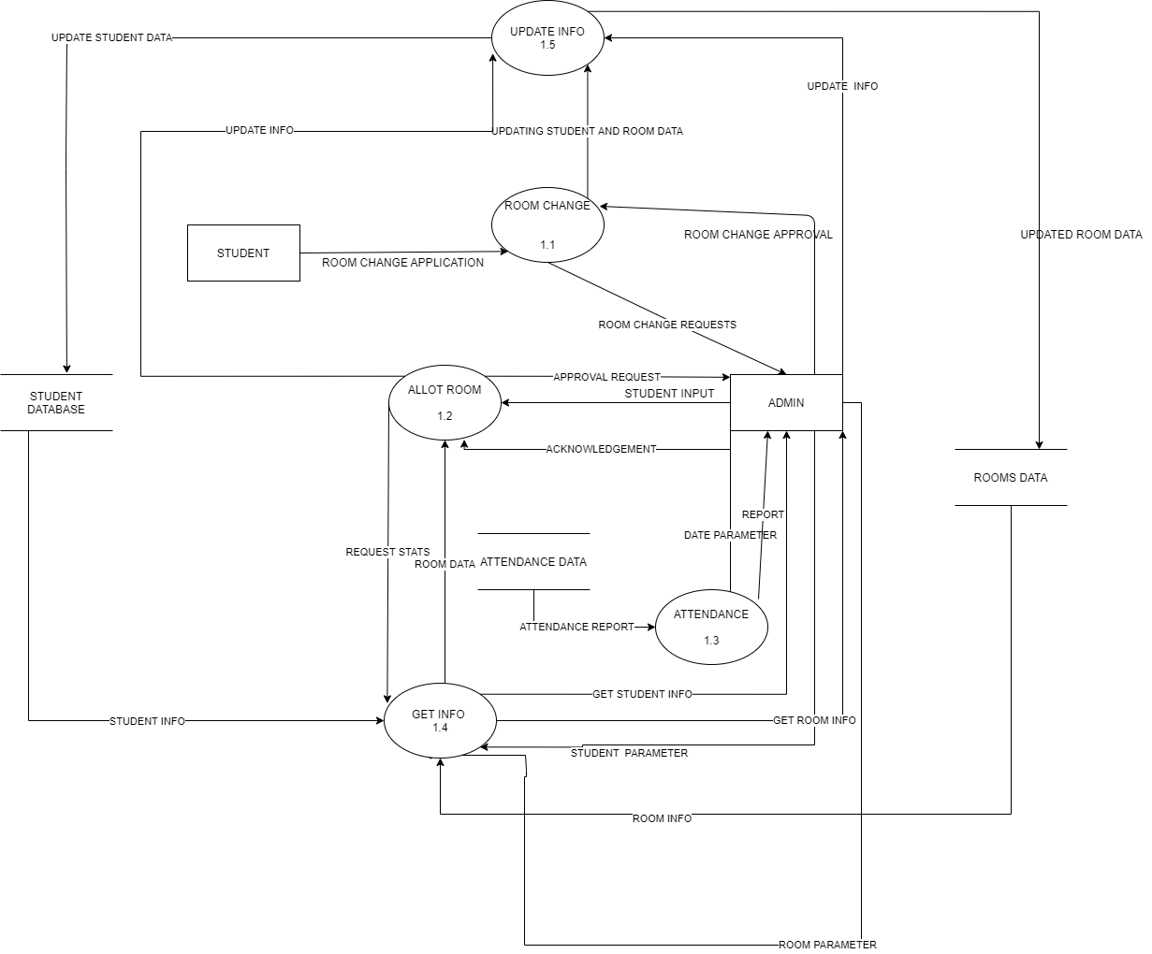

# **ERD**

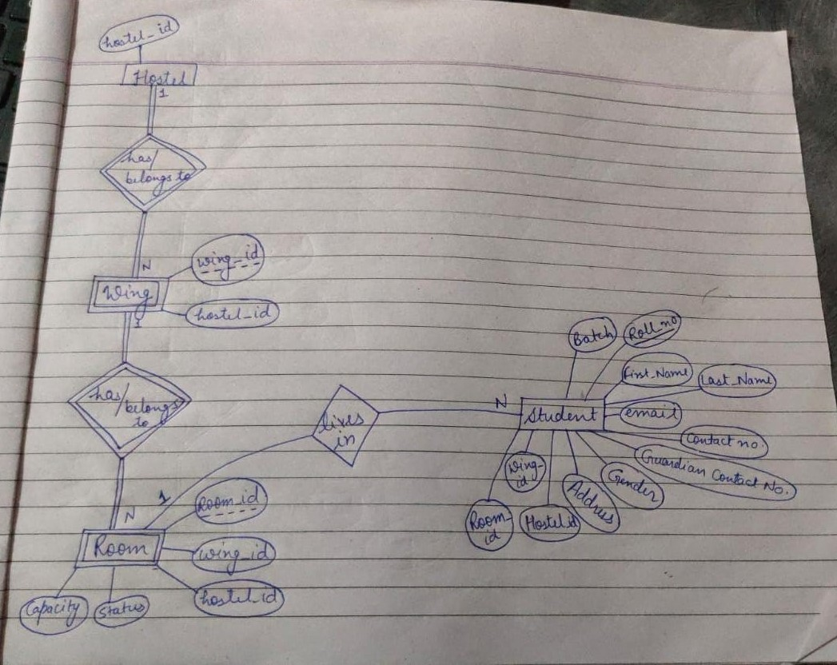

# **Class diagram**

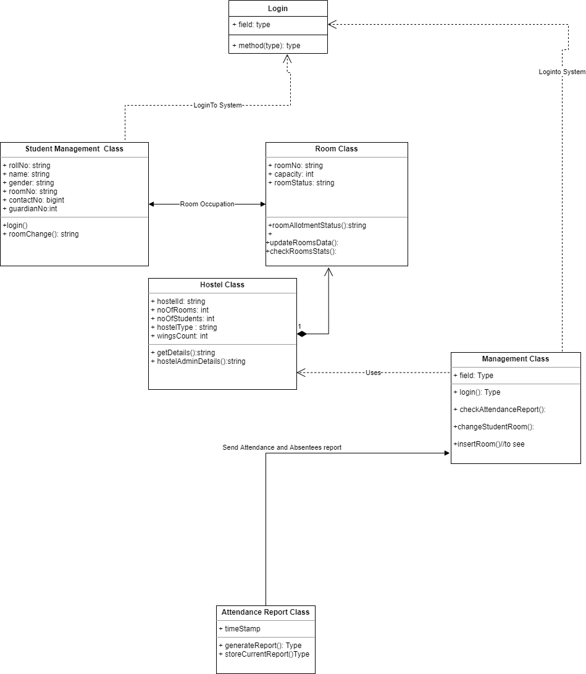

# **Database Schema:**

HOSTEL :

1NF, 2NF, 3NF

|  |  |  |
| --- | --- | --- |
| hostel_id(varchar(3)) | no_of_wings(int) | warden(varchar(20)) |
|  |  |  |

PK : hostel_id(varchar(3))

Note: considering only one warden per hostel (as per college id associated)

WING :

1NF, 2NF, 3NF

|  |  |  |
| --- | --- | --- |
| wing_id(char(1)) | hostel_id(varchar(3)) | no_of_rooms(int) |
|  |  |  |

PK : wing_id(char(1)), hostel_id (composite primary key)(varchar(3))

FK : hostel_id(varchar(3))

ROOM :

1NF, 2NF, 3NF

|  |  |  |  |  |  |
| --- | --- | --- | --- | --- | --- |
| room_id(char(3)) | wing_id(char(1)) | hostel_id(varchar(3)) | floor_no(int) | capacity(int) | occupancy(int) |
|  |  |  |  |  |  |

PK : room_id(char(3)), wing_id(char(1)), hostel_id(varchar(3)) (composite primary key)

FK : wing_id(char(1)), hostel_id(varchar(3))

STUDENTS :

1NF, 2NF, 3NF

|  |  |  |  |  |  |  |  |  |  |  |  |
| --- | --- | --- | --- | --- | --- | --- | --- | --- | --- | --- | --- |
| Roll_no  (char(8)) | f_name(varchar(20)) | l_name(varchar(20)) | college_email(varchar(21)) | contact_no(char(10)) | guardian_contact(char(10)) | Gender(char(1)) | Home_Address(varchar(50)) | room_id(char(3)) | wing_id(char(1)) | hostel_id(varchar(3)) | floor _no(int) |
|  |  |  |  |  |  |  |  |  |  |  |  |

PK : roll_no(char(8))

FK : room_id(char(3)), wing_id(char(1)), hostel_id(varchar(3))

Note: Only single contact_no, guardian_contact will be associated per student(roll no)

ATTENDENCE :

1NF, 2NF, 3NF

|  |  |
| --- | --- |
| datetime(DATETIME) | report.pdf(BLOB) |
|  |  |

PK : datetime(composite primary key)

# **MENU DESIGN**

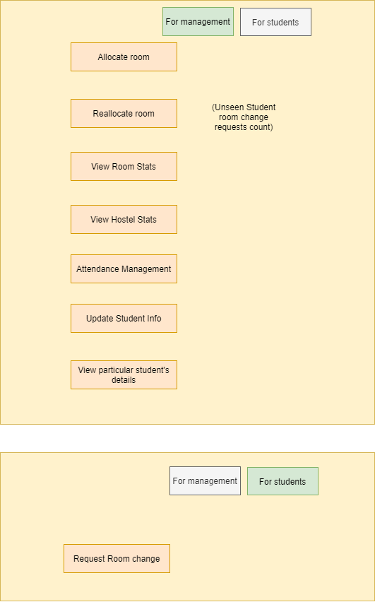

# **GUI DESIGN**

ROOM CHANGE GUI

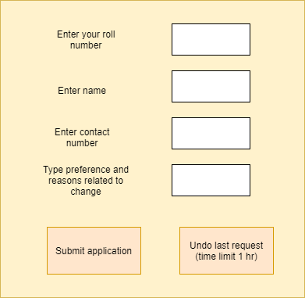

DISPLAY /SAVE ATTENDANCE REPORT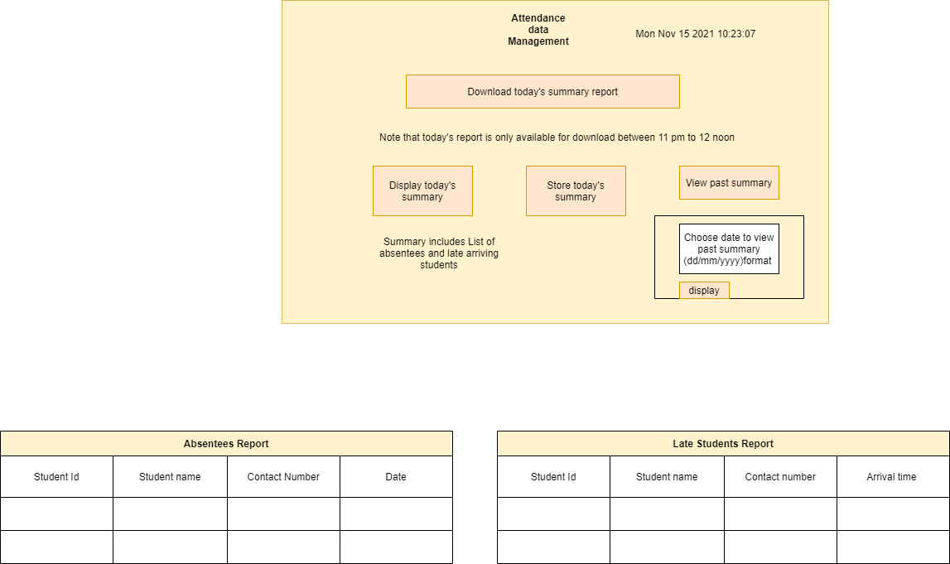

GET ROOM INFO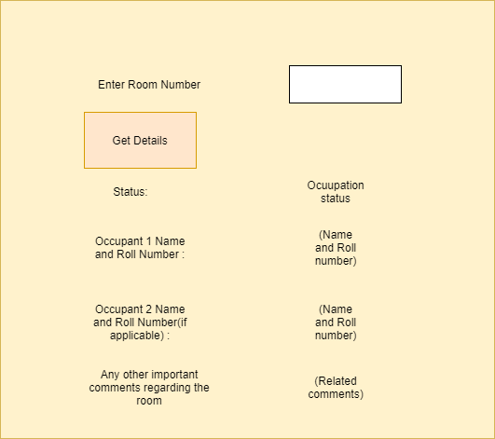

GET HOSTEL INFO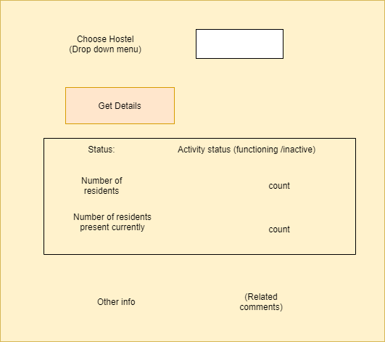

GET STUDENT DETAILS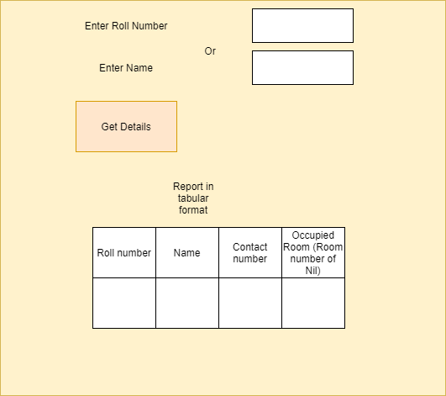

UPDATE STUDENT DATA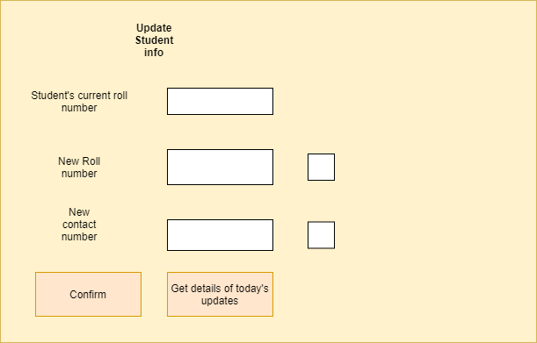

REALLOCATE ROOM

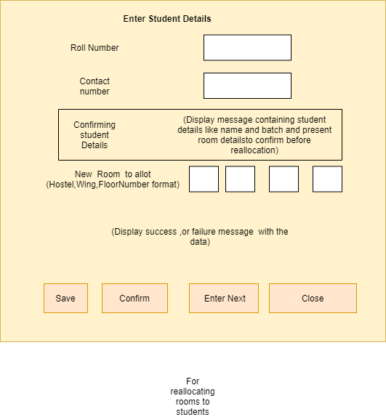

ALLOT ROOMS