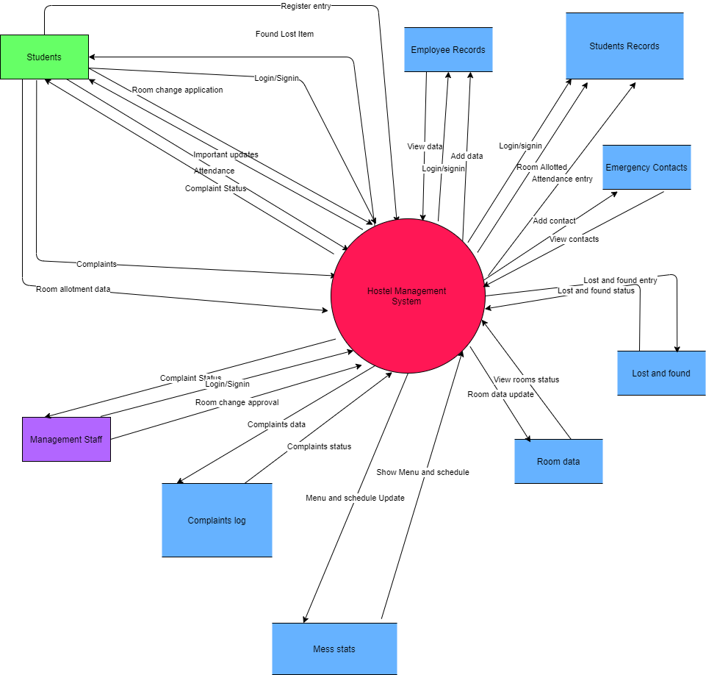
CONTEXT DIAGRAM /LEVEL 0 DFD

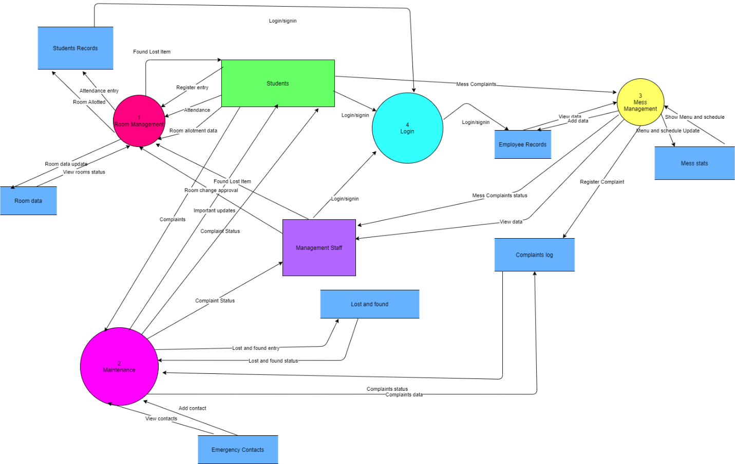

Level 1 DFD

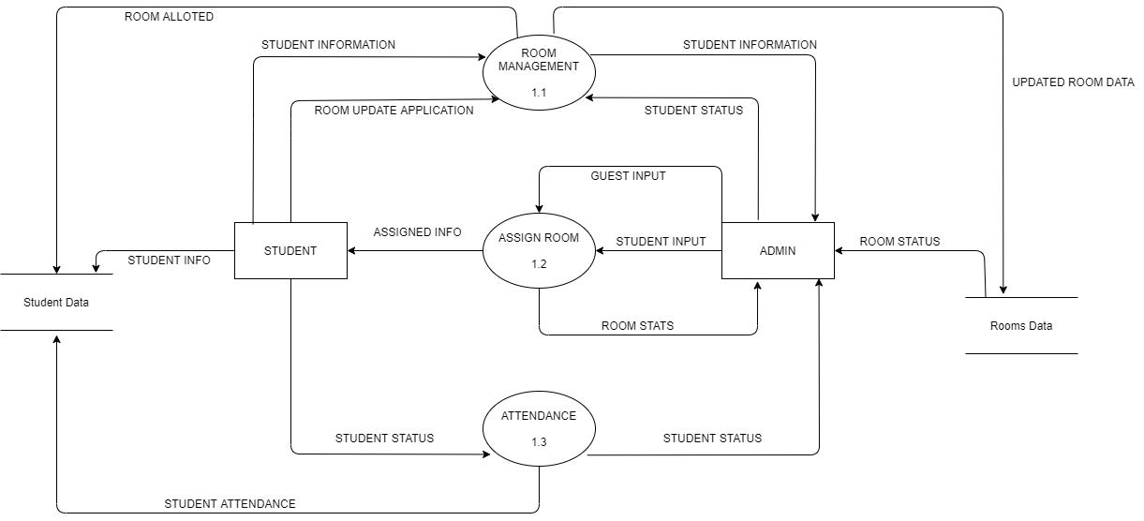

Level 2 Room Management DFD part

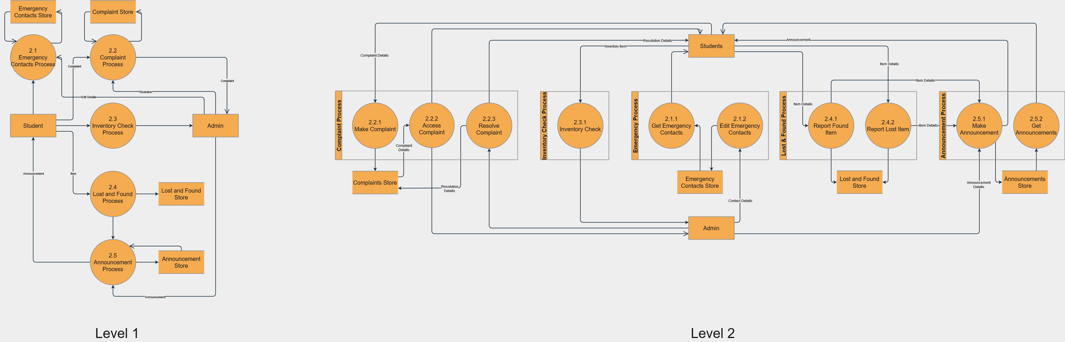
Level 2 DFD Maintenance part

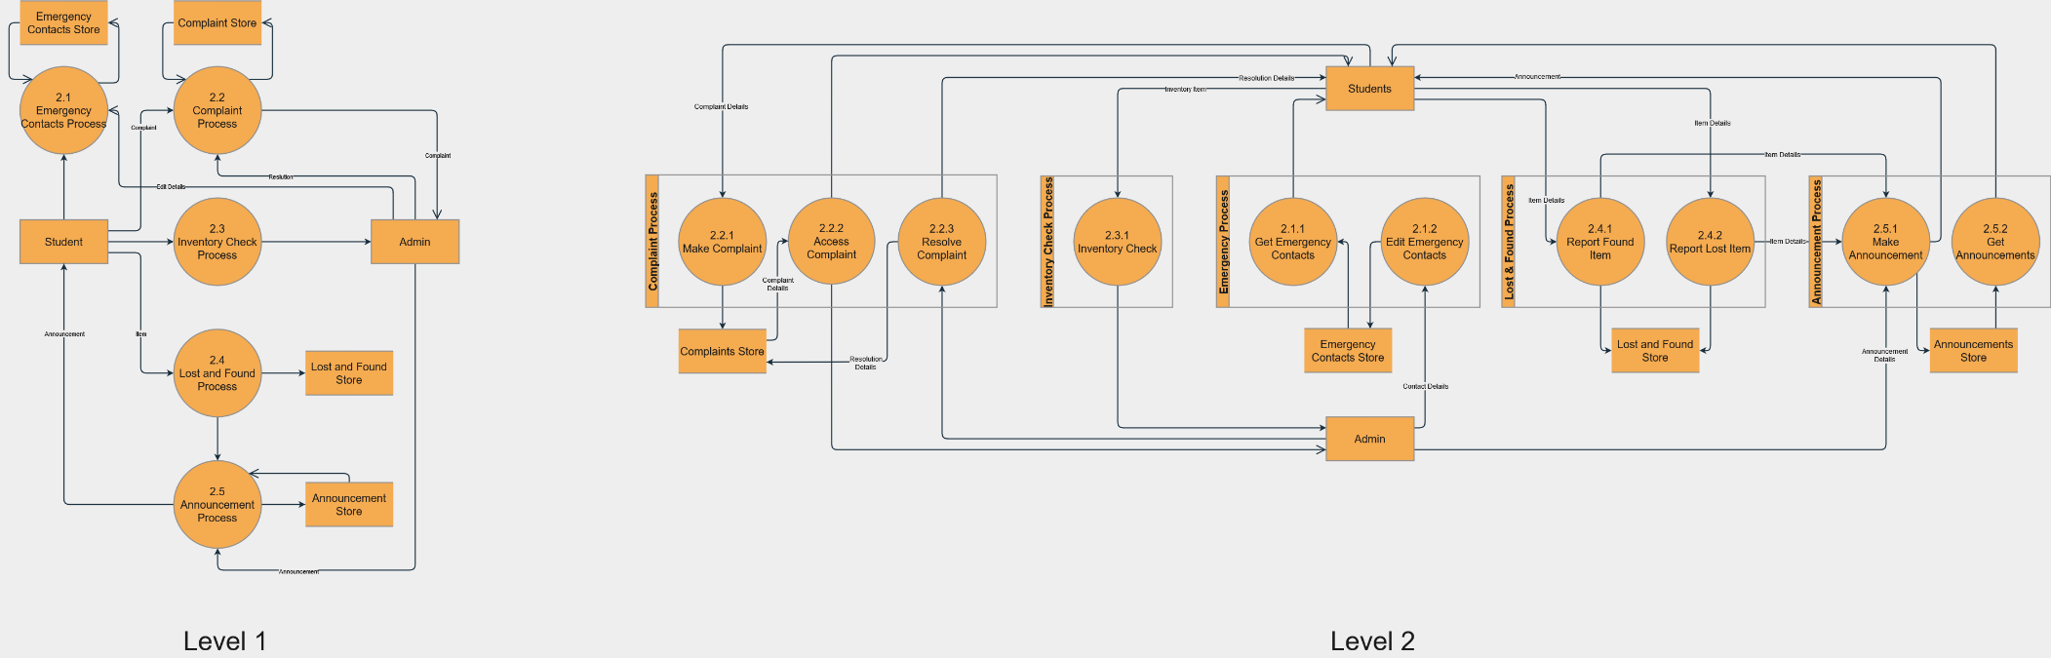
Level 3 DFD Maintenance part

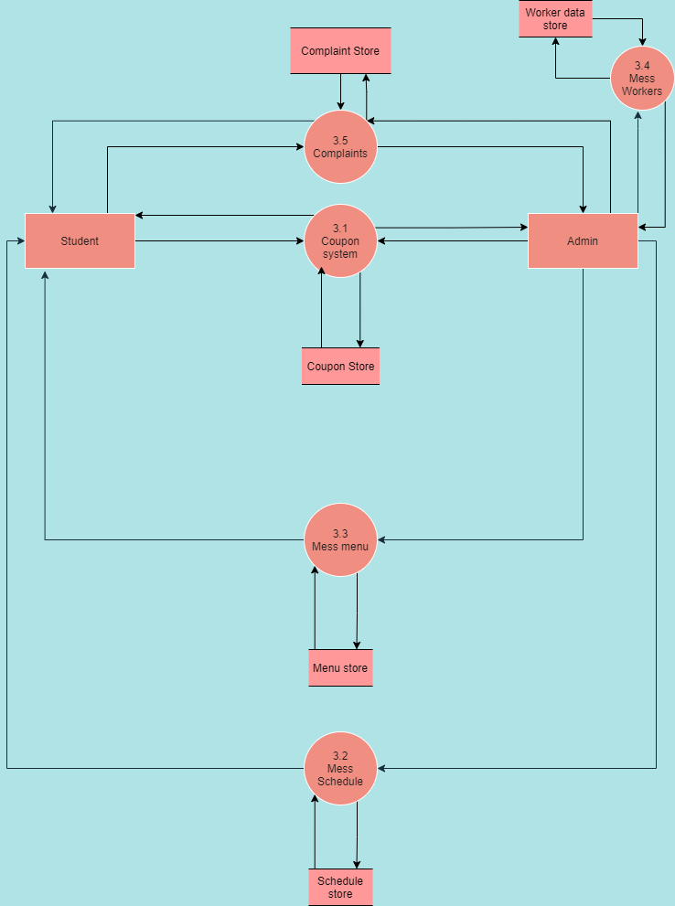
Level2 Mess Management DFD

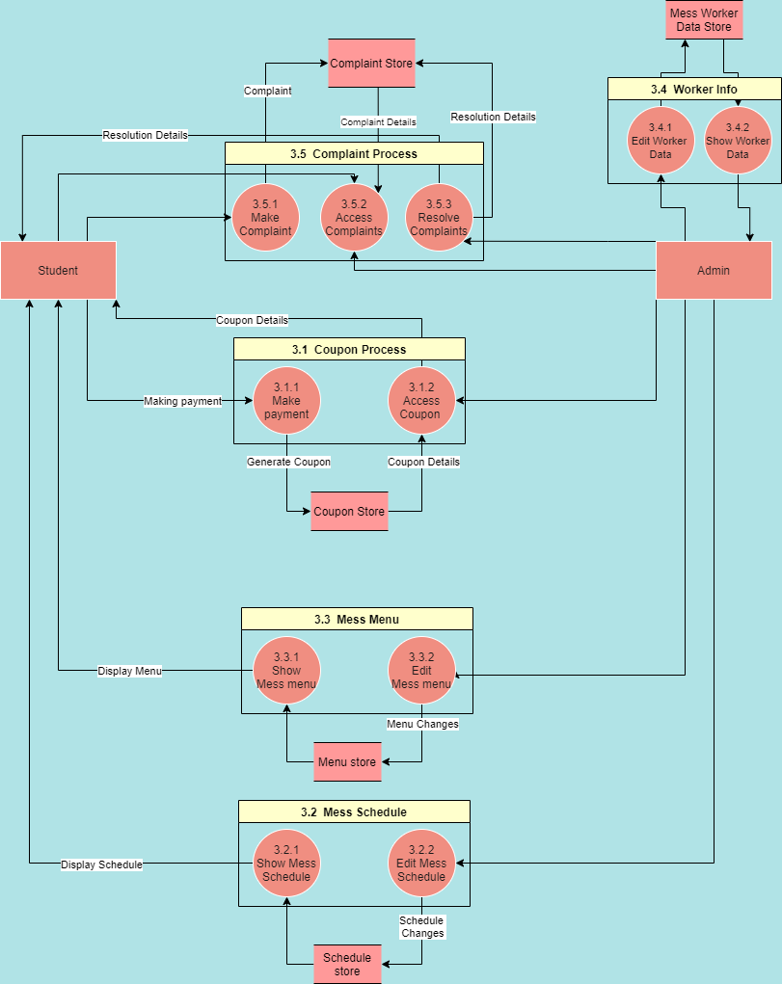

Level 3 Mess Management DFD

Processes Identified
- Room Management
  - Attendance data management
  - Allocation of new rooms to freshers (Make random allotments)
    - Lottery allotment
    - Refresh room allocation data
    - Room stats/Hostel stats
  - Room Data update
    - Room change applications
    - Data update (contact info)
    - Guest allotment if required

- Maintenance
  - Room Inventory Check
    - Purchase
    - Provide (and check availability)
  - Announcement Section
  - Lost and found
  - Call (For Emergency ONLY) [Contacts of IMPORTANT PEOPLE]
  - Room specific complaints(plumber,electricity...)
    - Register Complaint
    - View complaint status
    - Rating
- Mess Management
  - Digital access to coupon whenever coupon system is applied
    - Payment
    - Coupon
  - Mess schedule
  - Mess menu
  - mess workers related data(part functionality can be implemented)
    - Add/Remove/Edit worker data
    - Show worker data
  - Complaints
    - Register Complaint
    - Access Complaint
    - Resolve complaint
Additional requirements
Reporting bugs,suggesting app modifications

Data stores
Employee records
Student records
Rooms data
Lost and found
Emergency contacts
Mess stats (schedule and menu)
Complaints log
Source/sinks
Students
Management

