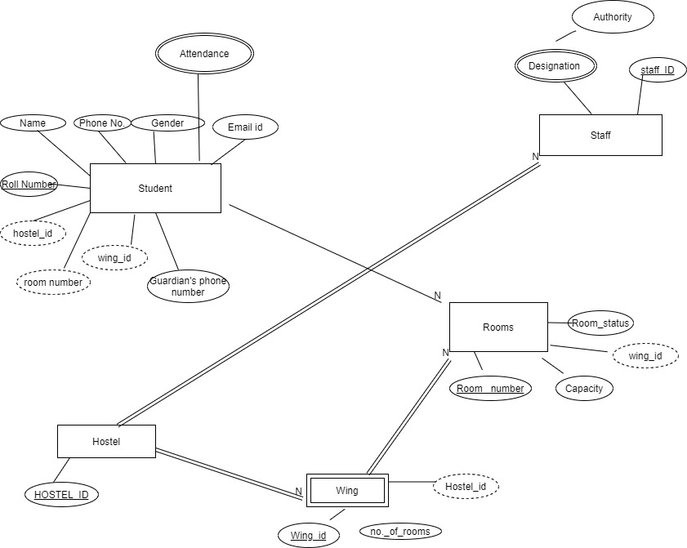

Entity relationship diagram for Room Management submodule.

Entity relationship diagram for Mess management subtopic
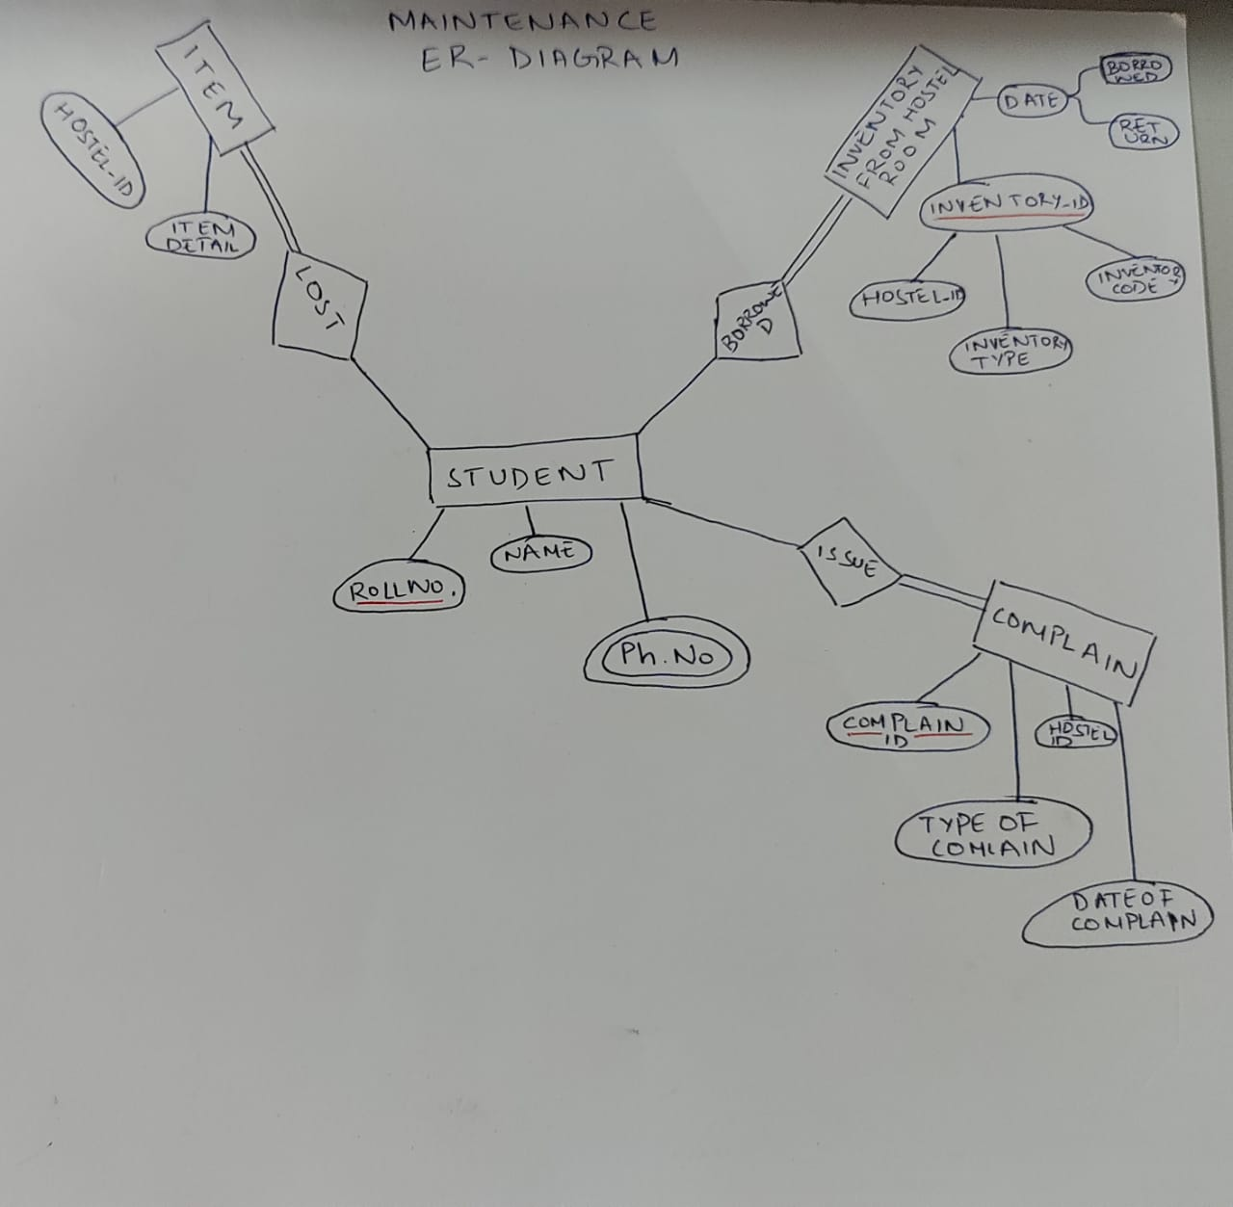
Entity Relationship diagram for Maintenance subtopic

