ISD Lab Group 3 Project
Design submission for Room Management

Created by
Rishabh Sahu | 19ucs129
Bhavya Sehgal | 19ucs155
Mayank Raj | 19ucs151
Paawan singal | 19ucs153
Siddhant Gupta | 19ucs106
Abhishek singhal | 19ucs127
Akshit Sethi | 19ucs104
Warul Sinha | 19ucs119
Tanay Makharia | 19ucs122
Manan Pulinkumar Gandhi | 19ucs130
Kush Gandhi | 19ucs131
Jhanvi Thakuria | 19ucs132

Index
DFD
ERD
Class diagram
Database Schema:
MENU DESIGN
GUI DESIGN

DFD

ERD
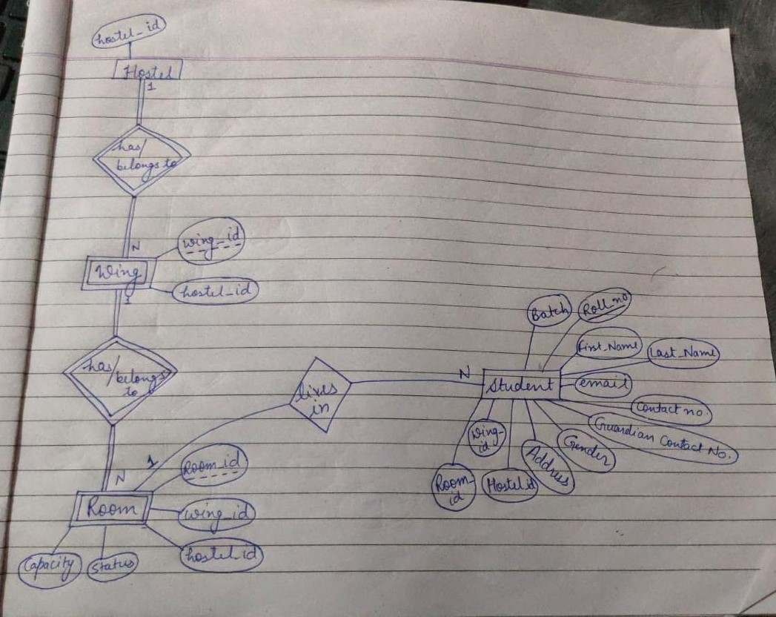

Class diagram
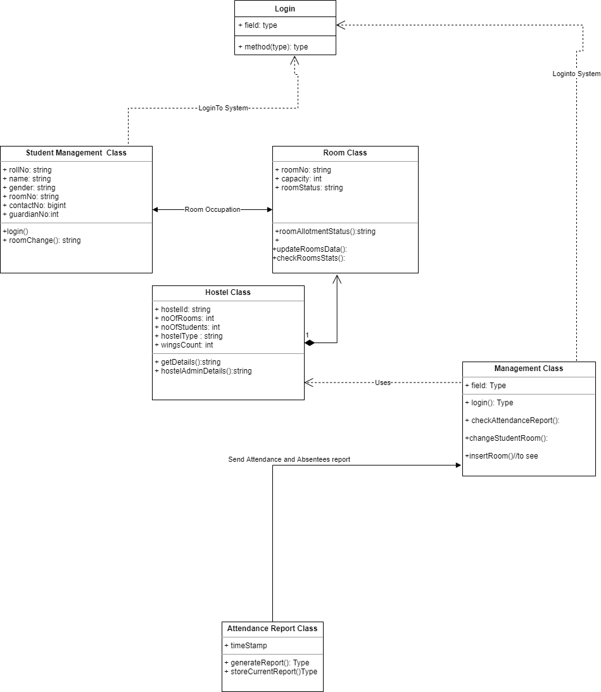

Database Schema:
HOSTEL :
1NF, 2NF, 3NF
hostel_id(varchar(3)) | no_of_wings(int) | warden(varchar(20))

PK : hostel_id(varchar(3))
Note: considering only one warden per hostel (as per college id associated)

WING :
1NF, 2NF, 3NF
wing_id(char(1)) | hostel_id(varchar(3)) | no_of_rooms(int)

PK : wing_id(char(1)), hostel_id (composite primary key)(varchar(3))
FK : hostel_id(varchar(3))

ROOM :
1NF, 2NF, 3NF
room_id(char(3)) | wing_id(char(1)) | hostel_id(varchar(3)) | floor_no(int) | capacity(int) | occupancy(int)

PK : room_id(char(3)), wing_id(char(1)), hostel_id(varchar(3)) (composite primary key)
FK : wing_id(char(1)), hostel_id(varchar(3))

STUDENTS :
1NF, 2NF, 3NF
Roll_no  (char(8)) | f_name(varchar(20)) | l_name(varchar(20)) | college_email(varchar(21)) | contact_no(char(10)) | guardian_contact(char(10)) | Gender(char(1)) | Home_Address(varchar(50)) | room_id(char(3)) | wing_id(char(1)) | hostel_id(varchar(3)) | floor _no(int)

PK : roll_no(char(8))
FK : room_id(char(3)), wing_id(char(1)), hostel_id(varchar(3))
Note: Only single contact_no, guardian_contact will be associated per student(roll no)

ATTENDENCE :
1NF, 2NF, 3NF
datetime(DATETIME) | report.pdf(BLOB)

PK : datetime(composite primary key)

MENU DESIGN
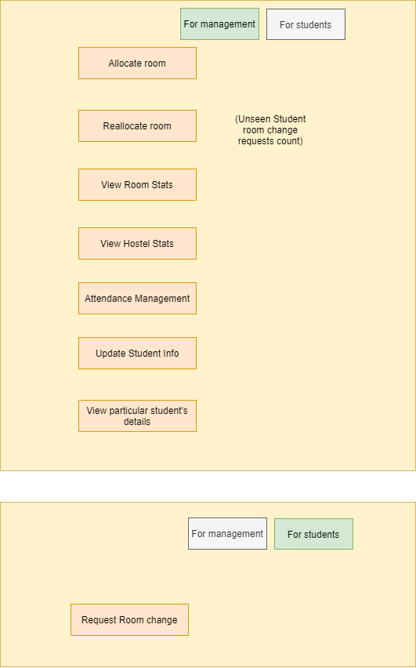

GUI DESIGN

ROOM CHANGE GUI
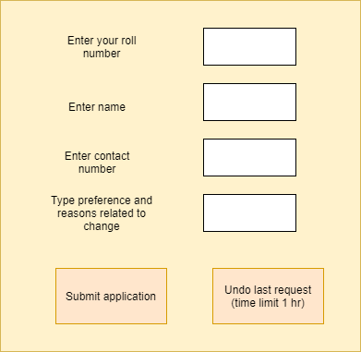

DISPLAY /SAVE ATTENDANCE REPORT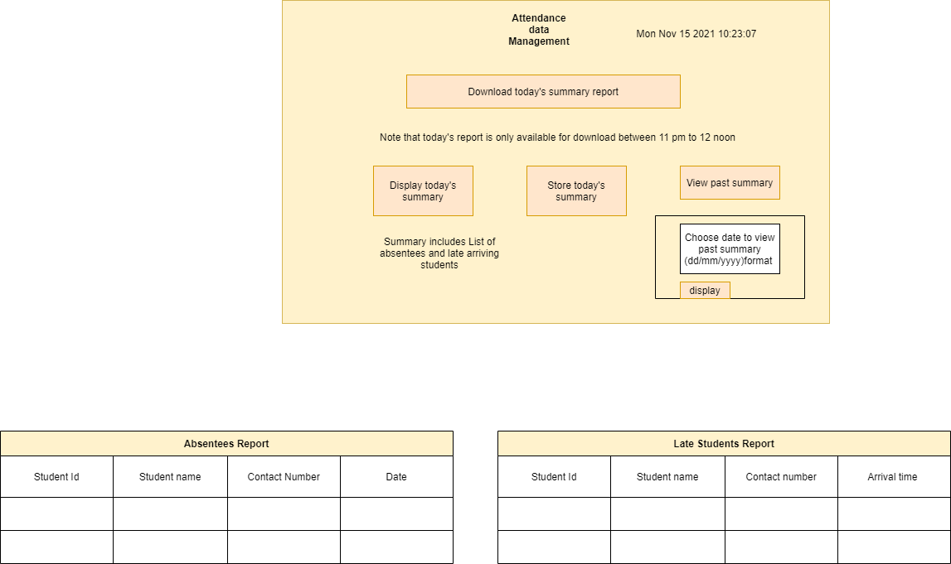
GET ROOM INFO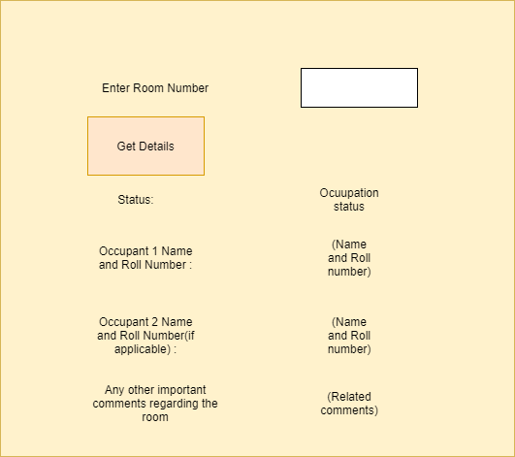

GET HOSTEL INFO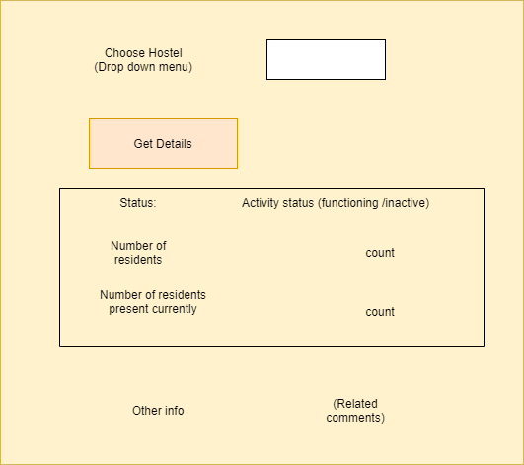
GET STUDENT DETAILS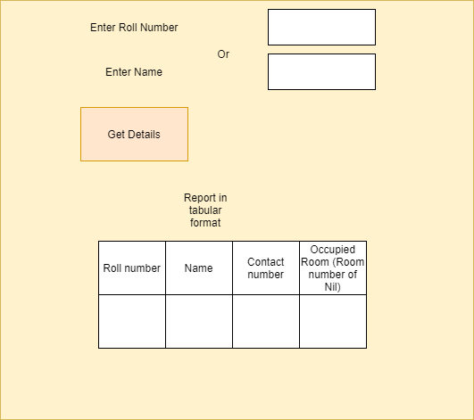
UPDATE STUDENT DATA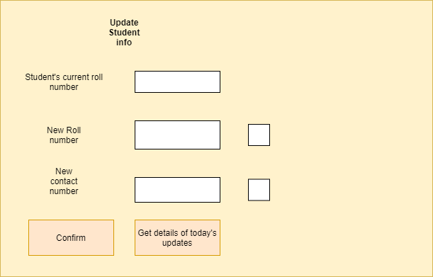
REALLOCATE ROOM
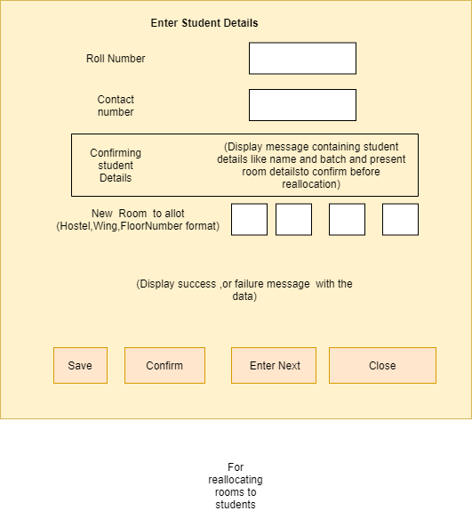

ALLOT ROOMS