PCA Analysis: Three-Dimensional and Two-Dimensional Plots of Top Three PCA Components
Three-Dimensional Plot of Top Three PCA components
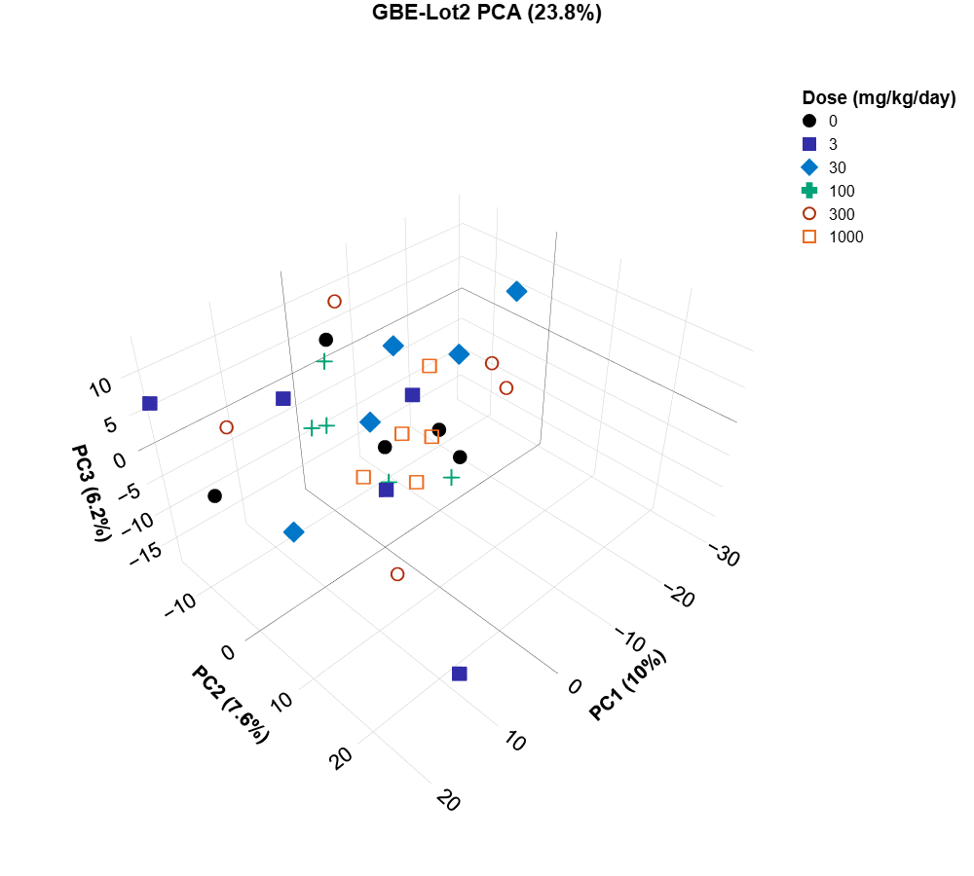

Two-dimensional plot of top three PCA components
Two-Dimensional Plot of PCA 1 Component vs. PCA 2 Component
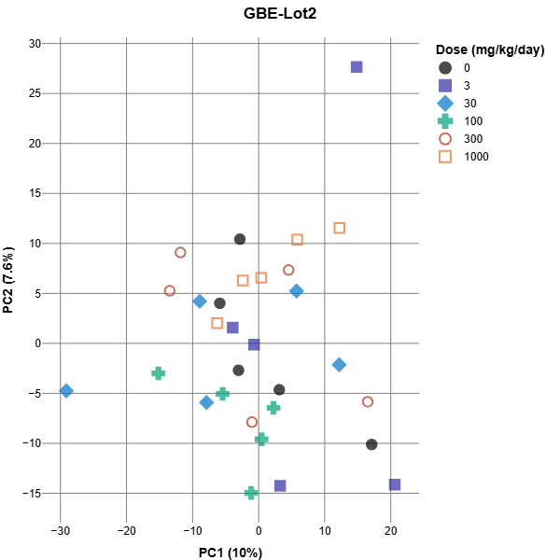

Two-Dimensional Plot of PCA 1 Component vs. PCA 3 Component
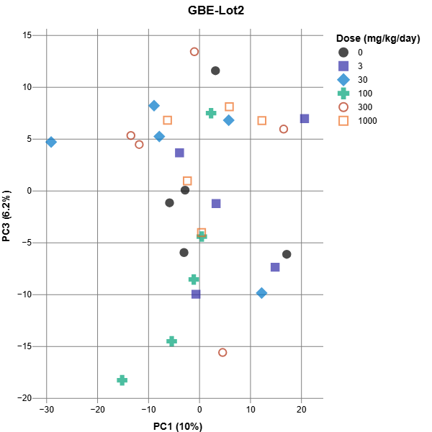

Two-Dimensional Plot of PCA 2 Component vs. PCA 3 Component
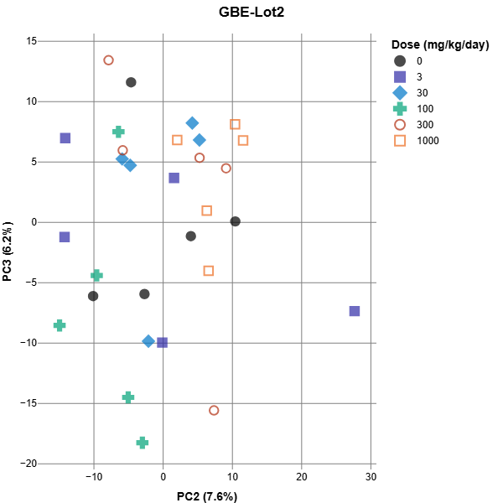

The principal component analysis (PCA) plots are generated using R scripts from the Division of Translational Toxicology, NIEHS. The three 2-dimensional PCA plots and the 3-dimensional PCA plot are created using tidyverse R library and plotly R library, respectively. The original R code was modified to output the expected format of the PCA plots.

