Collaborative Document Editor
with AI Writing Assistant

Backend Architecture & System Design
Assignment 1 — Part 2 Backend Documentation
march 2026

Section 2.2 — System Design (C4 Model)

C4 Level 1 — System Context Diagram
This diagram shows the Collaborative Editor system and its relationships with external actors. Users interact with the system through a web browser. The system communicates with an Email Service for sending verification and notification emails, an AI Service for powering the writing assistant features, and a File Storage service for storing document attachments and images.

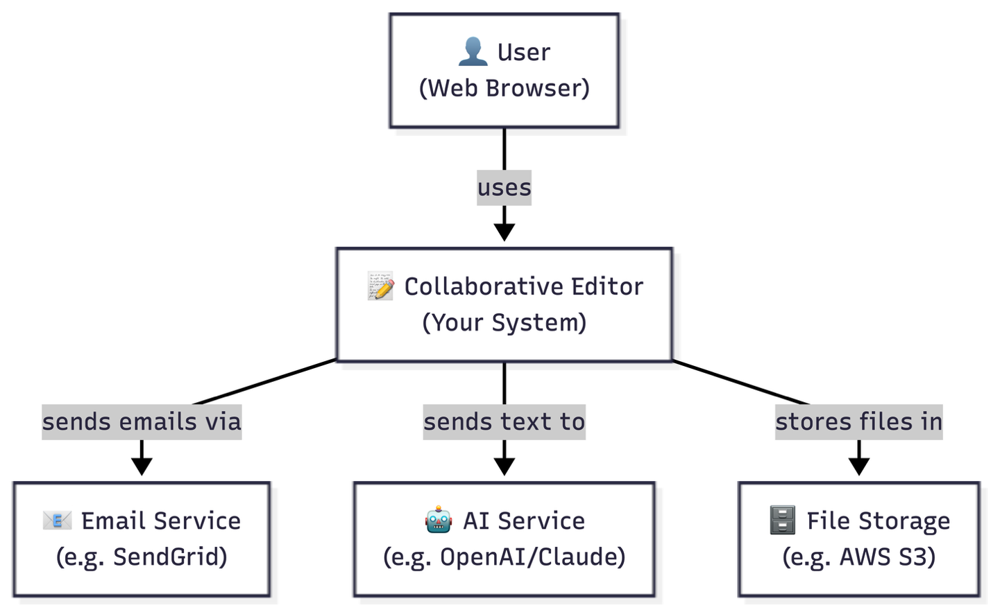

C4 Level 2 — Container Diagram
This diagram shows the major containers inside the Collaborative Editor system. The Frontend serves the document editing interface and maintains a real-time connection for live collaboration. Auth0 handles all authentication including login, registration, JWT token generation and session management. The Backend API built with FastAPI handles all business logic and validates JWT tokens with Auth0 on every request. PostgreSQL stores all persistent data. Redis Cache stores active sessions and temporary editing state for fast access. The Real-time Service syncs edits between connected users. AWS S3 handles file storage, SendGrid handles emails, and an external AI Service powers the writing assistant.

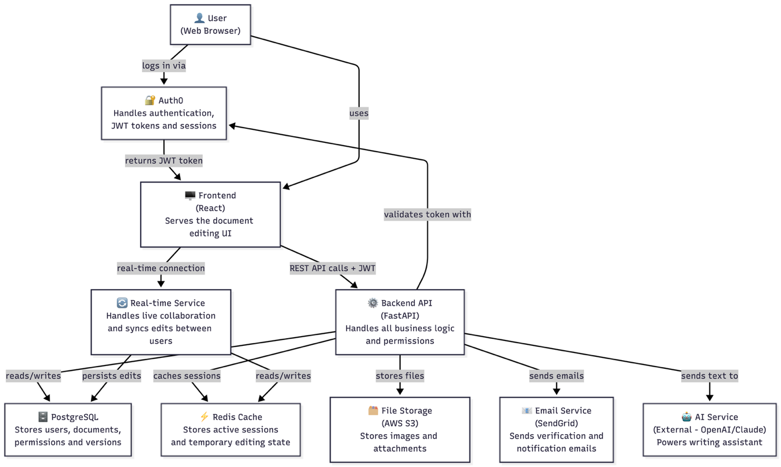

C4 Level 3 — Component Diagram (Backend API)
This diagram shows the internal components of the Backend API. Every incoming request first passes through the Auth Module which validates the JWT token with Auth0. The Documents Module handles all document operations and communicates with the Permissions Module to verify access rights before performing any action. The Versions Module is triggered by the Documents Module whenever a document is saved, creating a new snapshot. The Real-time Module handles incoming edits from connected users, stores temporary state in Redis for speed, and persists final changes to PostgreSQL through the Database Module.

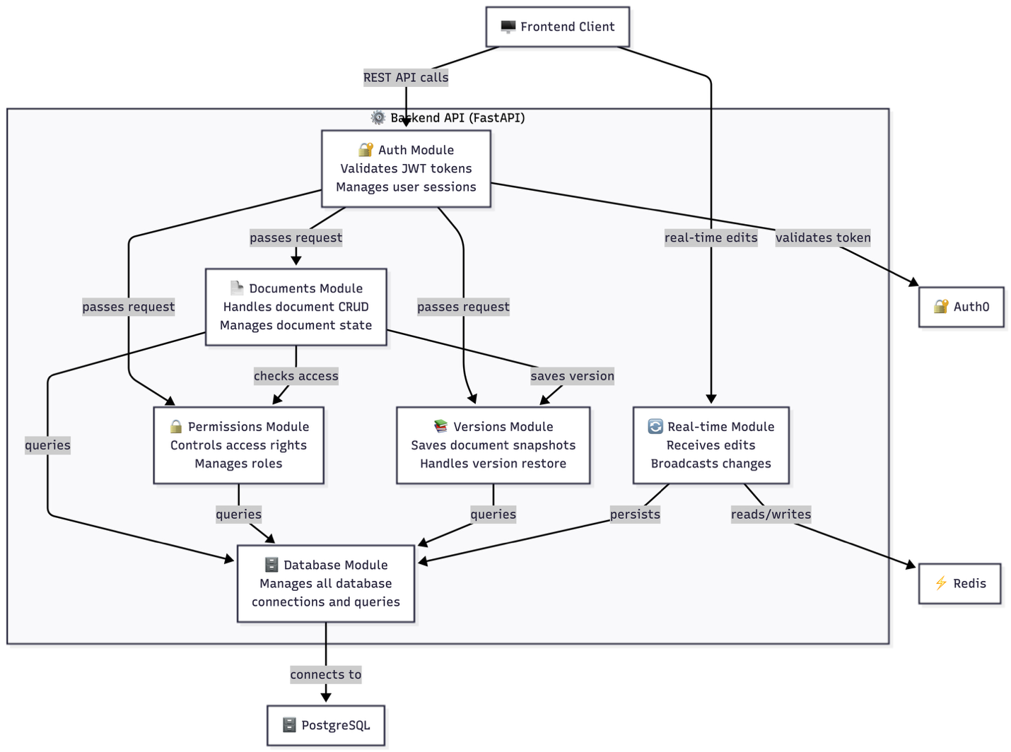

Feature Decomposition
The backend is decomposed into six independent modules, each with a clearly defined responsibility, set of dependencies, and exposed interface.

1. Auth Module
Field | Details
What it does | Validates JWT tokens on every incoming request and confirms the user's identity before passing the request to any other module.
What it depends on | Auth0 (external) for token validation
What it exposes | A middleware function that other modules use to protect their endpoints. Returns the current user's id and role to the requesting module.

2. Documents Module
Field | Details
What it does | Handles all document operations including creating, reading, updating and deleting documents. Manages document state and triggers version snapshots on every save.
What it depends on | Auth Module, Permissions Module, Versions Module, Database Module
What it exposes | Document CRUD endpoints: GET /documents, POST /documents, GET /documents/{id}, PUT /documents/{id}, DELETE /documents/{id}

3. Permissions Module
Field | Details
What it does | Controls who can access which document and at what level. Manages roles (owner, editor, commenter, viewer) and enforces access rules on every document operation.
What it depends on | Auth Module, Database Module
What it exposes | Permission management endpoints and a checkPermission() function used internally by the Documents Module before any operation.

4. Versions Module
Field | Details
What it does | Saves full snapshots of a document every time it is saved. Allows users to view version history and restore any previous version.
What it depends on | Auth Module, Permissions Module, Database Module
What it exposes | Version management endpoints and a saveVersion() function triggered by the Documents Module on every save.

5. Real-time Module
Field | Details
What it does | Handles live collaboration between users editing the same document. Receives edits from connected users, broadcasts changes to all others in the same document session, and persists final changes to the database.
What it depends on | Auth Module, Redis Cache, Database Module
What it exposes | A real-time connection endpoint that the frontend connects to for live collaboration. Broadcasts document changes to all connected users.

6. Database Module
Field | Details
What it does | Manages all database connections and queries. Acts as the single point of contact between all other modules and PostgreSQL. Handles connection pooling and query optimization.
What it depends on | PostgreSQL (external)
What it exposes | Database connection and query functions used by all other modules. No endpoints exposed directly to the frontend.

API Design
The system uses REST as its API style. All endpoints are prefixed and grouped by resource. Every protected endpoint requires a valid JWT token passed in the Authorization header.

Endpoint Summary
Auth
POST /auth/register
POST /auth/login
POST /auth/logout

Documents
GET /documents
POST /documents
GET /documents/{id}
PUT /documents/{id}
DELETE /documents/{id}

Permissions
GET /documents/{id}/permissions
POST /documents/{id}/permissions
PUT /documents/{id}/permissions/{user_id}
DELETE /documents/{id}/permissions/{user_id}

Versions
GET /documents/{id}/versions
GET /documents/{id}/versions/{version_number}
POST /documents/{id}/versions/restore/{version_number}

Full API Contracts
POST /auth/register
Receives:
{ "name": "John Doe", "email": "john@example.com", "password": "password123" }

Returns:
{ "id": 1, "name": "John Doe", "email": "john@example.com", "created_at": "2026-02-01T10:00:00" }

Errors:
400 → email already exists
400 → missing required fields

POST /auth/login
Receives:
{ "email": "john@example.com", "password": "password123" }

Returns:
{ "token": "eyJhbGciOiJIUzI1NiIsInR5cCI6IkpXVCJ9...",
"user": { "id": 1, "name": "John Doe", "email": "john@example.com" } }

Errors:
401 → wrong email or password
400 → missing fields

POST /auth/logout
Receives: nothing (JWT token in header)
Returns: { "message": "Logged out successfully" }
Errors: 401 → not logged in

GET /documents
Receives: nothing (JWT token in header)
Returns:
{ "documents": [ { "id": 1, "title": "My Document", "owner_id": 1,
"created_at": "2026-02-01T10:00:00", "updated_at": "2026-02-01T10:00:00" } ] }
Errors: 401 → not logged in

POST /documents
Receives: { "title": "My New Document" }
Returns:
{ "id": 1, "title": "My New Document", "content": {}, "owner_id": 1,
"created_at": "2026-02-01T10:00:00", "updated_at": "2026-02-01T10:00:00" }
Errors: 401 → not logged in | 400 → title is missing

GET /documents/{id}
Receives: nothing
Returns:
{ "id": 1, "title": "My Document", "content": {}, "owner_id": 1,
"created_at": "2026-02-01T10:00:00", "updated_at": "2026-02-01T10:00:00" }
Errors: 401 → not logged in | 403 → no permission | 404 → not found

PUT /documents/{id}
Receives: { "title": "Updated Title", "content": {} }
Returns: { "id": 1, "title": "Updated Title", "content": {}, "updated_at": "2026-02-01T10:00:00" }
Errors: 401 → not logged in | 403 → no permission | 404 → not found

DELETE /documents/{id}
Receives: nothing
Returns: { "message": "Document deleted successfully" }
Errors: 401 → not logged in | 403 → not the owner | 404 → not found

GET /documents/{id}/permissions
Receives: nothing
Returns:
{ "permissions": [ { "user_id": 2, "user_name": "Jane Doe", "role": "editor" } ] }
Errors: 401 → not logged in | 403 → no permission | 404 → not found

POST /documents/{id}/permissions
Receives: { "user_id": 2, "role": "editor" }
Returns: { "user_id": 2, "document_id": 1, "role": "editor" }
Errors: 401 → not logged in | 403 → not the owner | 400 → user already has permission

PUT /documents/{id}/permissions/{user_id}
Receives: { "role": "viewer" }
Returns: { "user_id": 2, "document_id": 1, "role": "viewer" }
Errors: 401 → not logged in | 403 → not the owner | 404 → permission not found

DELETE /documents/{id}/permissions/{user_id}
Receives: nothing
Returns: { "message": "Access removed successfully" }
Errors: 401 → not logged in | 403 → not the owner | 404 → permission not found

GET /documents/{id}/versions
Receives: nothing
Returns:
{ "versions": [ { "id": 1, "version_number": 1, "created_by": 1, "created_at": "2026-02-01T10:00:00" } ] }
Errors: 401 → not logged in | 403 → no permission | 404 → not found

GET /documents/{id}/versions/{version_number}
Receives: nothing
Returns:
{ "id": 1, "document_id": 1, "version_number": 1, "content": {},
"created_by": 1, "created_at": "2026-02-01T10:00:00" }
Errors: 401 → not logged in | 403 → no permission | 404 → version not found

POST /documents/{id}/versions/restore/{version_number}
Receives: nothing
Returns:
{ "message": "Document restored to version 1",
"document": { "id": 1, "title": "My Document", "content": {}, "updated_at": "2026-02-01T10:00:00" } }
Errors: 401 → not logged in | 403 → no permission | 404 → version not found

Authentication & Authorization

User Types
User Type | Description
Regular User | Anyone who registers and uses the application
Admin | Manages the system and has visibility over all documents

Roles & Permissions
The system distinguishes between system-wide roles (stored in the User table) and document-level roles (stored in the Permission table).

Document-Level Role Permissions:
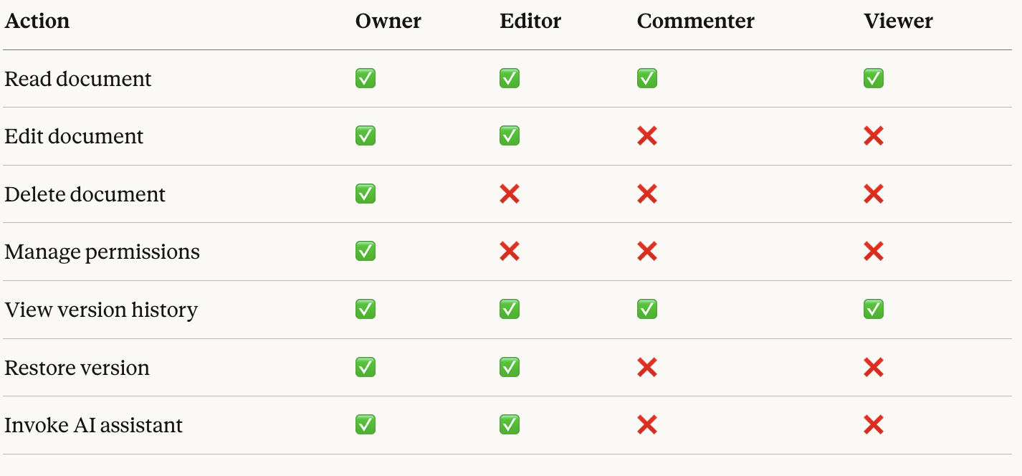

Authentication Flow
Step | Action
1 | User logs in via Auth0
2 | Auth0 validates credentials and returns a JWT token
3 | Frontend stores the token
4 | Frontend sends the token with every subsequent request
5 | Backend validates the token with Auth0 on each request
6 | Backend checks document-level permissions for the requested resource
7 | Request is allowed or rejected based on the user's role

Privacy Considerations
- Document content sent to the AI Service is sensitive and users must be informed their content may be processed by a third-party service.
- AI interaction logs should have a defined retention policy — recommended: deletion after 90 days.
- Passwords are never stored directly — Auth0 handles all credential management.
- JWT tokens expire after a configured time period to limit exposure.
- All communication is encrypted in transit via HTTPS.

Communication Model

Approach
The system uses WebSockets via Yjs for real-time communication. Unlike polling, WebSockets maintain a persistent bidirectional connection between the client and server, enabling instant propagation of edits. Yjs is selected over raw WebSockets because it handles conflict resolution automatically using CRDTs (Conflict-free Replicated Data Types), eliminating the need for custom synchronization logic.

How It Works
Event | Behavior
User opens a document | Frontend establishes a WebSocket connection to the Real-time Service via Yjs. The server registers the user as active on the document and sends the current document state.
User types | Yjs captures the edit and sends it to the Real-time Service, which broadcasts the change to all other connected users instantly.
Simultaneous edits on same region | Yjs handles this automatically using CRDTs. Both edits are merged without data loss and all users converge to the same final document.
User disconnects | The server detects the dropped connection. Other users see the user go offline. All changes made while offline are queued locally.
User reconnects | Yjs automatically syncs all missed changes and the user rejoins the active session with the current document state.

Server Failure Handling
- Active editing sessions are persisted in Redis.
- If the Real-time Service goes down, users see a reconnecting message and the frontend queues all edits locally.
- When the service recovers, queued edits are synced automatically.
- No data is lost because Redis persists active session state and PostgreSQL stores the last saved document state.

Scaling
Each document session runs on the Real-time Service. Redis allows multiple Real-time Service instances to share session state, meaning additional instances can be added as user load grows without session loss.

Trade-offs
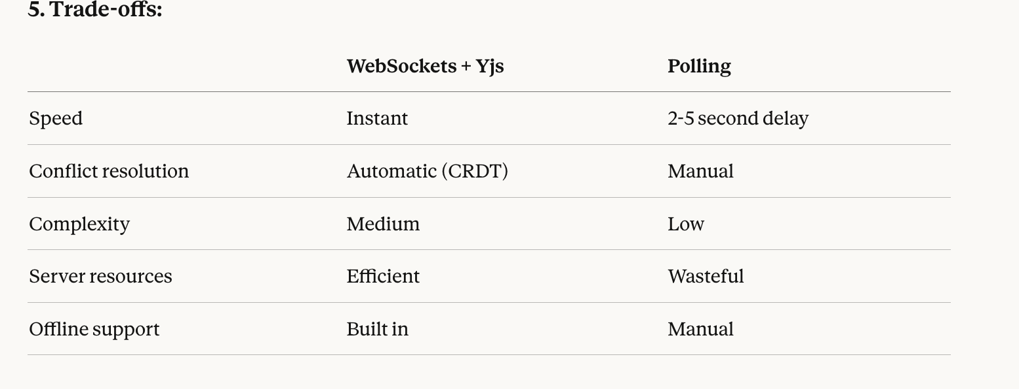

Section 2.3 — Code Structure & Repository Organization

Monorepo vs Multi-repo Decision
We chose a monorepo approach, keeping frontend, backend, and shared code in a single repository. This decision was made because the team is small, type definitions are shared between frontend and backend, and a monorepo reduces the overhead of managing multiple repositories and coordinating versioned dependencies.

Directory Layout
collaborative-editor/
│
├── frontend/
│ ├── src/
│ │ ├── components/ ← UI components
│ │ ├── pages/ ← application pages
│ │ ├── hooks/ ← React hooks
│ │ └── services/ ← API call functions
│ └── package.json
│
├── backend/
│ ├── app/
│ │ ├── main.py ← FastAPI entry point
│ │ ├── auth/ ← Auth module
│ │ ├── documents/ ← Documents module
│ │ ├── permissions/ ← Permissions module
│ │ ├── versions/ ← Versions module
│ │ ├── realtime/ ← Real-time module
│ │ └── database/ ← Database module
│ ├── tests/
│ │ ├── unit/ ← unit tests
│ │ └── integration/ ← integration tests
│ └── requirements.txt
│
├── shared/
│ └── types/ ← shared type definitions
│
├── .env.example ← environment variables template
├── .gitignore ← prevents secrets being committed
├── docker-compose.yml ← runs all services together
└── README.md

Shared Code
Shared type definitions live in the /shared directory. This ensures that data contracts between frontend and backend are defined once and never duplicated. For example, the Document type is defined in /shared/types and imported by both the frontend and backend, ensuring both sides always agree on the shape of the data.

Configuration Management
All secrets and credentials are stored in a .env file that is never committed to the repository. A .env.example file documents which variables are required without exposing real values. This applies to database credentials, Auth0 keys, AWS S3 keys, and any third-party API keys.

Testing Structure
Tests live in backend/tests and are split into two directories: unit tests for testing individual functions in isolation with no external dependencies, and integration tests for testing API endpoints end-to-end with a real database connection. The AI service is always mocked in tests to avoid real API calls, reducing cost and making the test suite fast and reliable.

Section 2.4 — Data Model

Database Tables
The system uses PostgreSQL as its primary database. Document content is stored as JSONB to accommodate flexible rich-text structures. All other fields use standard relational types.

User
User
────────────────────────────────────────
id INT Primary key
name VARCHAR User's display name
email VARCHAR Unique login identifier
password VARCHAR Hashed (managed by Auth0)
role VARCHAR System-wide role: 'admin' | 'user'
created_at TIMESTAMP Account creation time

Document
Document
────────────────────────────────────────
id INT Primary key
title VARCHAR Document title
content JSONB Rich-text content (flexible structure)
owner_id INT Foreign key → User.id
created_at TIMESTAMP Creation time
updated_at TIMESTAMP Last modification time

Permission
Permission
────────────────────────────────────────
id INT Primary key
user_id INT Foreign key → User.id
document_id INT Foreign key → Document.id
role VARCHAR 'owner' | 'editor' | 'commenter' | 'viewer'

Version
Version
────────────────────────────────────────
id INT Primary key
document_id INT Foreign key → Document.id
content JSONB Full copy of document content at this point
version_number INT Incrementing version counter per document
created_by INT Foreign key → User.id
created_at TIMESTAMP Snapshot creation time

AI Interaction
AIInteraction
────────────────────────────────────────
id INT Primary key
document_id INT Foreign key → Document.id
user_id INT Foreign key → User.id
selected_text TEXT The text the user highlighted
action VARCHAR 'summarize' | 'translate' | 'rewrite'
suggestion TEXT AI-generated response
status VARCHAR 'accepted' | 'rejected' | 'partial'
created_at TIMESTAMP Time of invocation

Entity-Relationship Diagram
The Mermaid source code for this diagram is provided below. A rendered image is embedded alongside it.

erDiagram
User { int id string name string email string password string role datetime created_at }
Document { int id string title jsonb content int owner_id datetime created_at datetime updated_at }
Permission { int id int user_id int document_id string role }
Version { int id int document_id jsonb content int version_number int created_by datetime created_at }
AIInteraction { int id int document_id int user_id text selected_text string action text suggestion string status datetime created_at }
User ||--o{ Document : "owns"
User ||--o{ Permission : "has"
Document ||--o{ Permission : "has"
Document ||--o{ Version : "has"
Document ||--o{ AIInteraction : "has"
User ||--o{ AIInteraction : "triggers"

Key Design Decisions
- Permissions are stored in a separate table rather than embedded in the Document table, allowing many users to have different roles on the same document without duplication.
- Document content is stored as JSONB to support flexible rich-text structures. Image support will be added later by storing image URLs in the content field and uploading files to AWS S3.
- Versions store full copies of document content rather than diffs, prioritizing simplicity and fast restore operations over storage efficiency.
- Version numbers are tracked explicitly as an incrementing integer per document, enabling unambiguous retrieval of any specific version.

Section 2.5 — Architecture Decision Records
The following four ADRs document the most consequential design decisions made for this system, spanning real-time collaboration, data storage, API style, and versioning strategy.

ADR 1 — Use Yjs for Real-time Collaboration
Field | Details
Title | ADR 1 — Use Yjs for Real-time Collaboration
Status | Accepted

Context
The system requires multiple users to edit the same document simultaneously with instant change propagation. Conflicts must be handled when two users edit the same region at the same time. The options are to build custom synchronization logic from scratch or adopt an existing library.

Decision
We chose Yjs as our real-time collaboration library. Yjs uses CRDTs (Conflict-free Replicated Data Types) to automatically resolve conflicts between simultaneous edits without data loss. It integrates with the WebSocket protocol and provides built-in offline support and reconnection handling.

Consequences — Positive
- Conflict resolution is handled automatically with no custom logic required
- Built-in offline support and automatic reconnection
- Saves significant development time compared to building a custom sync layer
- Battle-tested in production collaborative editing applications
Consequences — Negative
- Introduces an external library dependency
- Team must learn the Yjs API before implementing
- Less direct control over conflict resolution behavior

Alternatives Considered
- Raw WebSockets: rejected — conflict resolution would need to be built entirely from scratch, adding significant complexity and risk
- Socket.io: rejected — handles connection management well but still requires manual conflict resolution logic
- Operational Transformation (OT): rejected — significantly more complex to implement correctly than CRDTs, with no meaningful advantage at our scale

ADR 2 — Use PostgreSQL on Neon DB as the Database
Field | Details
Title | ADR 2 — Use PostgreSQL on Neon DB as the Database
Status | Accepted

Context
The system needs to store users, documents, permissions, versions, and AI interactions. The data has complex relationships — a document is owned by a user, shared with multiple users at different permission levels, and linked to many versions. We evaluated Firebase (NoSQL), Supabase (PostgreSQL as a service), and Neon DB (serverless PostgreSQL).

Decision
We chose PostgreSQL hosted on Neon DB. PostgreSQL handles our relational data naturally and supports JSONB for flexible document content, giving us the benefits of both relational and document storage. Neon DB is selected over self-hosted PostgreSQL because it is serverless, scales automatically, and requires no infrastructure management.

Consequences — Positive
- Complex relational queries (e.g. all documents a user can edit) are simple and efficient
- JSONB support handles flexible document content without sacrificing relational integrity
- Neon DB eliminates infrastructure overhead for the team
- Strong consistency guarantees across all data
Consequences — Negative
- More complex than Firebase for simple use cases
- Neon DB introduces an external service dependency
- Team requires SQL knowledge to work effectively with the database

Alternatives Considered
- Firebase: rejected — complex relationships are painful to model in NoSQL. Querying all documents a user can edit requires multiple reads in Firebase but a single join in SQL
- Supabase: considered seriously as it also uses PostgreSQL and includes a built-in auth layer. Rejected because we are already using Auth0, making Supabase's primary advantage redundant. Neon DB is more focused and lightweight for our needs
- Self-hosted PostgreSQL: rejected — requires infrastructure setup and maintenance which adds unnecessary complexity for a team of three

ADR 3 — Use REST for API Design
Field | Details
Title | ADR 3 — Use REST for API Design
Status | Accepted

Context
The system needs an API layer connecting the frontend to the backend for document CRUD, permission management, version history, and authentication. The main options are REST, GraphQL, and gRPC. Real-time communication is handled separately by Yjs, so the API only needs to handle standard request/response operations.

Decision
We chose REST as our API style. Each resource — documents, permissions, versions — maps naturally to REST endpoints. FastAPI provides excellent built-in REST support and automatically generates OpenAPI documentation, which simplifies frontend integration and testing.

Consequences — Positive
- Simple and well understood by all team members
- FastAPI generates automatic OpenAPI documentation with no additional work
- Easy to test using standard HTTP tools
- Clear and predictable mapping between endpoints and resources
Consequences — Negative
- Can result in multiple requests for complex data retrieval scenarios
- No built-in subscription mechanism (handled separately by Yjs)
- Less flexible than GraphQL for highly dynamic query requirements

Alternatives Considered
- GraphQL: rejected — our API operations are straightforward CRUD. GraphQL introduces query complexity that is only justified for highly flexible or nested data fetching requirements, which we do not have
- gRPC: rejected — optimized for internal service-to-service communication and overly complex for a browser-facing API. Poor native browser support makes it unsuitable for our use case

ADR 4 — Store Full Document Copies for Version History
Field | Details
Title | ADR 4 — Store Full Document Copies for Version History
Status | Accepted

Context
The system must maintain version history so users can view previous versions and restore them. There are two primary approaches: storing a full copy of the document at each version snapshot, or storing only the incremental changes (diffs) between versions.

Decision
We chose to store full copies of the document content at each version snapshot. Every time a document is saved, a complete copy of the JSONB content is written to the Version table alongside an incrementing version number and a timestamp.

Consequences — Positive
- Simple to implement with no additional processing logic
- Restoring any version requires a single database read
- No need to replay a chain of changes to reconstruct historical state
- Easy to display version history with full content previews
Consequences — Negative
- Uses more storage than a diff-based approach
- Large documents with frequent saves will accumulate significant storage over time

Alternatives Considered
- Diff-based versioning: rejected — more storage-efficient but significantly more complex to implement. Restoring version 10 would require replaying all changes from version 1 through 10. The storage cost of full copies is acceptable at our scale and the simplicity benefit is substantial
- Event sourcing: rejected — designed for comprehensive audit trails and complex state reconstruction, which goes beyond our current versioning requirements

