

A 24 Full Factorial Design with Two blocks to Investigate the Factors Influencing Glass Transition Temperature (Tg) and Crystallization Temperature(Tx) of AlYFe metallic glass by FlashDSC

Conducted by:

Ye Shen

Department of Material Science and Engineering

 December 3, 2013

**Abstract:**

A  experiment in two blocks was conducted by FlashDSC to analyze how the four factors- annealing temperature, annealing time, heating rate, doping-influence glass transition temperature(Tg) as well as crystallization onset temperature (Tx) of Al-Y-Fe metallic glass. Eight of the combinations were repeated twice and the remaining eight combinations were only done once. The result shows that heating rate is the most significant factor. A strategy of increasing Tg and Tx was proposed based on the result.

**Introduction:**

**-Background and Goal**

Al based metallic glass attracts great interest as a promising structure material. One way to improve its mechanical property is to create nanocrystals in the amorphous matrix. [1] Therefore, it is important to study the glass transition behavior and crystallization behavior of glasses, characterized by glass transition temperature Tg and crystallization temperature Tx respectively. In this project, our goal is to increase Tg and Tx by analyzing and adjusting the following four factors: annealing time, annealing temperature, heating rate of the instrument and doping.

**-Key Concepts**

* *FlashDSC*:It is an instrument that can measure the heat flow to or from a sample as a function of temperature or time and thereby allows physical transitions to be quantitatively measured(Fig.3). [2] In its control panel, we can control how the sample’s temperature changes with time, that is to say, we could control heating rate, heating temperature, heating time. (Fig.1) In its result panel, we could observe how heat flow changes with temperature and determine Tx, Tg. (Fig.2)
* *Glass transition temperature (Tg) and crystallization onset temperature (Tx)*: Tg defines the temperature when metallic glass begins to go through glass transition, which is an endothermic behavior. Therefore, Tg is characterized as the onset of the endothermic peak. In the contrast, Tx is the onset temperature of the exothermic peak because crystallization is a exothermic reaction. (Fig.2)

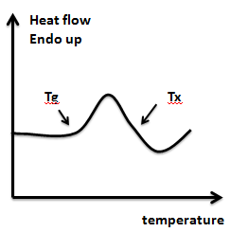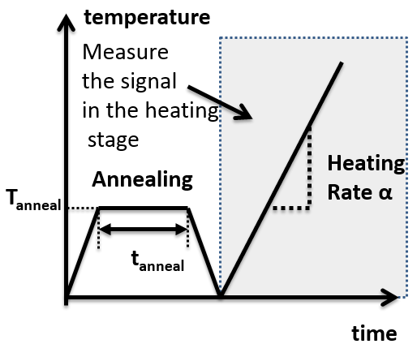

Fig.1 In the control panel of flashDSC, we can design a heat treatment process with two stages: annealing stage and heating stage. Annealing temperature Tanneal and annealing time tanneal and heating rate α are shown schematically

Fig.2 In the result panel of flashDSC, we can get the signal measured from the 2nd stage (heating stage). Tg and Tx are the onset temperatures for glass transition and crystallization. The signals from the first stage can also be gathered, however, they are of less importance and we will not analyze them.

- **Detailed Description of Factors & Blocks**

* ***Factor A*:** *annealing temperature* is the temperature we use for pre-annealing before the measurement of Tg and Tx. It is shown in Fig.1 as Tanneal. We predict that the higher the annealing temperature, the higher the glass transition temperature Tg and crystallization temperature Tx, because annealing can stabilize the glass.

Fig.1 Heat treatment process with two stages: annealing stage and heating stage. Annealing temperature Ta and heating rate α are shown schematically

* ***Factor B***: *annealing time* is how long we do isothermal annealing at the annealing temperature. It is shown in Fig.1 as tanneal. The prediction is the longer the annealing time, the higher the Tg and Tx, because annealing can stabilize the glass.
* ***Factor C***: *heating rate* used for the continuous heating to measure Tg and Tx in the heating stage. It is shown as the slope α of the temperature vs. time relationship in Fig.2. According to the Kissinger relationship [3], we predict the higher the heating rate, the bigger the Tx and Tg.
* ***Factor D***: *doping*. The undoped sample is Al88Fe5Y7 metallic glass. The doped sample is Al87Fe5Y7Pb. By doping 1 at% Pb, crystallization should be promoted. Therefore, Tx and Tg should be lower.
* ***Block B1***: flashDSC use reusable *chip* sensors for measurement and sample are directly put on the chips. In idealized world, all the chips are the same. However, we are not sure about that. Therefore, I will block this effect. Since chips are expensive (50$ each), I just use two chips No. 22104 and No. 22105 for this project. The image and description of chip is shown in Fig. 3.

  

Fig.3 From left to right, chip sensor image, installation of chip to the machine, image of FlashDSC, respectively. To get fast cooling rate and heating rate, both the chip and the sample is very small. The sample area on the chip is 500um*500um. We need a piece of hair to pick up the sample and put it on the chip.

* ***Block B2***: I run 16 runs in two days. Each day can act as a block.

**Methods:**

**-Experimental Procedure**

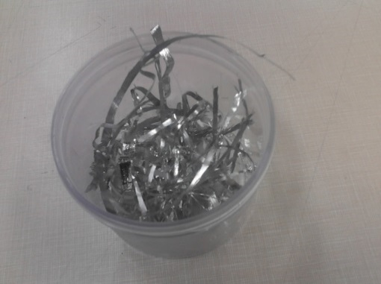Metallic glass ribbons of Al88Fe5Y7 and Al87Fe5Y7Pb1 were produced by melt spinning method (Fig.4). We have 7 batches of Al88Fe5Y7 and 5 batches of Al87Fe5Y7Pb1. Instead of using block, I use randomization to eliminate the batch difference. By taking the same amount of sample from each batch and then cutting them into small pieces for use and then mixing them together for the same composition, I can randomly choose one piece from the mixing each time.

Before running the flashDSC, we must try to make sure that all the pieces of sample to use are of the same shape and same weight.

First, use R code sample(1:16, 8) to choose 8 runs to be repeated twice. Then, use R code sample(1:24,24) to randomize the running order for each combination. After putting the sample in the flashDSC, we can program the heat treatment process and get the result. An important point in programming the heat treatment process is to determine the other parameters except of our experimental factors-annealing temperature, annealing time and heating rate of the heating stage. We set the heating rate for annealing stage (1000K/s), cooling rate (-1000K/s) for both the annealing stage and heating stage to be the same for all the runs. After each run, the chip is totally cleaned by distill water.

Fig.4 metallic glass ribbons made from melt spinning.

- **Pilot Study**

According to literatures and my previous experiment experiments, we know two things. First, no matter how we adjust A,B,C,D, the responses Tx, and Tg can show up. Second, I have an idea of the range of A,B,C,D to use. Therefore, I do not need pilot study to decide the level of factors.

The purpose of the pilot design is to determine if we actually need replications. I randomly choose a combination of A,B,C,D.

|  |  |  |  |  |
| --- | --- | --- | --- | --- |
| Experiment condition: A(+,240°C), B(+,600s), C(-, 5000K/s), D(-,Al88Fe5Y7), B1(-,No.22104), B2(-, 1st Day) | | | | |
| Run | 1 | 2 | 3 | Standard Error |
| Tg | 310.23°C | 323.40°C | 335.21°C | 12.49°C |
| Tx | 386.54°C | 389.90°C | 399.42°C | 6.68°C |

As we can see, the standard error is quite large. FlashDSC is a stable machine and the big error is due to the difference in sample size, sample shape, sample-chip contact condition, sample thickness for the samples we use each time. Both the chip and the sample are very small and we even have to use optical microscope and a piece of hair to handle the sample, therefore, it is impossible to decrease the error by adjusting the samples (Fig.3). In conclusion, it is necessary to do replications. Due to the limited time, we only repeat half of the combinations twice.

- **Factor level**

|  |  |  |  |  |
| --- | --- | --- | --- | --- |
| Designation | Factor | High Level **+** | Low Level - | Reasons for the choice of levels |
| A | Annealing temperature | 240°C | 220°C | Crystallization is sensitive to temperature.  240°C and 220°C make a big difference.[4] |
| B | Annealing time | 600s | 120s | Crystallization progresses with time. 120s is enough to produce some amount of nuclei. 600s will let the material have adequate time to go through crystallization. [4] |
| C | Heating rate | 10000K/s | 5000K/s | Tx and Tg shift with the change of heating rate. 10000K/s and 5000K/s are two normal speed for fast and slow heating. |
| D | Doping | Al87Fe5Y7Pb1 | Al88Fe5Y7 | Al87Fe5Y7Pb1 is my target composition. I use Al88Fe5Y7 as a comparison. |
| B1 | Chip | No. 22104 | No.22105 |  |
| B2 | Day | 1st Day | 2nd Day |  |

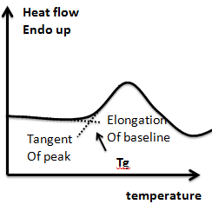**- Response**

Tg and Tx are the responses of this study, which are continuous but deterministic. The data is gathered by analyzing the Heat flow vs. Temperature relationship. (Fig.2). We draw the tangent of the peak slope and elongate the baseline and then we can get the cross point, which is the Tg (Tx follows the same procedure). (Fig.5) This is an objective step. Therefore, for each data point, we draw lines to get the intersection point for three times and then get the average value for the final data.

Fig.5 curve analyze: to determine Tg

The two responses Tg and Tx also have a relationship between each other. They increase and decrease at the same time.

**Data:**

* Data organized by run order

|  |  |  |  |  |  |  |  |  |  |
| --- | --- | --- | --- | --- | --- | --- | --- | --- | --- |
| Run order | A  (Tanneal) | B  (tanneal) | C  (Heating  Rate) | D  (Doping) | B1=ABD  (chip) | B2=ACD  (day) | Name | Tg(°C) | Tx(°C) |
| 1 | - | - | + | - | - | + | c | 327.45 | 392.67 |
| 2 | + | - | - | - | + | + | a | 319.63 | 366.38 |
| 3 | - | + | - | - | + | - | b | 320.91 | 373.45 |
| 4 | + | - | + | - | + | - | ac | 337.65 | 394.44 |
| 5 | + | + | + | + | + | + | abcd | 351.91 | 413.98 |
| 6 | - | + | + | - | + | + | bc | 336.12 | 392.13 |
| 7 | - | - | + | + | + | - | cd | 343.01 | 417.01 |
| 8 | + | - | - | + | + | - | ad | 330.84 | 383.21 |
| 9 | - | + | - | + | - | + | bd | 321.5 | 372.08 |
| 10 | + | + | - | + | - | + | abd | 345.18 | 396.21 |
| 11 | + | - | + | + | - | + | acd | 336.95 | 400.15 |
| 12 | - | + | + | - | + | + | bc | 346.19 | 406.16 |
| 13 | - | + | - | + | - | + | bd | 325.04 | 378.66 |
| 14 | + | + | - | - | - | + | ab | 333.48 | 383.07 |
| 15 | + | + | + | + | + | + | abcd | 361.67 | 418 |
| 16 | + | - | - | + | - | - | ad | 331.59 | 389.37 |
| 17 | + | + | - | - | - | + | ab | 331.12 | 376.83 |
| 18 | - | - | - | - | - | - | (1) | 305.83 | 370.83 |
| 19 | + | + | + | - | - | - | abc | 354.58 | 409.60 |
| 20 | - | - | - | + | + | - | d | 310.64 | 379.70 |
| 21 | - | - | + | + | + | - | cd | 331.92 | 401.84 |
| 22 | + | - | + | - | + | - | ac | 332.33 | 391.19 |
| 23 | - | + | + | + | - | - | bcd | 340.63 | 404.76 |
| 24 | - | - | - | - | - | - | (1) | 322.09 | 371.82 |

* Data organized by block

|  |  |  |  |  |  |  |  |  |  |  |  |  |
| --- | --- | --- | --- | --- | --- | --- | --- | --- | --- | --- | --- | --- |
| B1=  ABD | B2=  ACD | B1B2=  BC | Block | Name | Tg(°C) | | | | Tx(°C) | | | |
| Rep1 | Rep2 | mean |  | Rep1 | Rep2 | mean |  |
| - | - | + | I | (1) | 322.09 | 305.83 | 313.96 | 132.19 | 371.82 | 370.83 | 371.325 | 0.49 |
| + | + | + | II | a | 319.63 |  | 319.63 |  | 366.38 |  | 366.38 |  |
| + | - | - | III | b | 320.91 |  | 320.91 |  | 373.45 |  | 373.45 |  |
| - | + | - | IV | ab | 331.12 | 333.48 | 332.3 | 2.78 | 376.83 | 383.07 | 379.95 | 19.47 |
| - | + | - | IV | c | 327.45 |  | 327.45 |  | 392.67 |  | 392.67 |  |
| + | - | - | III | ac | 332.33 | 337.65 | 334.99 | 14.15 | 391.19 | 394.44 | 392.815 | 5.28 |
| + | + | + | II | bc | 346.19 | 336.12 | 341.155 | 50.70 | 406.16 | 392.13 | 399.145 | 98.42 |
| - | - | + | I | abc | 354.58 |  | 354.58 |  | 409.6 |  | 409.6 |  |
| + | + | + | II | d | 310.64 |  | 310.64 |  | 379.7 |  | 379.7 |  |
| - | - | + | I | ad | 331.59 | 330.84 | 331.215 | 0.28 | 389.37 | 383.21 | 386.29 | 18.97 |
| - | + | - | IV | bd | 321.5 | 325.04 | 323.27 | 6.26 | 372.08 | 378.66 | 375.37 | 21.65 |
| + | - | - | III | abd | 345.18 |  | 345.18 |  | 396.21 |  | 396.21 |  |
| + | - | - | III | cd | 331.92 | 343.01 | 337.465 | 61.49 | 401.84 | 417.01 | 409.425 | 115.1 |
| - | + | - | IV | acd | 336.95 |  | 336.95 |  | 400.15 |  | 400.15 |  |
| - | - | + | I | bcd | 340.63 |  | 340.63 |  | 404.76 |  | 404.76 |  |
| + | + | + | II | abcd | 351.91 | 361.67 | 356.79 | 47.63 | 413.98 | 418 | 415.99 | 8.08 |

**Results and Analysis:**

* Standard Error Calculation
* Standard Error Calculation by the method calculating replicated runs



From repeated experiments, we can calculate.











|  |  |  |  |  |  |  |
| --- | --- | --- | --- | --- | --- | --- |
|  | Tg | Tg CI | | Tx | Tx CI | |
| A (Tanneal ) | **12.0194** | 5.7487 | 18.2901 | 5.1925 | -0.7927 | 11.1777 |
| B (tanneal) | **12.8144** | 6.5437 | 19.0851 | 6.965 | 0.9798 | 12.9502 |
| C (Heating  Rate) | **16.6131** | 10.3424 | 22.8838 | **24.485** | 18.4998 | 30.4702 |
| D (Doping) | 4.6456 | -1.6251 | 10.9163 | **10.32** | 4.3348 | 16.3052 |
| AB (chip)+B1 | 3.7019 | -2.5688 | 9.9726 | 7.0637 | 1.0785 | 13.0489 |
| AC (day)+B2 | -2.8669 | -9.1376 | 3.4038 | -2.0537 | -8.0389 | 3.9315 |
| BC+B1B2 | 1.2606 | -5.0101 | 7.5313 | 1.6437 | -4.3415 | 7.6289 |
| AD | 2.5131 | -3.7576 | 8.7838 | 2.1537 | -3.8315 | 8.1389 |
| BD | -0.4144 | -6.6851 | 5.8563 | -2.7737 | -8.7589 | 3.2115 |
| CD | -1.2306 | -7.5013 | 5.0401 | -1.2962 | -7.2814 | 4.689 |
| ABC | 1.9381 | -4.3326 | 8.2088 | 0.64 | -5.3452 | 6.6252 |
| ABD+B1 | 0.8006 | -5.4701 | 7.0713 | 1.625 | -4.3602 | 7.6102 |
| ACD+B2 | -3.8431 | -10.1138 | 2.4276 | -4.315 | -10.3002 | 1.6702 |
| BCD | -2.1581 | -8.4288 | 4.1126 | -0.2475 | -6.2327 | 5.7377 |
| ABCD | 1.8969 | -4.3738 | 8.1676 | 0.9237 | -5.0615 | 6.9089 |

* Standard Error Calculation by the method of neglecting high order interactions



  

|  |  |  |  |  |  |  |
| --- | --- | --- | --- | --- | --- | --- |
|  | Tg | Tg CI | | Tx | Tx CI | |
| A (Tanneal ) | **12.0194** | 6.0034 | 18.0354 | 5.1925 | -0.2685 | 10.6535 |
| B (tanneal) | **12.8144** | 6.7984 | 18.8304 | 6.965 | 1.504 | 12.426 |
| C (Heating  Rate) | **16.6131** | 10.5971 | 22.6291 | **24.485** | 19.024 | 29.946 |
| D (Doping) | 4.6456 | -1.3704 | 10.6616 | **10.32** | 4.859 | 15.781 |
| AB (chip)+B1 | 3.7019 | -2.3141 | 9.7179 | 7.0637 | 1.6027 | 12.5247 |
| AC (day)+B2 | -2.8669 | -8.8829 | 3.1491 | -2.0537 | -7.5147 | 3.4073 |
| BC+B1B2 | 1.2606 | -4.7554 | 7.2766 | 1.6437 | -3.8173 | 7.1047 |
| AD | 2.5131 | -3.5029 | 8.5291 | 2.1537 | -3.3073 | 7.6147 |
| BD | -0.4144 | -6.4304 | 5.6016 | -2.7737 | -8.2347 | 2.6873 |
| CD | -1.2306 | -7.2466 | 4.7854 | -1.2962 | -6.7572 | 4.1648 |
| ABC | 1.9381 | -4.0779 | 7.9541 | 0.64 | -4.821 | 6.101 |
| ABD+B1 | 0.8006 | -5.2154 | 6.8166 | 1.625 | -3.836 | 7.086 |
| ACD+B2 | -3.8431 | -9.8591 | 2.1729 | -4.315 | -9.776 | 1.146 |
| BCD | -2.1581 | -8.1741 | 3.8579 | -0.2475 | -5.7085 | 5.2135 |
| ABCD | 1.8969 | -4.1191 | 7.9129 | 0.9237 | -4.5373 | 6.3847 |

* Checking Assumptions

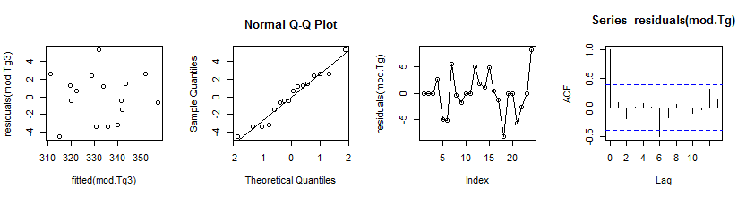

Fig.6 From left to right: residual~fitted value plot, Qqplot, time series plot, ACF plot. All of them are for Tg

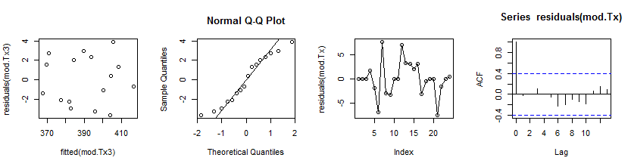

Fig.7 From left to right: residual~fitted value plot, Qqplot, time series plot, ACF plot. All of them are for Tx.

There are three assumptions needed to be met. From residuals~fitted value plot, we know equal variance assumption is met. The qqplots tell us normality is met. Times series plots and ACF plots show independence assumption is met for both Tg and Tx. For the ACF plot of Tg, there is a outlier at Lag 6, which might need further consideration.

**Conclusions:**

1. The change in method of S.E calculation doesn't have big influence on the result. In comparison, the method of using repeated runs has more degree of freedom and gives narrower confidence interval.
2. The result shows for Tg, factor A(annealing temperature), B(annealing time), C(heating rate) are of significance. For Tx, factor C(heating rate) and D(doping) are of significance. The Daniel's plot confirms this conclusion.

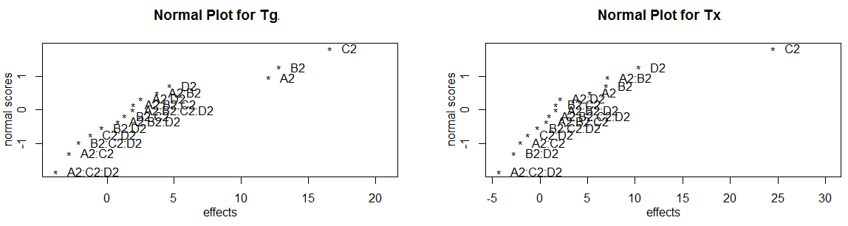

Fig.8 Daniel's plot for Tg(left) shows A,B,C are of significance. For Tx(right), C and D are of significance

1. The block effects are not obvious. Even though confounded with two factor interactions, B1, B2 and B1B2 still have a small value. If more tests will be performed in the future, there is no need to block this two factors.
2. To increase Tg and Tx, the following combination should be adopted: A(+,240°C), B(+,600s), C(+,10000K/s), D(+, Al87Fe5Y7Pb1). The predictions for A,B,C before experiments are met. However, the results for D are contradicted with my predictions, which is very interesting. Here is my explanation. In common sense, the doping of Pb can provide crystallization sites and promote crystallization. This works for the situation without annealing.[6] In this experiment, samples are annealed. Therefore, the nucleation sites are already occupied during the nucleation stage and cannot exert its function in the continuous heating stage. Instead, it can even have a reverse effect of hinder
3. For the future work, more tests will be done to make sure factor D (doping) gives a positive influence on Tx and Tg. If this is really the case, other material characterization methods will be used to get an explanation of this phenomenon. Also, to further narrow down the confidence interval, more replications will be done.

**Appendix:**

#data in run order

Tg<-c(327.45,319.63,320.91,337.65,351.91,336.12,343.01,330.84,321.5,345.18,336.95,346.19,325.04,333.48,

361.67,331.59,331.12,305.83,354.58,310.64,331.92,332.33,340.63,322.09)

Tx<-c(392.67,366.38,373.45,394.44,413.98,392.13,417.01,383.21,372.08,396.21,400.15,406.16,378.66,

383.07,418,389.37,376.83,370.83,409.60,379.70,401.84,391.19,404.76,371.82)

A<-c(-1,1,-1,1,1,-1,-1,1,-1,1,1,-1,-1,1,1,1,1,-1,1,-1,-1,1,-1,-1)

B<-c(-1,-1,1,-1,1,1,-1,-1,1,1,-1,1,1,1,1,-1,1,-1,1,-1,-1,-1,1,-1)

C<-c(1,-1,-1,1,1,1,1,-1,-1,-1,1,1,-1,-1,1,-1,-1,-1,1,-1,1,1,1,-1)

D<-c(-1,-1,-1,-1,1,-1,1,1,1,1,1,-1,1,-1,1,1,-1,-1,-1,1,1,-1,1,-1)

mod.Tg<-lm(Tg~A*B*C*D)

mod.Tx<-lm(Tx~A*B*C*D)

#calculation of main effects and standard error for Tg by repeated runs

summary(mod.Tg)$coefficient*2

#calculation of main effects and standard errorfor Tx by repeated runs

summary(mod.Tx)$coefficient*2

####################################################################

#remove the two repeated runs and put in the average of the values

Tg2<-c(313.96,319.63,320.91,332.3,327.45,334.99,341.155,

354.58,310.64,331.215,323.27,345.18,337.465,336.95,340.63,356.79)

Tx2<-c(371.325,366.38,373.45,379.95,392.67,392.815,399.145,

409.6,379.7,386.29,375.37,396.21,409.425,400.15,404.76,415.99)

A2=rep(c(-1,1),8)

B2=rep(c(-1,-1,1,1),4)

C2=rep(c(-1,-1,-1,-1,1,1,1,1),2)

D2=c(rep(-1,8),rep(1,8))

#Do Daniel's Plot

mod.Tg2=lm(Tg2~A2*B2*C2*D2)

mod.Tx2=lm(Tx2~A2*B2*C2*D2)

library(FrF2)

par(mfrow = c(1,2))

DanielPlot(mod.Tg2,autolab = F)

DanielPlot(mod.Tx2,autolab = F)



####################################################################

mod.Tg3=lm(Tg2~A2*B2+A2*C2+A2*D2+B2*C2+B2*D2+C2*D2)

mod.Tx3=lm(Tx2~A2*B2+A2*C2+A2*D2+B2*C2+B2*D2+C2*D2)

#calculation of main effects and standard error for Tg by neglecting high order interactions

summary(mod.Tg3)$coefficient*2

#calculation of main effects and standard error for Tx by neglecting high order interactions

summary(mod.Tx3)$coefficient*2

####################################################################

#####check assumptions

par(mfrow = c(1,4)) #for Tg

plot(residuals(mod.Tg3)~fitted(mod.Tg3))

qqnorm(residuals(mod.Tg3))

qqline(residuals(mod.Tg3))

plot(residuals(mod.Tg), type = 'o')

acf(residuals(mod.Tg))



plot(residuals(mod.Tx3)~fitted(mod.Tx3))# for Tx

qqnorm(residuals(mod.Tx3))

qqline(residuals(mod.Tx3))

plot(residuals(mod.Tx), type = 'o')

acf(residuals(mod.Tx))

par(mfrow = c(1,1))



**comments:** There are three models shown in my R code for different purposes.

|  |  |
| --- | --- |
| Model | function |
| mod.Tg,mod.Tx | Calculation of S.E by using the repeated runs.  Run order is reserved in this model. Therefore, ACF and time series plot adopt this model. |
| mod.Tg2,modTx2 | Used for Daniel's plot |
| mod.Tg3,modTx3 | Calculation of S.E by neglecting high order interactions.  Qqplot and residuals~fitted value plot use this model. |

**Reference:**

[1] G.Wilde, Advanced Engineering Materials.p125-130,(2003)

[2] FlashDSC brochure http://www.masontechnology.ie/files/documents/MT30.pdf

[3] N. Mehta, A. Kumar,Journal of Optoelectronics and Advanced Materials Vol. 7, No. 3, June 2005, p. 1473 - 1478

[4] R.I. Wua, G. Wilde, John H. Perepezko,Materials Science and Engineering A301 (2001) 12 – 17