Practical 6:- IP Security (IPsec) Configuration
Aim :- Configure IPsec on network device to provide secure communication and protect against unauthorized access and attacks.
Topology
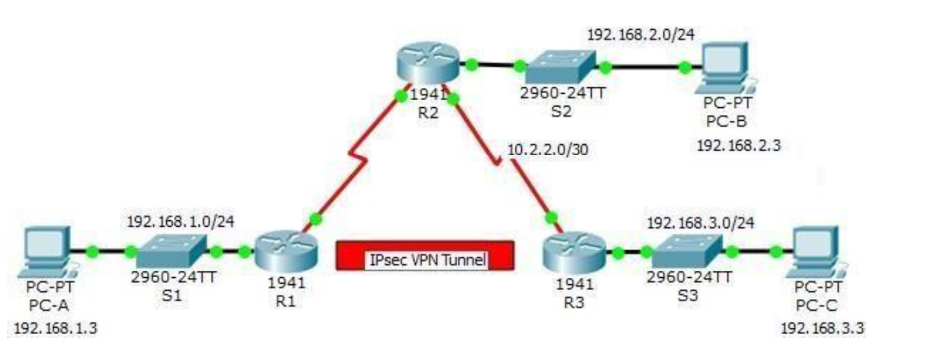
Addressing Table
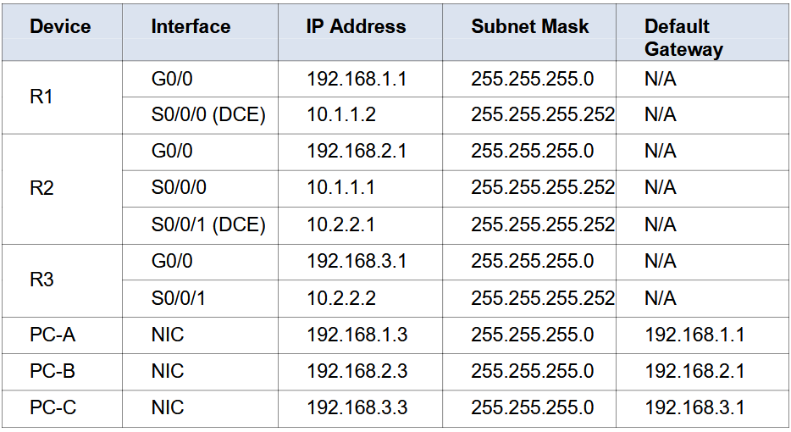
Objectives
- Verify connectivity throughout the network.
- Configure R1 to support a site-to-site IPsec VPN with R3.
Background / Scenario
The network topology shows three routers. Your task is to configure R1 and R3 to support a site-to-site IPsec VPN when traffic flows between their respective LANs. The IPsec VPN tunnel is from R1 to R3 via R2. R2 cts as a pass-through and has no knowledge of the VPN. IPsec provides secure transmission of sensitive information over unprotected networks, such as the Internet. IPsec operates at the network layer and protects and authenticates IP packets between participating IPsec devices (peers), such as Cisco routers.
ISAKMP Phase 1 Policy Parameters
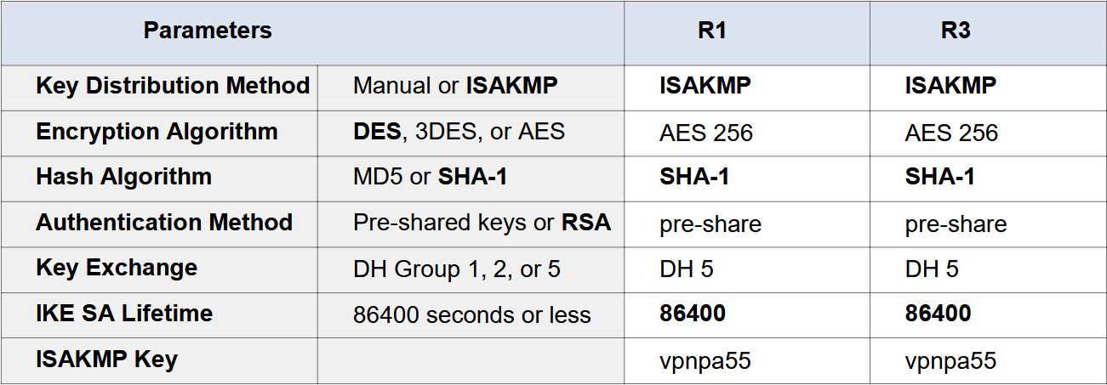
Note: Bolded parameters are defaults. Only unbolded parameters have to be explicitly configured.
IPsec Phase 2 Policy Parameters
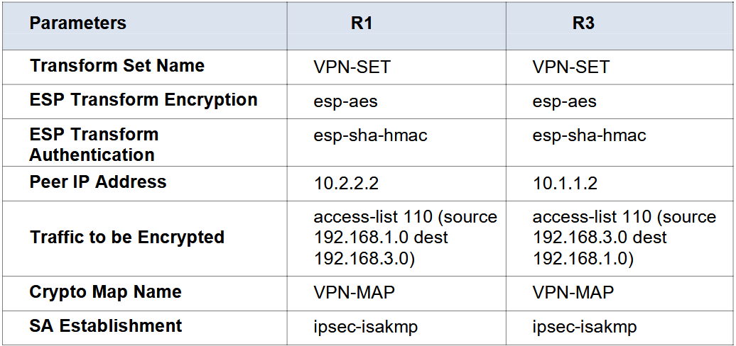

The routers have been pre-configured with the following:
- Password for console line: ciscoconpa55
- Password for vty lines: ciscovtypa55
- Enable password: ciscoenpa55
- SSH username and password: SSHadmin / ciscosshpa55
- OSPF 101

For all Routers
ROUTER(config)#enable password ciscoenpa55
ROUTER(config)#line c 0
ROUTER(config-line)#password ciscoconpa55
ROUTER(config-line)#exit
ROUTER(config)#line VTY 0 4
ROUTER(config-line)#password ciscovtypa55
ROUTER(config-line)#exit
ROUTER(config)#username SSHadmin password ciscosshpa55
Configure OSPF
R1(config)#router ospf 101
R1(config-router)#network 192.168.1.0 0.0.0.255 area 0
R1(config-router)#network 10.0.0.0 0.255.255.255 area 0
R1(config-router)#

R2(config)#router ospf 101
R2(config-router)#network 10.0.0.0 0.255.255.255 area 0
R2(config-router)#network 192.168.2.0 0.0.0.255 area 0

R3(config)#router ospf 101
R3(config-router)#network 192.168.3.0 0.0.0.255 area 0
R3(config-router)#network 10.0.0.0 0.255.255.255 area 0
Static Routing For R1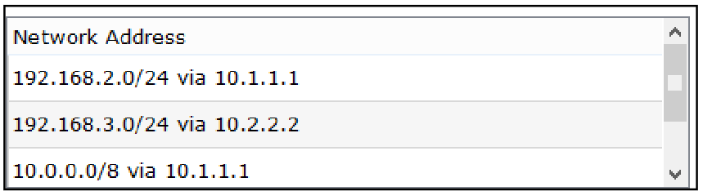
Static Routing For R2
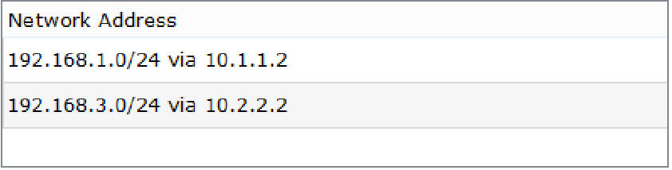
Static Routing For R3
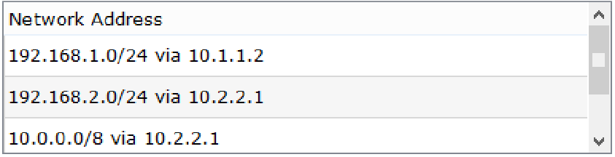

Part 1: Configure IPsec Parameters on R1
Step 1: Test connectivity.
Ping from PC-A to PC-C.

Step 2: Enable the Security Technology package.
On R1, issue the show version command to view the Security Technology package licenseinformation.
a If the Security Technology package has not been enabled, use the following command to
enable the package.
R1(config)# license boot module c1900 technology-package securityk9 ACCEPT? [yes/no]: y
R1(config)#do write
R1(config)#do reload
b. Accept the end-user license agreement.
c. Save the running-config and reload the router to enable the security license.
d. Verify that the Security Technology package has been enabled by using the show version command.

Step 3: Identify interesting traffic on R1.
Configure ACL 110 to identify the traffic from the LAN on R1 to the LAN on R3 as interesting. This interesting traffic will trigger the IPsec VPN to be implemented when there is traffic between the R1 to R3 LANs. All other traffic sourced from the LANs will not be encrypted. Because of the implicit deny all, there is no need to configure a deny ip any any statement.
R1(config)# access-list 110 permit ip 192.168.1.0 0.0.0.255 192.168.3.0
0.0.0.255

Step 4: Configure the IKE Phase 1 ISAKMP policy on R1.
Configure the crypto ISAKMP policy 10 properties on R1 along with the shared crypto key vpnpa55. Refer to the ISAKMP Phase 1 table for the specific parameters to configure. Default values do not have to be configured. Therefore, only the encryption method, key exchange method, and DH method must be configured.
Note: The highest DH group currently supported by Packet Tracer is group 5. In a production network, you would configure at least DH 14.
R1(config)# crypto isakmp policy 10
R1(config-isakmp)# encryption aes 256
R1(config-isakmp)# authentication pre-share
R1(config-isakmp)# group 5
R1(config-isakmp)# exit
R1(config)# crypto isakmp key vpnpa55 address 10.2.2.2

Step 5: Configure the IKE Phase 2 IPsec policy on R1.
a. Create the transform-set VPN-SET to use esp-aes and esp-sha-hmac.
R1(config)# crypto ipsec transform-set VPN-SET esp-aes esp-sha-hmac
b. Create the crypto map VPN-MAP that binds all of the Phase 2 parameters together. Use
sequence number 10 and identify it as an ipsec-isakmp map.
R1(config)# crypto map VPN-MAP 10 ipsec-isakmp
R1(config-crypto-map)# description VPN connection to R3
R1(config-crypto-map)# set peer 10.2.2.2
R1(config-crypto-map)# set transform-set VPN-SET
R1(config-crypto-map)# match address 110
R1(config-crypto-map)# exit

Step 6: Configure the crypto map on the outgoing interface.
Bind the VPN-MAP crypto map to the outgoing Serial 0/0/0 interface.
R1(config)# interface s0/0/0
R1(config-if)# crypto map VPN-MAP

Part 2: Configure IPsec Parameters on R3
Step 1: Enable the Security Technology package.
a. On R3, issue the show version command to verify that the Security Technology package
license information has been enabled.
b. If the Security Technology package has not been enabled, enable the package and
reload R3. R3(config)# license boot module c1900 technology-package
securityk9 ACCEPT? [yes/no]: y
R3(config)#do reload
f. Accept the end-user license agreement.
g. Save the running-config and reload the router to enable the security license.
h. Verify that the Security Technology package has been enabled by using the show
versioncommand.

Step 2: Configure router R3 to support a site-to-site VPN with R1.
Configure reciprocating parameters on R3. Configure ACL 110 identifying the traffic from the LAN on R3 to
the LAN on R1 as interesting.
R3(config)# access-list 110 permit ip 192.168.3.0 0.0.0.255 192.168.1.0 0.0.0.255
Step 3: Configure the IKE Phase 1 ISAKMP properties on R3.
Configure the crypto ISAKMP policy 10 properties on R3 along with the shared crypto key vpnpa55.
R3(config)# crypto isakmp policy 10
R3(config-isakmp)# encryption aes 256
R3(config-isakmp)# authentication pre-share
R3(config-isakmp)# group 5
R3(config-isakmp)# exit
R3(config)# crypto isakmp key vpnpa55 address 10.1.1.2

Step 4: Configure the IKE Phase 2 IPsec policy on R3.
a. Create the transform-set VPN-SET to use esp-aes and esp-sha-hmac.
R3(config)# crypto ipsec transform-set VPN-SET esp-aes esp-sha-hmac
b. Create the crypto map VPN-MAP that binds all of the Phase 2 parameters together.
Usesequence number 10 and identify it as an ipsec-isakmp map.
R3(config)# crypto map VPN-MAP 10 ipsec-isakmp
R3(config-crypto-map)# description VPN connection to R1
R3(config-crypto-map)# set peer 10.1.1.2
R3(config-crypto-map)# set transform-set VPN-SET
R3(config-crypto-map)# match address 110
R3(config-crypto-map)# exit

Step 5: Configure the crypto map on the outgoing interface.
Bind the VPN-MAP crypto map to the outgoing Serial 0/0/1 interface. Note: This is not graded.
R3(config)# interface s0/0/1
R3(config-if)# crypto map VPN-MAP

Part 3: Verify the IPsec VPN
Step 1: Verify the tunnel prior to interesting traffic.
Issue the show crypto ipsec sa command on R1. Notice that the number of packets encapsulated,
encrypted, decapsulated, and decrypted are all set to 0.
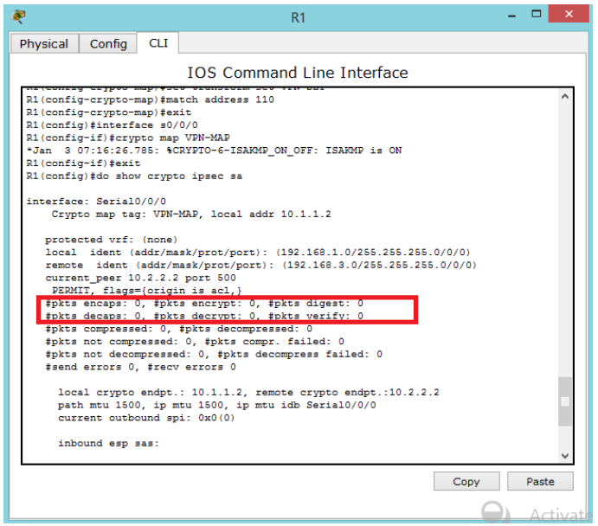

Step 2: Create interesting traffic.
Ping PC-C from PC-A.

Step 3: Verify the tunnel after interesting traffic.
On R1, re-issue the show crypto ipsec sa command. Notice that the number of packets is more than 0, which indicates that the IPsec VPN tunnel is working.

Step 4: Create uninteresting traffic.
Ping PC-B from PC-A. Note: Issuing a ping from router R1 to PC-C or R3 to PC-A is not interesting traffic.

Step 5: Verify the tunnel.
On R1, re-issue the show crypto ipsec sa command. Notice that the number of packets has not changed, which verifies that uninteresting traffic is not encrypted

