Rebirth of the Player Piano

By Terry Smythe
smythe@shaw.ca

Introduction

Whether a vorsetzer, upright pumper, or a reproducing piano, all are dependent upon rolls of paper punched with holes to provide the basic variable - music. The paper music rolls make it possible today to hear a real piano played by the legendary masters.

While the piano itself can be repeatedly restored into perpetuity, the original rolls cannot be restored. Time is their fatal enemy. All of the original paper music rolls will eventually become unusable as they deteriorate over time.

Back in September 1988, I wrote an article for the AMICA Bulletin, "Future of Paper Rolls", in which I stated:

"...we are totally failing to focus attention on the very heart of what we purport to support. We seem to have become woefully complacent about doing something about preserving our recorded music for all time. Paper music rolls are absolutely guaranteed to one day self-destruct and die. Yet so many of us, myself included, tend to treat them as if they were an inexhaustible, self renewable resource. ...one of the goals for this endeavour is the development of a process to "read" rolls into some kind of portable reader on the owner's premises."

Some 14 years later, the eventual death of original paper music rolls is coming into ever sharper focus. The self-destruction process is now visibly underway.

A number of technically competent people, seeing this inevitability, have designed and constructed fine quality perforating machinery to make new recuts of the old rolls available. This is admirable, commendable, is widely supported and making a huge contribution towards keeping player pianos alive and performing well.

A Player Piano Rebirth

In recent years, we are beginning to see an evolutionary development of contemporary electronic devices to make it possible to preserve the content of paper music rolls in electronic form.

The preservation of the content of music rolls is now becoming a reality by means of lo-cost scanners that can be built by most any technically competent person, and migrated around the world to various people owning large collections of original rolls. The objective being to convert the content of these rolls into midi format. Over time, a huge library of these conversions can be made freely available to anybody inclined to have them.

While player pianos have been threatened by the predictable demise of original paper music rolls, these new developments marrying leading edge technology with turn-of-the-century technology are having the effect of provoking a rebirth of interest in, enjoyment of player pianos, and perhaps most important - preservation for all time of the performances by legendary masters of the piano as they personally recorded their artistry on paper rolls.

My Roll Scanner

With a background in government administration and management, I was not at all prepared to undertake this endeavour. I could not have done it without the help (in random order) of Richard Stibbons, Jim Cullen, Bob Pinsker, Albert deBoer, Warren Trachtman, Gene Gerety, Spencer Chase, Kevin Keymer, Jack Breen, Ross Chapman, Bill Earnest, Peter Phillips, Wes Melander, Milton Schenk, James Stoyka, John Klassen, Henry Bohncke, Bill Flynt, to name but a few. My apologies to those I may have overlooked. The essential issue is that if I can successfully build and use a music roll scanner, then most anybody can.

Basically, my scanner started out in life as a rusty old AutoTypist roll frame, an early automatic typewriter built around pneumatic player piano technology. After cleaning it up, painting, and substituting some conventional player piano spool box parts, I was ready to go, or so I thought. It has been an interesting adventure. Caution..... My scanner, while adequate from my viewpoint, is modest compared to what others have achieved. That does not make it “poor”. Just simple and easy to build using common lumber and conventional player piano spool box parts.

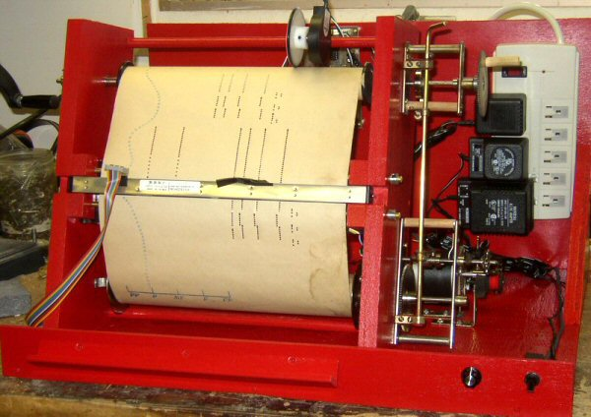

The MK3 System

Richard Stibbons in the UK is the developer of this MK3 system for scanning music rolls. After successfully scanning several thousand rolls, Richard perceived it would be possible to accelerate the process dramatically and developed a concept for doing so. Kevin Keymer in the USA converted the concept into a working circuit. Richard in turn then came up with a final circuit board design incorporating the speed-up circuit, and named it the MK3a system.

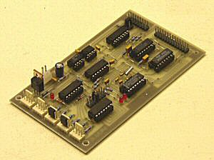

Roll Scanner Construction

The construction of a roll transport for the scanner can be elegant and costly, or it can be modest, often benefiting from a healthy dose of resourcefulness. Most of the scanners in use today are modest, built with a mix of conventional player piano spool box parts and ordinary hardware store products.

Two years ago, I built my first roll scanner based on an AutoTypist roll frame. At the time, I did not realize that this configuration offers some interesting positive features not readily apparent. This is the second scanner I’ve built, this one also based on an AutoTypist roll frame configuration, but using conventional player piano spool box parts/transmission.

Wood construction was good enough for original player piano spool boxes, so I chose to continue with wood construction for this scanner, largely because of ease, working with limited tools. I do not have a machine shop, nor access to one for hobby purposes.
The 2 side panels are ¾” clear pine approximately 16” x 5 ½”. Several critical ingredients:

- Paper path must be sufficiently angular as to enhance probability of the paper laying flat as it passes beneath the CIS sensor.

- With the scanner frame leaning back, the CIS sensor lens are protected from falling paper fluff.

- The 2 side panels, after being generally cut to size, must be clamped tightly together for slim pilot holes for later enlargement for the 4 corners of the roll transport. I use a 3/32” drill for these pilot holes. It is absolutely imperative that the roll ends up tracking perfectly. These pilot holes make it all possible.

- At same time, while clamped together, cut the notches to hold the CIS, absolutely at right angles to the paper path.

- Note that the unit is not vertical. It is important for it to lean back to make possible the use of gravity and friction to hold a loosely held encoder accurately in place during a scan.

- The two side panels are separated by three ½” hardwood dowels 13 3/8” long, the same width as a typical player piano spool box. Useful to use oak or birch carefully selected for straightness. Cut all 3 at same time to ensure all are exactly same length.

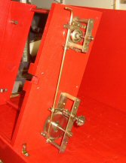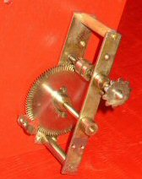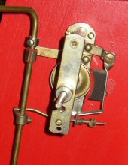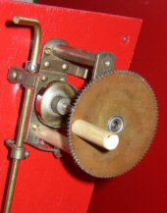
Single bracket anchor
Manual rewind
Source roll brake set very light
These are the parts from a typical player piano spool box. Note that I have cut the frame in approximately 1/3 and 2/3, by best guess. The objective is to lengthen out the paper path between the CIS and the source roll. At 8’/minute paper speed, things happen very quickly, and very easy to tear a roll off its core. Note that the take-up spool rewind brake has been removed. The source roll brake is required, but set to provide a very light braking action, just enough to keep the paper flat under the CIS. Automatic powered rewind following a scan is hazardous, so a manual rewind is provided for. Keep it simple. In this scanner, the upper portion needed a ½” hole to accommodate its bearing shaft. Elsewhere is a pic of the reverse side of this showing a 9/16” hole drilled half-way through. Note that the assembly is anchored to the floor with only a pair of tiny angle brackets, nothing more than that needed as gravity does the rest to hold it in place. And finally, the original control arm, now too short, had to be replaced with common 3/16” brass rod.

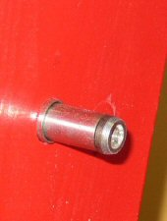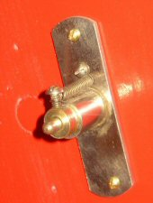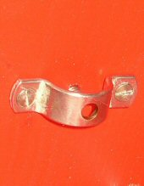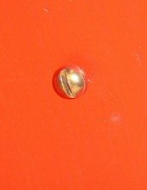
Note that this idler chuck has a dimpled face, far more desireable for pin-end 65 and 58n rolls.
The 1/8” pilot hole for the upper left chuck can now be enlarged to accommodate this spring loaded idler chuck. When searching for player piano spool box parts, try to find an idler chuck that has a dimpled face. These ordinarily appeared in transitional player pianos in approximately 1912-1913 to accommodate both 88n and 65n rolls. Hard to find, but very desireable if there is a likelyhood of scanning 65n and/or 58n rolls. The lower left is simply an adjustable bearing screw, helps in centering the take-up spool. The 1/8” pilot hole here may not have to be enlarged to accommodate this friction fit screw. Try it before enlarging it! Once enlarged, it cannot be shrunk if screw is too loose, then an aggravating repair job is needed.

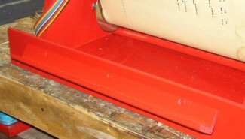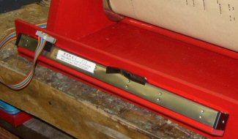
To change a roll, it will be necessary to temporarily remove the CIS and park it. A convenient method is attachment of a strip of common right angle outside wood moulding, commonly used to blend 2 drywall surfaces on an outside corner. I slightly plane one corner to facilitate mounting it an angle. Let gravity hold it in place while changing a roll.

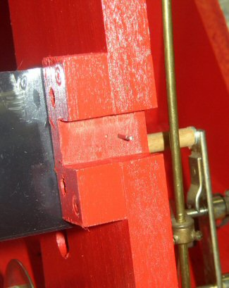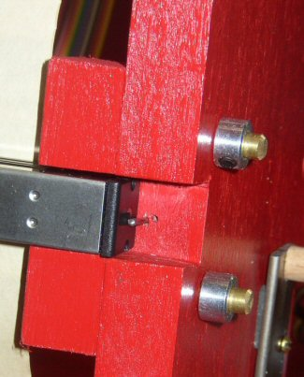

It is important that the CIS be mounted as centered as possible, each and ever time it is inserted to scan a roll. A simple method of doing so is to insert a common headless finishing nail in a desired stop point. Every time the CIS is installed, it will always be correctly positioned against the stop pin.

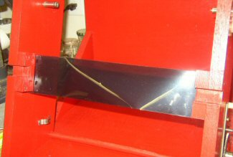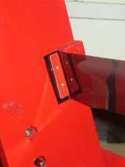
ccfl mounting bracket
The ccfl light source is a bit too strong for the CIS/Bit Twiddling capability, so some neutral density filter is needed. In this case, I added 3 layers to achieve a light source that made it possible to acquire a good image with the BT pot roughly midway in its 10-turn travel. Desireable to have this filter as close as possible to the CIS. I find this stuff tricky to handle, and a little difficult to get it tight and flat. This neutral density filter is routinely available from suppliers that cater to the theatrical industry. Note these little brackets I made to carry the ccfl lamp. Makes it very easy to replace a bulb. Bulb location is somewhat trial and error to find the best spot. The lamp must be parallel to the CIS, both vertically and horizontally. In use, avoid placing the scanner assembly with an outside window in the background, as the CIS is sensitive to light sources other than just the ccfl lamp.

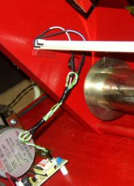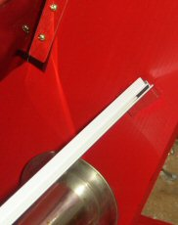

I have positioned the ccfl lamp into a pair of little brackets to facilitate easy replacement. In the pic on the left is a fundamental error. At the time I did not know that the lamp and its companion inverter should be placed as close together as possible. Because of the high frequency and low current involved, the wires should be kept as short and far away from each other as practical. Since then, I have cut the length of that wire to an absolute minimum. Both the ccfl lamp and its companion inverter come from All Electronics. They are recommended for one another, but the ccfl lamp connector does not fit the inverter. I cut off the connector and substituted a connector I salvaged from an old motherboard.

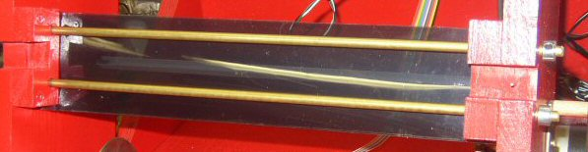

These two ¼” brass rods, commonly available from Home Depot, make it possible for the paper roll to pass past the CIS as flat as possible. It is understood that the focal length of 2.5mm is recommended. In this scanner, I ended up with a space of about 1mm between the moving paper and the face of the CIS. In this scanner, a very good image emerged at this setting.

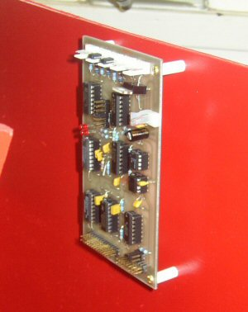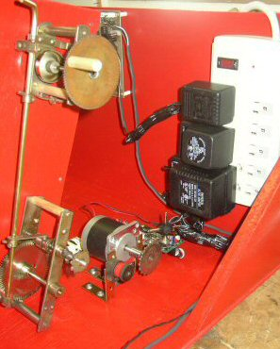

The backboard of this scanner provides a convenient place to mount the MK3a board, preferably on stand-offs. It is equally convenient for mounting a power bar, the type that is designed for 3 power supplies and 4 power cords. Everything, including a dedicated scanner computer can be run off this power bar. In this case, I chose to use 3 power supplies, rather than a single multiple output power supply. The stepper motor requires a 12vdc/800mamp, the ccfl lamp/inverter require a 12vdc/400mamp, and the MK3a board, with its own voltage regulator, can accept a power supply of anywhere from 6vdc to 15vdc of about 400mamp. In the pic on the right I’ve installed the stepper motor and its controller, and an idler salvaged from a player piano spool box. The idler is needed to maintain a little tension on the ladder chain.

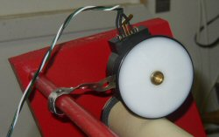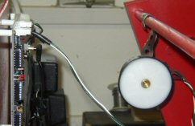

This is a curiously interesting installation of a high-end optical encoder. It is curious because its attached in a very sloppy manner. Its companion pick-off wheel must ride on the center of the roll regardless of the roll’s diameter. So the relationship between the top spreader bar and the source roll position is important. As the roll diameter shrinks during a scan, the encoder rides in an arc progressively closer to the core. This positioning of the spreader bar and the source roll make for a very good installation. Its attachment does not need to be precise because when in place for a scan, the forces of gravity and friction keep it riding accurately on the roll. Works like a champ! At scan-end, I simply roll the encoder backwards and let it hang in behind while I change the roll. I attached the encoder to the spreader bar using a short length of common plumbing strapping.

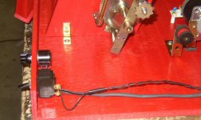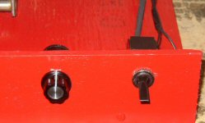

The short vertical front panel provides a convenient location for the Bit Twiddling 10-turn potentiometer. This pot adjusts the quality of the image. If the scanner was a camera, this fuction would be called “adjusting the aperature for best exposure”. It is attached to the MK3a board. The toggle switch is spliced into the 12vdc line to the stepper motor controller. As a roll scan is completed, it is critical that the scan software (CIS.EXE) be stopped before the motor is stopped, or at the same precise moment. If the motor is stopped prior to the software, the encoder is still reporting paper movement, but with the paper at a dead stop, final midi playback will suffer from a severe tempo problem. The MK3a system does provide for splicing the stepper controller into the Mk3a board, a modification I will incorporate at some other time in the future. For now, this approach works well.

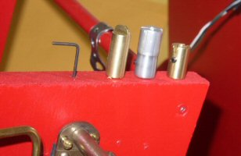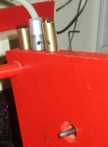

It is possible, using conventional 88n spool box parts, to provide for scanning not only 88n rolls, but also 65n and 58n rolls. All that is required is a set of driver chucks for the right side of the source roll. In the left pic is the line-up of 88n, 58n and 65n chucks. The right pic shows the same line-up, with an empty drive shaft. In the pics following, it can be seen that the spring loaded left idler chuck compensates for overall roll width. The original drive shaft was 3/16”. A convenient substitution is 3/16” brass rod. The overriding objective here is to have a set of chucks that ensure the roll is centered under the CIS.

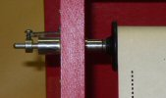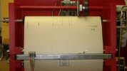

Here a conventional 88n roll is mounted. The right pic shows the 88n chuck installed and locked. The left pic shows how the left idler chuck compensates under spring pressure. The center pic shows the roll centered.

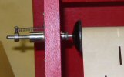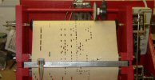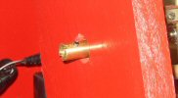

Here a 65n roll is mounted. The right pic shows the 65n chuck installed and locked. The left pic shows how the left idler chuck compensates under spring pressure. The center pic shows the roll centered.

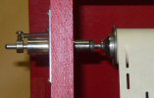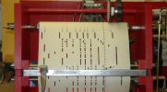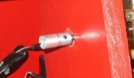

Here a 58n roll is mounted. The right pic shows the 58n chuck installed and locked. The left pic shows how the left idler chuck compensates under spring pressure. The center pic shows the roll centered.

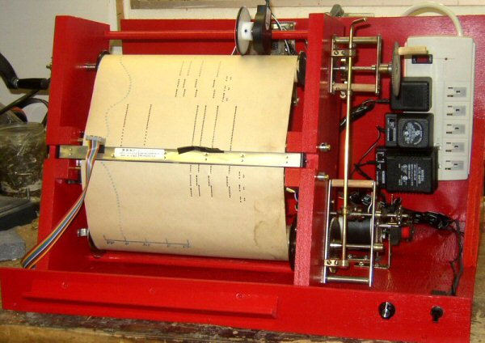

Here is the completed scanner in operation. Not particularly elegant or pretty or portable, but quite effective in operation. Perhaps of some importance to some folks, it is inexpensive. The components shown here are the same components illustrated elsewhere on <members.shaw.ca/smythe/rebirth>

The Roll Scanning Process

With the scanning software (CIS.EXE) running and a roll in motion, an approximate image of the roll’s hole pattern will be displayed on the computer screen. At 8’/minute, a typical 88n roll will be scanned in about 2 minutes. Here are a couple of images of what I see on screen.

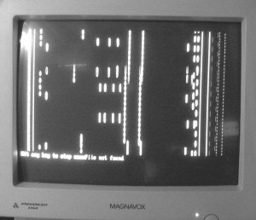



Some Observations

Some of my most delightful, entertaining scans have emerged from rolls absolutely unplayable because of their physical condition. In their early life, they were simply played to death. Richard’s MK3 software does not look for paper edge, so torn or worn roll edges do not cause a problem. Missing leaders do not cause a problem because I simply tape the leading edge of the paper to the take-up spool.

By chance a group of severely fire damaged rolls came my way, ragged and charred edges, spool ends melted, et al…. Yet Richard’s Mk3 system came through with flying colours. All were scanable, producing decent quality music.

At 8'/minute, my typical scan is about 2 minutes, but after watching carefully through about a dozen scans, I suddenly noticed that during one of them, the roll slipped to the left slightly, then ran for a few feet like that, then slipped back to the right. That roll was a badly damaged roll.

My brake on the source side was set a little too tight. Because badly damaged rolls typically had been played to death in their day, the drive slot in the right spool end was badly worn, allowing the roll to slip out of lock, then slip back into lock a couple of turns later.

I found a couple of other rolls in similar physical condition, and noticed a few of them behaved similarly. I've just relaxed the brake on the right side and increased the spring tension on the left side, and rescanned them successfully.

Some old rolls are severely damaged through strings of perforations, again making them totally unplayable on a player piano. However, on the MK3a system, I’ve found I can crudely repair the rolls with crystal clear mending tape right over the perforations. This desperate measure does work quite successfully to salvage the content of a roll that would otherwise end up in the fireplace. Light, not air, must pass through the emergency tape repair.

Conclusions

14 years ago, I wished for a method of capturing the content of music rolls in some computerized form with the objective in mind of preserving their content for all time, no differently than repeatedly restoring a player piano into perpetuity. It has come to pass. A dream has been fulfilled.

True, methods of storing data in digital form has no proven perpetual life expectancy equal to that of paper. But what we do have proven is the ability of clever people to find ways over time of converting data from one digital form into another, thus ensuring their preservation for all time. Of that, I am confident.

Julian Dyer has recently proven that scans from the MK3a system can produce exact copies, punch-for-punch the same as the originals, faithfully capturing the original roll content. So faithful that it is now possible to accurately recreate a new recut of an old roll that is a precise copy of the original. It may look visually different, but a player piano will not be able to tell the difference. This is a huge breakthrough for those wanting to obtain high quality recuts of old production rolls.

The MK3a system is proving itself to be remarkable robust and tolerant. In just a few short months, I have successfully scanned over 2,000 rolls. Many of these rolls are virtually unplayable, but their content has been captured and preserved, hopefully for all time.

No doubt there are many collectors like me with original rolls in tatters, but reluctant to destroy them. There is hope! They have a fighting chance of being scanable to capture their content. Do not destroy them! Those having such rolls in their collection should consider donating them to any one of the group of people worldwide now owning homemade scanners.

Several people within the Rollscanner discussion group also own Disklavier, PianoDisc, Pianomation and Pianocorder pianos. All have found that the midi files emerging from roll scanning will produce credible performances on their instruments.

Through the magic of the internet, it has been possible for me to successfully construct a roll scanner, something for which I am quite unsuited. I could not have done it without the help of many people, all through internet exchange of ideas and information. If I can do it, anybody can do it.

A word of caution….. Perseverance is critical. Very easy to become discouraged. There were heart-stopping moments during my early efforts. However, with the enduring help of very clever people within the rollscanning community, I was eventually successful.

To see additional information about roll scanning and what other people are doing, and what are scanning systems are in place, have a look at the following web sites:

My own home page showing what others are doing, and my downloadable midi files to date (~2,000 midi files to date):
http://members.shaw.ca/smythe/rebirth.htm

Peter Phillips’ ( a pioneer in roll scanning) home page:
http://members.optushome.com.au/eleced/

Spencer Chase’s E-Rolls and Midi Valve system
http://www.spencerserolls.com/

The International Association of Mechanical Music Preservationists
http://www.iammp.org/

Discussion Group for Roll Scanning
http://groups.yahoo.com/group/Rollscanners/

Stay tuned…….

Terry Smythe
55 Rowand Avenue
Winnipeg, MB
Canada R3J 2N6
(204) 832-3982
smythe@shaw.ca
http://www.mts.net/~smythe

