Scanner Design Variations
by Albert de Boer
Sept. 2003

It seems that almost every day I spend some time thinking of, and experimenting with ideas intended to improve the quality of scans made with my ‘experimental’ scanner design, using the MK3bt board and its associated scanning software.
Those of you that have build scanners have surely noticed the importance of a constant focal distance of the paper to the CIS array and keeping the paper parallel and square to this element during its travel.
There are several other factors involved that have influence on the accuracy of a cis file as to how well the cis file represents the actual hole pattern of the roll.
However my following comments are only related to maintaining a constant (correct) focal distance during the process of scanning.
In his latest posting Julian Dyer suggests the usage of a curved surface over which the paper moves in order to improve on maintaining a constant focal length.
This would be feeding into the natural tendency of the paper to curve, a condition established by it having been rolled on a core and thus stored. By using a curved surface Julian observed a substantial improvement. Making the paper move over a curved surface in the area of the CIS seems to easily pass logical scrutiny.
Strange as it may seem I was at the same time experimenting with this same idea, but did not get the encouraging results Julian did.
Obviously I was not duplicating his setup.
After several attempts with various curvatures and slot width I still have not achieved the same results. My light source consists of a 12” fluorescent bulb part of an ‘ under the kitchen cupboard’ fixture bought at Wall-Mart.
I worked with slots varying from 1/16 to 1/8 wide, but did not seem to be able to get enough light to the CIS array. Using a wider slot and thus allowing more light to pass would also allow for move potential movement of the paper and defeating the initial reason for the curved surface. I guessed that the light source was my problem I also found that measuring the focal length was rather tricky and difficult to establish along the entire length of the slot.
To verify that nothing else was contributing to this problem, I reinstalled my former ‘over the CIS’ guides consisting of two ¼” dia. brass tubes, one ahead and one on the other side of the CIS , spaced 1 ½ “ apart.
The ends of the two tubes ends are inserted small, flanged, double shielded miniature ball bearings having an ID of ¼” and OD of 5/8” .
Two bearings each are seated in two separate brackets, which in turn are attached with screws to the inside of side plates of the scanner.
Room is provided to allow fore and aft as well as up and down adjustment of the brackets to which the two tubes, which I call rollers, are attached.
By laying a small piece of flat sheet material ( I used Lexan) of known thickness on top of the two rollers, the distance of the plane of the set of rollers to the CIS element, or rather the two black raised edges of the sides of the CIS body, can be easily established as well as setting that plane parallel to the plane established by the CIS body edges.
With the roll leader attached to the driven take up spool, a flat piece of transparent stock ( again, I used Lexan) was laid on top of the paper, so that the pair of roller guides supported it in a stable fashion. The roll paper would now move between the set of roller supports and the Lexan. This piece of Lexan measures 13 ¾” by 3 ¾”, ¼” thick.
The scanners side brackets are spaced 14 ½” apart. To prevent this cover sheet from moving with the paper, a pair of pins protruding inward from the side plates prevents forward motion.

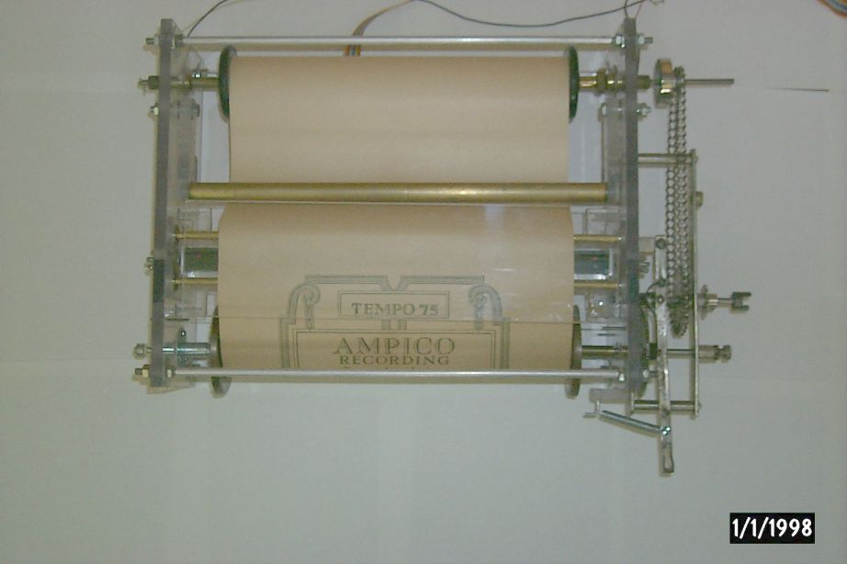

The natural tendency of the moving paper to bow in the direction of the Lexan cover is now apposed by the presence of that sheet and thus the paper moves across the CIS in a controlled, flat parallel fashion.
I observed no unwanted movement of the paper except on the edges when there are unrepaired small tears.
Several rolls of various quality and material were scanned and I did not observe unwanted movement of the paper that would affect focal length.
By the way, the focal length was easily set at 2.5 mm.
When during scanning the paper moves at a speed of about 4 ft/min, the two rollers usually do not rotate, but when some physical imperfection appears that increases the momentary friction of paper to roller, the roller will move ( rotate). I must add that I created an ‘ imperfection’ by making a few small tear at the beginning of a punched hole and folded the thus made lip upwards. No additional damage occurred to the roll.
Damage to a roll will of course result in an incorrect cis file with respect to that produced by a ‘perfect’ roll.
I initially had some concerns about the friction increase and danger of damage.
There were no signs supporting these concerns. The points of friction are minimal and I believe that chances for damage are far less than when used in the original intended way (running over the tracker bar).
The take up roll is driven through a gear reduction by a stepper motor and moves at a fixed rate of one step ( 1.8 degrees per step) per scan.
With the somewhat increased friction, the paper winds quite tightly on the take up spool.
The EOR sensor provides up front tension.
All in all, I am quite satisfied with this arrangement, although improvements will always be sought.
I use Richard Stibbons’ cis32. software for scanning.
For processing the file I used scn31U and mid31U, also authored by Stibbons and listened to the resulting .mid files using CAKEWALK..
In order to play the scanned files on my Ampico A equipped Chickering reproducing Baby Grand, I converted the cis files to erollmid files using Warren Trachtman’s beta version of his ‘CISfileConverter’ software, dated July22, 03.
Then again using CAKEWALK and the Broadmoore PowerRoll I made my piano come to life, at least that’s what the neighbors say……
I will try to attach a picture of the setup, showing the Lexan cover in position ready to start. The large brass colored part running from side to side ahead of the CIS is the ‘ end of roll’ sensor.
My setup is experimental, with that I mean that it is meant to establish the design that produces the best results and at the same time keep the execution of the design within the limits of being able to be fabricated in my modest workshop. When I believe that I have reached my maximum design under the stated conditions, I hope to build ‘the final version’, if that time ever comes.
I have not made any attempt to check whether consecutively made scans of the same roll are identical to each other. This, of course, remains to be done in order to evaluate the above described method for effectiveness.
The above description in no way seeks to imply that the method used by Julian Dryer gives less satisfactory results.
This is just one other way of going about achieving maximum control of variables.
I will be glad to answer any questions you may have.
Just send me an e-mail
Albert de Boer

