Yet Another Roll Scanner 2

By Terry Smythe
smythe@shaw.ca

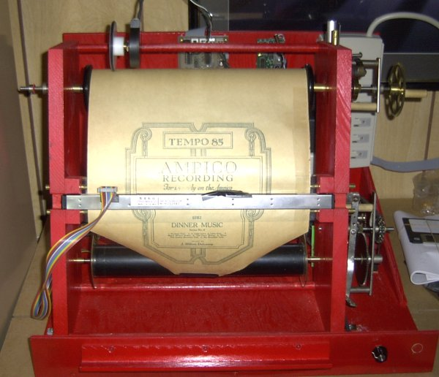

Two years ago, I built my first roll scanner based on an AutoTypist roll frame. At the time, I did not realize that this configuration offers some interesting positive features not readily apparent. This is the third and last scanner I’ve built, this one also based on an AutoTypist roll frame configuration, but again using conventional player piano spool box parts/transmission.

Wood construction was good enough for original player piano spool boxes, so I chose to continue with wood construction for this scanner, largely because of ease, working with limited tools. I do not have a machine shop, nor access to one for hobby purposes.

The 2 side panels are ¾” clear pine approximately 16” x 5 ½”. Several critical ingredients:

- Paper path must be sufficiently angular as to enhance probability of the paper laying flat as it passes beneath the CIS sensor.

- With the scanner frame leaning back, the CIS sensor lens are protected from falling paper fluff.

- The 2 side panels, after being generally cut to size and shape, must be clamped tightly together for slim pilot holes for later enlargement for the 4 corners of the roll transport. I use a 3/32” drill for these pilot holes. It is absolutely imperative that the roll ends up tracking perfectly. These pilot holes make it all possible. If you send me your mailing address in an email smythe@shaw.ca, I’ll mail you a photocopy of my template for these pilot holes.

- At same time, while clamped together, cut the notches to hold the CIS, absolutely at right angles to the paper path. I have learned that best position for the CIS is in line with the face of the brass rods, so the notches should line up with the brass rod holes.

- While still clamped together, pilot holes are also drilled for the brass rods. All these pilot holes ensure the finished scanner has the piano roll passing behind the CIS absolutely perpendicular.

- Note that the unit is not vertical. It is important for it to lean back at about a 15 degree angle to make possible the use of gravity and friction to hold a loosely held optical encoder accurately in place during a scan.

- The two side panels are separated by three ½” hardwood dowels 13 3/8” long, the same width as a typical player piano spool box. Useful to use oak or birch carefully selected for straightness. Cut all 3 at same time to ensure all are exactly same length

The roll scanner tends to emulate a conventional player piano spool box. Thanks to Al Pedworth, who contributed some spool boxes to the project, I have been able to make 3 roll scanners using these readily available parts, as illustrated below.

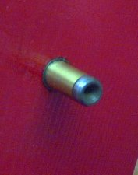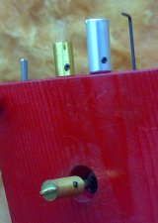
.

These two pictures illustrate the top source spool box chucks. Note the one on the left has a dimpled face, a type that appeared in spool boxes in the 1912 era when both 65n and 88n rolls were being marketed simultaneously. This dimpled chuck can accept both 88n and 65n rolls. By chance, this same chuck can also accept 58n rolls that had a left end almost identical to 65n rolls.

The picture on the right illustrates to top right drive chuck. Because the roll scanner can accept and deal with 88n, 65n and 58n rolls, 3 different chucks are made available. Each chuck is so constructed as to ensure the roll is centered within the roll frame. This is necessary because of the take-up spool which has its catch pin centered.

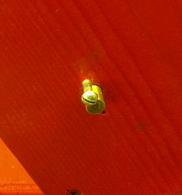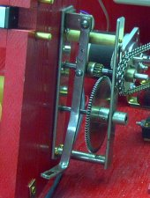

The take-up spool has as its left chuck a common player piano friction fit guide pin, held in place with a common wood screw. Once adjusted for roll centering, it is locked in place. The right hand side is part of a conventional player piano transmission, which is stripped of its rewind brake.

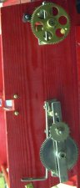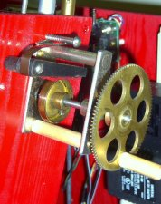

Conventional player piano spool box transmission is adapted to the roll scanner, first by cutting it into 2/3, 1/3 segments, to stretch out the paper path. With the paper moving at ~8’/minute, the end of the roll can appear very quickly with a risk of tearing it off the core. The top right segment of the transmission has fitted to it a conventional source roll brake, set very light. Its sole objective is to ensure the paper lays flat as it passes over the brass guide rods. Note that the knotches for the CIS line up with the brass guide bars.

Many player piano rolls are extremely fragile, so motorized rewind is not appropriate. Manual rewind is highly recommended. Again, from within an array of spool box parts, a low speed drive gear has a diameter sufficient to add a small piece of dowelling for a finger grip. Super simple, but effective.

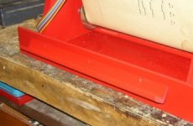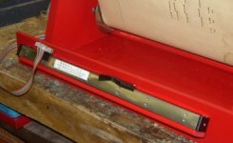

To change a roll, it will be necessary to temporarily remove the CIS and park it. A convenient method is attachment of a strip of common right angle outside wood moulding, commonly used to blend 2 drywall surfaces on an outside corner. I slightly plane one corner to facilitate mounting it an angle. Lets gravity hold it in place while changing a roll.

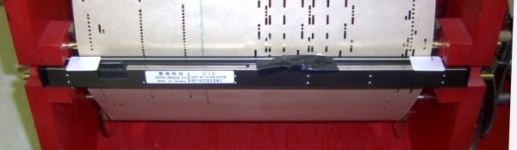

Due to minor variations on dimensions of right hand roll spool ends, roll centering becomes more an art than an engineering feat. When a roll is first inserted into the scanner and advanced to the start point, the CIS can then be centered. Pencil marks on the CIS help in the centering. This centering is important and must be done for every roll scanned. In practice, quite simple and quick.

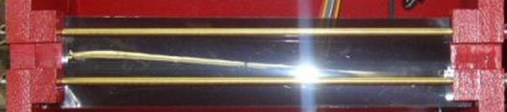

The ccfl light source is a bit too strong for the CIS/Bit Twiddling capability, so some neutral density filter is needed. In this case, I added 2 layers to achieve a light source that made it possible to acquire a good image with the BT pot roughly midway in its 10-turn travel. Desireable to have this filter as close as possible to the CIS. I find this stuff tricky to handle, and a little difficult to get it tight and flat. This neutral density filter is routinely available from suppliers that cater to the theatrical industry.

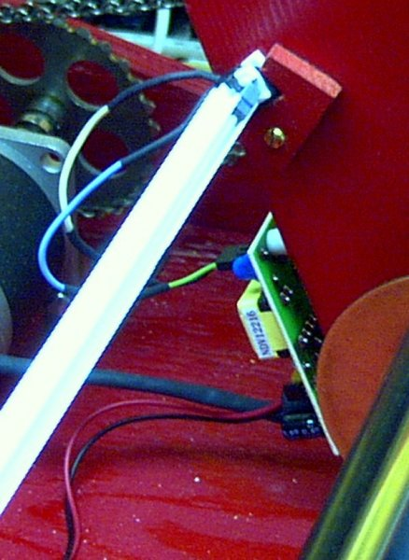

I have positioned the ccfl lamp into a pair of little brackets to facilitate easy replacement. Because of the high frequency and low current involved, the wires from the lamp to the inverter should be kept as short and far away from each other as practical. Both the ccfl lamp and its companion inverter come from All Electronics. They are recommended for one another, but the ccfl lamp connector does not fit the inverter. I cut off the connector and substituted a connector I salvaged from an old computer motherboard. The inverter runs on rather high voltage posing a shock risk, so good idea to mount it out of the way, in this case bottom of the back side of the scanner frame.

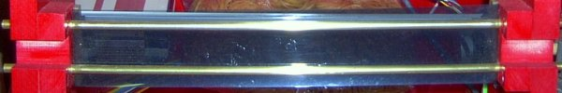

These two ¼” brass rods, commonly available from Home Depot, make it possible for the paper roll to pass past the CIS as flat as possible. It is understood that the focal length of about 2 mm is recommended. In this scanner, I ended up with a space of slightly less than 1mm between the moving paper and the face of the CIS. The CIS lens are about ½ mm inside from the face the face of the CIS. In this scanner, a very good image emerged at this setting.

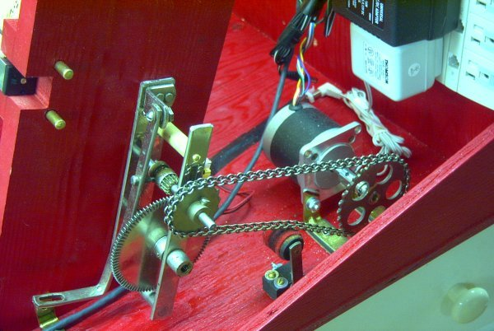

Most player pianp spool box transmissions contain 4 gears. For this scanner, I used a stepper motor from Jameco. Stepper motors, when running at less than maximum, are quite noisy, so by tinkering with the 4 gears, it is possible to achieve 7 to 8’/minute with the motor running reasonably quiet at maximum speed. A common player piano idler wheel takes up the unavoidable slack in the drive chain.

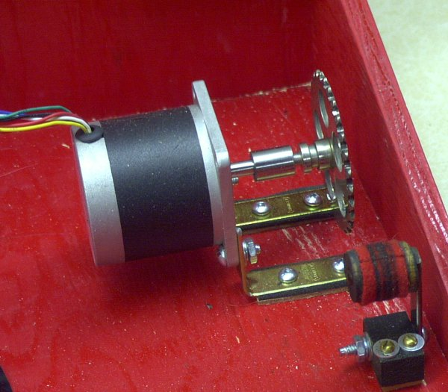

This stepper motor from Jameco is recommended. It ordinarily comes with a ¼” shaft. Conventional player piano gears all have a 3/16” shaft. An adapter is needed to reduce the shaft down to 3/16”. The gear itself is an idler gear intended for fast rewind, but is not needed for that purpose. Because it is an idler gear, it does not have a set screw installed, so I drilled a hole, tapped it and installed a 6/32 set screw.

Stepper motors tend to be somewhat noisy and vibrate at speeds lower than maximum. So best to mount it on rubber. On this one, I mounted it on both rubber and cork, both from common gasket material.
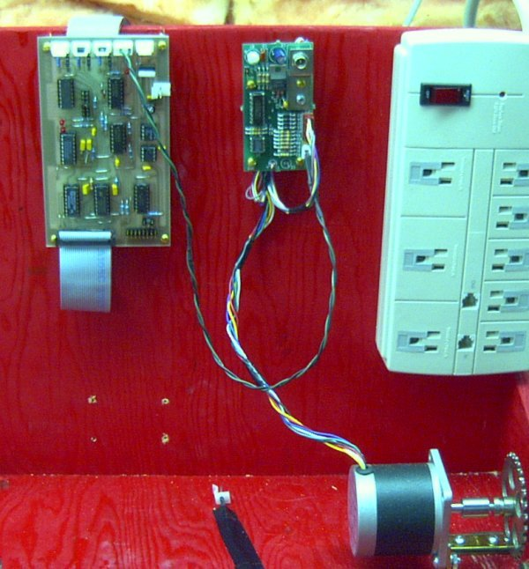

The back plane of the scanner’s framework is a convenient place to mount the MK3a board, the stepper motor controller and a power bar. I chose a power bar that facilitated 3 power supplies. I could have acquired a fancy power supply that provided all the voltages needed, but these 3 power supplies cost less than a multi-power supply. In this picture, please note that the stepper controller is connected to the MK3a board. A feature of the MK3a board makes it possible to stop and start a stepper motor with the CIS scanner software, a very nice feature.

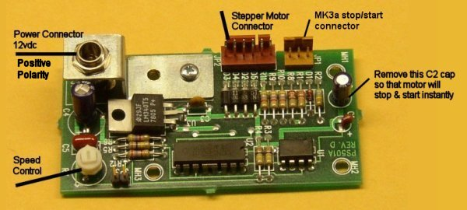

This is the recommended MD-1 stepper controller available from WZMicro.

This is the wiring connection needed to link the stepper controller to the MK3a board, to take advantage of the feature of controlling motor stop/start from within the CIS software. The 4-pin female connector to the MK3a board is routinely available from most any electronics parts store. The female connector on the stepper controller I salvaged from an old computer motherboard.
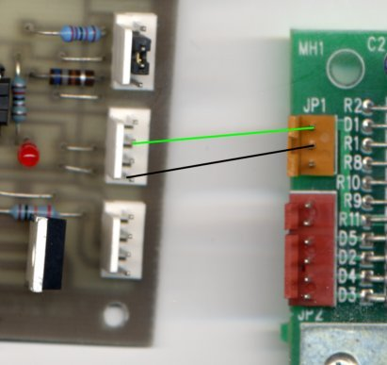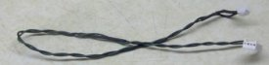

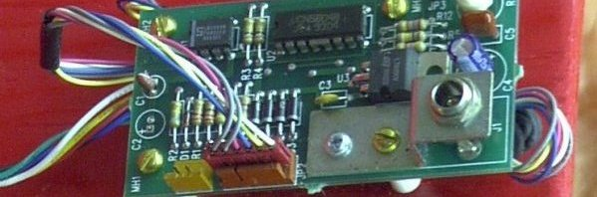

Note the 6-wire connector I salvaged from an old computer motherboard. I could have soldered the wires directly to the header, but this connector was handy. By chance, it is a type that will only fit one-way, whixh is a good feature. Note also the C2 cap removed to ensure instant motor stop/start.. The wires that ordinarily come with the motor are quite long, and the wires I found on this connector are also long. Rather than cut them to length and risk an error reconnecting, I simply bundled them together and stuffed them underneath the board

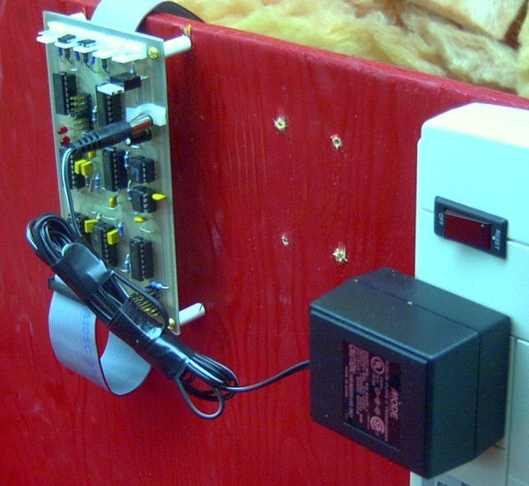

The MK3a board is mounted in a convenient location on the back plane of the framework. As it contains its own 5vdc voltage controller, its power supply cab anywhere between 5vdc to 15vdc. The one I have mounted here is a 6vdc/500mAmps, positive polarity. These wall wart type power supplies typically come with a female connector. The connector on the board does not match, so I simply bent over the negative side of the connector to make contact with the outside of the female power supply connector. These power supplies typically come with about 3’ of wire, so rather than cut the wire, I simply bundled it for cosmetic purposes.

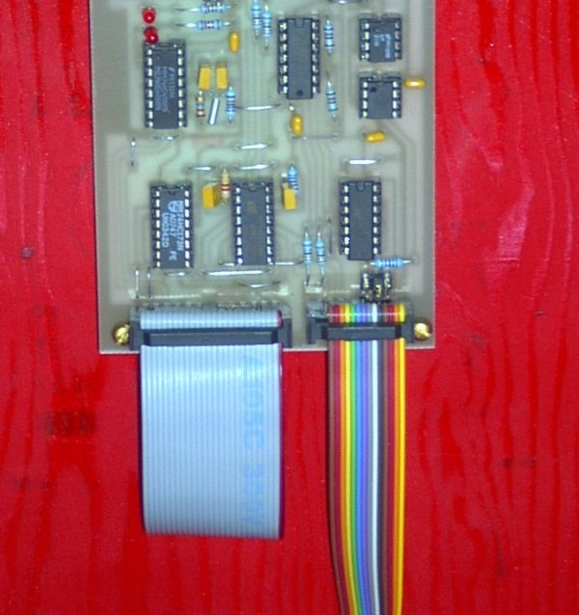

The MK3a board receives data from the CIS through the rainbow ribbon cable. The MK3a board sends data to the Lava card in the computer through the 25-wire blue ribbon cable. Note location of Pin 1 on the 25-wire ribbon cable, and Pin 1 (yellow wire) on the CIS rainbow cable. This is important, very easy to mount them backwards.

.

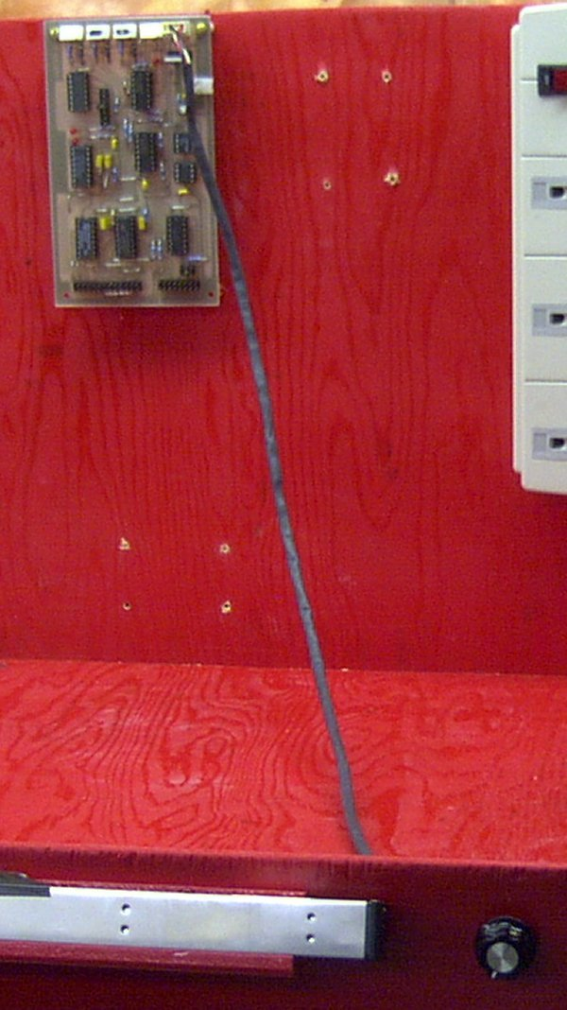
This is the connection for the Bit Twiddling 10-turn pot.
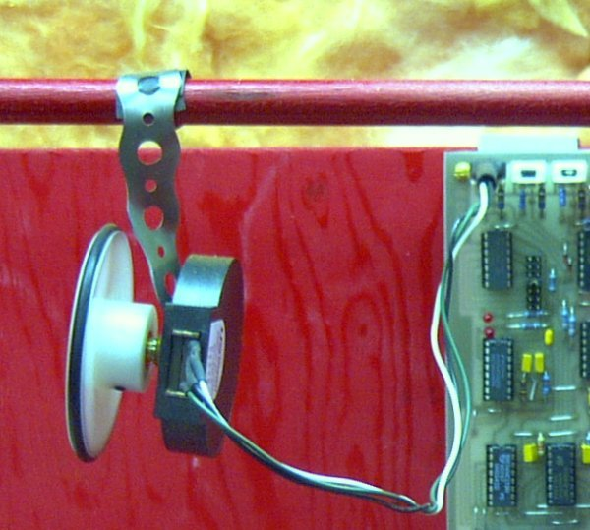

This is the manner in which the optical encoder, which reports paper movement to the CIS software, is loosely fastened to the scanner framework, and wired to the MK3a board. In this picture, the encoder is laying over backward as if to change a roll. The encoder does not be fastened in a precise manner, because in use, the forces of gravity and friction work together to hold it in place accurately throughout a roll scan. Look at picture at beginning of this document to see it in use with an Ampico reproducing piano roll.

Scanning nickelodeon rolls

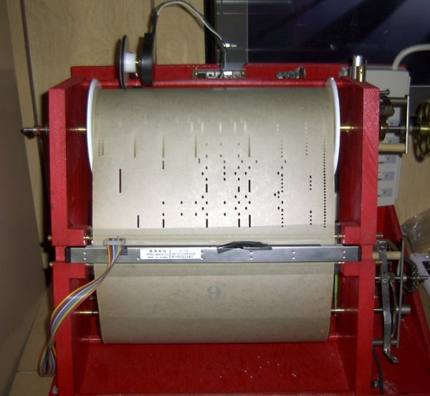

This roll scanner is capable of accepting and scanning 10-tune nickelodeon rolls. As these rolls have a paper width of 11 ¼”, the same configuration for scanning 88n rolls is used. See below the adapter plates needed to make this possible. As 10-tune nickelodeon rolls are very long, paper build-up on the take-up spool will provoke random stalling towards end of the roll, typically at about tune 9 or 10. To overcome this, each tune is scanned separately. The software and scanner are stopped between tunes, and during this break, the take-up roll is cinched up tight. Then next tune is scanned.

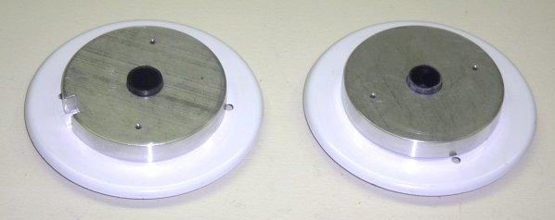

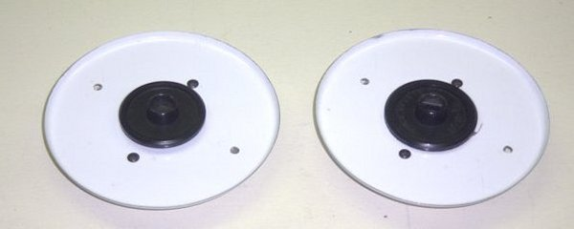

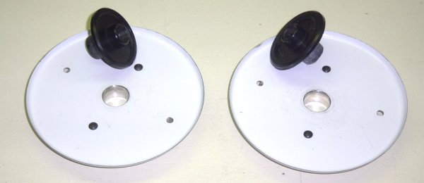

The white plates are common cosmetic electrical plates from Home Depot, intended to cover a removed power function. The middle holes are made to fit conventional 88n roll flanges. Super simple. The aluminum core inserts have a slight bevel to accommodate poor fitting cardboard cores.

Here is the completed scanner in operation. Not particularly elegant or pretty or portable, but quite effective in operation. Perhaps of some importance to some folks, it is inexpensive. The components used here are the same components illustrated elsewhere on <members.shaw.ca/smythe/rebirth>

