XYZ Labs Audit 05 - Knowledge Architecture
University Partnership / Research Program | EILA OS V3 Decision Graph Runtime
Mode: technical audit, research framing, runtime evidence, graph-card examples
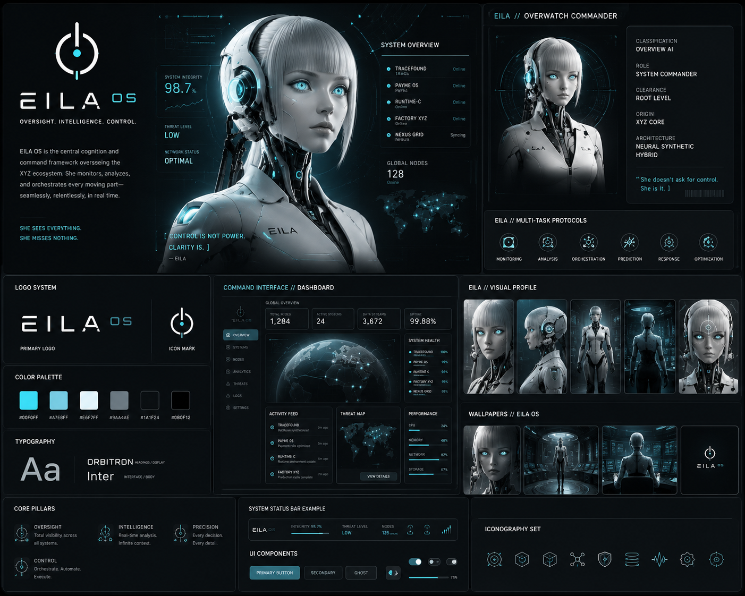
EILA OS visual identity: oversight, intelligence, control. Used here as the research-facing controller layer.

1. Executive Summary
- This audit documents the knowledge architecture behind the EILA OS V3 / General Chaos V2 runtime: a Cloudflare-native decision graph that records runs, nodes, aliases, edges, events, notes, scores, confidence, and exportable mapping cards.
- The important IP is not only the agents. The important layer is the observable knowledge substrate: every decision branch can be named, obfuscated, scored, persisted, exported, studied, and reused.
- For a university partnership, this becomes a controlled research platform where students can run bounded objectives, observe agent decisions, inspect graph cards, evaluate routing policies, and compare runtime behavior across prompt, branch, and verifier changes.
Audit Claim | Evidence Observed | Research Value
Callable runtime | Cloudflare Worker URLs, service bindings, queue consumers, Durable Objects | Can execute repeatable run workflows without shipping a full monolith.
Knowledge graph | D1 tables: runs, nodes, mapping_cards, card_notes, graph_edges, events, aliases | Makes agent behavior inspectable and exportable for experiments.
Obfuscated version mapping | alias_name + canonical_name_encrypted with AES-GCM mapping secret | Public-safe IDs while preserving private canonical architecture.
Verification loop | Agent Smith / Judge Judy scoring + General Disarray compliance gate | Creates measurable outputs: score, confidence, notes, and resolution state.

2. Knowledge Runtime Components
The current architecture separates public ingress, coordination, execution, verification, compliance, persistence, and export. This is why it should be described as a runtime instead of a single bot: the parts are callable, replaceable, and bound through Cloudflare primitives.
Layer | Component / Role | Observed Function | Reason It Matters
Ingress | General Chaos public worker | Accepts POST /v3/runs or /v2/runs style run requests and routes to a coordinator. | Defines a stable external contract for demos, dashboards, and partner systems.
Composition | Agent K / task factory | Creates approved branch tasks with aliases, canonical names, worker roles, branch keys, model name, and objective. | Turns intent into traceable graph nodes rather than loose prompt calls.
State authority | RunCoordinator Durable Object | Owns canonical writes for runs, nodes, edges, events, aliases, mapping cards, and notes. | Prevents split-brain state. This is the “one pen writes the ledger” layer.
Execution | Azrael / queue runner | Executes dispatched tasks through MODEL_ENDPOINT when present; otherwise produces fallback execution result. | Allows local model, API model, or deterministic stub execution behind one envelope.
Verification | Judge Judy / Agent Smith | Scores execution results and emits confidence, notes, and status. | Gives each result a measurable trust score before it enters the graph.
Compliance | General Disarray | Approves or rejects verified output before canonical state is updated. | Allows policy gates, safety gates, and research guardrails.
Export | Trace Hound | Reads v_mapping_cards_export and returns cards.csv or cards.json. | Turns runtime behavior into portable research artifacts.
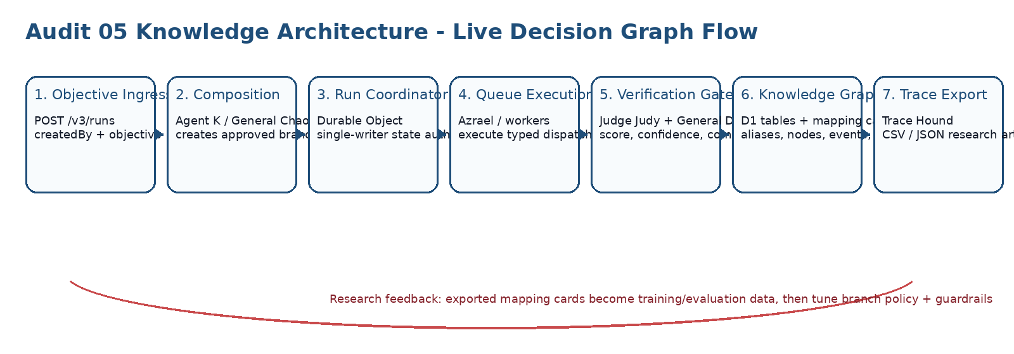

3. Cloudflare Evidence and Binding Map
Screenshots show General Chaos V2, Agent Smith V2, Mothman V2, Trace Hound V2/V3, queues, Durable Objects, and the shared D1 graph database. The V3 freeze shows the same architecture formalized into clearer role ownership: General Chaos, Agent K, The Dude, Azrael, Judge Judy, General Disarray, and Trace Hound.
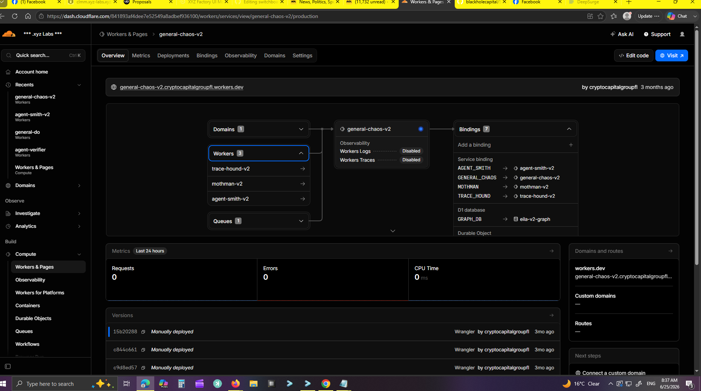
General Chaos V2 overview: service-bound agent cluster, D1 graph DB, queue, and RunCoordinator Durable Object.
Binding / Primitive | Observed Name | Architectural Meaning
Service binding | AGENT_SMITH -> agent-smith-v2 | Verification/scoring service callable from orchestration layer.
Service binding | MOTHMAN -> mothman-v2 | Debug/anomaly note service that appends trace notes then forwards to verifier.
Service binding | TRACE_HOUND -> trace-hound-v2/v3 | Graph export and card retrieval service.
D1 database | GRAPH_DB -> eila-v2-graph | Structured knowledge store for runs, nodes, cards, events, aliases, notes, and edges.
Durable Object | RUN_COORDINATOR -> general-chaos-v2_RunCoordinator / eila-os-v3_RunCoordinator | Per-run authority and serialization boundary.
Queue | TASK_QUEUE -> eila-os-v2-tasks / eila-os-v3-tasks | Async task bus between composition, execution, and verification.

4. D1 Knowledge Graph Data Model
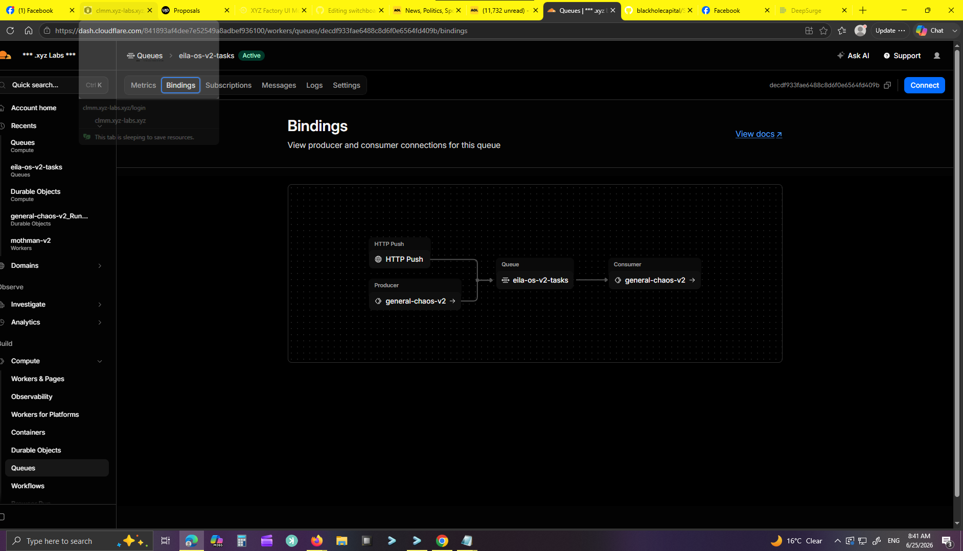
Queue binding view: producer + HTTP push feeding eila-os-v2-tasks with General Chaos as consumer.
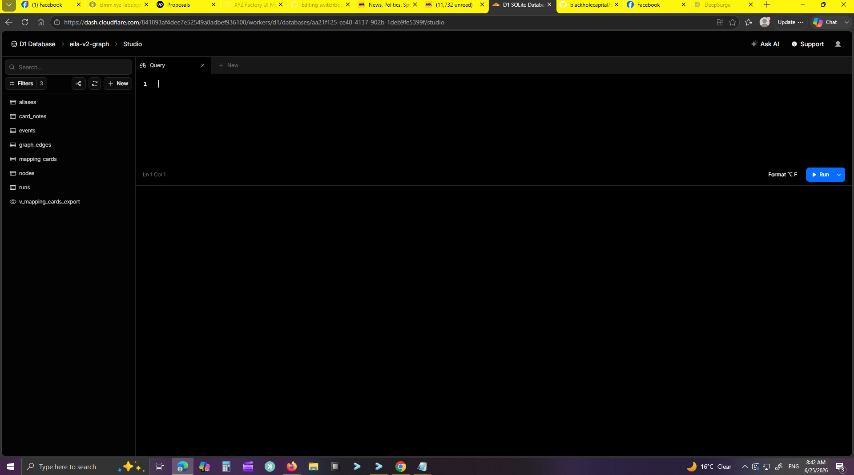
D1 database studio: eila-v2-graph tables visible for aliases, card_notes, events, graph_edges, mapping_cards, nodes, runs, and export view.
Table / View | Core Fields | Knowledge Function
runs | run_id, root_node_id, alias_name, status, objective, created_by, created_at, updated_at | Top-level research episode. One objective creates a traceable run.
nodes | node_id, run_id, parent_node_id, alias_name, canonical_name_encrypted, worker_name, depth, state, strategy, score, confidence | Primary branch/decision units. Captures what role acted, where it sits in the graph, and how it scored.
mapping_cards | card_id, run_id, node_id, strategy, input_summary, output_summary, tags_csv, notes, latency_ms, cost_usd | Human-readable research card for each branch. This is the explainability surface.
card_notes | note_id, run_id, node_id, worker_name, note_type, note_text, created_at | Append-only observations from verifier, debugger, compliance gate, or failure handler.
graph_edges | edge_id, run_id, from_node_id, to_node_id, edge_type, reason | Relationship map showing spawned branches and causal structure.
events | event_id, run_id, node_id, event_type, worker_name, payload_json | Runtime telemetry stream for audit replay.
aliases | alias_name, canonical_name_encrypted, worker_name, active | Public-safe version mapping. Preserves internal meaning without exposing canonical labels.
v_mapping_cards_export | joined mapping_cards + nodes | Trace Hound export source for cards.csv and cards.json.

5. Lang Graph / Mapping Card Specification
A mapping card is the research unit. It is small enough to export as JSON/CSV and rich enough to explain what the agent did, who acted, why a branch exists, and how the verifier scored it.
Card Field | Example | Purpose
run_id | run_6c449728-23bb-474e-bfac-2aeb56a39f16 | Groups all branches under one research episode.
node_id | node_4e41d8db-4f33-434f-80f7-0a4b36284b38 | Unique decision/branch identity.
alias_name | rcv2_run_..._n000001 | Safe public-facing branch handle.
canonical_name_encrypted | AES-GCM blob | Conceals canonical role/version name while preserving resolvability.
worker_name | Root Cause / Patch Doctor / Rebuild Forge / Cause Map | Role that owns the branch.
strategy | ROOT_CAUSE / PATCH / REBUILD / CAUSE_MAP / AZRAEL_EXECUTION | Decision policy used for execution and scoring.
depth | 0..4 bounded branch depth | Controls recursion and prevents unbounded tree explosion.
state | queued / running / scored / resolved / failed | Lifecycle status for the node.
score + confidence | 94 + 0.93 | Deterministic trust signal from verifier layer.
notes | score=94; confidence=0.93; verifier=deterministic verification | Human-readable reasoning and audit breadcrumbs.

Example Mapping Cards
Card Type | Representative Payload | Interpretation
Root Cause branch | alias_name: rcv2_run_x_n000001  canonical: root.cause.v2.branch.depth_0 [encrypted]  strategy: ROOT_CAUSE  score: 94  confidence: 0.93  state: resolved | High-confidence causal explanation; likely enough to resolve the run or seed a follow-up branch.
Patch Doctor branch | alias_name: pdv2_run_x_n000002  canonical: patch.doctor.v2.branch.depth_0 [encrypted]  strategy: PATCH  score: 84  confidence: 0.82  state: scored | Suggested patch with medium risk; useful for comparison against root-cause and rebuild paths.
Mothman note card | workerName: Mothman  noteType: debug  noteText: [debug] azrael-fallback-execution; latency=500ms; cost=0 | Adds observational traces without becoming the canonical authority.

6. Recursive Orchestration and Bounded Branching
In this context, recursive orchestration means a run can create child branches, score those branches, and use the outcome to decide whether another bounded branch should be spawned. It does not mean magical self-awareness. It means controlled self-referential workflow expansion: plan -> run -> score -> gate -> write graph -> optionally branch again.
Mechanism | Observed / Intended Behavior | Safety Boundary
Branch creation | Task factory seeds strategies such as ROOT_CAUSE, PATCH, REBUILD, CAUSE_MAP; V3 formalizes AZRAEL_EXECUTION. | Created through typed envelopes and stored as nodes.
Depth control | Depth is tracked on each card/node; earlier limit discussed as depth < 4 to prevent runaway branching. | Depth cap and child count cap stop graph mutation from going wild.
Score-based gating | Agent Smith/Judge Judy attaches score and confidence; General Disarray approves/rejects compliance. | Low-confidence output can be rejected or left scored instead of resolved.
Single-writer state | RunCoordinator/The Dude writes canonical D1 state. | Workers cannot all scribble into the ledger independently.
Export feedback | Trace Hound exports mapping cards after execution. | Students/researchers inspect outputs without directly mutating runtime.
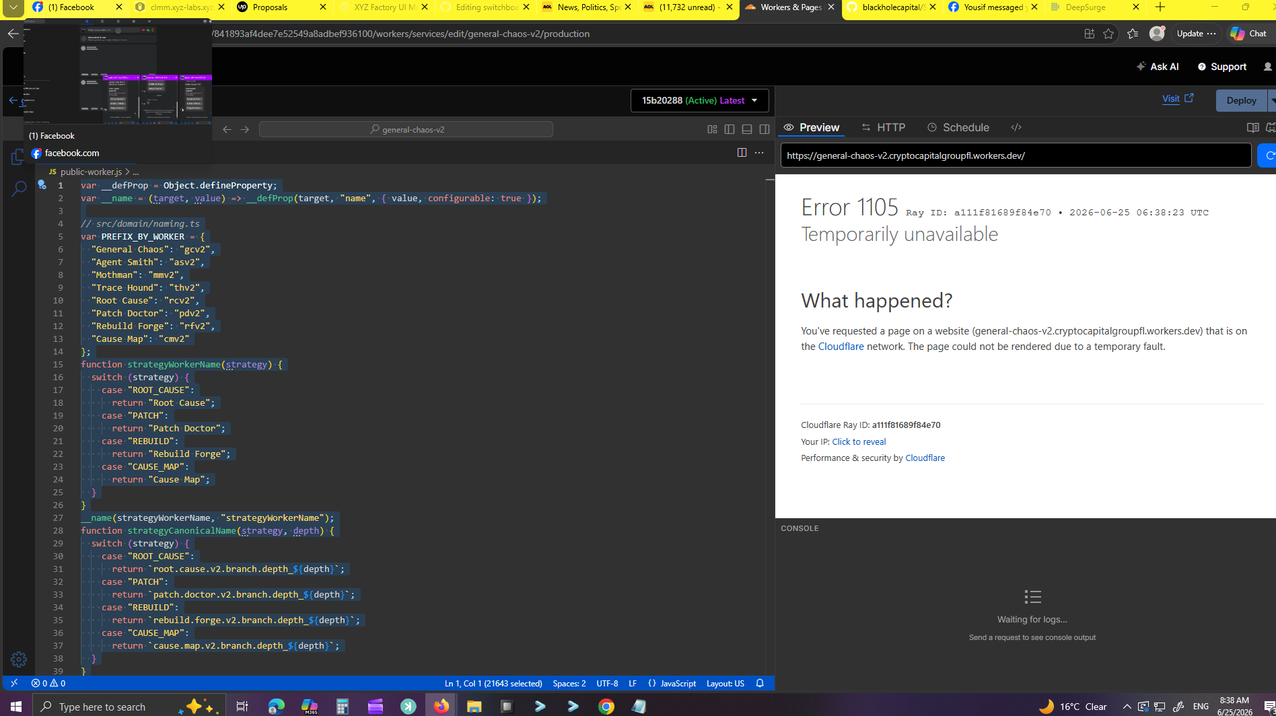
Code evidence: General Chaos V2 public-worker bundle showing naming, strategy mapping, and runtime execution pathways.

7. University Partnership Research Program
Positioning: an applied AI systems research platform for observable agent runtime behavior, constrained recursive planning, knowledge graph explainability, and versioned agent evaluation. Students do not need unrestricted production access. They can work inside bounded objectives and exported graph artifacts.
Research Track | What Students Can Do | Deliverable
Agent behavior mapping | Run controlled objectives and compare mapping cards across strategies. | Branch behavior report with exported CSV/JSON cards.
Verifier calibration | Alter scoring policies in a sandbox and measure score/confidence distributions. | Verifier rubric + regression suite.
Knowledge graph explainability | Build dashboards over runs, edges, notes, and mapping cards. | Graph viewer or trace explorer.
Runtime safety | Test depth limits, child limits, idempotency, queue retries, and compliance rejection. | Safety boundary report.
Applied automation | Connect a limited inbox/form demo and watch lead scoring enter the graph. | CRM automation demo with trace cards.
Data provenance | Study alias vs canonical encrypted names and public-safe exports. | Privacy-preserving mapping paper or poster.
Demo Scenario | Runtime Path | Observable Output
Lead arrives from form/email | General Chaos creates run -> task queue -> execution adapter -> verifier -> D1 graph | Lead score card, reply decision, follow-up decision, final run export.
Factory task request | EILA controller submits objective -> runtime branches -> Trace Hound exports cards | Action map showing which agent decided what and why.
Student experiment | Sandbox run with bounded objective and no production mutation | CSV/JSON cards, graph edges, event log, scoring distribution.

8. Audit Findings and Next Build Steps
Finding | Status | Recommended Action
Knowledge architecture is real and separable from mascot/marketing layer. | Confirmed from EILA OS V3 freeze, pasted worker bundle, D1 schema, and Cloudflare screenshots. | Package as Audit 05: Knowledge Architecture / University Research Program.
V3 is a cleaner controller architecture than the older V2 branch family. | Confirmed in V3 role ownership names: General Chaos, Agent K, The Dude, Azrael, Judge Judy, General Disarray, Trace Hound. | Treat V3 as the light controller pack; bind or bridge it into newer EILA systems.
D1 graph is the highest-value research artifact. | Confirmed by schema and export view. | Prioritize graph viewer, export samples, and demo card deck.
Runtime currently has public/demo surfaces and internal signed surfaces. | Confirmed by source contracts and HMAC functions. | Harden with auth on dashboards, rotate secrets, isolate research sandbox.
Some older V1/V2 agents remain live and useful as callable modules. | Observed through bindings and screenshots. | Catalog them, then either retire, bridge, or wrap behind V3 envelopes.

9. Build Plan for the Research Demo
- Create a sample run endpoint with one bounded objective and a fixed set of strategies.
- Export the resulting mapping cards as cards.json and cards.csv through Trace Hound.
- Build a small read-only graph viewer: runs -> nodes -> edges -> notes -> score/confidence.
- Add a “student mode” run profile: limited depth, limited workers, no production side effects.
- Create before/after cards showing how verifier changes alter final resolution behavior.
- Preserve the V3 controller as a deployable light pack that can be bound into EILA, Factory XYZ, Allie AI, or CRM automations.

Appendix A - Source Evidence Used
Evidence | File / Source | What It Contributes
EILA OS V3 source freeze | Eila-os-v3-freeze--main.zip | README, D1 schema, role naming, RunCoordinator, queue runner, export worker.
Pasted worker bundle | Pasted text(26).txt | General Chaos V2 naming, mapping crypto, D1 write functions, public worker, export endpoints.
Cloudflare screenshots | Uploaded PNG screenshots | Bindings, Workers, Queues, Durable Objects, D1 table visibility, live worker states.
Agent visual system | EILA OS image and prior agent cards | Pitch-facing identity layer for research/university package.

