**Intelligent System**

**Weekly Report**

| **Project name:** | **Delivery Vehicle Routing System** |
| --- | --- |
| **Student Name:** | Nguyen Van Quoc (104198640)  Tran Hung Quoc Tuan (105000908)  Mai Hoang Dai Vy (104993201)  Nguyen Ha Minh Chau(104663478) |
| **Week 3 (18/02/2025)** | |

1. **Tasks Completed.**

✅**Understanding Project Requirements**

* Reviewed the assignment document and making criteria
* Defined the key project components:

+ Master Routing Agent (MRA) – Responsible for assigning optimal route

+ Delivery Agents (Das) – Vehicles that follow assigned routes

✅**Research on optimization techniques**

* Investigated different optimization algorithms for Vehicle Routing Problems (VRP):

+ **Google OR – tools** (for baseline implementation)

+ **Genetic Algorithm** (GA) (for heuristic optimization)

+ **Ant Colony Optimization** (ACO) (for alternative route selection)

+ **Particle swarm optimization** (PSO)

+ **A* Algorithm** (for shortest pathfinding)

**⇒ Our program will run on Genetic Algorithm (GA).**

**⇒ Why we choose GA?**

* Handle complex delivery problems
* Capable of finding good solutions
* Balance a combination of different goals (delivering more packages and. traveling less)
* Good flexibility in switching between constraints (vehicle capacity, maximum distance)
* **GA workflow:**

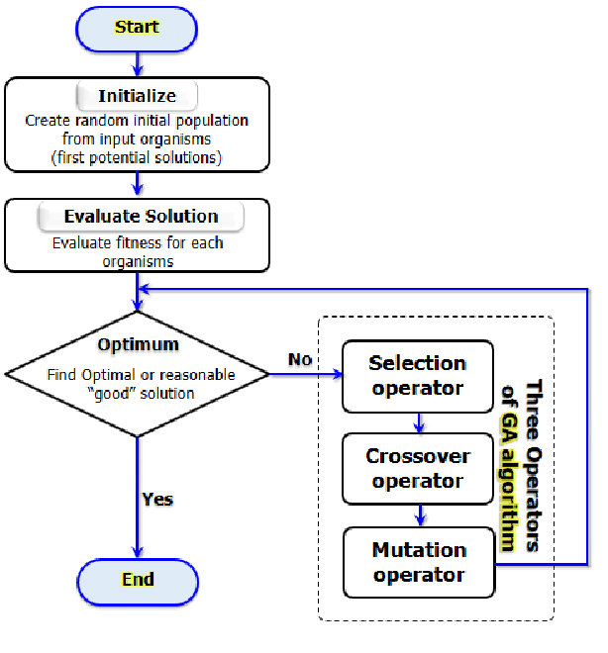

✅**Sequence Diagram.**

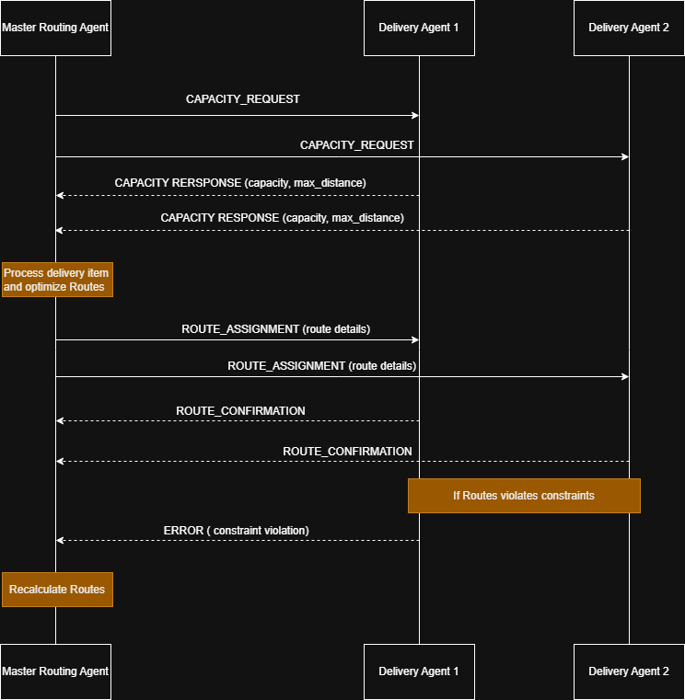

✅**Make some demos and test some algorithms**

* Based on research on the internet some demos of VRP were created

+ Link GitHub: <https://github.com/blacki0214/VRP_system.git>

1. **Challenges.**

**⚠️** We haven’t studied Introduction to AI, so we haven’t understood some algorithms.

* Picking the right algorithm for a problem can feel overwhelming. With so many options available, we’re not always clear which one will work best.
* We have to ensure high-quality data to make it clean and reliable.

1. **What could we do to improve our work?**

* We need to enhance our understanding and knowledge of various algorithms for this unit.
* Optimize our coding efficiency, and strengthen our technical expertise.

1. **Plan for next week.**

**📌**Create Sequence Diagram for interaction between MRA (Master Routing Agent) and DAs (Delivery Agent)

📌Implement a basic VRP solver using OR – tools

📌Start coding MRA and DAs interaction logic