**Visualization of Unemployment Rate across USA**

*Mingxuan Luo u1266548 u1266548@utah.edu*

*Yulan Wang u1264235 youlan9115@gmail.com*

*Qing Ye u6007114* [*q.ye@utah.edu*](mailto:q.ye@utah.edu)

**1 Basic Info.**

Project repository:

<https://github.com/blackispower/Unemployment-in-USA>

**2 Background and Motivation.**

Unemployment is describing the state that a person above some specified age is not in paid [employment](https://en.wikipedia.org/wiki/Employment) or [self-employment](https://en.wikipedia.org/wiki/Self-employment) and are currently available for work during the [reference period](https://en.wikipedia.org/wiki/Reference_period). It is measured by the unemployment rate. Factors influencing unemployment rate may be caused by the [recession](https://en.wikipedia.org/wiki/Recession) of economy, new [technologies](https://en.wikipedia.org/wiki/Technology), policies of the government and so forth.

We decided to visualize the unemployment rate across USA. We would like to reveal the trend of unemployment of specific regions (country- level, state- level and county- level) over time. We also want to look at the unemployment rate difference under the leadership with different presidents. We are interested in this topic because this is very relevant to our daily life.

**3 Project Objectives.**

**3.1** The primary questions you are trying to answer with your visualization

3.1.1 Reveal the trend of unemployment of specific regions over time.

3.1.2 Explore and compare the country- level, state- level and county- level unemployment.

3.1.3 Find the regions with extremely high or low  unemployment rate.

3.1.4 Look at the crime rate in different regions. Check whether there might be an relationship between crime rate and unemployment rate.

**3.2 Things we could learn and accomplish. List the benefits.**

3.2.1 Provide instructions for people to choose where to work, live and study.

3.2.2 Learn to design a visualization that could provide people with the information they need the most without any biases.

3.2.3 Practice our skills with JS and D3.

**4 Data.**

**4.1** Unemployment rate:

Kaggle: <https://www.kaggle.com/jayrav13/unemployment-by-county-us>

Bureau of Labor Statistics <https://data.bls.gov/timeseries/LNS14000000>

**4.2** Crime rate:

death penalty information center

https://deathpenaltyinfo.org/facts-and-research/murder-rates/murder-rates-by-state-by-region

https://deathpenaltyinfo.org/facts-and-research/murder-rates

**5. Data Processing**

The dataset provides us with the unemployment rate date in different counties across USA from 1990 to 2016. We need to preprocess the data to get aggregation of the data from county to state.

D3 could provide us with the function to sum up and average data.

**6. Visualization Design**.

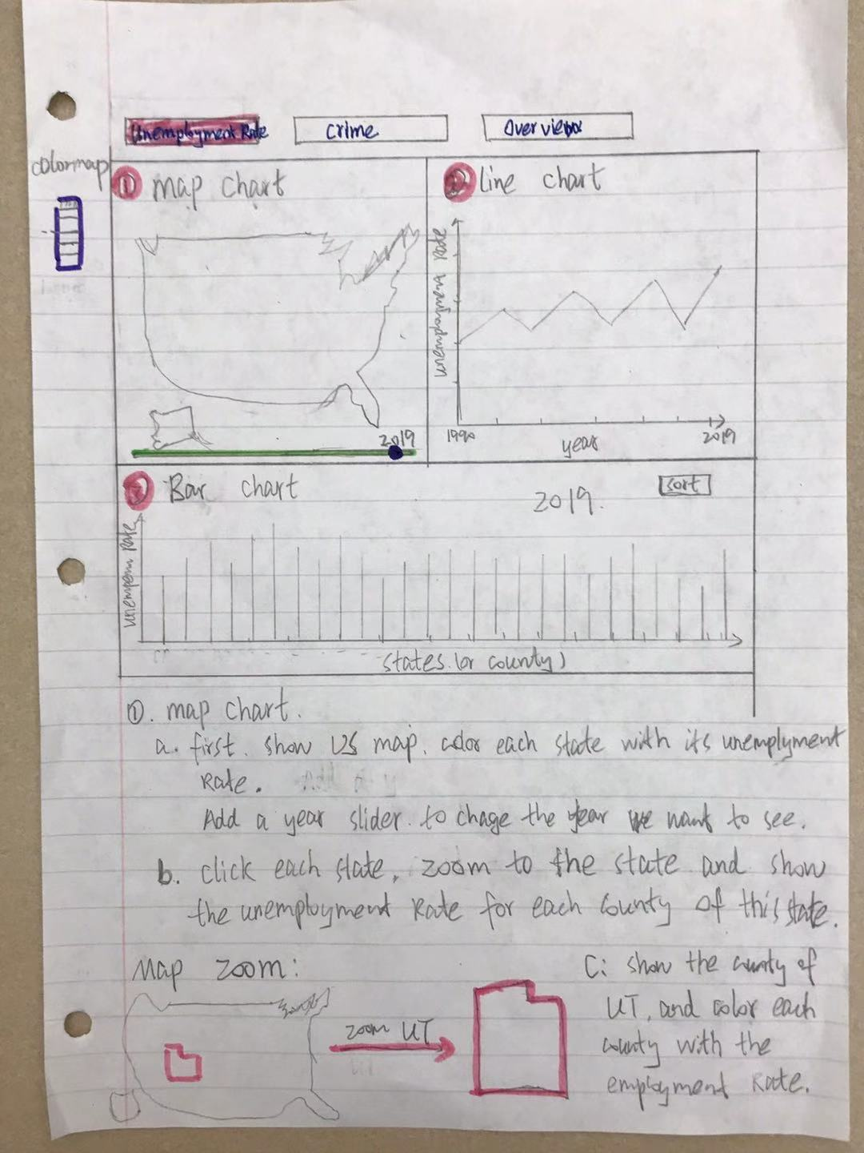

**Figure 1**

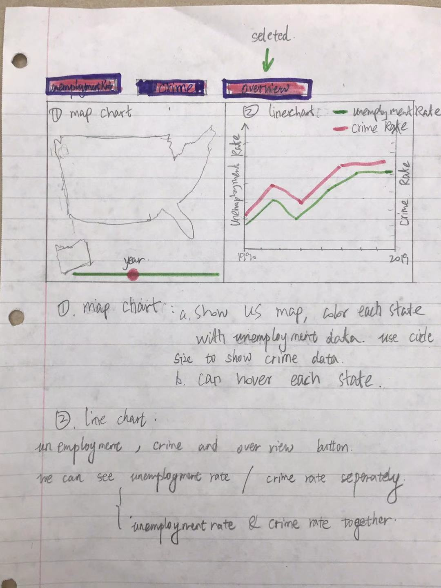

**Figure 2**

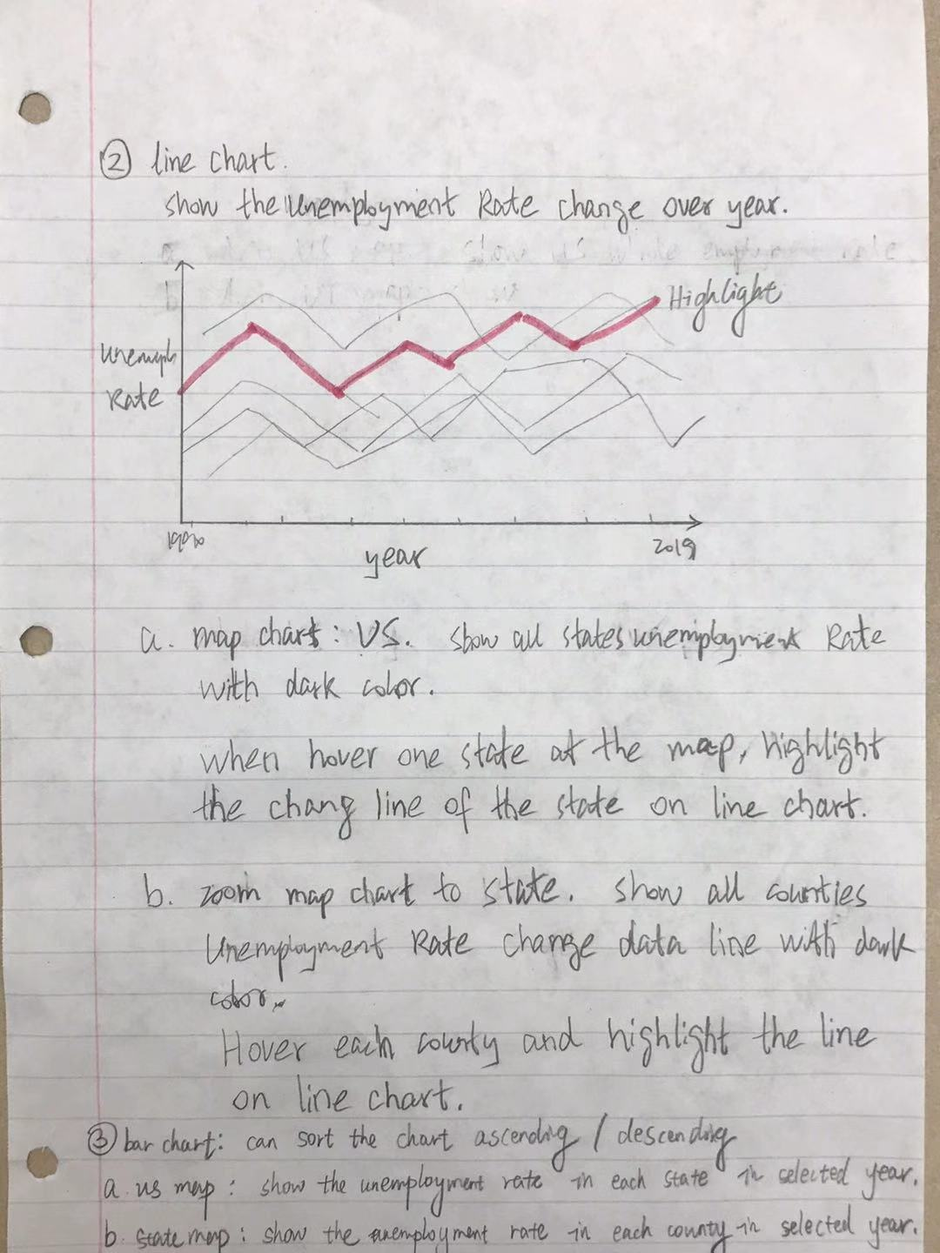

**Figure 3**

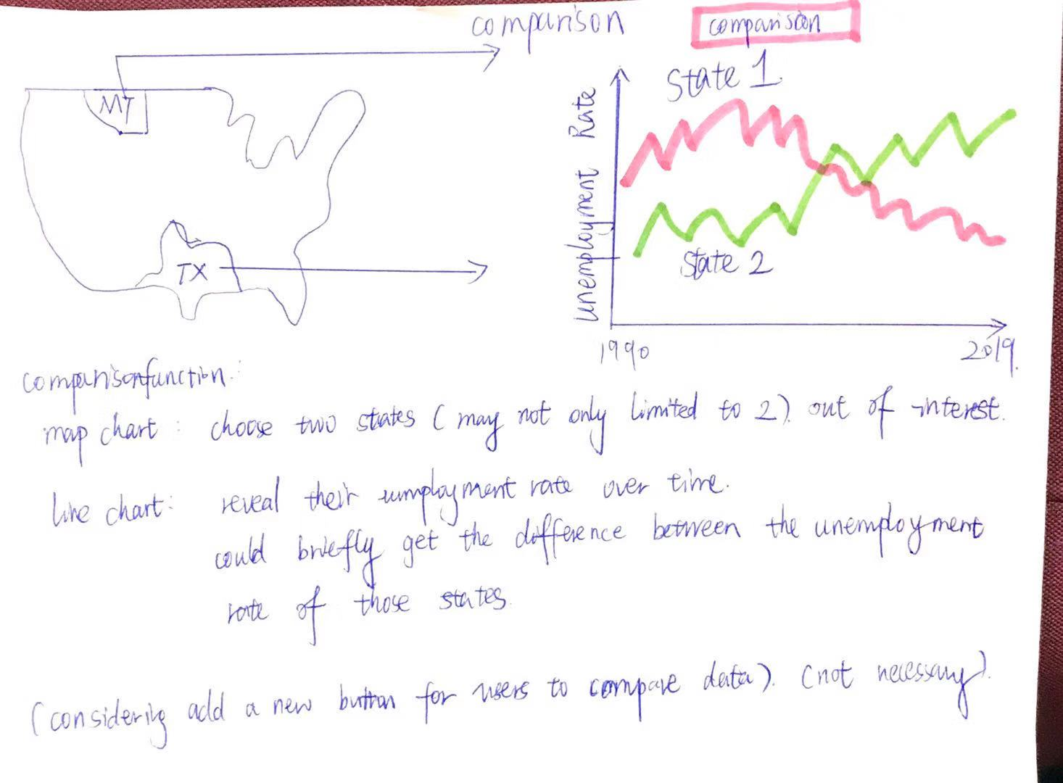

**Figure 4**

The overview of the visualization consists of three parts: map chart, line chart and bar chart, and can toggle between the unemployment rate, the crime rate and the combined view.

Map chart is coded by color, suggesting the rate of unemployment/crime rate in each state. And on the combined view, the color indicates the unemployment rate while the crime rate is represented by the size of a circle. A year slider on the bottom can switch between different years. A tool tip should appear on hover. If a state is clicked, the map would zoom in and show a more detailed unemployment rate information in different counties. (Figure 1 -3).

Line chart for the first two view shows the change over the years and it would highlight the corresponding line for a state when hovering on a specific one. It changes into a scatter plot with X-axis and Y-axis showing the stastitics. When clicking on a state, because we only have data for unemployment rate for each county, the line chart only show changes for the unemployment rate for each county. A description box shows the crime rate and overall unemployment rate in the state. (Figure 1 -3).

Bar chart shows the comparison between states/counties for a specific year. Hovering on map or a bar would highlight each other. The whole chart could sort by alphabetic order or the statistics (Figure 1 -3).

Additional functions: we are thinking of let users to choose over 2 states to compare the unemployment rate of those states (Figure 4).

**6.1** Must-Have Features.

Three views for the map chart and the corresponding functions in line and bar charts

**6.2** Optional Features.

Zooming function for each counties’ data.

**7. Project Schedule.**

7.1 Oct 20th - Oct 25th :

design visualization and wrap up proposal.

7.2 Oct 26th - Nov 1st :

get feedback from the professors, TAs and classmates in the peer review session. Improve the design and in the mean time, finish collecting the data.

7.3 Nov 2nd - Nov 8th (milestone):

get started to finish the basic functions of the visualization.

7.4 Nov 9th- Nov 15th:

check the basic functions to make sure no bugs exists and add more advanced functions

7.5 Nov 16th - Nov 22nd:

wrap up the coding part and make sure there’s no big mistakes.

7.6 Nov 23rd – Nov 27th:

upload the visualization and record the demo video.