RPS Scenario manager allows administrators to view all current scenarios and metadata for an ArcGIS Rest Service. It is recommended to clean up unused or test scenarios in order to keep the database clean and maintained. Too much data in the tables can reduce performance depending on ArcGIS Server setup.

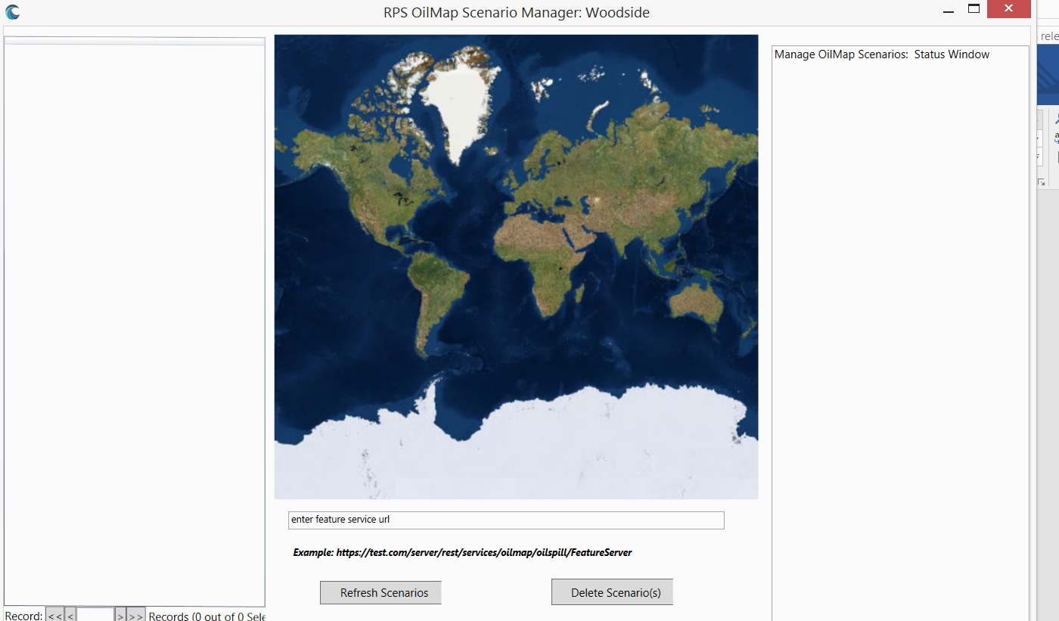

Add a Rest Feature service to the OilMap Scenario and click Refresh. A list of scenarios will show on the left window. After selecting unused scenarios, click delete scenarios and it will clean up all corresponding layers with the service.

