Experimental School’s Computer

Programs

This document is a collection of programs for the experimental school’s computer from around 1970. There are not very many programs known, these all come from the first course on the school’s computer.

A Program to Compute the Surface Area and Volume of a Sphere.

Address | Contents | Comments
0 |  | Spare
1 |  | Spare
2 | r
3 | a
4 | b
5 | 3.14159
6 | 4
7 | 3
8 |  | Spare
9 |  | Spare
10 | 7802 0507 | Input r; display 3.14159 and 3
11 | 7203 0202 | a ← r x r
12 | 7203 0305 | a ← a x 3.14159
13 | 7203 0306 | a ← a x 4
14 | 7204 0302 | b ← a x r
15 | 7304 0407 | b ← b ÷ 3
16 | 7902 0304 | Display r, a and b
17
18
19
20

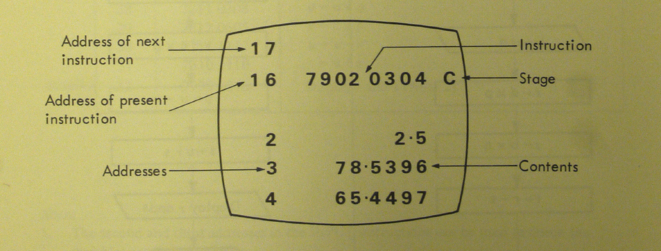

SOLUTION OF TWO LINEAR SIMULTANEOUS EQUATIONS

Address | Contents | Comments
0 |  | Spare
1 |  | Spare
2 |  | Spare
3 | a
4 | b
5 | p
6 | c
7 | d
8 | q
9 | r
10 | s
11 | u
12 | v
13
14
15 | 7803 0303 | Input a
16 | 7804 0303 | Input b
17 | 7805 0403 | Input p
18 | 7806 0504 | Input c
19 | 7807 0605 | Input d
20 | 7808 0706 | Input q
21 | 7209 0705 | r ← d x p
22 | 7210 0408 | s ← b x q
23 | 7109 0910 | r ← r - s
24 | 7210 0307 | s ← a x d
25 | 7211 0406 | u ← s - u
26 | 7110 1011 | s ← s – u
27 | 7309 0910 | r ← r ÷ s
28 | 7211 0308 | u ←a x q
29 | 7212 0605 | v ← c x p
30 | 7111 1112 | u ← u - v
31 | 7310 1110 | s ← u ÷ s
32 | 7909 1010 | Display r and s; stop

