Notes on Experimental Schools Computer

Words
The documents refer to words as storing decimal digits. There is mention of a decimal digit being 4 bits. This is useful as it implies that the sign is stored as 4 bits, but presumably one of the codes that don’t represent a decimal digit: A-F in hexadecimal. The actual code used for positive and negative don’t seem to be mentioned. A decimal digit can’t be used as even though the sign digit is in a position that is never a digit for a floating point word, the sign is used to detect an instruction when an instruction is loaded from store. Instructions use all of the decimal digits. On a real machine a floating point word could be loaded in to a register and examined to determine the sign codes.

Instructions
Basic instructions are stored two to a word in the store. There's not a lot of information about how these two words are executed. The simulator assumes one is executed and then the next. The instruction at digits a-d is executed first and then the e-h digits.
How this is done when the A,B and C keys are pressed is unknown as there isn’t any information at this detail yet. For now, just running the top basic instruction is enough to get the simulator running, then the lower instruction execution can be added.
From the instruction card:

This shows how two instructions in a single word are executed after entering them from the keyboard using the KI RESET key. It implies that the sequence of keys to execute it is A, B, C, A, B, C. The simulator works on this sequential execution of two instructions in one word.
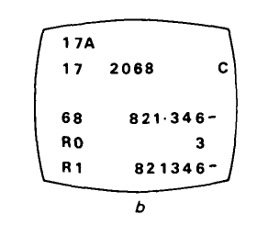
The examples of display sometimes show an interesting extra character. Display ‘b’ here, shows a 17A in the IAR position and below it the auxiliary IAR of 17. This implies that the 2068 four digit instruction is at the first four digits of a word and the second four digit instruction is at what it calls the ‘A’ position, 17A in this case. Stage C displays the next instruction address in the IAR and the currently processed instruction in the auxiliary IAR.

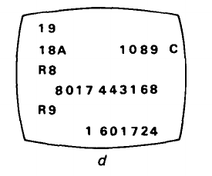
Similarly, display ‘d’ shows the completion of an instruction at address 18A and the IAR is showing the address of the next instruction at address 19. This confirms the ordering of the nn and nnA addressing.

These screens imply an extra bit or flag associated with the IAR that is used to execute the pairs of 4 digit instructions.

Instruction Stages
The simulator tries to give a display of the stages and use the stages as the original computer did, but there aren’t many examples of the stages and their display.

Stage A Display
There is an example of the stage A display in the IET paper. Displays for other instructions aren’t available.
This stage A display is a
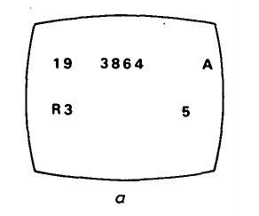

Stage B Displays

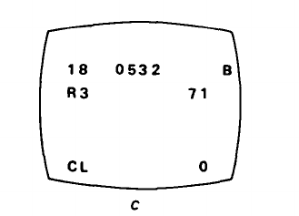
A stage B display is shown here. From the description given in the IET document this should be a stage C display as the instruction (a compare of R3 with 2) has been executed and the control latch value is shown. This implies that the stages aren’t fixed in terms of function, but are rather three processing stages that can be used for whatever is required. The values used are displayed, using some system of determining what should be displayed, maybe a tabe for each instruction.

Flowchart Document
When the ‘A First Course on the School’s Computer’ document was found, there was a four page handwritten document inside it. This had two flowcharts and two programs, one for b^{N}, and one for log N. These use a jump instruction with opcode 74, which is not the instruction in the standard three address instruction set.
Standard instruction:
Branch to Aa1 if (Aa2) = (Aa3)
whereas the instruction description in the flowcharts document is this:

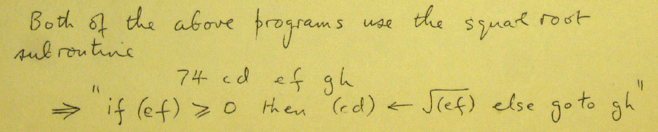
So, both of these program seem to use a non-standard instruction, and so the extracode for instruction 74 has to be altered in order to run these programs.

Questions

Was it possible to enter the ‘A’ flag of the IAR from the keyboard?
There is an ‘A’ key on the keyboard but there’s no record of it being used to enter an address. If this flag wasn’t entered then the only way to run an instruction in the second 4 digits of a word is to run the first instruction followed by the second.

https://www.cs.ox.ac.uk/research/publications/
https://www.cs.ox.ac.uk/teaching/handbooks.html
https://www.cs.ox.ac.uk/files/13731/CS%20Handbook%20final.pdf
https://maps.ox.ac.uk/bd821e30-d8ba-11eb-a363-059e537832a1

