Notes on Experimental Schools Computer

Words
The documents refer to words as storing decimal digits. There is mention of a decimal digit being 4 bits. This is useful as it implies that the sign is stored as 4 bits, but presumably one of the codes that don’t represent a decimal digit: A-F in hexadecimal. The actual code used for positive and negative don’t seem to be mentioned. A decimal digit can’t be used as even though the sign digit is in a position that is never a digit for a floating point word, the sign is used to detect an instruction when an instruction is loaded from store. Instructions use all of the decimal digits. On a real machine a floating point word could be loaded in to a register and examined to determine the sign codes.

Instructions
Basic instructions are stored two to a word in the store. There's not a lot of information about how these two words are executed. The simulator assumes one is executed and then the next. The instruction at digits 1-4 is executed first and then the 5-8 digits.
How this is done when the A,B and C keys are pressed is unknown as there isn’t any information at this detail yet. For now, just running the top basic instruction is enough to get the simulator running, then the lower instruction execution can be added.
From the instruction card:

This shows how two instructions in a single word are executed after entering them from the keyboard using the KI RESET key. It implies that the sequence of keys to execute it is A, B, C, A, B, C. The simulator works on this sequential execution of two instructions in one word.
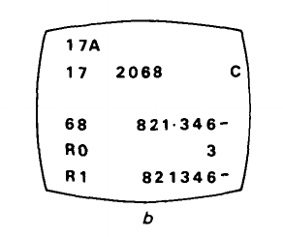
The examples of display sometimes show an interesting extra character. Display ‘b’ here, shows a 17A in the IAR position and below it the auxiliary IAR of 17. This implies that the 2068 four digit instruction is at the first four digits of a word and the second four digit instruction is at what it calls the ‘A’ position, 17A in this case. Stage C displays the next instruction address in the IAR and the currently processed instruction in the auxiliary IAR.

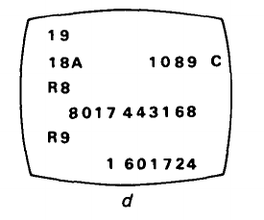
Similarly, display ‘d’ shows the completion of an instruction at address 18A and the IAR is showing the address of the next instruction at address 19. This confirms the ordering of the nn and nnA addressing.

These screens imply an extra bit or flag associated with the IAR that is used to execute the pairs of 4 digit instructions.

Instruction Stages
The simulator tries to give a display of the stages and use the stages as the original computer did, but there aren’t many examples of the stages and their display.

Stage A Display
There is an example of the stage A display in the IET paper. Displays for other instructions aren’t available.
This stage A display is a
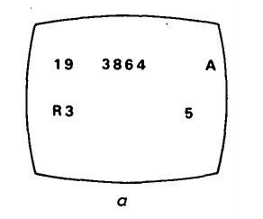

Stage B Displays

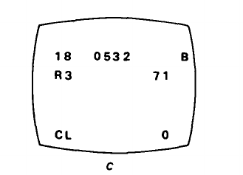
A stage B display is shown here. From the description given in the IET document this should be a stage C display as the instruction (a compare of R3 with 2) has been executed and the control latch value is shown. This implies that the stages aren’t fixed in terms of function, but are rather three processing stages that can be used for whatever is required. The values used are displayed, using some system of determining what should be displayed, maybe a table for each instruction.

Keyboard Register

Looking at the data flow diagrams it appears that the keyboard register cannot be used to input data directly to the registers. It can therefore be a single word register as it does not have to be able to write to R8 and R9.

The internal workings of number and instruction entry isn’t clear from the documents. When entering an instruction, the digits entered become the instruction code directly, with leading zeros not shown. Instructions are 4 or 8 digits, but must be entered as 8 digits when writing to the store. 4 digit instructions must be entered in pairs. The question of number entry is more interesting as if the digits ‘12’ are entered, if it is intended that this is a number then a sign digit must be placed in digit ‘a’, otherwise it will be interpreted as a n instruction. For negative numbers the trailing ‘-’ keypress will load a -ve sign into digit ‘a’, but for positive numbers there is no corresponding ‘+’ key. It appears that numbers have to have a decimal point when entering them, and that is the keypress that puts a +ve sign digit in digit ‘a’.

Number format in registers

Figure 11 of the IEE document shows R8 and R9 with (double length) integers that have been added together. Registers always hold integers, floating point instructions always work with store addresses, and the extracode instructions that perform the floating point operations operate on the numbers as integers using the special instructions that load numbers into registers in parts.

The double length registers seem to have been added to allow floating point multiplication and division to be added as extracode instructions. Multiplying two 6 digit numbers requires a 12 bit result which can easily be truncated back to 6 digits. Obviously overflow occurs if the discarded digits are not in the fractional part of the number.

Loading different size registers

There is an instruction that loads a register with the contents of another register. This instruction can load single word register with double length registers and vice versa. The behaviour of these transfers isn’t in the documentation. As the single and double size registers hold 6 and 12 digits respectively, there is room for a sign. So, when moving a single word register to a double, the 6 digits appear in the lower 6 digits of the double word register and the sign is also transferred.
When transferring a double word register to a single word register the sign is transferred and the lower 6 digits of the double word register are transferred to the lower 6 digits of the double word register. When performing arithmetic and transferring, the same rules are used.

Core Store
The core has 222 words (32 bit) of memory.
00-99 Program space
100-199 Extracode space
200-207 R0 to R7
208,218 R8
209,218 R9

Questions

Was it possible to enter the ‘A’ flag of the IAR from the keyboard?
There is an ‘A’ key on the keyboard but there’s no record of it being used to enter an address. If this flag wasn’t entered then the only way to run an instruction in the second 4 digits of a word is to run the first instruction followed by the second.

https://www.cs.ox.ac.uk/research/publications/
https://www.cs.ox.ac.uk/teaching/handbooks.html
https://www.cs.ox.ac.uk/files/13731/CS%20Handbook%20final.pdf
https://maps.ox.ac.uk/bd821e30-d8ba-11eb-a363-059e537832a1

