Psion Organiser II Low Battery Warning Circuit

The low battery warning circuit, shown below is designed to detect when the battery is too low for the organiser to operate. From Martin Prest’s power PCB circuit diagram:

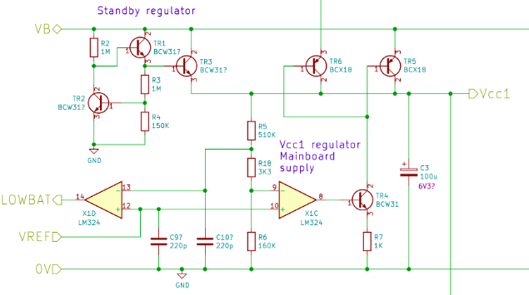

it can be seen that the warning detection op-amp (X1D) is comparing the reference voltage (1.22V) with the Vcc1 supply rail. This is not what you would initially expect from a circuit that is a low battery warning test as the battery voltage as it isn’t actually tested. Instead, the circuit is detecting when the supply rail can no longer be maintained by the regulator that is fed from the battery.
The op-amp has two inputs, the negative input is fed with the a divided supply voltage, the positive is connected to the reference voltage. When the divided supply voltage is above the reference then the op-amp output is negative, when it drops below the reference the op amp output goes high. That high level is fed to a port on the organiser processor and the code detects the low battery state and handles it as required.

The reference circuit uses a temperature compensated reference to generate the 1.22V:

