Psion 8/16 Memory Pac

This datapack holds 16K bytes using a 27128 type EPROM. One side of the PCB is shown below:

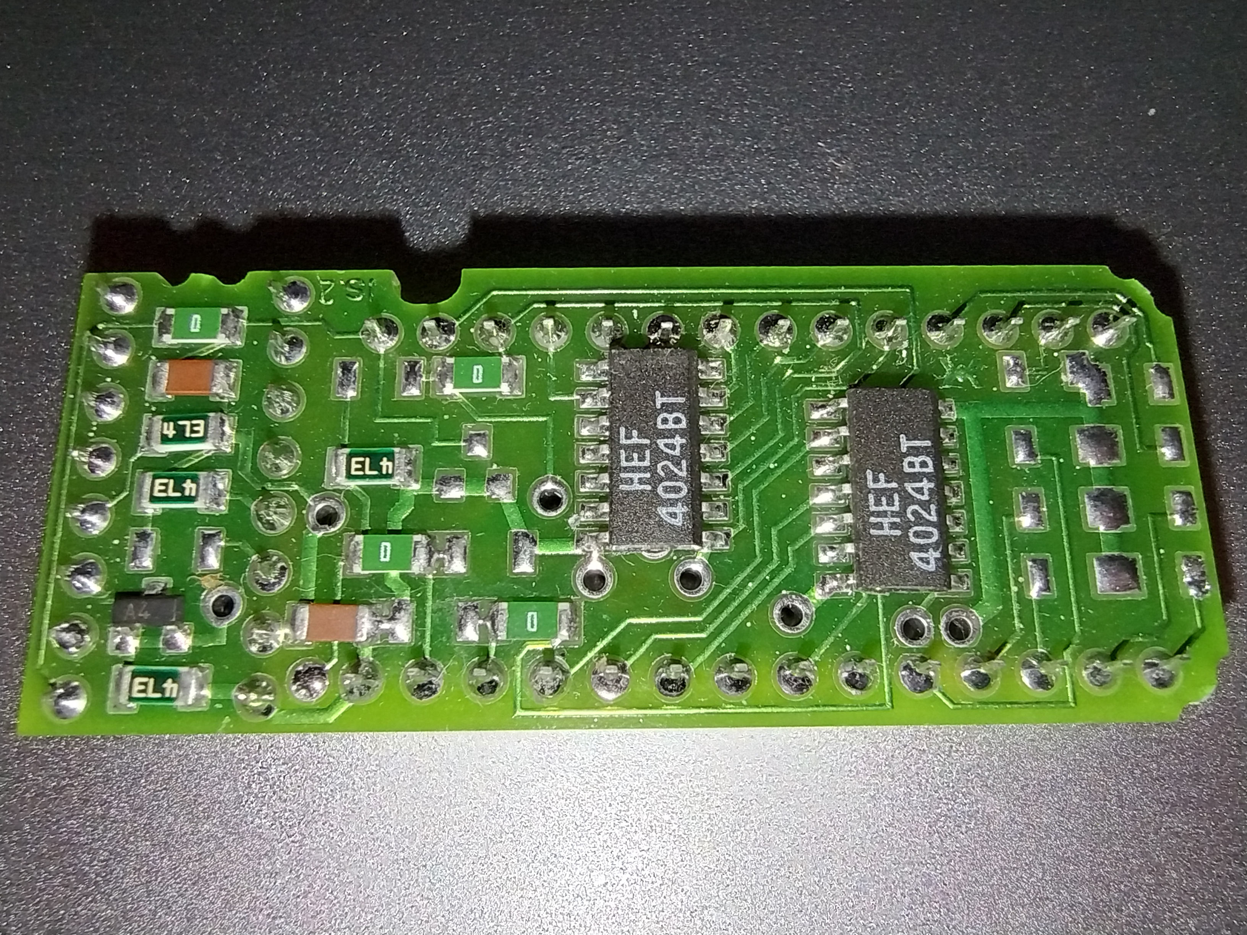

There are three zero ohm links on this PCB that can be moved to alternative positions. A fourth zero ohm link has no alternative position.

The top link swaps the upper 4024 counter CLK signal between PGM and the lower counter highest output. This selects linear (as shown in the photo0 and paged operation.

The middle link selects the PROG pin of the EPROM to be either PGM or 5V. This appears to be a write protect.

The lower link selects the A13 pin of the EPROM to be either the Q6 output of the upper 4024 or +5V. This selects between 8K or 16K.

The links on the datapack in the phot above are set for: Linear, Write enabled 16K.

