INSTALL ARCH LINUX
by : _blackjezreel_
support by archwiki, ostechnix

Preparation
- Make sure you have nice internet connection and enough time to setup your own arch :D
- Download arch iso on archlinux.org
- Make it bootable using dd on linux or using etcher/rufus on windows
- Set boot to USB

Installation System
- Connect to wifi
wifi-menu -o wlp3s0 *depend on your wifi interface
- Test connetction ping google.com
- Update the system clock
timedatectl set-ntp true
- Partition Hard Drive
check partition table with fdisk -l
We’re going to create three partitions.
Root partition, /dev/sda1, as primary bootable with size 10GB and ext4 formatted. Swap partition, /dev/sda2, as primary with size 2xRAM size. Logical partition, Home, /dev/sda5, rest of the space and ext4 formatted.
- Format root partition (/dev/sda1)
mkfs.ext4 /dev/sda1
- Make swap on swap partition (/dev/sda2)
mkswap /dev/sda2
swapon /dev/sda2
- Mount /dev/sda1 on /mnt
mount /dev/sda1 /mnt
- Edit mirror
vi /etc/pacman.d/mirrolist
add this line on top :
## Indonesia
Server = http://mirror.poliwangi.ac.id/archlinux/$repo/os/$arch
Server = http://suro.ubaya.ac.id/archlinux/$repo/os/$arch
- Install base arch linux
pacstrap /mnt base base-devel
- Create fstab file
genfstab /mnt >> /mnt/etc/fstab
cat /mnt/etc/fstab

Set Up Arch Linux
- Chroot to Installed Arch
arch-chroot /mnt /bin/bash
- Set Locale
nano /etc/locale.gen
Uncomment en_US.UTF-8 UTF-8 (delete #)
locale-gen
- Set Time zone
nano /etc/locale.conf
add this line : LANG=en_US.UTF-8
list timezone : ls /usr/share/zoneinfo/
ln -s /usr/share/zoneinfo/Asia/Jakarta /etc/localtime
hwclock --systohc --utc
- Set Root Password
passwd
- Set Network Configuration
nano /etc/hostname and nano etc/hosts and set your hostname eg. jezreel
systemctl enable dhcpcd
- Install Grub
pacman -S grub os-prober
grub-install /dev/sda
grub-mkconfig -o /boot/grub/grub.cfg
- Add new user
useradd -m -g users -G wheel,storage,power -s /bin/bash hans
- Set password for user
passwd hans
- Install sudo
pacman -S sudo
- Add user to sudoers
visudo
uncomment this line :
%wheel ALL=(ALL) ALL
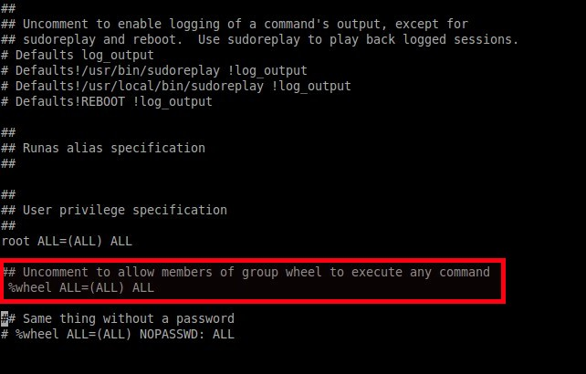
Install Deepin Desktop
pacman -S deepin deepin-extra
Edit file /etc/lightdm/lightdm.conf
find line #greeter-session=example-gtk-gnome and change to greeter-session=lightdm-deepin-greeter (delete #)

Another Essentials Setup
Run Network manager service
systemctl start NetworkManager.service
systemctl enable NetworkManager.service

exit and reboot. Login into normal user

Install some essentials packages
pacman -S xorg git zsh screenfetch gedit networkmanager firefox dialog moc gimp inkscape calibre gpick hostapd dnsmasq iw xdg-user-dirs

Install yaourt
nano /etc/pacman.conf
add this line :
[archlinuxfr]
SigLevel = Never
Server = http://repo.archlinux.fr/$arch
Save and close the file.
pacman -Sy yaourt
git clone https://aur.archlinux.org/package-query.git
sudo chmod +777 -R package-query/
cd package-query/
makepkg -si (do not run on root)
git clone https://aur.archlinux.org/yaourt.git
cd yaourt/
makepkg -si (do not run on root)
cd .. && rm -rf package-query/ yaourt/

Install another packges from yaourt (do it one by one package)
yaourt neofetch gradio rambox spotify

