WCF

服务契约： IapplicationService

操作契约：CheckSimpleValidation、GetData、HashAndSetData、LogOn、SetData

代码分析：

interface Iactor{

bool Disposed

bool IsChild

}

**ADO.NET Entity Framework**

业务逻辑(./Server/Modules/..)

(SSI.Server.Shared)

Stored Models(实体类)

Mappings(映射关系)

数据源

Linq to sql

Conceptual Models(IssiContext、IJobContext)

Entity Data Model

**Server文件夹**

SSI.Server.Core

SSI.Server.DataContext

SSI.Server.DataModel

SSI.Server.Services

SSI.Server.Terminal

DependencyModule.cs 、Program.cs用到了Ninject。主要是解决应用程序的依赖

SSI.Server.Wcf

**Utilities文件夹**

**SSI.DataContracts程序集**

**SSI.SS.DataAccess程序集**

**App.config**

: Set default connection factory()

Set Database Provider()

**EF6**

**//**A context object class which represents the entire Springbrook database.

**SsiContext** : BaseDataContext、ISsiContext

DbContext

IDataContext:IDisposable

ISsiContext

IJobContext

BaseDataContext

SsiContext

**SSI.Server.Core > Static文件夹 > CoreUtility.cs**

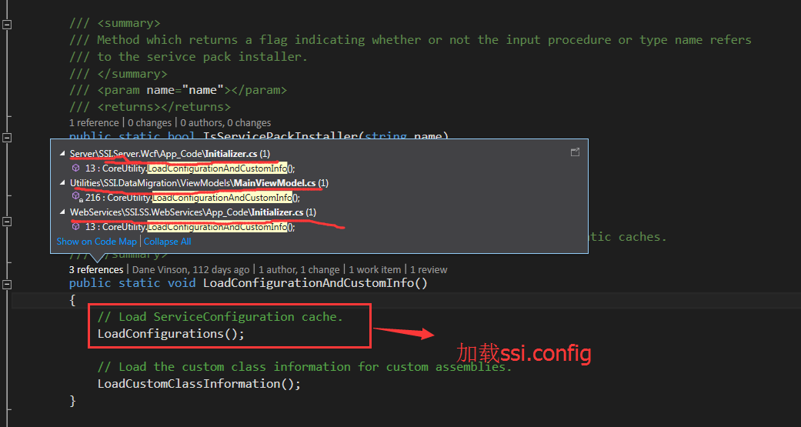

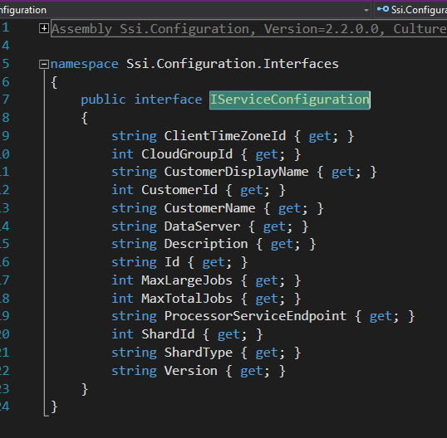

**Server > SSI.Server.Wcf > App_Code文件夹 > Initializer.cs**

作用：初始化http和net.tvp的WCF服务

DependencyResolver.Resolve()/DependencyModule.cs 🡺 解决应用程序开始时的依赖

CoreUtility.LoadConfigurationAndCustomInfo() 🡺 加载配置文件

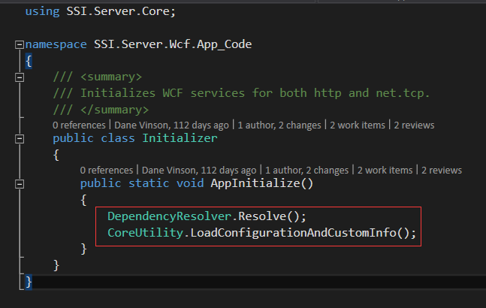

GetDataResult {DataSets、DataSetInfoCollection }

BaseResult(所有WCF结果对象的基类)

SetDataResult { DataSets、DataSetInfoCollection 、Errors }

**ServiceProvider**

**(**SSI.Server.Core > ServiceProvider.cs**)**

IServiceProvider

GetService

RegisterService<T>

RegisterService

ServiceProvider