光電中的數值方法

學生：陳居文 光電碩二

Home Work 2：Master Equation of Mode-lock Laser

Problem 1 ：

Write a Program to solve the above master equation assuming U(0,t) is known.

The Program I wrote is in the hw2.py python file.

In Line 1~4 , I import some python Module about math, and the utility module is the module I wrote to define some function for visualization.

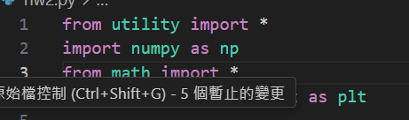

Fig. 1. Import some Python Module

In Line 6~18, I set all of the parameter used in this simulation file, including time resolution(dt), Round Trip time (dT) and all of the physical parameter in Master Equation. Detail definition is in Fig.2.

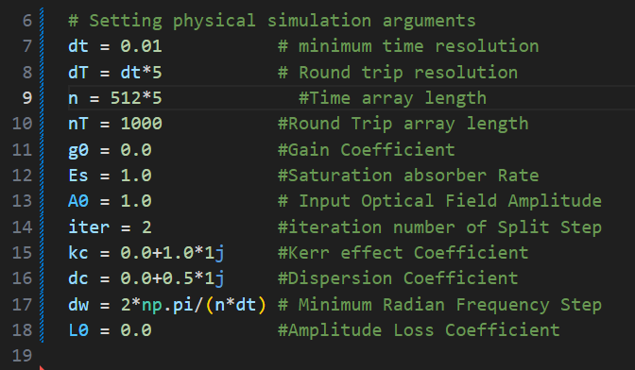

Fig. 2. Set all of parameters used in this Simulation file

In Line 25~36, this region create the array of time and Round Trip time.

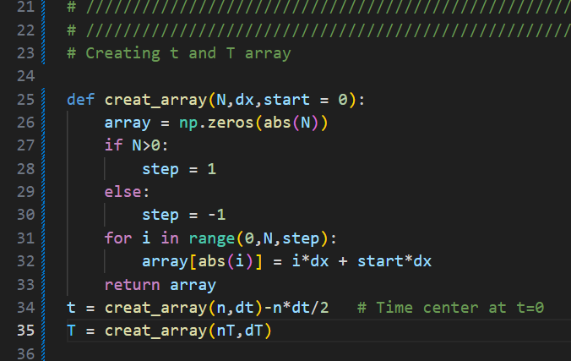

Fig. 3. Create array

In Line 39~44, phase shift from dispersion effect is defined. Also define the initial Soliton pulse as the initial condition of simulation.

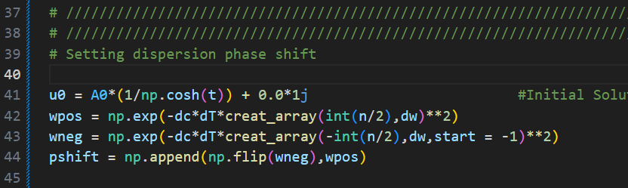

Fig. 4. Define Initial Condition and dispersion phase shift

The Split Step function is defined in Line 48~79.

Since the Master Equation can be simulated by theory of Split Step method. The Equation is as below.

Because this Simulation method involve explicit and implicit part, one must rewrite it as below

We can calculate the dispersion part by Fourier Transform, since the physical of dispersion effect means phase shift proportional to square of frequency.

In my code, I just need to multiply Fourier Transform of part by .

The Fourier Transform is executed in Line 61~68. In addition, integral of saturation absorber is executed in Line 56~59.

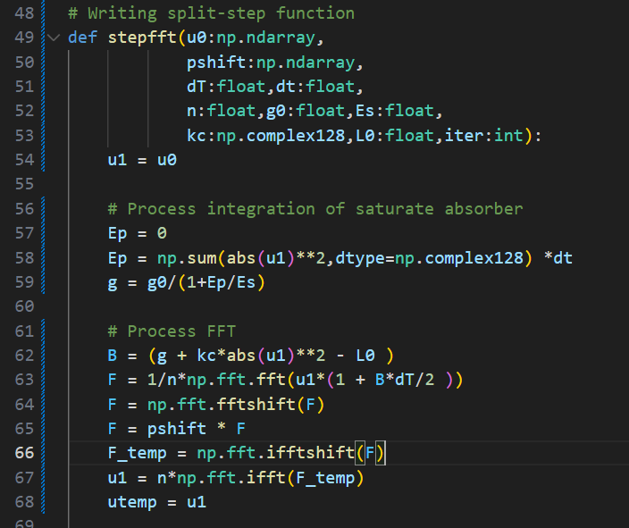

Fig. 5. Fourier Transform and Saturation intergral

The last but not least important part of Split step function is defined in Line 70~79.

The reason of iteration is the implicit part of my equation. Since the term

is approximated by in first step. We should calculate again by updated u0.

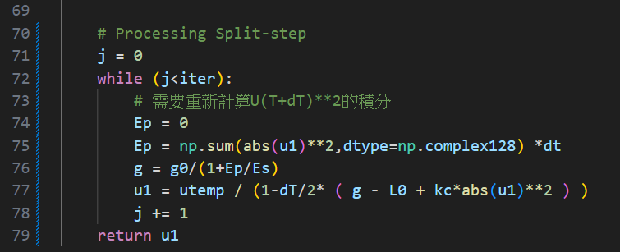

Fig. 6. Split Step iteration

As the consequence of Split Step iteration, the integral of saturation absorber should be updated according to updated U.

In Line 81~End contains Running Split Step Simulation by each Round Trip.

And visualize 3D result by Record, also the Energy at t=0 in each Round Trip.

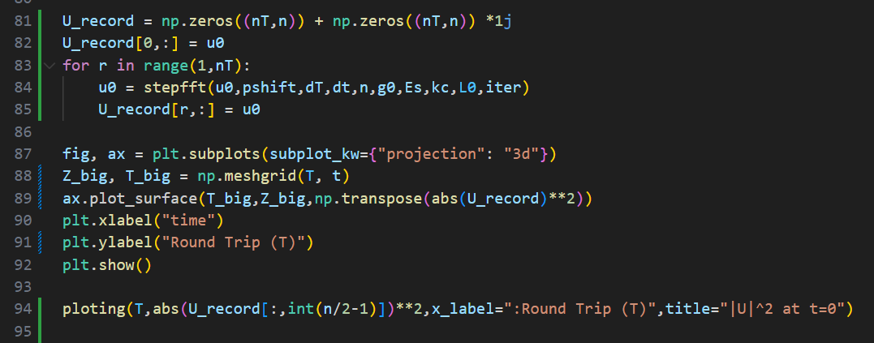

Fig. 7. Running Simulation and visualization

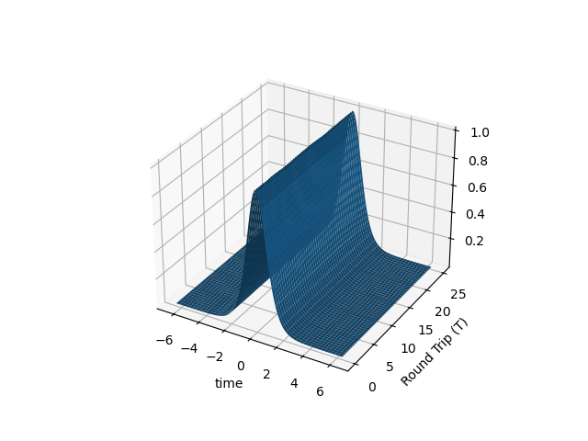Problem 2. Set di=0.5, dr=0, ki = 1.0,g0 = 0,l0 = 0 to reduce the problem into the nonlinear Schrodinger equation case. Check if you can correctly simulate the propagation of the fundamental soliton solution as described in the lecture notes. Let t=0 correspond to the time window center so that the pulse is centered in the time window.

Fig. 8. Soliton pulse of nonlinear Schrodinger equation

For nonlinear Schrodinger equation, only dispersion and Kerr effect is activated, as below equation shown. Since Kerr effect compensates phase shift of dispersion, we expect a pulse unchanged in each Round Trip Cycle. As Fig. 8. Shown.

Problem 3. Set di=0.5, dr=0.05, ki=1.0, kr=0.1, g0=4, l0=1.0, Es=0.5. Solve the equation to find the steady state solution. You can use the soliton pulse in 2 as the initial condition at T=0 and solve the equation for T>0 till the pulse shape remains unchanged. After that, set kr=0 and see if you can still get the steady state pulse.