**Task 1 (Architectural Design):**

N-tier architectures are often used for distributed web applications.

Which and how many tiers do you suggest for an online shop?

Sketch a solution with Java EE!

Assign the following functionalities to a suitable architecture level and the corresponding Java EE technology:

• Shopping cart,

• Input form for changing customer data by the customer,

• Discount calculation,

• Preparation of the contents of the shopping cart for presentation to the user

• Storage of customer data.

**Answer:**

Remote access is the better choice from future point of view because if we want to make growing system then its the good choice and we can make our application distributed and can run from different locations.

For a online shop, I suggest following tiers:

1. Client Tier (Web browser, User agent, Application Client)
2. Web Tier (Servlet, JSP)
3. Business Tier (EJB, JPA)
4. EIS Tier (Mysql)

**1. Client Tier:**

Client tier consists of web browsers, user agents and application clients (standalone application). Here web browsers and user agents communicate with web tier using HTTP protocol. On the other hand application clients directly communicate with business tier using JMS. However, application clients can also open HTTP connection and communicate using HTTP protocol.

**2. Web Tier:**

In the web tier, there are servlets and java server pages(JSP). This tier receives HTTP requests from client tier and send to business tier for further processing. After processing, web tier sends HTTP responses to client tier. Web tier is deployed in web container where web container consists of HTTP server, servlet engine/container, jsp engine/container.

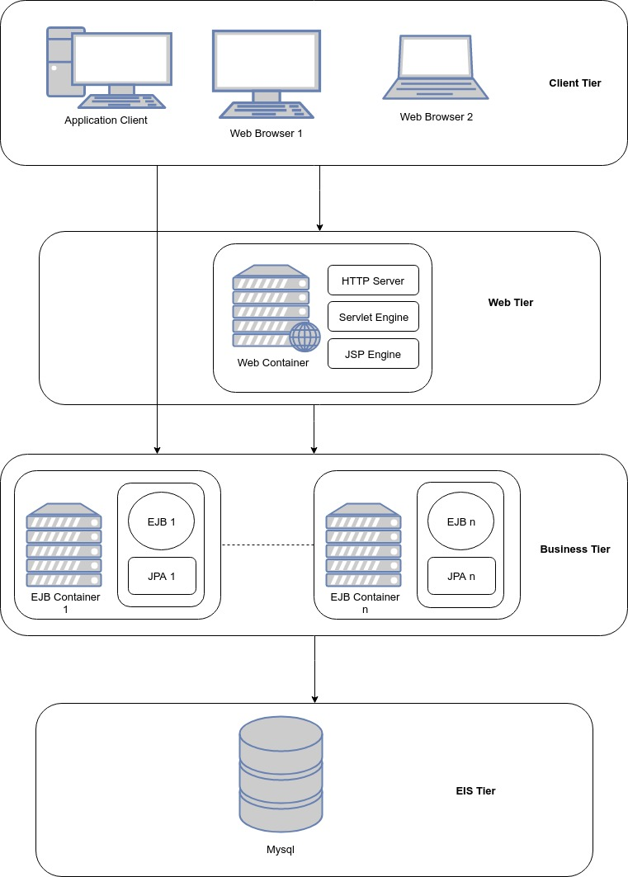

**Figure 1: N-tier architecture for online shopping**

**3. Business Tier:**

Business tier consists of two layers, one is business logic layer and another one is data access layer. In business logic layer, enterprise java beans(EJBs) are exist such as session beans, message driven beans. On the other hand, in data access layer, JPA that means java persistence entities, entity manager, transactions and connections to EIS tier

are exist. Business logic layer is focused on business components where rules and logics are implemented and data access layer is focused on saving, retrieving and other data manipulations with external databases or any kind of resources or other legacy systems. Business tier is deployed in EJB containers like Glassfish, Weblogic etc. They are also known as application servers.

**4. EIS Tier:**

EIS tier is consists of databases or any kind of resources or other legacy systems. It is known as Enterprise Information System Tier.

**Functionalities of online shopping:**

**• Shopping cart:**

Shopping cart functionality will be implemented in business tier using enterprise java bean. Here we will use stateful session bean and user access will be remote interface. When user session terminates, shopping cart data will be saved in database using JPA through ETS tier.

**• Input form for changing customer data by the customer:**

This functionality will be implemented in web tier using JSP and displayed to customer in client tier upon his request.

**• Discount calculation:**

Discount calculation will be implemented in business tier using enterprise java bean. Here we will use stateless session bean and user access will be local interface.

**• Preparation of the contents of the shopping cart for presentation to the user:**

This functionality will be implemented in web tier using servlet. The shopping cart contents will be get by calling shopping cart bean which will locate in business tier.

**• Storage of customer data:**

This functionality will be implemented in ETS tier using JPA. The customer data will be stored in mysql database.