PROJECT REPORT
What Drives Everyday Stress? Evidence from Smartphone Sensing and Self-Reports
Course: [Course name/code] | Semester/Section: [Details]
Department: [Department name] | Institution: [Institution name]

Team Details
S. No. | Team member name | Registration number
1 | [Enter name] | [Enter registration number]
2 | [Enter name] | [Enter registration number]
3 | [Enter name] | [Enter registration number]
4 | [Enter name] | [Enter registration number]
Submission date: [DD/MM/YYYY]

1. Dataset Source and Description
Dataset name: MobileWell100+ (multivariate longitudinal mobile dataset on individual and collective well-being)
Source and URL: Zenodo, University of Granada (Banos et al., 2022). https://doi.org/10.5281/zenodo.10975463
Date accessed: [DD/MM/YYYY] | Number of records: 14,431 stress reports from 103 participants | Number of variables: 15 (daily survey), 142 (initial survey), plus phone sensor streams

1.1 Brief description
MobileWell100+ follows 103 adults in Spain for four weeks (16 November – 14 December 2021). A smartphone app logged passive sensor data (screen events, physical activity, ambient noise and light, Wi-Fi and connectivity) and asked participants six times a day (08:00, 10:00, 13:00, 16:00, 19:00, 22:00) to rate how they felt at that moment. At enrolment, each participant also completed demographic questions and validated well-being scales, including GAD-7, PHQ-9, the Brief Resilience Scale and the I-PANAS-SF. The unit of observation is one daily report; for person-level questions it is the participant. The outcome is tense arousal, rated on a 0–100 slider from “very calm” to “very restless”, which we use as the measure of momentary stress.

1.2 Key variables
Variable | Type / units | Description
tense_arousal | Numeric, 0–100 | Momentary stress (outcome), daily survey
valence | Numeric, −50 to 50 | Momentary mood, very bad to very good
energetic_arousal | Numeric, 0–100 | Very tired (0) to very awake (100)
emotional_event | Numeric, −50 to 50 | Remarkable event since last report: < 0 unpleasant, 0 none, > 0 pleasant
screen_event | Categorical | SCREEN_ON / OFF / UNLOCKED; SCREEN_ON counted per hour
activity label | Categorical | STILL, ON_FOOT, IN_VEHICLE, ON_BICYCLE, TILTING; % of each hour still / in vehicle
GAD-7 / PHQ-9 | Numeric, 0–21 / 0–27 | Anxiety and depression symptom totals (initial survey)
BRS | Numeric, 1–5 | Brief Resilience Scale mean (items 2, 4, 6 reversed)
MENT_LS | Ordinal, 1–4 | Satisfaction with own mental health
PANAS negative affect | Numeric, 5–25 | Sum of upset, hostile, ashamed, nervous, afraid
Table 1. Variables used in the analysis

2. Data Preprocessing
- Data loading and initial inspection: the CSV files were read with pandas. The daily survey has 14,431 rows × 15 columns, the initial survey 103 × 142, the screen file 283,504 events and the activity file 5.9 million rows. Timestamps are local times stored as text.
- Missing values: the four affect ratings were complete. 434 reports lacked answer-timing columns, which were not needed, so those columns were dropped instead of the reports. In the hour before a report, activity data were missing for 34% of reports; these values were left missing and each test used only participants with enough data.
- Duplicate records: none found.
- Outliers / inconsistent values: screen-on counts were skewed (median 1, maximum 116 per hour) but plausible, so they were kept; tests on per-person averages limit their influence. TILTING (1.04 million activity records) was removed because it describes phone movement, not the user.
- Data type and format corrections: timestamps were parsed to datetime and rounded down to the clock hour. Sensor data were summarised per participant per hour (screen-on count, % of activity records IN_VEHICLE and STILL) and linked to each report through the full hour before it, so the unlock needed to answer the survey is not counted. Emotional event was recoded as unpleasant / none / pleasant, and dates as weekday / weekend.
- Encoding / transformation: participants use the slider very differently (personal means 0.9–94.5), so each report was labelled high or low stress relative to that participant’s own median; 2,073 reports at the median were left unlabelled. Energy and mood were split the same way. Questionnaire totals were computed and grouped with standard cut-offs (GAD-7 ≥ 10, PHQ-9 ≥ 10, BRS < 3). Average stress per participant was also grouped as above / below the median and into thirds for the z-test and chi-square test.
- Final dataset: 14,431 reports and 103 participants. Paired tests keep participants with at least three reports in each condition. The 386 MB activity file was reduced to a 1.3 MB hourly table so the project can be shared.
Preprocessing summary: about 6.2 million raw rows → one clean table of 14,431 reports and one of 103 participants.

3. Exploratory Data Analysis (EDA)
Questions explored: how stress is distributed, when it peaks, how much people differ, and what moves with it.

3.1 Descriptive statistics
Variable | Summary measure | Value | Interpretation
Tense arousal (all reports) | Mean / median (SD) | 34.3 / 31.0 (23.9) | Low-to-moderate stress; right-skewed, spikes at 0 (8.4%) and 50 (9.7%)
Mean stress per participant | Range (median) | 0.9–94.5 (35.7) | Very large differences between people
Valence; energetic arousal | Mean (SD) | 21.6 (21.4); 60.9 (25.1) | Mood mostly positive; usually fairly awake
Emotional event | % of reports | None 59.2, pleasant 31.5, unpleasant 9.3 | Unpleasant events are uncommon
Screen turned on (hour before) | Median (max) | 1 (116) | Skewed count
% of hour in a vehicle | Mean (median) | 7.1% (0%) | Most hours involve no travel
% of hour sitting still | Mean (SD) | 83.4% (27.1) | People are mostly stationary
GAD-7 anxiety | Mean (% ≥ 10) | 7.0 (28.2%) | 29 of 103 report at least moderate anxiety
Participants | Gender; age | 51 F, 52 M; 18–70 (median 46) | Balanced by gender, wide age range
Table 2. Descriptive statistics

3.2 Visual analysis and observations
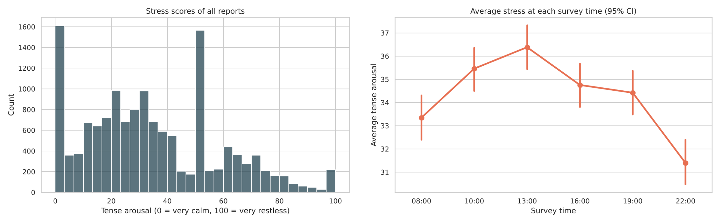
Figure 1. Distribution of tense arousal (left) and mean stress at each survey time with 95% CI (right)
Observation: stress values cluster below 50 with a long right tail; the spikes at 0 and 50 are the slider’s start and midpoint. Stress follows a daily cycle: it rises from 33.3 at 08:00 to 36.4 at 13:00 and falls to 31.4 at 22:00, in line with daytime work demands.
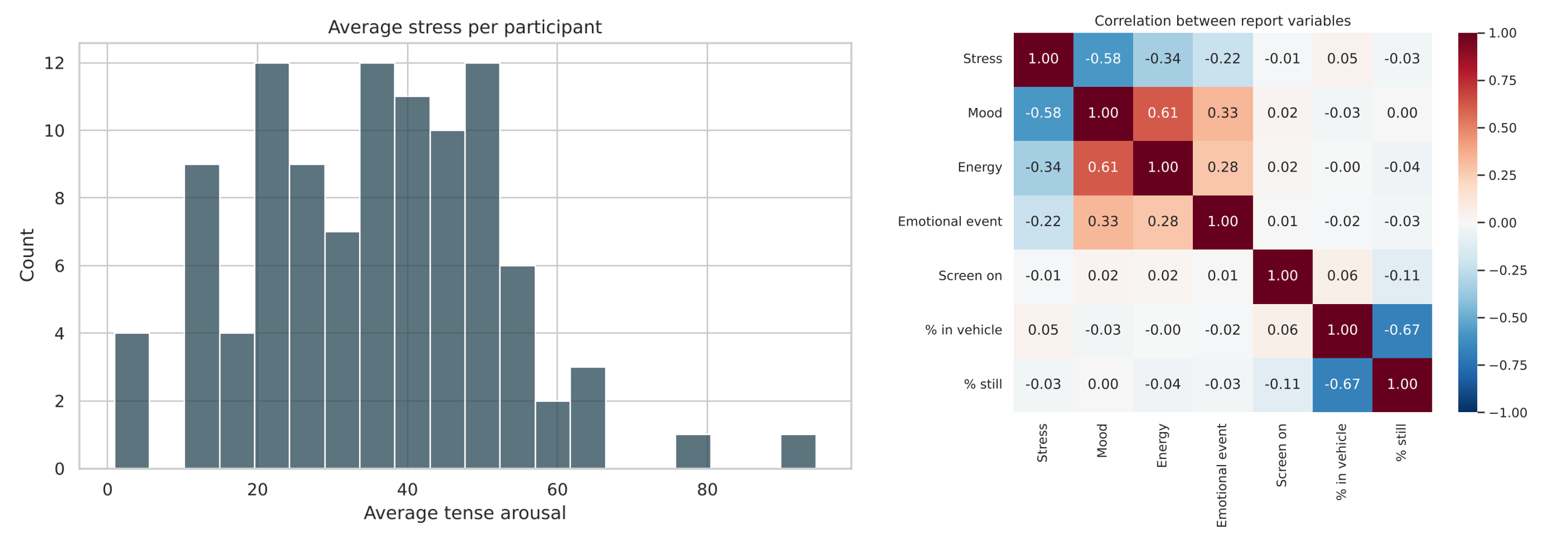
Figure 2. Mean stress per participant (left) and Pearson correlations between report-level variables (right)
Observation: typical stress levels vary widely between people, so pooled comparisons would mostly reflect who answered, not what was happening. Stress moves with mood (r = −0.58), energy (r = −0.34) and emotional events (r = −0.22). Pooled sensor correlations are near zero (|r| ≤ 0.05), so any sensor effect is small and will only show when each person is compared with themselves.
Key EDA insights: (1) Scale use differs strongly between people, which calls for within-person comparisons (paired tests). (2) Mood and energy track stress far more closely than any sensor. (3) Mean stress correlates with GAD-7 anxiety (r = 0.56), supporting tense arousal as a valid stress measure. (4) Activity data are missing for a third of reports, which reduces the sample for H2 and H3.

4. Confirmatory Data Analysis (CDA)

4.1 Research question and hypotheses
Research question: which momentary contexts and personal characteristics are associated with higher stress?
Null hypothesis (H₀): for each factor in Table 3 there is no difference in mean stress (or in the sensor measure) between the conditions compared, no difference in proportions (H8), or no association (H9).
Alternative hypothesis (H₁): a difference or association exists. All tests are two-sided.
Significance level (α): 0.05 for each test.

4.2 Statistical test and results
Test used: paired t-test (H1–H4, H6, H7), z-test for a mean difference (H5), two-proportion z-test (H8), chi-square test of independence (H9), independent-samples t-test (H10) and one-way ANOVA (H11, H12).
Reason for choosing the test: H1–H7 compare the same person in two situations, so the data are paired and the test works on each person’s difference; with 40–101 participants the mean difference is close to normal (central limit theorem). H5 has the largest sample (n = 101), so a z-test is used. H8 compares a proportion (share of people with above-median stress) between two independent groups. H9 relates two categorical variables, and all expected counts exceed 5. H10 compares two independent groups of unequal size and spread, so Welch’s t-test is used. H11 and H12 compare three groups at once, which ANOVA does without inflating the error rate of repeated t-tests.
ID | Comparison | Test | n | Statistic | p | Effect [95% CI] | Decision
H1 | Screen-on count, hour before: high vs low stress | Paired t | 93 | t(92) = 2.68 | 0.009 | +0.22 /h [0.06, 0.39] | Reject H₀
H2 | % of hour in vehicle: high vs low stress | Paired t | 86 | t(85) = 2.29 | 0.025 | +1.2 pp [0.2, 2.3] | Reject H₀
H3 | % of hour sitting still: high vs low stress | Paired t | 86 | t(85) = −2.58 | 0.012 | −2.7 pp [−4.7, −0.6] | Reject H₀
H4 | Unpleasant event vs no event | Paired t | 75 | t(74) = 10.88 | <0.001 | +17.1 [14.0, 20.2] | Reject H₀
H5 | Weekday vs weekend | z (mean diff.) | 101 | z = 4.67 | <0.001 | +2.5 [1.5, 3.6] | Reject H₀
H6 | Tired vs awake (own median) | Paired t | 93 | t(92) = 3.42 | <0.001 | +4.0 [1.7, 6.3] | Reject H₀
H7 | Bad vs good mood (own median) | Paired t | 90 | t(89) = 7.92 | <0.001 | +8.8 [6.6, 11.0] | Reject H₀
H8 | % above-median stress: GAD-7 ≥ 10 vs < 10 | Two-prop. z | 29/74 | z = 3.79 | <0.001 | 79% vs 38% [+23, +60 pp] | Reject H₀
H9 | PHQ-9 ≥ 10 × stress third | Chi-square | 103 | χ²(2) = 11.53 | 0.003 | Cramér’s V = 0.33 | Reject H₀
H10 | Resilience (BRS) < 3 vs ≥ 3 | Welch t | 27/76 | t(38.1) = 2.69 | 0.011 | +10.8 [2.7, 19.0] | Reject H₀
H11 | Mental-health satisfaction (3 groups) | ANOVA | 103 | F(2,100) = 3.76 | 0.027 | η² = 0.07 | Reject H₀
H12 | General negative affect (3 groups) | ANOVA | 103 | F(2,100) = 4.51 | 0.013 | η² = 0.08 | Reject H₀
Table 3. Results of the 12 tests. Effects are mean differences in stress points (higher-stress condition minus other) unless a unit is given; pp = percentage points; 95% CI from the t or z distribution.
Decision: all 12 tests give p < 0.05, so H₀ is rejected for each.
Conclusion in context: the strongest effects are emotional. After an unpleasant event, a person’s stress is 17.1 points higher than when nothing happened, and in bad-mood moments it is 8.8 points higher. Routine also matters: weekdays add 2.5 points and tiredness 4.0. Between people, 79% of those with anxiety symptoms have above-median stress against 38% without; depression symptoms are moderately associated with stress level (V = 0.33); low resilience adds 10.8 points; and stress is highest among people dissatisfied with their mental health or high in negative feelings (each explains about 7–8% of the variance). Phone sensors show small shifts in the hour before high-stress reports: slightly more screen use, more time in a vehicle and less time sitting still, which together suggest people are more on the move before they feel stressed. All results are associations, not causes.
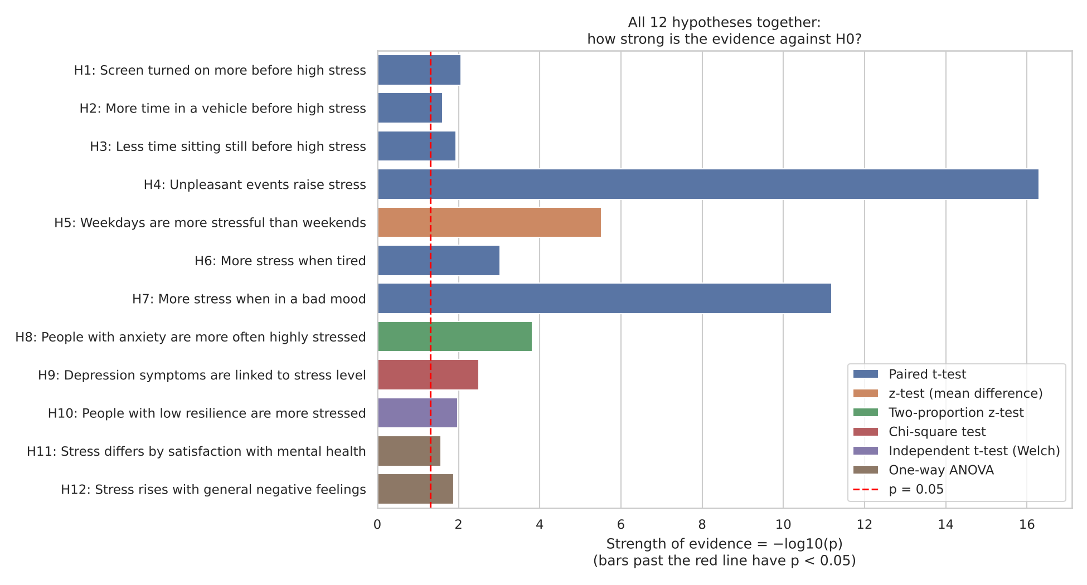
Figure 3. All 12 hypotheses together: strength of evidence, −log10(p); bars past the red line have p < 0.05. A chart for each test is in results/hypotheses of the project folder.

5. Findings and Conclusions

5.1 Major findings
1. Emotional context drives momentary stress most: stress is 17.1 points higher after an unpleasant event and 8.8 points higher in bad-mood moments.
2. Stress follows the daily and weekly routine: it peaks around midday (36.4 at 13:00 vs 31.4 at 22:00), is 2.5 points higher on weekdays and 4.0 points higher when people feel tired.
3. Mental-health traits set the baseline: 79% of people with anxiety symptoms are in the more-stressed half (vs 38%), and depression symptoms, low resilience and poor satisfaction with mental health show the same pattern.
4. Passive phone data pick up small changes before high stress (more screen use, more travel, less time still): useful as support for stress detection, not enough on their own.

5.2 Conclusion
The project set out to find which factors are associated with stress in everyday life. EDA showed a skewed stress scale, large differences between people and a midday peak, which led us to compare each person with themselves wherever possible. Using t-tests, z-tests, chi-square and ANOVA, all twelve hypotheses were supported at α = 0.05. Stress rises with unpleasant events, bad mood, tiredness and weekdays, and it is higher on average in people with anxiety, depression symptoms or low resilience. Smartphone sensors add a weaker signal. Income (ANOVA, p = 0.30), gender (t-test, p = 0.26) and employment (t-test, p = 0.65) showed no difference. The findings describe associations in this sample and do not establish causes.

5.3 Limitations and future scope
Limitations: 103 Spanish adults over four weeks in late 2021, during the pandemic, so results may not generalise. The design is observational and the direction of effects is unknown. Twelve tests were run; with a stricter Bonferroni threshold (0.05/12 = 0.004) only H4–H9 remain significant, so the sensor results and H10–H12 need confirmation. Hourly sensor windows are coarse, the median split discards part of the 0–100 scale, and several hypotheses were chosen after exploring the data.
Future scope: repeat the tests on a new sample, and use regression on the full stress scale to see which factors still matter when they are considered together.

References / Dataset Citation
Banos, O., Bailon, C., Damas, M., Goicoechea, C., Perakakis, P., Pomares, H., Rodriguez-Leon, C., Sanabria, D., & Villalonga, C. (2022). MobileWell100+: A multivariate longitudinal mobile dataset for investigating individual and collective well-being (Version 2) [Dataset]. Zenodo. https://doi.org/10.5281/zenodo.10975463. Accessed: [DD Month YYYY].
Kroenke, K., Spitzer, R. L., & Williams, J. B. W. (2001). The PHQ-9: Validity of a brief depression severity measure. Journal of General Internal Medicine, 16(9), 606–613.
Smith, B. W., Dalen, J., Wiggins, K., Tooley, E., Christopher, P., & Bernard, J. (2008). The brief resilience scale: Assessing the ability to bounce back. International Journal of Behavioral Medicine, 15(3), 194–200.
Spitzer, R. L., Kroenke, K., Williams, J. B. W., & Löwe, B. (2006). A brief measure for assessing generalized anxiety disorder: The GAD-7. Archives of Internal Medicine, 166(10), 1092–1097.
Thompson, E. R. (2007). Development and validation of an internationally reliable short-form of the Positive and Negative Affect Schedule (PANAS). Journal of Cross-Cultural Psychology, 38(2), 227–242.

